Economics Notes: Government Regulation

1. Price Ceiling
    - A maximum price set artificially by the government of firms so that goods are bought and sold at that price level which is below the market equilibrium price level. There will be a reduction in qty supplied and an increase in qty dd, which will cause an excess dd condition. E.g. HDB Public Housing

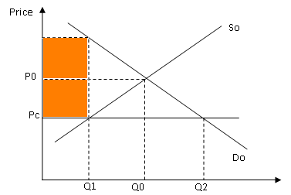

original price is set T Po and the price ceiling is at Pc – increase in quantity and decrease in quantity supplied - shortage at Pc – Q1 Q2
- evolve the rise of black market price at Pm – the highest price the consumer is willing to pay at this price level
    - Reasons for charging price ceiling:
- To prevent over-charging and have an equitable distribution of the product.
- To control the release of scarce and essential goods (especially during war time)/ essential merit good.
- Difficulties in imposing price ceiling
- May create an excess demand condition which cannot be resolved if there is no buffer stock.
- It contradicts the market principles which will undermine the efficiency of the economy. (shift and costless adjustment of recourses)
- may give rise to black market price if the market cannot have excess supply from buffer stock to meet demand

    - Effects of price ceiling
University Meritocracy
HDB Social allocation

Shortage of goods in the market requires rationing.

Black market may evolve.

Required to keep a buffer stock.

US Government set price ceiling during oil crisis in 2010 but the black market fails to evolve as the US government can take from the buffer stock to meet the excess demand.

UAE set up price ceiling for the rice market but they do not have a buffer stock to meet the excess demand. Consequently, a black market evolves.

HDB set price ceiling and there is no buffer stock to meet excess demand – but there is no black-market price – why? there are laws to control ownership

Rationing based on social allocation – draw lots, social based criteria
legal binding – prevent black market price

2. Price Floor
    - A minimum price set artificially so that goods are bought and sold at that price level which is above the market equilibrium price level
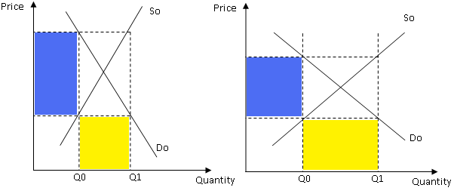
    - Reasons for setting floor price
- To protect the interest of the supplier (labour market, resource market) – to maintain their income – e.g. Wage.
- To stabilize the price of primary products maintain revenue for farmers
    - Effects of Price floor
    - Excess supply
    - Government needs a sum of money to stabilize the market. Hence, the government will attempt to use the method of price setting that will incur the least level of government expenditure. If the demand and supply are price-inelastic, the government will buy up the excess stock to create a buffer stock, assuming that the stock is non-perishable. (oil)
    - If the demand and the supply are price-elastic, the government will subsidize every unit brought by the consumers at the level of quantity where the floor price is set with an amount equals to the difference in value of the market-clearing price and the floor price. This is also introduced when the goods to regulated is perishable as the subsidy will encourage the consumption of the goods to ensure that there is market clearance at the floor price.

3. Direct Tax
    - Direct tax is directly levied by the authorities on the consumers/ business entry

3.1 Indirect Tax
    - Indirect tax is tax levied by the authorities on producers. The producers can then pass on the burden of the tax to the consumers.
- Specific tax, or per unit tax, is a constant tax amount levied on per unit of goods sold. It causes a parallel shift of the supply curve up and to the left.
- Ad volarum tax, a percentage tax, takes a percentage of the price of good concerned. It changes as the price of good changes. It changes the slope of the curve as the curve pivots anti-clockwise upwards.
- Lump sum tax is a fixed amount of tax regardless of the amount of quantity.

Tax Incidence
    - Tax incidence refers to the distribution of tax burden between the consumers and producers.

- (b) Japan increased its sales tax in April 2014. Using a diagram, explain what determines the size of the increase in the price of a good following such a tax increase. [4]

(sales tax is ad valorem – percentage change in tax based on price level – higher price tax per unit is higher)
- how increase in tax affect the price of the goods?
- identify and explain the factors that will affect the change in price of goods when tax is imposed?
(PED of the goods, amount of tax, types of tax)
- Draw diagram and describe – ad valorem

Consumer Tax Burden
    - Tax incidence that falls on the consumers (C_{t}).
    - Consumers will take the entire tax burden if demand is perfectly inelastic and if supply is perfectly elastic. (change in price= tax amt100 % CTB)
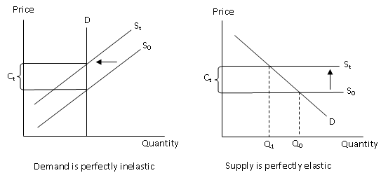

Producer Tax Burden
    - Tax incidence that falls on the producers (P_{t}).
    - Tax burden falls entirely on producers when supply is perfectly inelastic and when demand is perfectly elastic. (no. change in price- tax is 100%)
Q₀
Price
Quantity
S₀ / S_{t}
D
P_{t}
Supply is perfectly inelastic
Q₁
Q₀
Price
Quantity
S₀
S_{t}
D
P_{t}
Demand is perfectly elastic

Tax
Tax

4. Subsidy
    - Subsidy is a payment to the producers by the government. It lowers the cost of production and shifting supply curve down and to the right.
- Specific subsidy causes a parallel shift downwards and to the left.
- Ad valorem subsidy causes a pivoted shift in the clockwise direction.
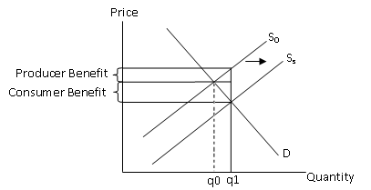
4.0 Deadweight Loss
- Consumer and producer welfare (surplus) loss when there is allocative inefficiencies as a result of the restriction of production due to the imposition of taxation
- Deadweight loss = C+D

process on subsidy
provision of subsidy – lower the cost of production – increase the supply – supply will shift rightward – decrease in price and increase in quantity.
producer benefit / consumer benefit (represented by the portion of decrease in price x qty)

Explain the impact on the producers and consumers when THERE IS A REMOVAL OF SUBSIDY.
- HOW THE REMOVAL SUBSIDY AFFECT THE RPICE AND OUTPUT
- Explain the impact of the consumer and producer in terms of the consumer benefit and producer beneift

5. Process on how market equilibrium is derived to depict the equilibrium price and output level

    - Market equilibrium is attained when the market demand is equal to market supply whereby the demand curve intersects the supply curve.
    - At market equilibrium, it will reflect the level of quantity and price level set by the market forces. Any changes in demand and supply will lead to a change in market equilibrium, indicating the new price and output level.
    - To attain market equilibrium, the consumers and producers will engage in a negotiation process. The consumers would increase (decrease) their quantity demanded while the producers would decrease (increase) their quantity supplied as price decreases (increases).
    - As the producers and consumers adjust their quantity supplied and demanded respectively as price changes, they would reach the equilibrium where they would agree to a particular price level which their quantity supplied and demanded are the same. This market equilibrium will change when there are changes in demand and supply.

Sample question 1. Explain how the price level of oil will increase
    - The change in the price of oil is determined by the market forces of demand and supply which will be determined at the new market equilibrium. For the case of a rise in price of oil, there must be a decrease in the supply of oil and an increase in the demand for oil that will contribute to the rise in the price of oil.
    - Causes of an increase in demand for oil
- Increase in income – increase in demand for more manufactured goods – increase in production – increase in demand for oil (oil is derived demand)
- Change in taste and preference
- Taxation and subsidies
- Government policy
    - Causes of a decrease in the supply of oil
- High cost of the crude oil
- High cost of production
- Limited capacity of the supply of the resources
- Government policy
- Technological deficiency
- It is also noted that the price of oil is likely to rise sharply as the price-inelastic demand and price-inelastic supply condition will contribute to this degree of a change in the price level when there is an increase in demand for oil or a fall in supply of oil.

1) Why the demand and supply oil is price-inelastic?

The price of oil will also rise despite an increase in supply of oil as the increase in demand for oil is greater for oil is greater than the increase in supply of oil.

2) Why the increase in demand of oil is greater than the increase in supply of oil?

The price of oil will also rise despite an increase in supply of oil as the increase in demand for oil is greater than the increase in supply of oil.

Why the increase in demand for oil is greater than the increase in supply of oil?

Increase in DD is > increase in ss
1. Affluence of the people large middle Y group
2. Huge population growth
3. Difficult to increase SS non-renewable resources
Hampered by distribution

3) Why decrease in DD for air travel is > decrease in SS of air travel? (Increase in oil price)
1. Decrease in dd is broad- based as recessions affect most consumers
2. Decrease in SS is limited as the fixed cost is more influential factor than the rise in variable cost the rise in price of oil.

Explain the impact of the occurrence of recession and a rise in oil price on the aviation industry (air travel).
- Explain that the impact of the aviation industry due to the above events is seen from the change in the market equilibrium of the aviation industry which will depict the change in price and output level of the air travel.
- Explain how the recession will affect the demand for air travel. Decrease Y decrease dd for air travel normal good
- Explain how the rise in oil price will affect the supply of the air travel-> Increase COP decrease SS
- Explain the extent of change in the price and output level of the air travel industry after considering the following factors:
1) The extent of change in demand and supply of air travel, decrease in DD<decrease in SS
2) Price elasticity of demand and supply of the air travel, DD and SS are price elastic.

DD is more elastic:
- low degree of necessity
- high degree of substitution
- production of y spent is large
- time period of consideration of produce is large

SS is more elastic:
- Availability of other transport means
- Time preparation is long.
Reduction is price is minimum but reduction in qty extension.

Other related areas of discussion
- Identify the factors that contributes to the increase in production in the industry
- Consider the impact on the car sales market when there is a reduction in the quota of cars due to reduction the number of COEs available and the occurrence of recession.
- It is said that the supply of fish will be reduced extensively as result of the overfishing while there is a growing affluence which will lead to a rise in the demand for fish.
  - Assess the impact of the above events on the fish market.

