Lsn 1 - CSQ Q4 Demand & Supply

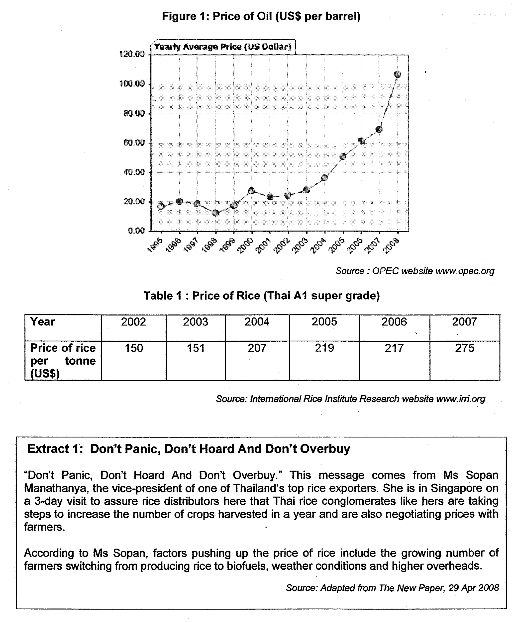

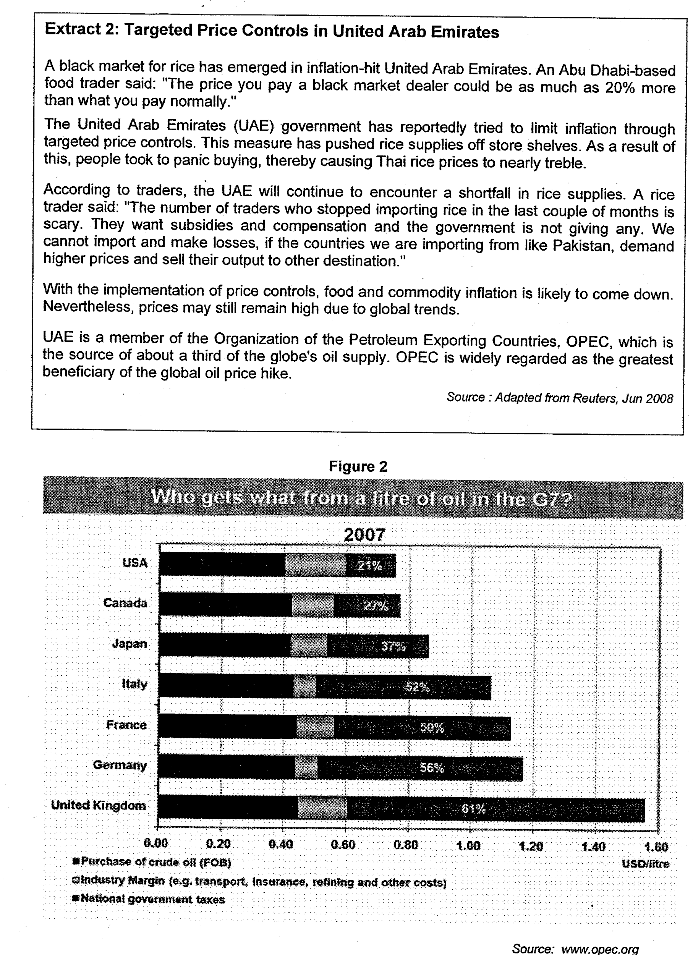

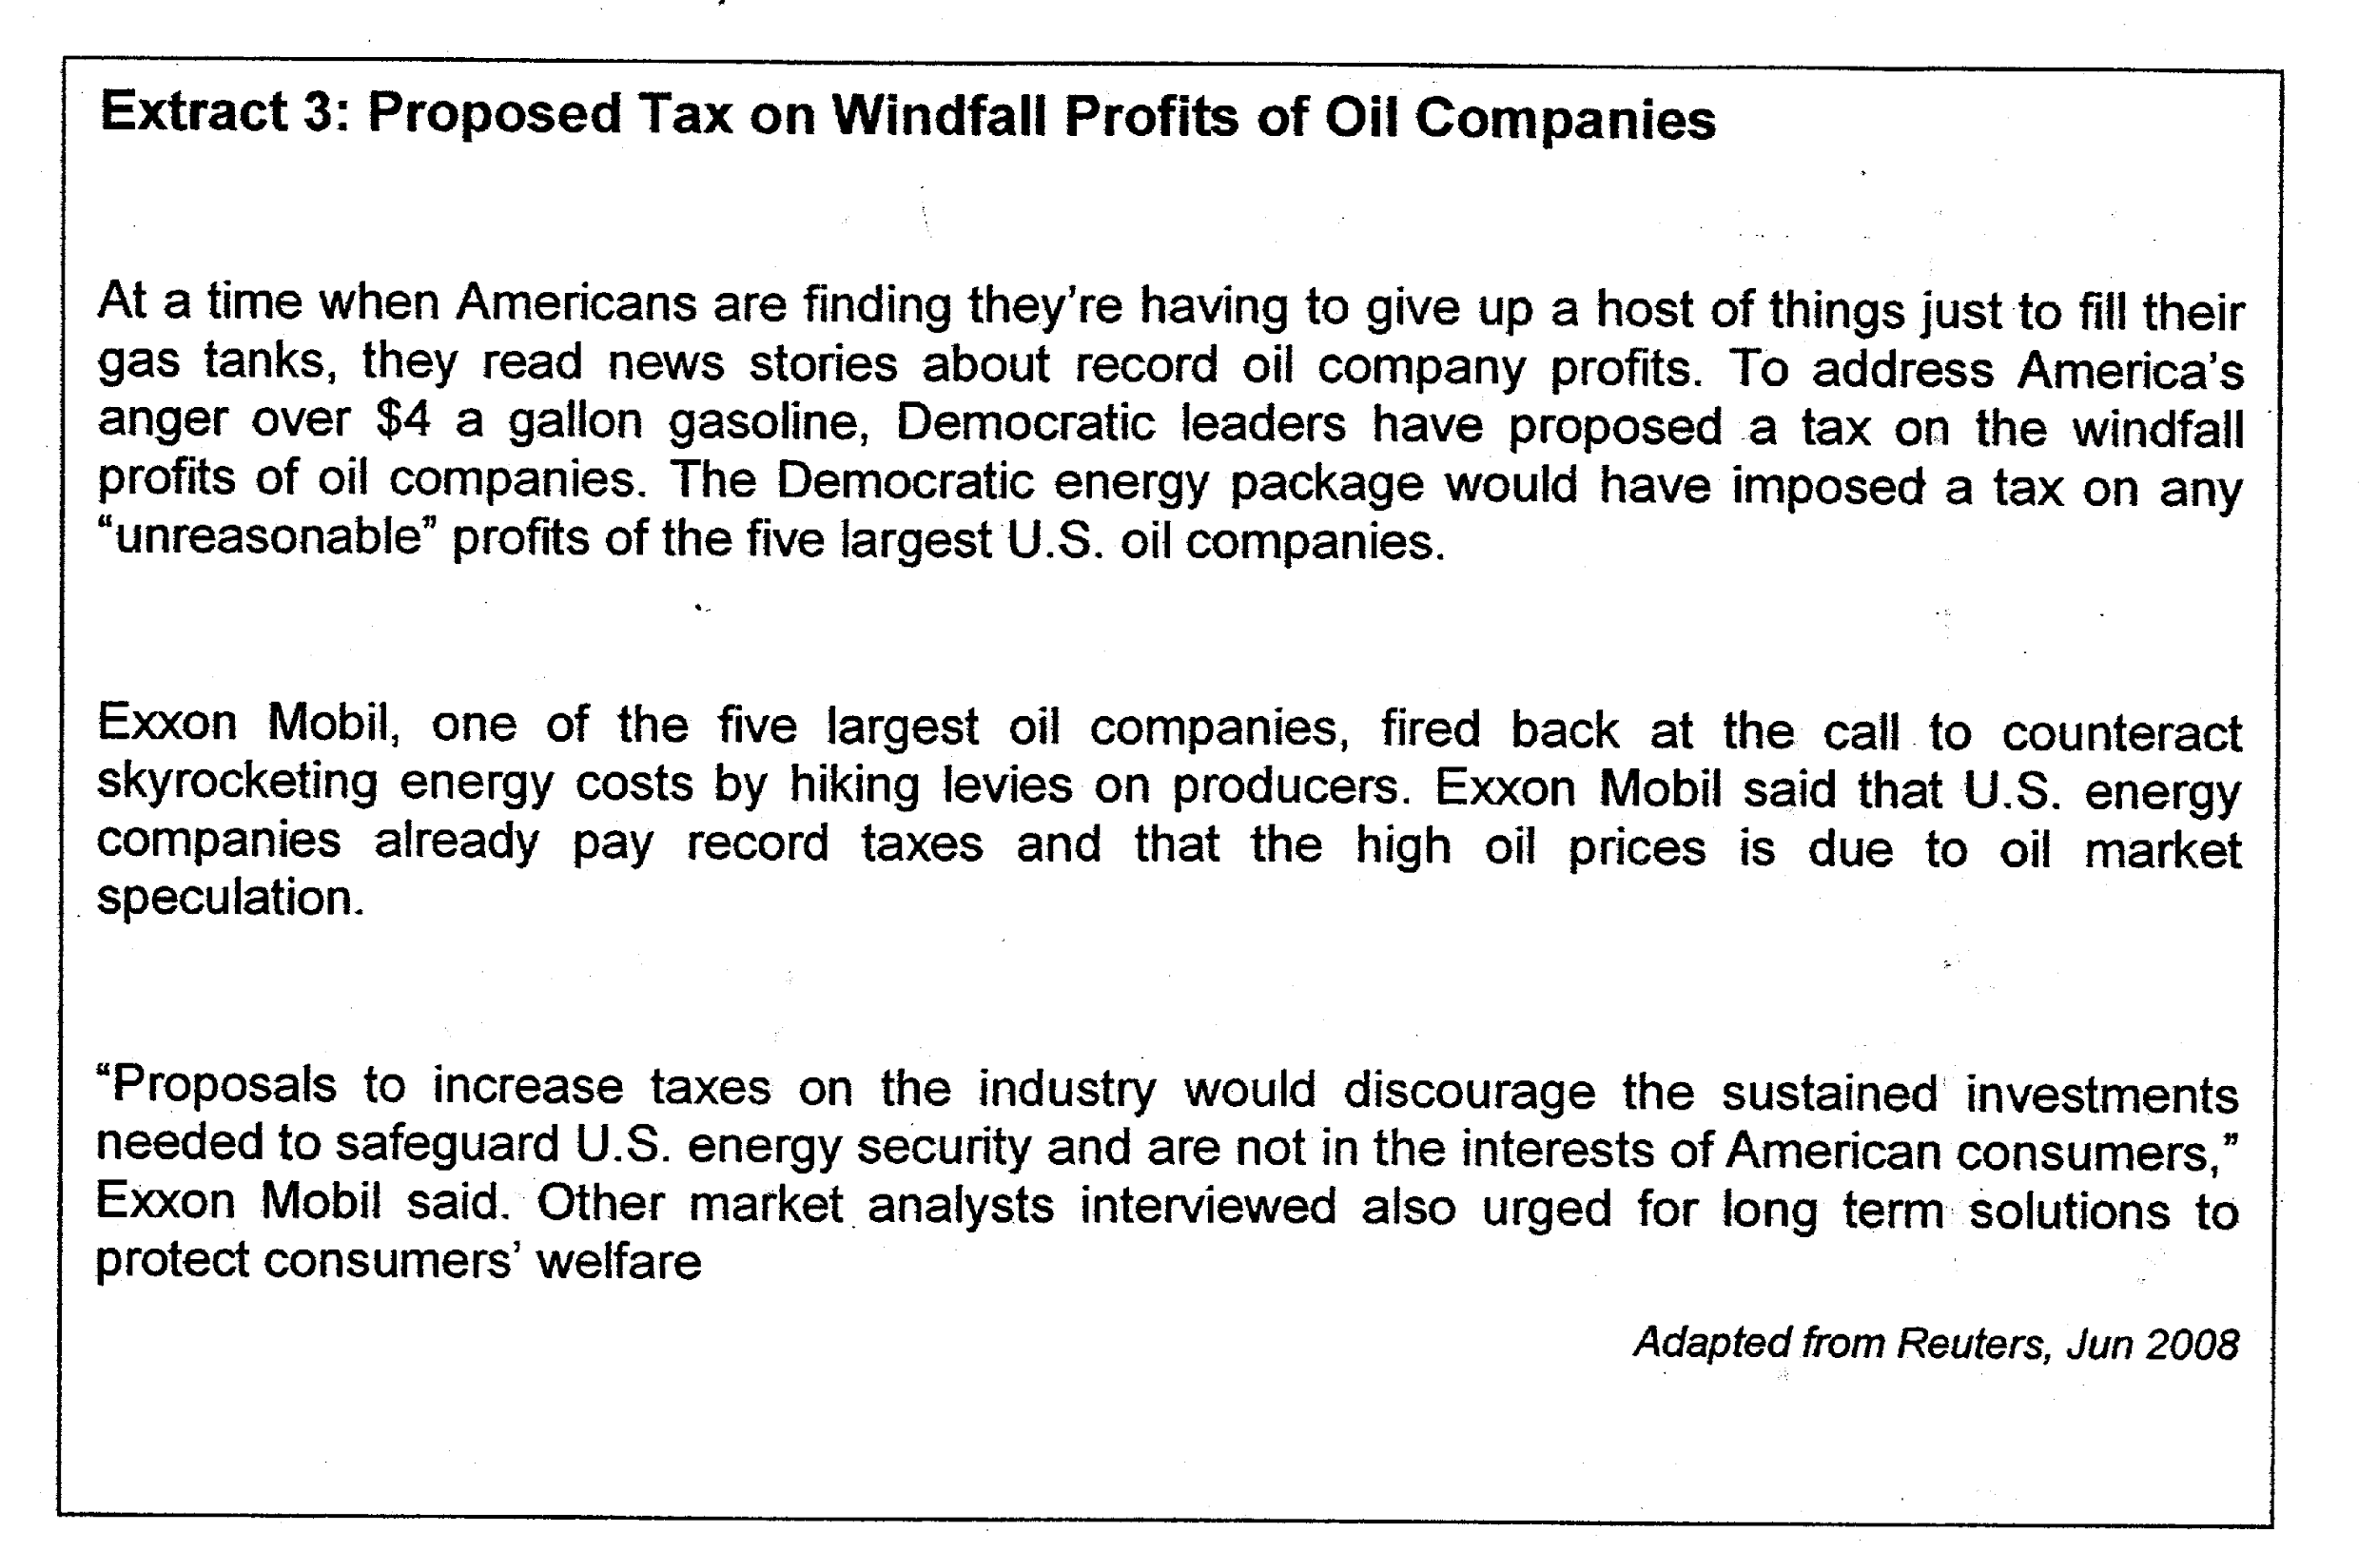
Questions
(a) (i) With reference to Figure 1 and Table 1, compare the trend of prices of rice and oil in the period 2004 to 2007. [2]

(ii) With reference to Extract 1, provide a possible explanation for the relationship between the price of rice and that of oil between 2004 and 2007. [2]/ (6)

(b) With reference to Extract 2, explain, with the aid of a diagram, how price controls implemented by the UAE government may affect

(i) the market for rice. [3]
(ii) the consumers. [2]

c) i) Is the demand for oil price elastic or inelastic? (3)
ii) Explain how price elasticity of demand would affect how the firm’s pricing strategy to increase total revenue. (3)

d) Discuss if the demand or supply factors will be more significant in influencing the price of oil. (5)

Total marks (20)

Suggested Answers
(a) (i) With reference to Figure 1 and Table 1, compare the trend of prices of rice and oil in the period 2004 to 2007. [2]

Both oil price and rice price increase. Oil price increases by about 100%, which is more than rice price increase (33%).

(a)(ii) With reference to Extract 1, provide a possible explanation for the relationship between the price of rice and that of oil between 2004 and 2007. [2]

Overhead -oil needed as a factor of production of rice, eg, use of machineries in farm, transportation. Oil price hike lead to increase in cost of production and therefore increase in price of rice.

OR
Biofuel production - oil price increase leads to increase in demand for biofuel which is a substitute of fossil oil. Resources, especially land, used for rice production will be diverted 🡪↓SS of land for rice 🡪↑COP🡪↓SS of rice🡪↑P of rice

(b) With reference to Extract 2, explain, with the aid of a diagram, how price controls implemented by the UAE government may affect

(i) the market for rice. [3]

Explain how the max price works to affect price of rice and the quantity transacted
Price Ceiling is the maximum legal price allowed by government. No rice can be bought or sold at prices above this upper limit. In order for a price ceiling to be effective, the legal maximum price has to be below the market equilibrium. Explain how shortage Q*-Q_{s} arises and transacted amount is lower at Q_{s} as compared to Q*
Definition/
Mechanism

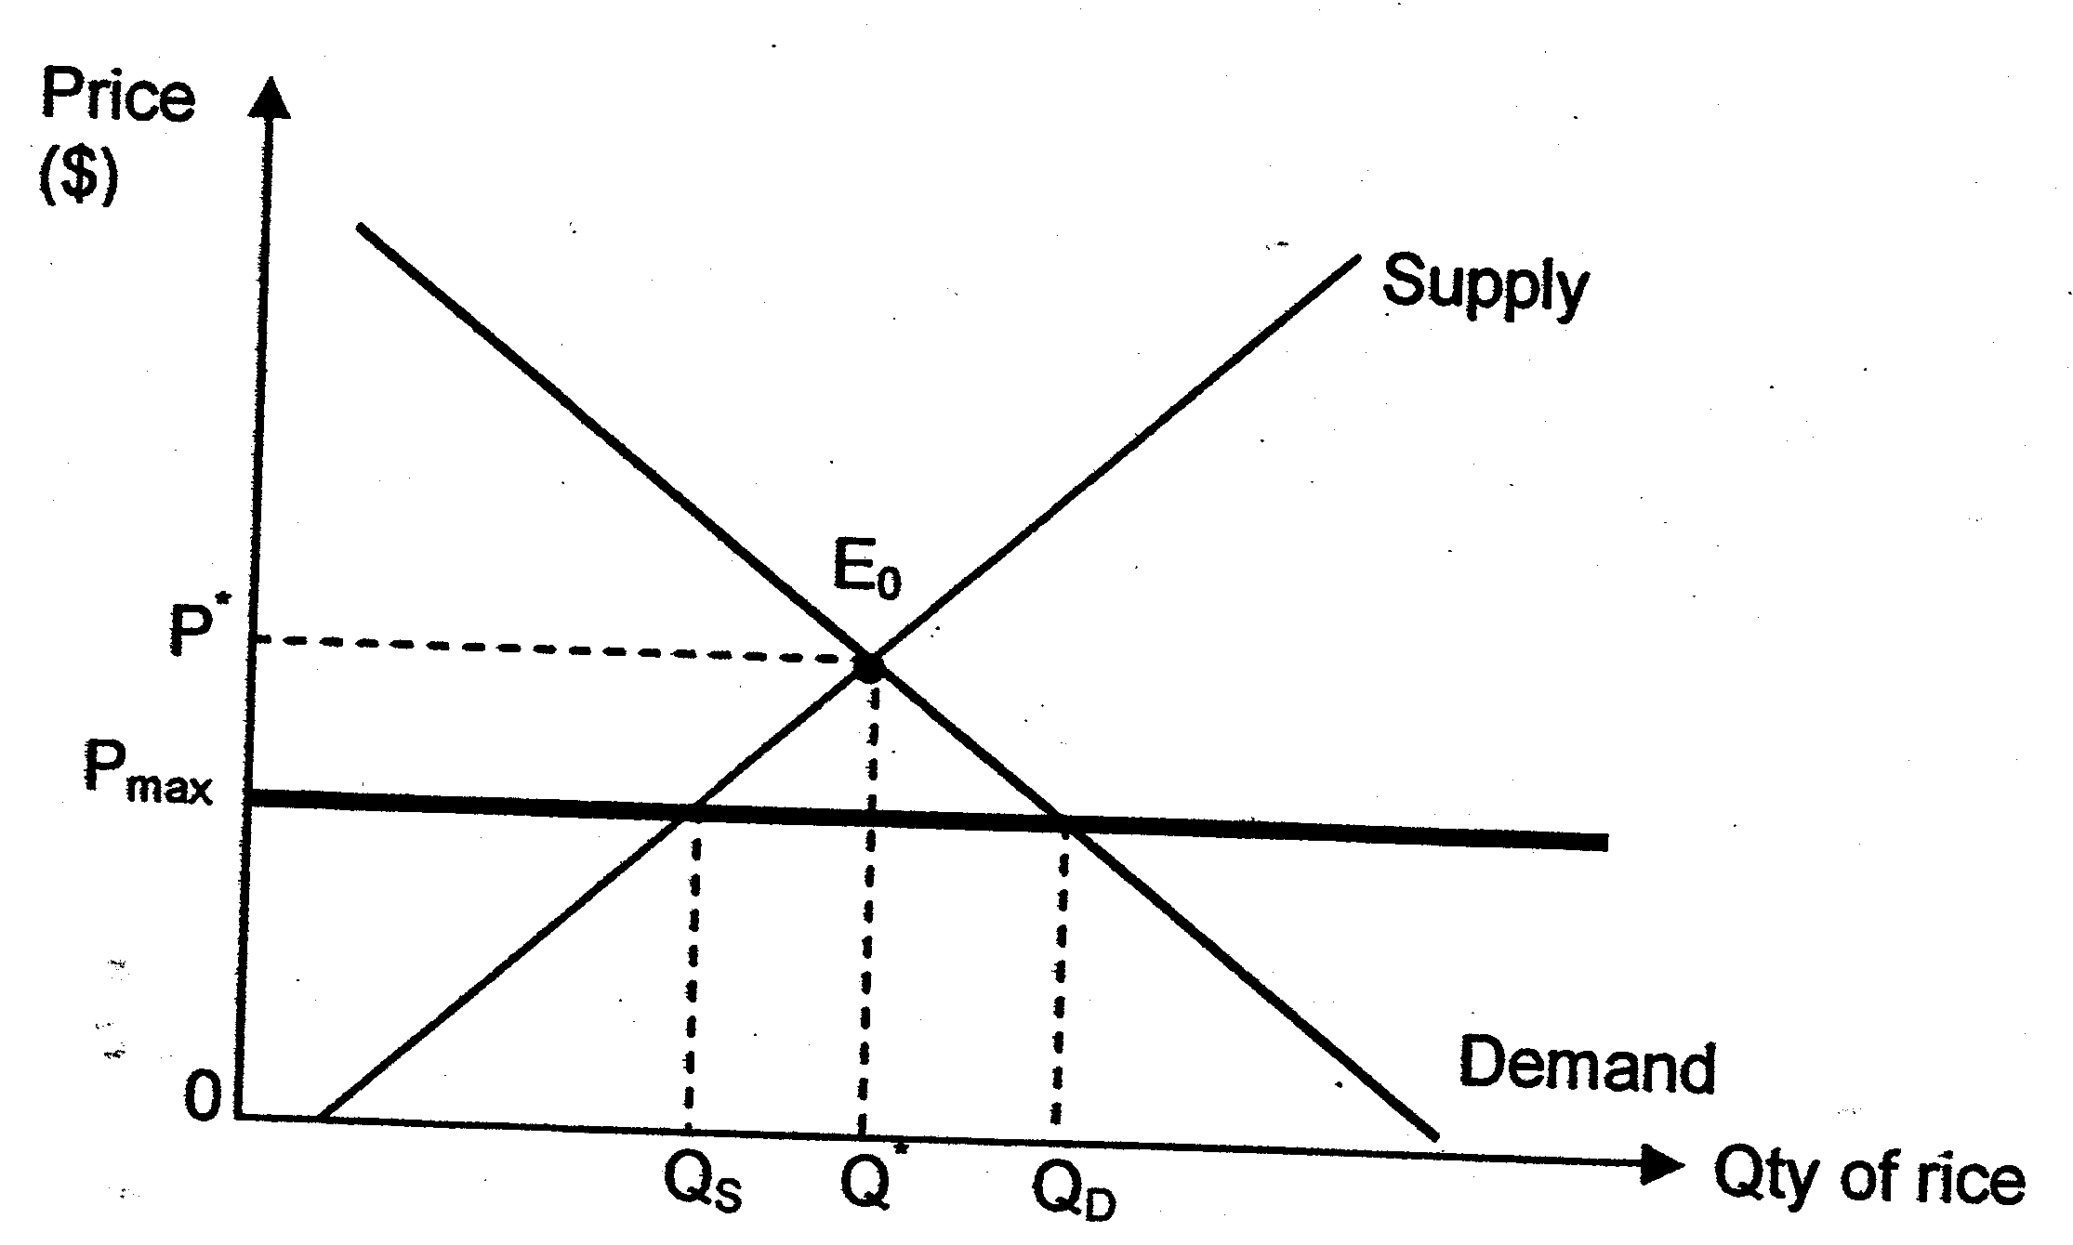
Government must be able to meet excess demand by drawing from the buffer stock or set allotment to ensure price ceiling is effective
Problems:
Emergence of black market
Undermine lower income group
Quality of product
Profit of producers – closure of the business

(b) With reference to Extract 2, explain, with the aid of a diagram, how price controls implemented by the UAE government may affect

(ii) the consumers. [2]

Explain how different groups of consumers are affected.
Explain how a black market may arise. Some consumers are able to purchase at a lower price P_{max} and they are better off now. However, others who were able and willing to purchase at P* are no longer able to do so. They may have to purchase from a black market at prices higher than P*. Quality of rice may be compromised.

oil importers. Their economic growth is likely to shrink because of higher cost of production and reduced world demand leading to lower AD in each country. These, if allowed to persist, will lead to poor consumer confidence and bleak biz outlook. World production is likely to fall leading to fall in demand for oil from UAE. In the long run, world recession is likely and UAE will go down with the rest of the world.

(e) Critically examine how the proposal of "a tax on any "unreasonable" profits of the five largest US oil companies" (Extract 3), is effective in protecting consumers' interests. [10]
Price, quality of the product, welfare of the consumers

Explain how 5 dominant oil firms are not allocative efficient and how consumers' interests are compromised
Monopoly power is present in the five largest oil company which are all able to make huge profits at the expense of consumers. Through producing low output and charging high price.

A dominant firm faces a downward sloping demand curve DD and MR as seen in

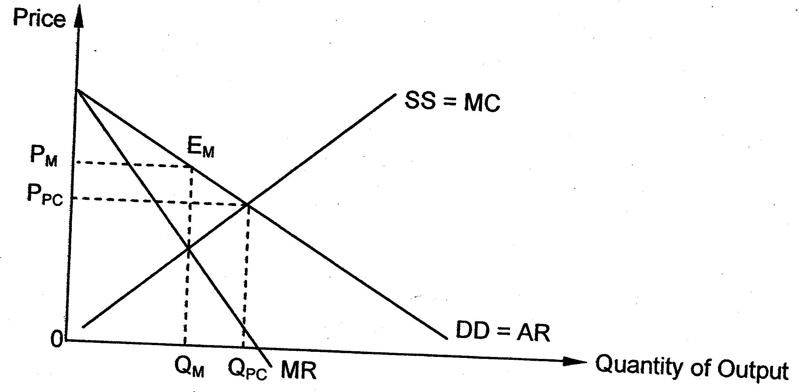
Market power
Allocative inefficiencyrise of DWL
Net social benefit gain will be reduced/fail to maximize
Price setting behaviourP,Qty
undermine consumer interest
Unequal distribution of income
Profit Maximisation output level of a Monopolist
(Note: diagram is not compulsory but students are likely to explain monopoly power better with than without the diagram)

The dominant oil firms together produce output Q_{m} and charge price (P_{m}). This price exceeds the opportunity cost (MC) of producing it. This means the society values the additional units of product higher than it values the alternative products these resources could otherwise produce. Hence, the firms are not allocatively efficient.

Dominant oil firms produce output Q_{m} charge price P_{m}
This is opposed to a higher output level QPC and lower price PPC if industry is provided by many firms which have no influence over price output level.

Consumers’ welfare is thus compromised by the inefficient allocation of resources. They are charged a higher price and only provided al lower output.

The unreasonable profits also imply an equity issue because top management and shareholders of these companies are able to enjoy greater bonuses as others, especially the poor, struggles with the oil price hike.

Explain how tax on unreasonable profits can protect consumers welfare:
A lump sum tax on the profits of these oil companies will enable the govt to channel tax revenue back to consumers, e.g., transfer payments to help lower income cope with the oil price hike, or providing subsidies in fuel related consumption. (Many students wrote generally that payments be given to the poor. This is not good enough. It should be directed to help them cope with the oil price hike.)

Explain how tax on unreasonable profits may not protect consumers welfare:
However, these oil companies will not have funds to engage in R&D to look for more efficient methods of production which may reduce ave cost of production. Lower average cost can be passed to consumers in terms of lower price.

Also investment on exploration of new oil wells which will lead to a larger supply and therefore lower price for consumers will be cut back because of hefty tax on oil firms' profits. High oil price is mainly due to speculation in the oil market and not the oil companies. Tax, though channelled to consumers, does not increase production level of the dominant firms.

Evaluation:
Whether the tax protects consumers' welfare depends on how the govt uses it to channel back to consumers to compensate for the high oil price.

Also, the govt may not know the costs of the firms to assess how much consumers are overcharged.

Judgement: The long run damage to consumers' welfare makes taxation on oil firms' profits undesirable.

Recommend: one or two appropriate policies (use evidence from the data provided. Extract 3 suggests long term solutions and investments, so explain these.). Examples:

- It might be better for the govt to allow more firms and therefore greater competition in the industry than to introduce tax on profits. This will ensure less dominance and possibly lower prices.
- Govt is already taxing heavily on the consumption and production of oil (table 2) and should use those tax, instead of additional tax on firms' profits, to encourage greater R&D to develop alternative energy sources like solar or wind energy.

i. Taxation🡪tax per unit🡪↑MC🡪profit maximisation (MC=MR)
- ↑P🡪allocative inefficiency worsen
- ↑P🡪tax is passed on to the consumer (DD for oil is price-inelastic)

ii. Taxation🡪lumpsum tax🡪eradicate supernormal ∏
- solve unequal distribution of income
- But price remains high/output low
- Same degree of allocative inefficiency 🡪DWL persist

Conclusion
Taxation is not an effective measure to solve inefficiency in resource allocation for market dominance

