2017 Economics – Economic Growth, Inflation, Unemployment – CSQ Q1

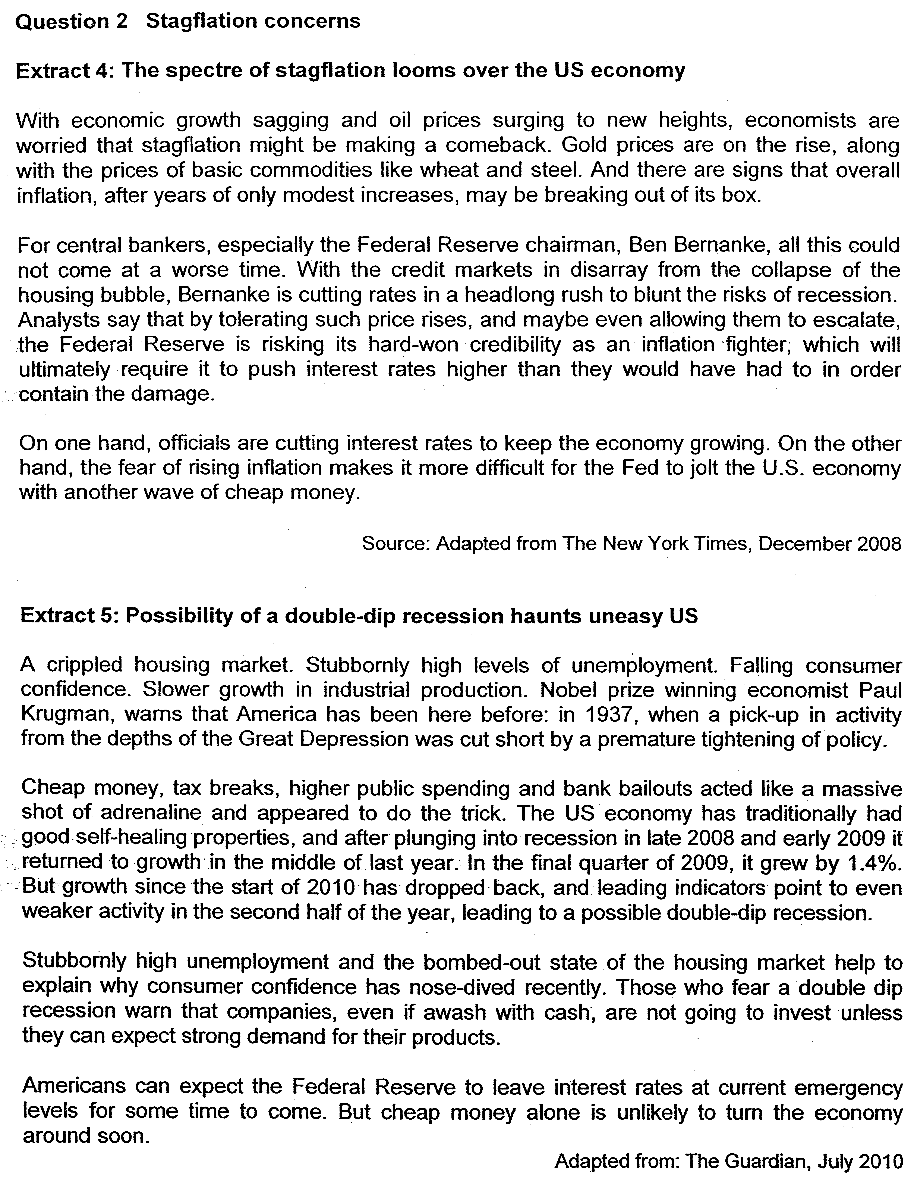

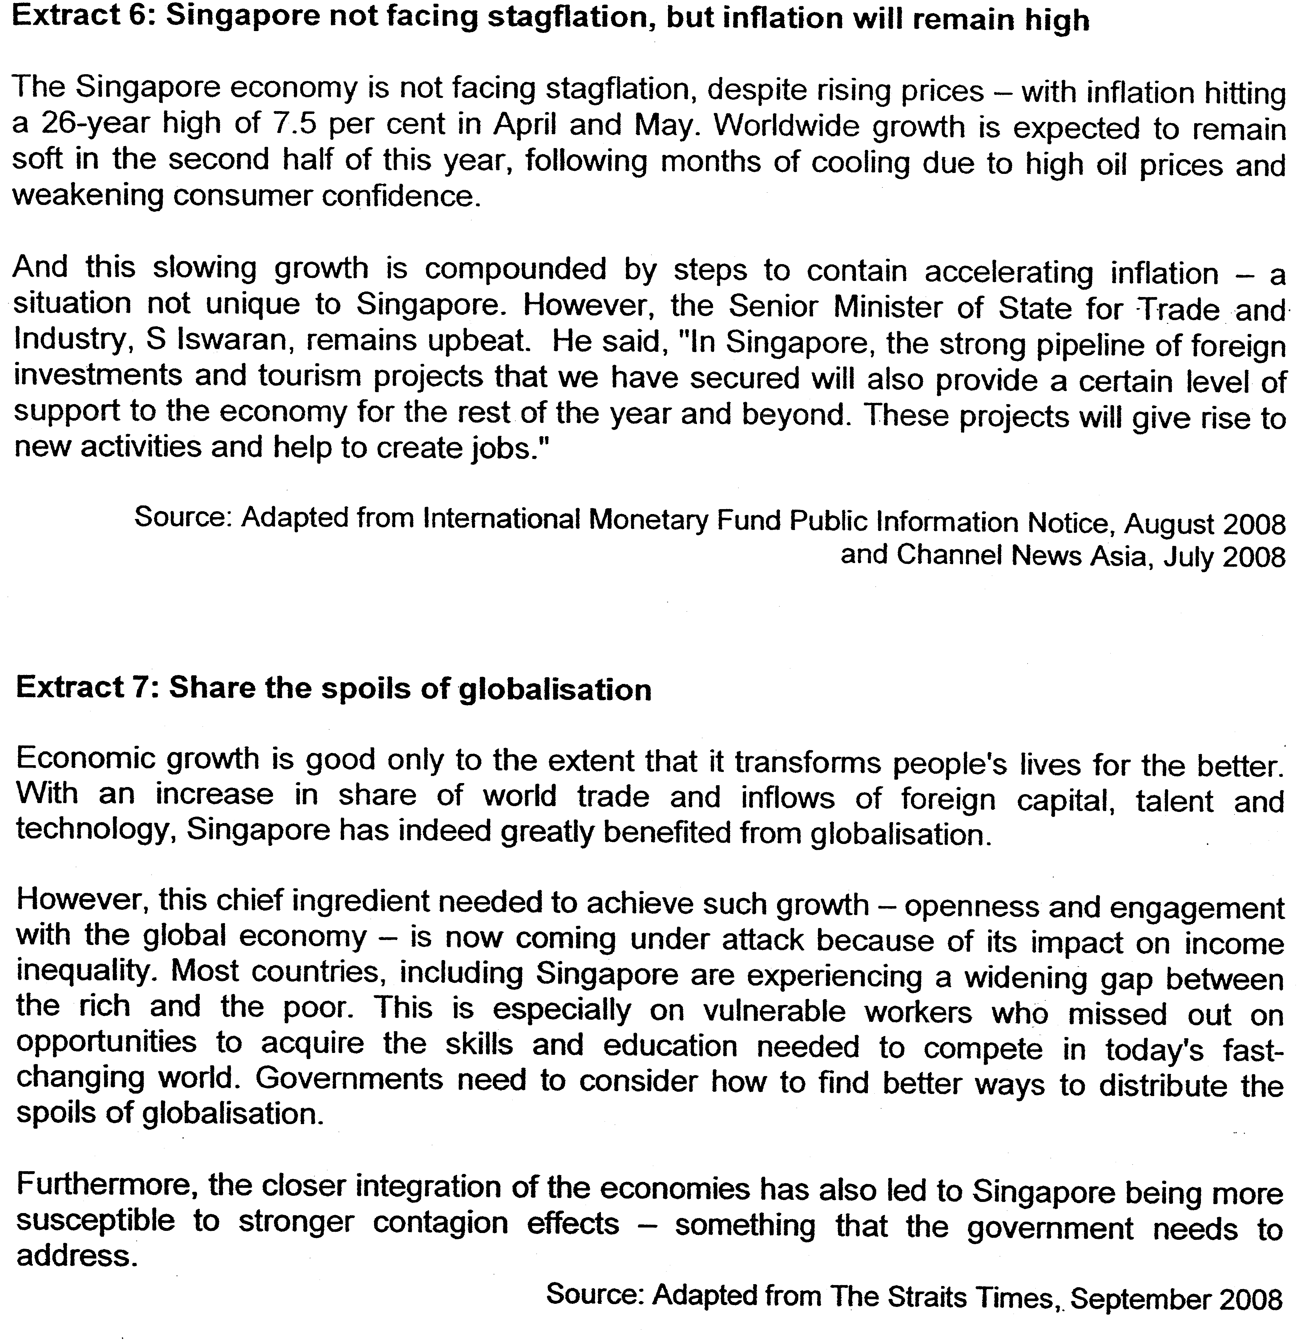

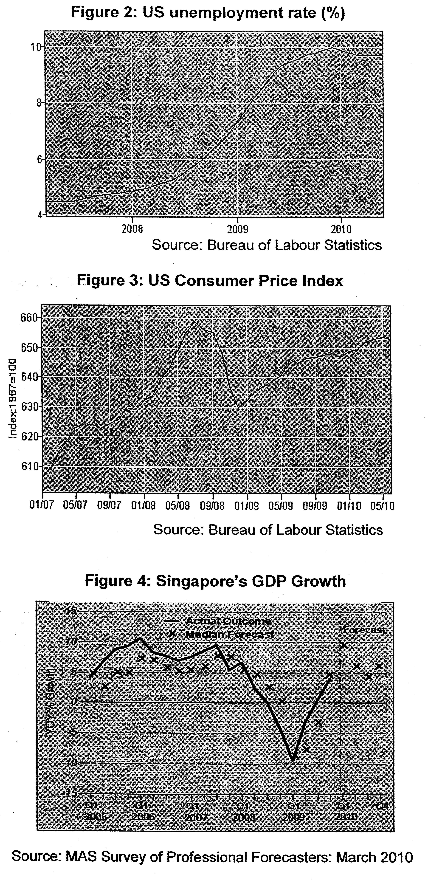

Questions

(a)(i) From Figures 2 & 3, compare the trends for unemployment and consumer prices from 2008 to 2010. [2]
(ii) Explain how the data suggest that the US is heading towards stagflation. [2]

(b)(i) Account for the US government's concern with unemployment and inflation. [4]
(ii) Evaluate the effectiveness of the policies implemented by the US to address the issues of low economic growth and high inflation. [6]

(c) Using AD/AS analysis, explain why the Senior Minister of State remains upbeat about the future economic situation in Singapore in spite of the high inflation rate. [6]

(d)(i) Using Figure 4, describe the trend of GDP growth in Singapore from 2007 (Q3) to 2009 (Q3). [2]
(ii) Discuss the view that the problems of increasing globalisation have outweighed the benefits for Singapore. [8]

[Total: 30 marks]

Suggested Answers
(a)(i) From Figures 2 & 3, compare the trends for unemployment and consumer prices from 2008 to 2010. [2]

Both trends were generally rising. [1m] CPl, however, fell sharply at the end of 2008 by about 30%. [1m]

Unemployment – recession – lower output contributed by decrease in AD - lower price level (unemployment, recession and lower price)

(ii) Explain how the data suggest that the US is heading towards stagflation. [2]

The data indicates that US is likely to head towards stagflation. With reference to Fig 2, USA is facing a rising unemployment rate. Her unemployment rate has been rising from 4% to about 10% in 2010. This suggests a sharp contraction of her national output over the same period of time. [1 m]
stagnation of economic activities – market pessimism

Extract 1 states that there might be cost-push inflation due to surging oil and gasoline prices. This is supported by Figure 3 where US CPl has risen by about (660-608/608X100= 8.8%) from 2007 to 2010. [1m]

(b)(i) Account for the US government's concern with unemployment and inflation. [4] (negative effects of unemployment and inflation)

Effects of unemployment:
1) Loss in Production and Income / standard of living
The loss of jobs brings about reduction in production and income, worsening likelihood of a double-dip - seen in extract 2

2) Loss in Tax Revenues + increase in G (budget deficit – public finance – increase in government debt)
The government loses tax revenues due to the loss in income due to the unemployed no longer pay income tax. Moreover, the government needs to spend on welfare payments. - increased spending seen in extract 2

Effects of inflation:
1) Negative effect on investment & growth (increase in cost of production – decrease profitability – reduce investment)

Investors may not be willing to invest due to lack of consumer confidence & cost push inflation may worsen the situation - seen in extract 1

2) Worsens unemployment – why?
cost of production will rise – reduce profitability – reduce investment – less production – decrease demand for labour – increase unemployment
For SG – why the government is more concerned with unemployment?
the cost of managing unemployment is higher than the cost in managing inflation – give more subsidy to the unemployed than to those who have lower purchasing power due to inflation
(b)(ii) Evaluate the effectiveness of the policies implemented by the US to address the issues of low economic growth and high inflation. [6]

Since the US is facing 2 main problems: high inflation rate and unemployment rate, they have tackled the problems by adopting:

1) Expansionary monetary policy i.e. cutting of interest rates (Cheap money)
In an expansionary monetary policy, the central bank will increase the money supply through the quantitative or qualitative monetary tools so as to lower interest rate which will lead to lower cost of borrowing. This will lower the cost of credit consumption which will induce higher level of consumption while the cost of borrowing will make investment more profitable, leading to higher level of investment. Consequently, there will be a rise in aggregate demand which will induce rise in national income and production via the multiplier effect. Hence, expansionary monetary policy can solve low economic growth.

2) Expansionary fiscal policy (through tax breaks & higher public spending)

The expansionary fiscal policy will increase the aggregate demand by raising government expenditure and lowering taxation which will contribute to the rise in the national income that will raise the production level, leading to rise in employment. Through the building of infrastructural development and provision of public services, production of goods and services will lead to more employment. Also, lowering of taxation will induce investment which will lead to more production. Hence, expansionary fiscal policy will solve low economic growth.

These 2 policies would increase AD of the economy, hence increasing national output and reducing unemployment rate. However, this policy will worsen the inflation rate as they will cause GPL to increase. Hence, Fed Reserve has to manage the two problems carefully as there are apparent conflict between the policy and the achievement of two goals.

need to evaluate their effectiveness

ss-side mgt policies – expand the availability of resources – lower the cost condition – shift LRAS to theright and contain inflation

- high degree of infrastructural development – increasing production – increase demand for labour – solve unemployment

(c) Using AD/AS analysis, explain why the Senior Minister of State remains upbeat about the future economic situation in Singapore in spite of the high inflation rate. [6]

- explain why the inflation rate is undermining the economic growth
- why the inflation rate will not be an issue
- i) supply side policies can lower the cost of production
- ii) aggregate demand will still increase

The Minister remains upbeat about the Singapore economy as Singapore is expecting a strong pipeline of foreign investments and tourism projects that will provide support to the Singapore economy. The expected rise in FDI and X will bring about a rightward shift of AD curve and hence increase the real national income of the country hence creating employment for the locals.

Inflationary pressure arising from the rise in AD is not a concern for the country as the rise in I will also bring about a rightward shift of the LRAS curve. Hence, cushioning the rise in GPL, bring about a sustained economic growth for Singapore.
Y₁=Yf₀
Y₂
Yf₂
AS₀
AS₁
P₀
P₁
GPL
Real GDP
AD₁
Y₀
AD_{o}
As seen from the diagram, the increase in aggregate demand from AD₀ to AD₁ will raise Real GDP from Y₀ to Y₁ but price level will increase from P₀ to P₁. With corresponding supply will expand from AS₀ to AS₁, and thus, lowering cost condition to decrease price which will induce increase in AD on a quantity basis. Consequently, the real GDP will increase from Y₁ to Y₂ while price falls from P₁ to P₂ without incurring inflationary effect where sustainable economic growth is attained.

(d)(i) Using Figure 4, describe the trend of GDP growth in Singapore from 2007 (Q3) to 2009 (Q3). [2]

GDP growth fell sharply for the period 2007Q2 to 2009Q1 before it started to increase until Q3 2009.

(d)(ii) Discuss the view that the problems of increasing globalisation have outweighed the benefits for Singapore. [8]

Structure of Development
1. Explain the benefits of globalization

- Increased consumption and production possibilities
- Promotes efficient allocation of resources
- Promote a higher level and value of investment
- Accelerate economic growth and raise employment opportunities
- Increase in welfare
- Keeps government power in check

2. Explain the problem of increasing globalization is eroding the benefits

- Higher degree of competitiveness for resources and export market
- Occurrence of structural unemployment
- Inflationary condition contributing to rising cost of living
- Growing income inequality among the nations and within the nations
- Labour market inequality
- Exploitation of cheap resources in developing countries
- Environmental issues

3. Explain why these problems may not eradicate the benefits

4. Evaluation

5. Conclusion

