Lesson No 1 – CSQ 1 – Central Economics Problems
Extract 7: A City Transformed

Since winning its bid for the 2016 Olympic Games seven years ago, Brazil’s Rio de Janeiro has undergone a construction boom, including new sports venues, subway connections, and more infrastructure. One of the flagship transportation efforts, Rio built a new subway extension linking popular beach areas with the neighbourhood where the Olympic Park is located. Enormous investment has been pumped into transportation infrastructure projects throughout the city, including the VLT Carioca (the Rio de Janeiro Light Rail) in the port district. The rail connects Rio’s domestic airport to a bus terminal and is aimed at revitalising the area.

The construction of the golf course, however, has stirred controversy. Golf is not widely played in Brazil, and though there is one small public course on the northern outskirts of Rio, Brazilian officials have touted the fact that after the Olympics, the course would become the first professional-quality public course in Brazil. But it was partially built on a protected nature reserve, angering local activists.

Source: The Wall Street Journal, August 2016

Figure 2: Selected economic indicators for Japan

Unemployment Rates

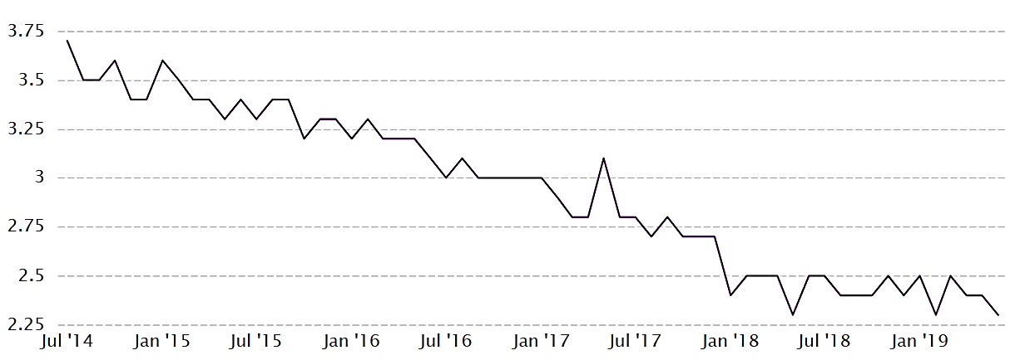

Gross Domestic Product
Sources: CEIC data, Organisation for Economic Co-operation and Development

CSQ – Lesson 1 – Central Economics Problems

a) Explain how the concept of opportunity cost is explained through the production possibility curve. (3)

b) Identify two factors that will affect how actual growth of the Brazilian economy through the Olympic games. (6)

c) Using extract 7 and a production possibility curve diagram, identify and explain two benefits of hosting the Olympics to the host economy. (6)

d) In a capitalistic economy like Brazil, why should certain game facilities be built by the government? (9)

e) Based on figure 2 and the production possibility curve, explain why the unemployment rate and GDP per capita and GDP per hour worked falls. (6)

