The oil market

Figure 1: World oil price
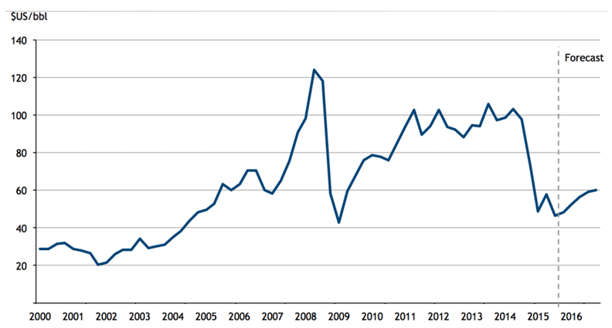
Source: Bloomberg, accessed 11 December 2015

Extract 1: Oil price plunge continues

The price of oil continued its steep fall on Friday, hitting five-and-a-half-year lows after the International Energy Agency (IEA) predicted demand next year would be lower than expected. Crude oil price has dropped 47% since June and fell to just over $61 a barrel. The oil price has plummeted in response to a massive build-up of shale-derived oil in the US through fracking, reduced fears of fighting in Iraq disrupting supplies, and due to the faltering world economy.

The Paris-based IEA singled out Venezuela as a potential flashpoint for trouble and the warning came as Venezuela’s currency, the bolívar, continued to lose close to 80% against the US dollar since the plunge in oil price. This is only part of an even bigger decline since Nicolas Maduro took office two years ago, and the oil price isn’t the only thing to blame. The country’s draconian capital flight controls, excessive money printing in face of a stalling economy are also factors.

But while the oil-producing countries face lost revenues and budget shortfalls, lower energy prices are expected to have a beneficial impact on the world economy. Many countries, particularly in Asia, are desperately dependent on foreign oil and gas imports, so cheaper prices should cut inflation and give impetus to manufacturing output and consumer spending. Analysts at investment bank ING said: “The recent fall in oil prices may not be sustained but, in the meantime, it provides a very welcome boost to real incomes for most major economies.”

Source: Adapted from The Guardian, 12 December 2014

Extract 2: US$20 Billion subsidy to fossil fuel industry

A joint investigative report by Oil Change International and the Overseas Development Institute reveals that, in the United States alone, the fossil fuel industry has benefitted from over $20 billion per year in government subsidies between 2008 and 2015.These subsidies occur throughout the fossil fuel exploration, production and transportation along the supply chain. This also means subsidizing oil spills, in which oil companies can write off the cost of clean-up as a business expense, including the 2010 BP oil disaster in the Gulf of Mexico. Subsidies are also used extensively in the research of new drilling technologies.

“Since the initial G20 commitment in Pittsburgh six years ago, US subsidies have increased dramatically in [the Obama] Administration, in line with the increase in US oil and gas production,” said Steve Kretzmann, executive director of Oil Change International. “The President can and must do more to eliminate subsidies at home amidst the growing government budget deficit and concerns on climate change.”

Source: Adapted from Overseas Development Institute, 12 November 2015

Extract 3: The true cost of oil production

Every link in the chain of oil production, from exploration through consumption, generates profound damage to the local environment and communities. As the industry moves towards increasingly risky forms of fossil fuel production, the impacts become more pronounced.

A notable Harvard Medical School study identifies impacts from many aspects of oil production. Exploration for new oil and gas often brings seismic explosions and the clearing of huge swaths of forest; drilling produces toxic drilling muds and waste waters; oil transport creates additional hazards, as oil spills from pipelines, tankers and tank farms are still routine, despite industry claims of safety measures. Oil refining creates further chemical, thermal and noise pollution and affects the health and safety of refinery workers and nearby communities and ecosystems. Gasoline and many of its additives are toxic and are associated with some types of cancer, with oil industry employees and those living near refineries, transfer and storage facilities at greater risk.

A 2011 United Nations Environment Programme study estimates that in Ogoniland, Nigeria, “countering and cleaning up the pollution and catalysing a sustainable recovery could take 25 to 30 years.”

Communities in Ogoniland have fought back against this oil pollution, through protest, which at times has met brutal repression, and through lawsuits. Several lawsuits specifically on gas flaring – the burning of natural gas during oil extraction - succeeded in obtaining a court order against flaring, however, Shell and other oil producers continue the practice despite the legislation enacted.

Source: Adapted from Oil Change International, 10 April 2014

Extract 4: Renewable energy can’t replace fossil fuels entirely

While technological advancements have made it possible for renewable energy to be used in many of the same applications as fossil fuels, there are still some limitations. For example, the energy efficiency of electric vehicles is much lower than traditional cars. Additionally, renewable energy can never and will not replace oil, coal and gas entirely. As the world's higher-quality fossil fuel reserves rapidly deplete, no combination of alternative energy sources is likely to be enough to sustain industries at their current scale. Nonetheless, large government funds have been poured into the renewable energy industry as countries seek to increase their energy self-reliance, which may bolster their economic resilience and reduce their ecological footprint.

Alternative energy sources have their own issues, such as energy transfer or destruction of the natural habitat. Hydro energy involves building dams and this, in turn, will destroy the habitat of the river or lake they are placed in. The past and the foreseeable future still belong to hydrocarbons, and we can expect natural gas, the cleanest of the hydrocarbons, to garner a bigger share of the global energy pie in the near and long term.

Source: Adapted from The Straits Times Forum, 17 December 2015

Questions:
(a) Using Figure 1, compare the overall change in world oil price between 2000 and 2008 with that between 2009 and 2014. [3]

(b) With reference to Extract 1,

- Identify and explain two reasons for the fall in world oil price after 2014. [4]

(c) Extract 2 mentions subsidies implemented by the US government in the fossil fuel industry. Comment on the possible consequences of the imposition of such subsidies for the producers and consumers of fossil fuel, as well as the US government. [8]

(d) (i) Briefly explain the relationship between fossil fuels and renewable energy. [2]

(ii) Identify one possible opportunity cost of pouring large government funds into the renewable energy industry. [1]

(e) Do you think the use of government legislation would be the best measure in tackling the circumstances as those described in Extract 3? [8]

Suggested Answers
(a) Using Figure 1, compare the overall change in world oil price between 2000 and 2008 with that between 2009 and 2014. [3]

Similarity: Both periods indicate increasing trend in oil price.
Difference: Rate of increase is larger in 2000 – 2008 as compared to 2009 – 2014.
Difference: 2009 – 2014 showed greater fluctuations in oil price.

(b) (i) With reference to Extract 1, identify and explain two reasons for the fall in world oil price after 2014. [4]

Increase in world SS of oil as production levels from producers rise due to “fracking in the US” OR “reduced fears of instability in Iraq”. With the rise in SS, ceteris paribus, equilibrium price of oil will fall.

Decrease in world DD of oil due to falling demand for oil due to lower economic growth / fall in real output in the “faltering world economy”. OR due to consumer expectations of falling future prices as there is “reduced fears of instability in Iraq”. With the fall in DD, ceteris paribus, equilibrium price of oil will fall.

(c) Extract 2 mentions subsidies implemented by the US government in the fossil fuel industry. Comment on the possible consequences of the imposition of such subsidies for the producers and consumers of fossil fuel, as well as the US government. [8]

As mentioned in Extract 2, the US government has implemented the use of a subsidy in the fossil fuel industry. This essay will aim to consider the various consequences on the consumers, producers and the US government.

Thesis: Subsidies benefit consumers and producers
The fossil fuel subsidy will benefit the consumers by making the fossil fuel more affordable (lower price) for the consumers, with more quantity available (higher q).

As seen from the diagram, with subsidy, the cost of production for the producers of fossil fuel drops. This will lead a rise in supply of fossil fuel as seen in the diagram by a movement from S1 to S2 (diagram is expected). With the demand for fossil fuel remaining the same, there is a surplus created at the initial price P1 as quantity supplied is greater than quantity demanded. This will create a downward pressure on the price until the new equilibrium is reached as a lower price P2 from P1. The new equilibrium also has a higher quantity of fossil fuel, rising from Q1 to Q2 in Figure 2. This results also in a higher consumer surplus, as shown in Figure 1, where consumer surplus increases with the lower price.

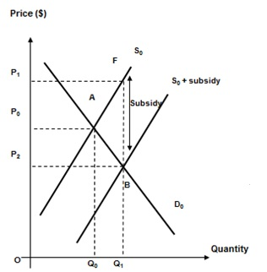

Figure 1: Subsidy in Fossil Fuel Production

Though the fall in price of fossil fuel may result in lower total revenue for producers given that demand for fossil fuel is relatively price inelastic, the per-unit subsidy given by the government on the increased quantity sold will more than cover the fall in TR due to the lowered price. This is reflected in the Figure 1, where there is an increase in total income of producers after subsidy P1FBP2 + P2BQ10. Thus, this will increase the profitability of the producers as the total revenue has increased after the subsidy has increased..

The subsidies are also given to lower the cost of R&D for producers, which will likely create higher incentive for producers to invest in the development of new methods of production which will lower cost of production further. Producers will also research into new innovations that will create better quality products that will have positive benefits to consumers. “These subsidies occur throughout the fossil fuel exploration, production and transportation along the supply chain” and/or “Subsidies are also used extensively in the research of new drilling technologies.” Thus, subsidies have benefits for the consumers and producers. However, there are also disadvantages with the use of government subsidies.

Anti-Thesis: Fossil fuel subsidies disadvantage 3rd parties & government
As shown from Figure 1, the use of subsidies has also increased the quantity of fossil fuel consumed from Q0 to Q1. As the production of fossil fuels leads to negative externalities as evidenced in Extract 3, “creates further chemical, thermal and noise pollution and affects the health and safety of refinery workers and nearby communities and ecosystem”. This will negatively impact consumers and producers who are 3rd parties in the oil transaction. (negative externality

Provision of subsidies in the fossil fuel industry in the long term will not only add significant financial strain on the government’s budget, there will also be less funds available for other uses which will post considerable opportunity cost.

Due to limited government budget, there is a trade-off when the US government provides fossil fuel subsidy. There is an opportunity cost involved in this policy decision. For example, the government will have to allocate a larger budget for the purpose of providing fossil fuel subsidy and have fewer funds to budget for other key areas of expense such as military defence, education and healthcare.

Also, even those with financial ability may exploit the opportunity and that might add on the burden on US government, which is currently running on a large government budget deficit. This will lead to the unintended consequence of financing the budget deficit with higher tax rates in future. The higher tax rates will create the disincentive to work and investment, which will negatively hurt the consumers and producers in the long run.

Conclusion
The subsidies do indeed benefit the consumers and producers especially in the short run with the lower price and higher profits; the imposition of a long term fossil fuel subsidy is not feasible as it will create a financial burden on the government and weakens its fiscal position. As seen in Extract 2, “President can and must do more to eliminate subsidies at home amidst the growing government budget deficit and concerns on climate change”, the use of the subsidy will likely leads to more negative consequences in the long run for all economic agents.

[Recommendation]
The use of a subsidy is merely a short-term intervention, which will create inefficiency in the market, especially when inefficient producers develop dependency on government for the subsidies. The government should instead encourage the use of cleaner renewable alternatives to fossil fuels which will seek to minimize the environmental impact as well.

(d) (i) Briefly explain the relationship between fossil fuels and renewable energy. [2]

Fossil fuels and renewable energy are substitutes in consumption.

As seen in Extract 4, “While technological advancements have made it possible for renewable energy to be used in many of the same applications as fossil fuels… the energy efficiency of electric vehicles is much lower than traditional cars”, though both could be used in satisfying the same wants / needs (for eg energy input for driving vehicles).

OR

When the price of fossil fuel increases, there will be a fall in quantity demanded of fossil fuel. Consumers will turn to renewable energy to meet their needs for energy input, thus the demand for renewable energy increase.

(d) (ii) Identify one possible opportunity cost of pouring large government funds into the renewable energy industry. [1]

One of the possible opportunity cost is spending by the government on other sectors such as healthcare, education or defence.

Not ebdiscussed.

(e) Do you think the use of government legislation would be the best measure in tackling the circumstances as those described in Extract 3? [8]
- how market failures occur due to production of oil
- how legislation works to solve market failures
-how effective is it
- How the other policies work
- why there are better polcies
Why other policies are not effective

Introduction
Market failure occurs when free markets fail to bring about an efficient allocation of resource when marginal social benefits do not equal marginal social costs. From Extract 3, as seen from “Oil refining creates further chemical, thermal and noise pollution and affects the health and safety of refinery workers and nearby communities and ecosystems”, it has been shown market failure occurs in the production of oil whereby third parties are negatively implicated. Hence there is a need for government intervention. Whether the use of government legislation or any other policy would be best depends on the criteria of effectiveness in achieving Qs and if there are any side effects of the policies in place, which this essay will seek to discuss.

Main Body
The implementation of government legislation would be best in resolving market failure in oil production. Government legislation refers to the application of law through various policies in resolving market failure. Where MSC is greater than MSB for all output levels, the use of government legislation in the form of a ban of oil production will be effective in resolving market failure.

Figure 2: A ban is socially efficient
O
MPC = MSC
MPB = MSB
Cost, Benefit
Q_{f}
Quantity of Oil Produced
MEC
MSC

In the case of fossil fuel production plant that may result in an extremely large negative externality (i.e. a large MEC). This causes the divergence between MPC and MSC to be extremely large. In Extract 3, it was mentioned that “Gasoline and many of its additives are toxic and are associated with some types of cancer, with oil industry employees and those living near refineries”, this is shown in Figure 2, where the negative externality from oil production is so large that MSC exceeds MSB at all outputs. MSC and MSB do not intersect, i.e. the socially efficient amount of fossil fuel to be produced is zero. It is more optimal to ban the good, as any non-zero production of fossil fuel would result in an inefficient resource allocation for society. Thus, a ban will be best when the MEC of oil production is extremely large for production plants situated in densely populated regions.

However, when the negative externalities generated by the oil production do not cause such a great divergence such that MSC exceeds MSB at all output levels, i.e. there is still a positive socially efficient quantity that should be consumed, it will be inefficient to implement a ban. As can be seen from the Figure 3, MSC does not exceed MSB at all levels of output, i.e. there is still a positive amount of good that is socially efficient if produced (Qs). Hence, by completely banning oil production, potential net benefit from producing oil is lost and this is illustrated by area A in Figure 3. In the example above, this area A, in fact, is far larger than the deadweight loss that would have been generated if the government had not intervened and had allowed the free market to prevail at Qf, as illustrated by area B. The ban has created an even larger welfare loss (A) than at free market equilibrium (B). Therefore, the use of government legislation in the form of a ban would not be the best measure in tackling negative externalities in oil production.

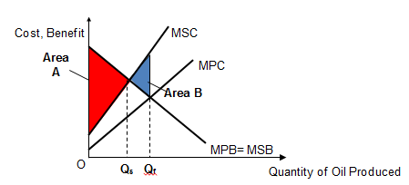

Beside the use of a ban, the government can consider the implementation of a Pigouvian tax to reduce the production of oil to Qs. The free market originally consumes at point Qf where MPB = MPC. Pollution Tax is a tax is imposed by the government on oil producers. With the imposition of tax equal to the MEC at Qs, there is internalisation of the negative externality, i.e. a tax makes oil producers consider the negative externality in their decision making. This causes the producers’ MPC to shift up to MPC*. As a result of this, the producers now produce until its new MPC*=MPB, i.e. at Qs. The allocative efficient output is achieved and the deadweight loss is eliminated. There is also a change in prices in the market. The equilibrium price was initially at P1 but the new price is P3.

The pollution tax will increase government revenue. And thus which is a source of funds to finance economic, social and community development projects (e.g. build or enhance the infrastructure). The increase in tax revenue can also be used as a subsidy to producers in developing cleaner technologies to reduce the negative externalities in oil production.

However, it is difficult to estimate MEC and therefore an accurate amount of pollution tax. An over-valuation of MEC means that output is below social optimum and society’s welfare is not maximised. An under-valuation of MEC will also not maximise society’s welfare as the output is reduced but the tax is not sufficient to reduce output to the social optimal level. In addition, the demand for oil is price inelastic, thus producers will shift the burden of the tax to consumers and the fall in quantity produced will not be as effective as targeted.

In conclusion, the effectiveness in achieving Qs should determine if the use of government legislation will be the best measure in tackling negative externalities in oil production. The ban is the best measure when the MEC is extremely large as the socially efficient quantity of production is zero in such cases. Alternatively, market-oriented measures such as pollution tax could be implemented to reduce the production levels to Qs too. The government should implement a combination of policies as they complement one another

