Suggested Answers

(a) (i), Define price elasticity of demand., [1]
Price elasticity of demand (PED) is a measure to show the responsiveness, of the quantity demanded of a good or service to a change in its price, ceteris paribus. [1] PED gives the percentage change in quantity demanded in response to a one percent change in price.

(ii), What can you conclude from the evidence in Extract 1 about the likely value of the price elasticity of demand of gambling?, [2]
Extract 1 suggests that gambling is highly addictive and successful advertising reinforces such behaviour. [1] Therefore, the demand should be highly inelastic and |PED| < 1. [1]

(iii), With reference to Extract 2 and the aid of a diagram, explain how the increase in betting charges accounts for the change in the UK’s household expenditure on gambling., [4]
It is already established that PED is highly inelastic (from a(ii)). Extract 2 concludes that “the amount spent on gambling has been rising rapidly”, “even as the betting charges (prices) are rising.” Given the elasticity we expect a less than proportionate fall in quantity demanded when prices rise. [1] In these circumstances, the household expenditure / total revenue of the firms (P X Q) will increase. [1]

Diagram and reference to diagram (see below). [2]

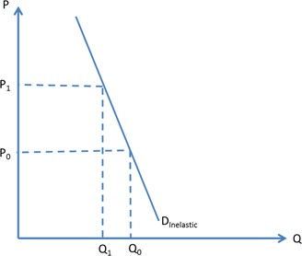

With reference to the diagram above, the increase in betting charges from P0 to P1 caused a less than proportionate decrease in quantity demanded from Q0 to Q1. This caused the total expenditure on betting to increase from P0 X Q0 to P1 X Q1.

(b), Compare the trends between the non-remote and remote gambling revenues in the UK from April 2011 to March 2017., [2]
Comparing general trend: Both trends increased. [1]
Comparing other aspects: Remote gambling increased at a faster rate or non-remote gambling was always higher. [1]

Markers’ Comment
(c), With reference to Extracts 2 and 3, account for the growth of the gambling industry in the UK and comment whether the change in supply is likely to be more important than the change in demand in explaining the growth., [7]
Explain [4m]
DD factor - ↑ in no. of consumers → more people are text-savvy and comfortable going online → DD increases → DD shifts right; or change in taste & preferences due to successful advertising → DD increases → DD shifts right.
SS factor - more betting machines, casinos, use of technology to develop mobile gaming apps to allow online access → SS increases → SS shifts right.
[2 marks for each DD & SS factor]

Comment [3m]:
Students should make a judgement on whether demand or supply shifts more. While both demand and supply have been rising, from the extracts we may conclude that the demand factor may be stronger due to the highly addictive nature of gambling and the aggressive advertising expenditure committed by the industry.

On the other hand, extract 2 suggests that there may be limits to growth as the remote segment becomes saturated. Also, gambling remains a regulated industry. These could have a limiting effect on supply. Take a stand.

(d), Using the concept of price elasticity of supply and a diagram, explain how the economic recovery in Las Vegas caused housing prices to grow “by double digits.”, [5]
An economic recovery in Las Vegas would suggest that income levels in that area is likely to increase due to greater economic activity. Given rising income, demand for normal goods such as housing will increase, shifting demand to the right. [1]
Extract 5 also provides evidence that “the number of housing units available for sale has fallen 30% over the past year.” This suggests quite clearly that the price elasticity of supply is highly inelastic (|PES| < 1) due to low stocks. [1]
With demand shifting to the right, because of the price inelastic supply, the increase in price is likely to be large (“double digits”). [1]
Diagram and reference to diagram (see below). [2]

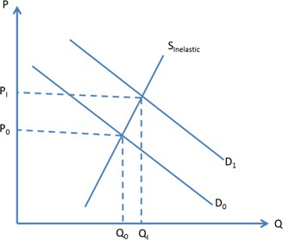

With reference to the diagram above, the increase in demand for housing caused a large increase in the price of housing from P0 to P1.

