May Intensive Revision
Case Study Practice – Cost of Production/Market Structures

The Pharmaceutical Industry

Extract 1: World vaccine market grows to $25b in 2010
The world market for preventative vaccines totalled $25.3 billion in 2010, up from $22.1 billion in 2009, according to a report published by Kalorama Information.

“At $25 billion, it’s still too small to replace all of the bad news in the pharmaceutical industry – the industry will have to advance its research and development (R&D) in other biologic areas, as well,” said Kalorama publisher Bruce Carlson. “But, it has helped balance sheets at the majors.” Together, Sanofi Pasteur, GlaxoSmithKline, Merck & Co., Pfizer and Novartis held four-fifths of the market in 2010.

“We think pharmacos are continuing to invest in vaccines because it is uncultivated land, for the time being, nearly free from generic threat,” continued Carlson. “While the broader drug market has been heavily impacted by the ongoing introduction of low cost generic alternatives, these are largely absent in the vaccine market.” A generic drug is a drug that is exactly the same as the brand-name drug, but can only be produced after the brand-name drug's patent has expired.

Kalorama indicated that sales to Latin America, India and China will grow at double-digit rates. “We continue to see over nine percent growth in sales, and in some emerging markets the rate of growth is even faster.” said Carlson.

Pandemic influenza scares provided another boost to the business. Repeated outbreaks of avian flu in recent years have prompted widespread fear that a new strain might develop into a global scourge. Governments around the world wasted no time in ordering vaccines. Innovators are also working on cell-based manufacturing techniques that promise to be quicker and more reliable.

“One challenge for companies to be aware of is we see that increasingly the ‘refusal to immunize’ is an issue,” said Carlson. “It’s not affecting the growth projections we have, but it’s something drug companies would need to be aware of as the number of vaccine products increase.” This underlines the issue of profits as more marketing efforts are needed.

Sources: Healthcarefinancenew.com, August 2011 & The Economist, Oct 2009

Extract 2: Patent Expiry Strategies of Big Pharma

With an unusually high number of blockbuster drugs going off patent by 2013, many pharmaceutical companies are under a lot of pressure to develop innovative strategies to counteract the revenue loss from these generic drugs.

Brand name drug companies, such as Pfizer and GlaxoSmithKline, are using a number of strategies to either extend their market exclusivity period for their blockbuster drugs and resorting to mergers and acquisitions to prevent generic competition to their drugs.

Glaxo's diverse operating platform should more than offset patent expirations for respiratory drug Advair and antiviral drug Valtrex. The magnitude of the company's reach is further evidenced by drugs that span all major therapeutic classes, as well as vaccines and consumer goods. The diverse platform insulates the company from problems with any single product. The vaccine business should drive strong returns as fewer competitors remain in the market, increasing the pricing power for new vaccines. Specifically, the company's human papillomavirus (HPV) vaccine to prevent cervical cancer, Cervarix, holds blockbuster potential and should compete well with Merck's Gardasil on the basis of price.

Source: Morningstar.co.uk, February 2011 & Pharma-Reports, January 2012

Extract 3: Merck, GSK cut price of cervical cancer shots for poor countries

Drugmakers Merck and GlaxoSmithKline (GSK) have cut the price of cervical cancer shots in a deal that will deliver them to poor countries for less than $5 a dose. Global Alliance for Vaccines and Immunisations (GAVI), a non-profit group that funds bulk-buy vaccine programs for poor countries, will deliver the cut-price shots.

The vaccines - Merck's Gardasil and GSK's Cervarix - can retail more than $100 in developed countries and have been introduced in immunization campaigns in rich regions like the United States and Europe in recent years.

A study published in 2011 found that since 1980, new cervical cancer cases and deaths have dropped substantially in rich countries - mostly due to better screening and earlier detection – but increased sharply in poor regions. Sub-Saharan Africa has 22 percent of all cervical cancer cases worldwide.

The U.S. drugmaker Merck said it expects to supply around 2.4 million doses of Gardasil at $4.50 per dose to GAVI-eligible countries between 2013 to 2017. British rival GSK said its Cervarix shot would cost $4.60 per dose.

Yet critics said the deal was still far too expensive for many poor countries - particularly since the vaccines need to be given as three doses to ensure full protection against HPV. Merck made $1.63 billion and GSK more than $416 million from their HPV vaccines in 2012 alone. The companies were accused of "seeking to maximize their profits on the backs of developing countries" by international charity Medecins Sans Frontieres.
Source: Reuters.com, May 2013

Extract 4: Government will continue to promote biomedical industry

In Singapore, the Economic Development Board (EDB) is responsible for building and supporting key industry sectors. The EDB provides a number of tax and grant incentive schemes for foreign and domestic investors to attract investments, including in the biomedical industry which consists of pharmaceutical and medical technology sectors. These include the Research and Development Assistance Scheme where grants are offered to support specific projects on product or process R&D that lead to the enhancement of the company’s competitiveness and in-house capability development.

"We can't be in all industries, some will not fit into Singapore but high value, knowledge intensive industries such as the biomedical science will continue to have a role here for a very long time," said PM Lee at the 40th anniversary of GSK's first manufacturing plant in Singapore.

Source: Asiaone, 1 Nov 2012

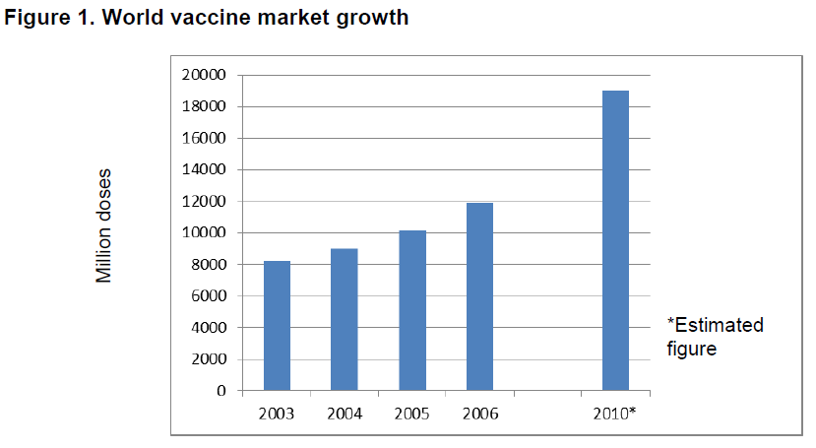
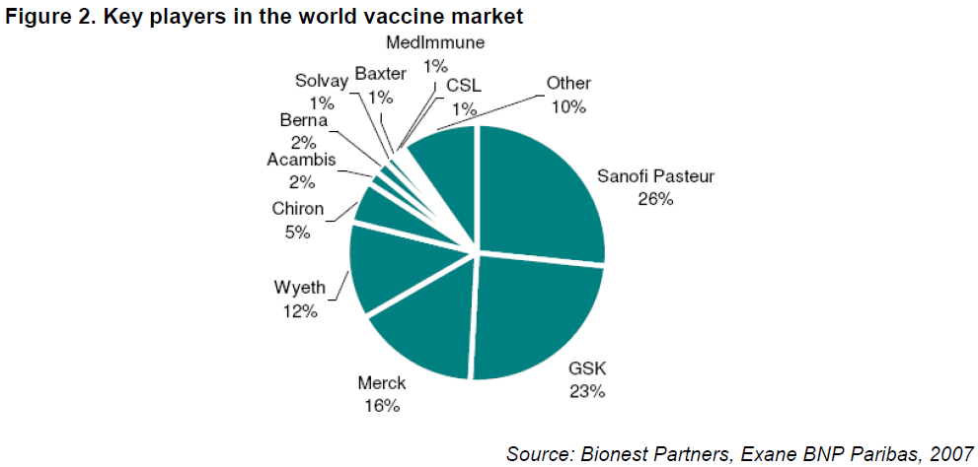

Questions
(a) (i) Describe the trend in the world vaccine market growth from 2003 to 2010. [1]

(ii) Explain one demand side reason and one supply side reason for the above trend. [4]

(b) Explain the form of price discrimination practised by the pharmaceutical firms. [3]

(c) Explain two characteristics that suggest pharmaceutical firms are oligopolistic. [4]

(d) Discuss the effects of blockbuster drugs patent expiry on the profits of GSK. [8]

(e) Discuss the desirability of the Singapore government providing grants on R&D in the biomedical industry. [10]

[Total: 30 marks]

Suggested Answers

(a)(i) Describe the trend in the world vaccine market growth from 2003 to 2010. [1]

The quantity of vaccine doses has increased from 2003 to 2006 and is estimated to increase further by 2010.

(a)(ii) Explain one demand side reason and one supply side reason for the above trend. [4]

[No need diagram]
Demand side reasons:
- Government policy from fear of flu pandemic (quote)
- Higher income from emerging countries and vaccine seen as a normal good.

Supply side reasons:
- Goods in competitive supply – Fall in price of drugs due to competition from generic drugs → firms are motivated to research on vaccine instead.
(profit margin from the sale of drugs is lower than the profit margin from the sale of vaccination)

- No. of ‘producers’ – Cell-based manufacturing techniques that promise to be quicker and reliable → producers are more willing to research in vaccine market due to more guaranteed potential returns (patent assures them of profit)

Which factor is most important?
The supply side as the degree of competition determines the supply of the goods

(b) Explain the form of price discrimination practised by the pharmaceutical firms. [3]

- 3rd degree price discrimination
- Market segmented into developed/rich countries and developing/poor countries. (based on the income factor – determined the price elasticity of the MR and AR)
How the two different markets are separated – proportion of income spent on the good, degree of substitution (availability of substitutes)
- Demand for vaccines by people developed rich countries are relative price inelastic as they are more well-off and in a better position to be vaccinated
- Proportion of income spent on vaccines is less than the demand for vaccines in developing countries, which are relative price elastic as they are less well-off and see vaccines as non-necessity/ proportional of income spent on vaccines is more → higher price in developed countries vs lower price in developing countries

(c) Explain two characteristics that suggest pharmaceutical firms are oligopolistic. [4]

Mutual dependence – Similar pricing of cervical cancer vaccine suggests mutual dependence. Briefly explain why oligopolistic firm consider action/reaction of rivals when making its own decision – (no adv to increase or decrease price – price rigidity) rival firms will change their price to match the decision of the firm

Barriers to entry – Patents issued by government OR need for high capital cost due to R&D on drugs and vaccine suggests existence of barriers to entry → new firms cannot easily enter → industry dominated by few large firms.

(d) Discuss the effects of blockbuster drugs patent expiry on the profits of GSK. [8]

Short Run:
- Expiry of patents →competition from generic drugs → fall in demand → DD & AR curves shift left → supernormal profits fall
- Draw diagram on how the MR and AR will fall and leads to normal profit.

Long Run:
- R&D on vaccine → increase in demand → DD & AR curves shift right
- However, R&D incurs higher fixed cost too. Marketing of new vaccine incurs higher fixed cost too → AC curve shifts up.
- supernormal profit – the GSK will increase their advertising efforts to reduce competition
- Draw diagram – increase AR and MR, become price inelastic through advertising,
Average will rise, no change in MC

Evaluation:
Extract 1 suggests firm is able to make at least normal profits
OR
Extract 2 suggests increase in revenue from higher dd > higher cost from R&D/ marketing → firm is able to still make supernormal profits in LR.

(e) Discuss the desirability of the Singapore government providing grants on R&D in the biomedical industry. [10]

Thesis: Desirability of government providing grants on R&D
On society/ economy:
- Extract 1: Repeated outbreaks of avian flu in recent years have prompted widespread fear that a new strain might develop into a global scourge
- Extract suggests vaccines are market with positive externalities in consumption (3rd parties will not be infected with flu virus) → Explain how R&D corrects market failure in pharmaceutical industry with positive externality with diagram.

[Also accept answer on R&D is a market with positive externalities in production
and how grant on R&D increases supply of R&D].

- Extract 4: We can't be in all industries, some will not fit into Singapore but high value, knowledge intensive industries such as the biomedical science will continue to have a role here for a very long time
- Due to educational policies → skilled labour → C.A. in high value manufacturing industry. Grant on R&D in biomedical industry → reduce cost of conducting R&D → process innovation → produce same amount of goods with less resources → reduce in opportunity cost → increase C.A. in biomedical industry → with specialization and trade → increase output → increase NY
- Process innovation → AS increases (assuming biomedical industry is major sector in economy) → X: cost competitive → increase NX → increase economic growth, employment and improve current account
- Product innovation → quality &/or new drugs/ vaccines → C & X increases → AD increases → increase economic growth, employment and improve current account

Evaluation: Biomedical sector is capital/ knowledge-intensive

On consumers:
  - Process innovation → reduce cost of production → lower price → higher CS.
  - Product innovation → dynamic efficiency → better quality &/or variety of drugs/ vaccines → higher consumer welfare.

Anti-thesis: Undesirability of government providing grants on R&D
  - R&D to pharmaceutical firms → if successful R&D: produce goods at relatively low cost → gain market share → may lead to greater market power→ explain one disadvantage of high market power to consumers or society
  - Opportunity cost of grants
  - Cost of grant come from tax revenue → may lead to higher tax rates

