JC Economics CSQ – Term 1 2015

National Income Accounting
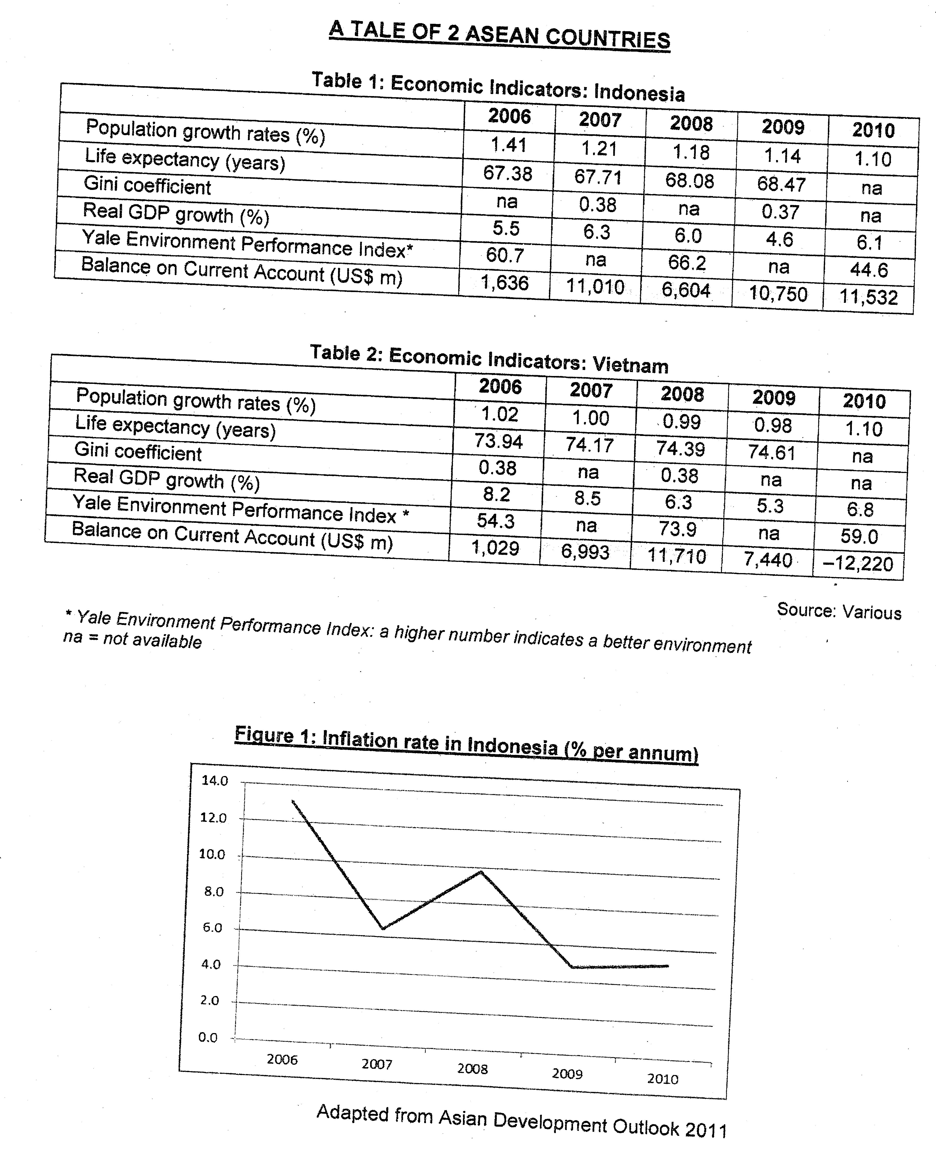

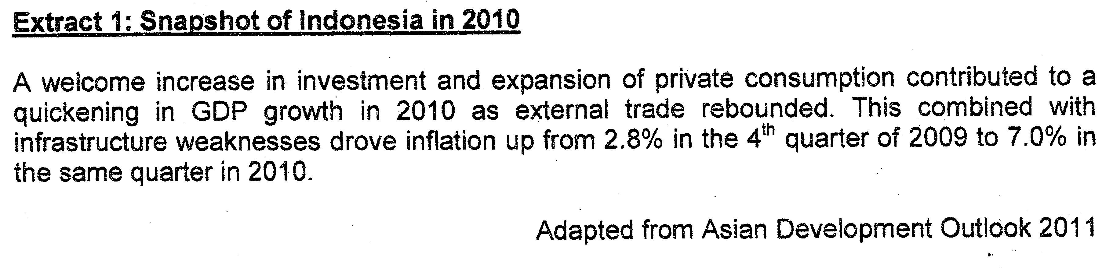

Answer the following questions
(a) Define Real GDP. [2]

(b) With reference to Table 1, account for the trend in real GDP per capita from 2006 to 2010 for Indonesia. [2]

(c) What is the difference between the current account balance for Indonesia and Vietnam between 2008 and 2010? [2]

(d) Describe the trend in consumer prices in Indonesia between 2006 and 2010. [2]

(e) Using an AD-AS diagram, explain the cause of inflation in Indonesia in 2010. [4]

(f) Discuss the usefulness of the data provided in comparing the living standards between Indonesia and Vietnam. [8]

[Total: 20m]

