Essay Question 13
Consumer price inflation in Singapore averaged 4.2% during 2010-2012 due to falling labour productivity, rising housing as well as Certificate of Entitlement (COE) prices. Extremely low interest rates coupled with stronger economic conditions globally have also led to private debt-to-GDP ratio in Emerging Asia rising from 97% in 2008 to 122% in 2012.
Adapted from http://www.mas.gov.sg, accessed July 2015

Explain whether internal or external factors are the main cause of inflation in Singapore. [10]
Introduction
State possible types of inflation in Singapore: Demand pull inflation due to rising AD and cost-push inflation due to falling AS. This essay aims to explain both the domestic (internal) and external factors which contribute significantly to the persistent rise in general price level of final goods and services in Singapore and consider which factors are more prevalent in causing the persistent rise in prices.

Main Body
1) One of the external factors causing demand-pull inflation in Singapore is rising affluence of trading partners.
Rising affluence of trading partners such as China means there is a rise in real national income of such countries. This will lead to a rise in their purchasing power. Singapore will experience a rise in demand for her exports from these countries. This leads to a rise in Singapore’s total export revenue.
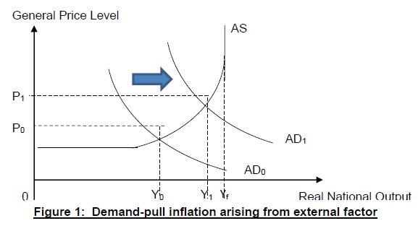

As seen from the diagram, assuming total expenditure on imports constant, there is a rise in (X-M). Thus, there is a rise in aggregate demand shown by a rightward shift of AD curve from AD0 to AD1. Assuming the country is operating near full employment, there will be a shortage of final goods and services which exerts upward pressure on GPL. GPL continues to rise until shortage is eliminated. The persistent increase in the general price level services from P0 to P1 depicts demand-pull inflation.

2) Singapore’s higher inflation could also be due to falling labour productivity which is considered an internal factor.

In Singapore, due to influx of low-skilled foreign workers, there is a fall in labour productivity. This leads to a rise in unit cost of production.

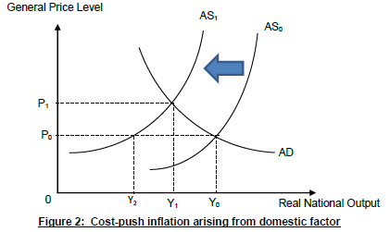
As seen from the diagram, economy with a higher cost of production will reduce their SRAS, represented by a leftward shift of SRAS curve from SRAS0 to SRAS1. Shortage of Y0Y2 at original GPL P0 will exert upward pressure on GPL as explained earlier. Thus, resulting in persistent rise in general price level of goods and services which means there is cost-push inflation.

3) Another internal factor that caused cost-push inflation in Singapore is rising COE prices.

Rising COE prices whereby private transport users have to pay a higher price for the certificate to allow them to drive their private vehicles on the roads. This applies to firms which use their vehicles as capital goods to transport final goods and services which means it contributes to a rise in transportation costs. A higher cost of production, assuming revenue constant, will lead to lower profits. Producers will reduce SRAS. Thus, the persistent rise in general price level of goods and services causes cost-push inflation.

Conclusion
In conclusion, it is highly likely external factors such as rising affluence of trade partner to be the main cause of demand-pull inflation in Singapore because she is heavily reliant on external demand given her small domestic demand. Thus, net exports take up a relatively large proportion (32%) of Singapore’s GDP. Any rise in (X-M) will have a significant impact on Singapore’s AD which in turn will have a significant impact on the rise in her GPL.

