Essay Question 13
Singapore Airlines, caught between the rapid emergence of airlines from the Gulf countries (for example, Emirates) and low cost Asian rivals, is attempting to revive growth by cutting prices.
Source: CNBC
(a) Using appropriate examples, explain the various internal economies of scale enjoyed by an airline company. [10]

Approach
  - Explain what it means for an airline company to expand.
  - Followed by this, explain 3 sources of IEOS, using examples, which can result from such an expansion.
  - Explain using a diagram how LRAC is lowered when there is such an expansion.

Introduction
Internal economies of scale (IEOS) are the cost savings a firm experience as it increases its scale of production/operation. Thus, as the scale of production/operation increases, the long run average cost will fall (as the total cost is spread over a larger range of production/operation).

Main Body
There are different types of IEOS that an airline company can enjoy when they expand their scale of operation. Expansion of scale of operation in this case may refer to the number of passengers they carry, the number of flights they operate or even the number of airports they serve/fly to.

There are IEOS from organizational administrative economies. As an airline company grows its operation, there is greater flexibility to employ specialists to be in-charge of customer service management, sales and advertisement, human resource management, training of the crew, finance etc. This will help the airline company to achieve higher managerial efficiency and lower average cost of operation.

There are technical IEOS from spreading overheads and indivisibilities. As an airline embarks on R&D for more fuel efficient planes or better quality of in-flight experience, they will incur significantly large costs of embarking on such investments. Similarly, for each airline company the fleet of aircraft constitutes a huge fixed cost. An airline company also has to incur high start-up cost in terms of the technology required, routes to be chosen and setting up of the facilities (especially in terms of logistics) at different airports. Thus, all these investments in fixed costs tend to be viable and cost efficient only with a large scale of operation (such that the long run average cost is lowered with increase in scale of operation).

There are financial IEOS that can be enjoyed by an airline company. An airline company may have to obtain funds from financial institutions to carry out their operations and research projects. The larger the scale of operation (for example, SIA or Emirates which not only have aircrafts with large (passenger/seat) capacity but also serves many airports), the lower is the interest rate on loans. This is because the scale of operation directly affects their credit worthiness as a borrower (less risk of default). Thus, a lower interest rate will help to lower the average cost of the firm. Similarly, the administering of the interest rate can be spread over a large scale of output which will lower long run average costs.

An airline company may enjoy commercial EOS by enjoying cost cutting form advertisement to attract many tourists and gain market share both in the domestic market as well as the international market. As the advertisement cost can be considered to be a fixed cost, the average cost of advertising will be lower for SIA which has large scale of operation over long run.

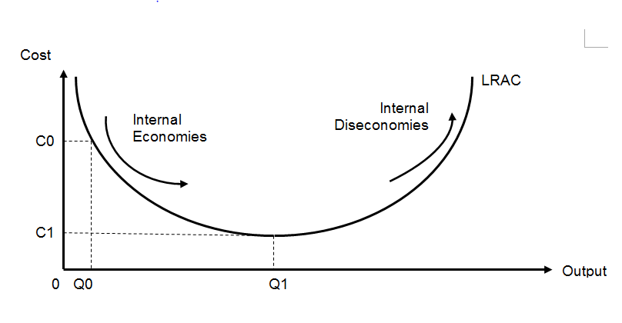
As seen from the diagram, the IEOS enjoyed by a firm can be shown using a LRAC curve. As the airline company expands/has a higher scale of operation from Q0 to Q1, the long run average cost falls from C0 to C1.

Conclusion
Thus, an airline company will enjoy different IEOS from large scale of operation and move down along the LRAC. However, the assumption is that the company will choose to operate on the LRAC at any given level of operation. It is important to note that as the airline company keeps expanding their scale, they may incur higher long run average cost after expanding beyond a certain scale of operation (i.e. internal diseconomies of scale).

Essay Question 3
Singapore Airlines, caught between the rapid emergence of airlines from the Gulf countries (for example, Emirates) and low cost Asian rivals, is attempting to revive growth by cutting prices.
Source: CNBC

(b) Given the market structure Singapore Airlines is operating in, discuss if the business strategy used is the best way to survive the threats in the airline industry. [15]

Question Approach
- Identify and justify the market structure that Singapore Airlines is operating in and analyse the current threats
- Identify the ‘business strategy’ based on preamble as price competition
- Set criteria to decide what is ‘best’
- Thesis: Given the market structure, price competition is a good strategy to survive the threats based on the criteria – show how the strategy helps Singapore airlines to meet the criteria and respond to the threats
- Anti-Thesis 1: Given the market structure, price competition is not a good strategy to survive the threats based on the criteria- show how the strategy may actually worsen the problems for Singapore Airlines
- Anti-Thesis 2: Given the market structure, other strategies are better to survive the threats based on the criteria- show two other relevant strategies that can be used by Singapore Airline

Introduction
The market structure that Singapore Airlines (SIA) is operating in is oligopoly. This is due to the high BTE in the form of huge start of cost especially, in terms of investing in the fleets of aircrafts. This results to very few dominant firms in the market who capture a significant market share. This allows the firms to enjoy long run supernormal profit.

However, with the entry of new competitors in the market as mentioned in the preamble, the market share of Singapore Airlines may fall and due to the availability of substitutes including the low-cost carriers (budget airlines), PED>1 [AR may fall and become more price elastic]. Thus, with this new threat of competition, over time, SIA may face a declining profit level. To revive their growth and profit, SIA is engaging is price-cutting strategy which is a form of price competition. Profits can be defined as the excess of total revenue over total costs. (reduction in profit – leads to the need of a strategy to counter this loss of profit)

It is important to examine if this strategy is the best strategy for SIA, assuming that their main goal is to effectively revive and sustain their profit levels.

Note: identification and explanation of the industry as a monopolistic competition market structure is also accepted but the analysis must match the identification

Main Body
Thesis: Given the market structure, price competition is a good strategy to survive the threats based on the criteria set

SIA can give discounts to attract more customers to avail their services. The fall in price should increase the quantity demanded of their services. This is especially if SIA is engaging in predatory pricing to keep threats of competition from Emirates and low cost carriers at bay.

It is important to note that given that PED<1 in the oligopolistic market structure that they are operating in, the total revenue may fall initially as quantity demanded rises less than proportionately, however, as they reduce substitutability and regain their market share, they can increase price to increase total revenue. Temporarily, they may be earning sub-normal profit, but as they may have accumulated long run super normal profit, they may be able to survive the short run fall in profit levels. Moreover, the IEOS enjoyed by SIA is significantly large as mentioned in part a, thus, they may still be able to break even while charging lower prices.
(lower price will increase total revenue as dd is now price elastic / cost saving from IEOS allows them to lower price)
Thus price-cutting strategy may be effective for SIA especially to preserve market share and revive profit. This is true assuming that the price cuts are not matched by the rivals.

Anti-Thesis 1: Given the market structure, price competition is not a good strategy to survive the threats based on the criteria

SIA is operating under oligopolistic market structure as explained before. This means there is existence of mutually interdependent behavior. Thus, a price-cut by SIA may be followed by Emirates for the long haul flights and by low cost carriers for the short haul flights, especially on routes served by both of these airlines. They can do so by announcing special offer price or discounts. Due to the presence of few dominant firms, there is a presence of very high degree of rival consciousness, whereby, an increase is price is not followed by rivals but a reduction in price will make the rivals to follow suit. This makes the PED<1 below the price-output combination decided in the market. And a fall in price will only increase quantity demanded less than proportionately as competitors are also offering lower prices. (not advisable for the SIA to decrease when the demand becomes price -inelastic)

Thus, as SIA cuts price and other rivals follow, there will be an aggressive price war which ultimately results to lower total revenue of all firms [as fall in price leads to less than proportionate rise in quantity demanded, total revenue falls]. Assuming total costs don’t change, this will lower the profit level of SIA.

Due to the characteristic of mutual interdependence, prices tend to be stable in oligopoly and so, it may not be a prudent decision for SIA to engage in price-cutting as it is not a sustainable policy and may not be effective in reviving growth/profit.

Anti-Thesis 2: Other strategies (non-price competition) may be better for SIA to revive their growth and profit.

Advertising (or product differentiation by adding in-flight services like free WiFi etc.) could be a better alternative. SIA is already very well known for its safety, on-time arrivals and departures as well as comfort. However, they can still continue engaging in advertising to create brand loyalty among the customers. (Kris flyer) This helps to increase AR and make PED<1 (and XED<1 as well) such that they can charge higher price to increase TR. Assuming that the rise in TR exceeds the advertisement costs, profits will increase. Such brand loyalty will also increase the BTE making PED even more inelastic, and help them to preserve market share and long run profit. This is also a feasible strategy considering the accumulated long run super normal profit.

Business partnership with other airlines and expanding regional network to tap on to the growing economics in the neighbouring economies may be a possible solution (for example, AirVistara in India). This will help them to increase AR and increase profit (Assuming rise in TR > rise in cost). It is safe to assume that expanding into the regional markets, especially the developing ones, will help them to also enjoy lower labour cost required to run the various services of an airline company. Thus, overall profit levels will increase.

Introducing low cost services especially for short-haul travels [to compete with the low cost airlines] like Scoot or Silk Air to achieve market share even in the low cost segment and increase AR to increase profit. By such diversification, they can also ensure that they are more equipped to at least maintain their profit level, even if demand falls in the market they have traditionally served.

Cost Reduction can also be a feasible strategy. Considering the dominance that Singapore Airlines has had, it is expected that they have past supernormal profits that they can use to invest in more fuel efficient aircrafts. This will help them to lower the fuel cost and as Profit= TR- TC, lowering of their total costs, will also help them to increase profit. However, as TR is already expected to fall because of the threat of competition in the market, the lowering of TC may not lead to a rise in profit, but may only allow to at least not reduce the profit significantly or maintain the current profit levels.

Conclusion
Price-cutting is not the best strategy over long run as it may lead to a price war, given the nature of the industry. However, if they really want to engage in price war temporarily, they may have to cut cost simultaneously to be able to survive the price-war. Given their IEOS, it may be feasible for SIA to use price-cutting as a strategy for a short period of time. However, due to the nature of the industry non-price competition may be more preferred over the long run.

