J1 June Intensive Revision 2014

Market Structures (Type I) – Q1

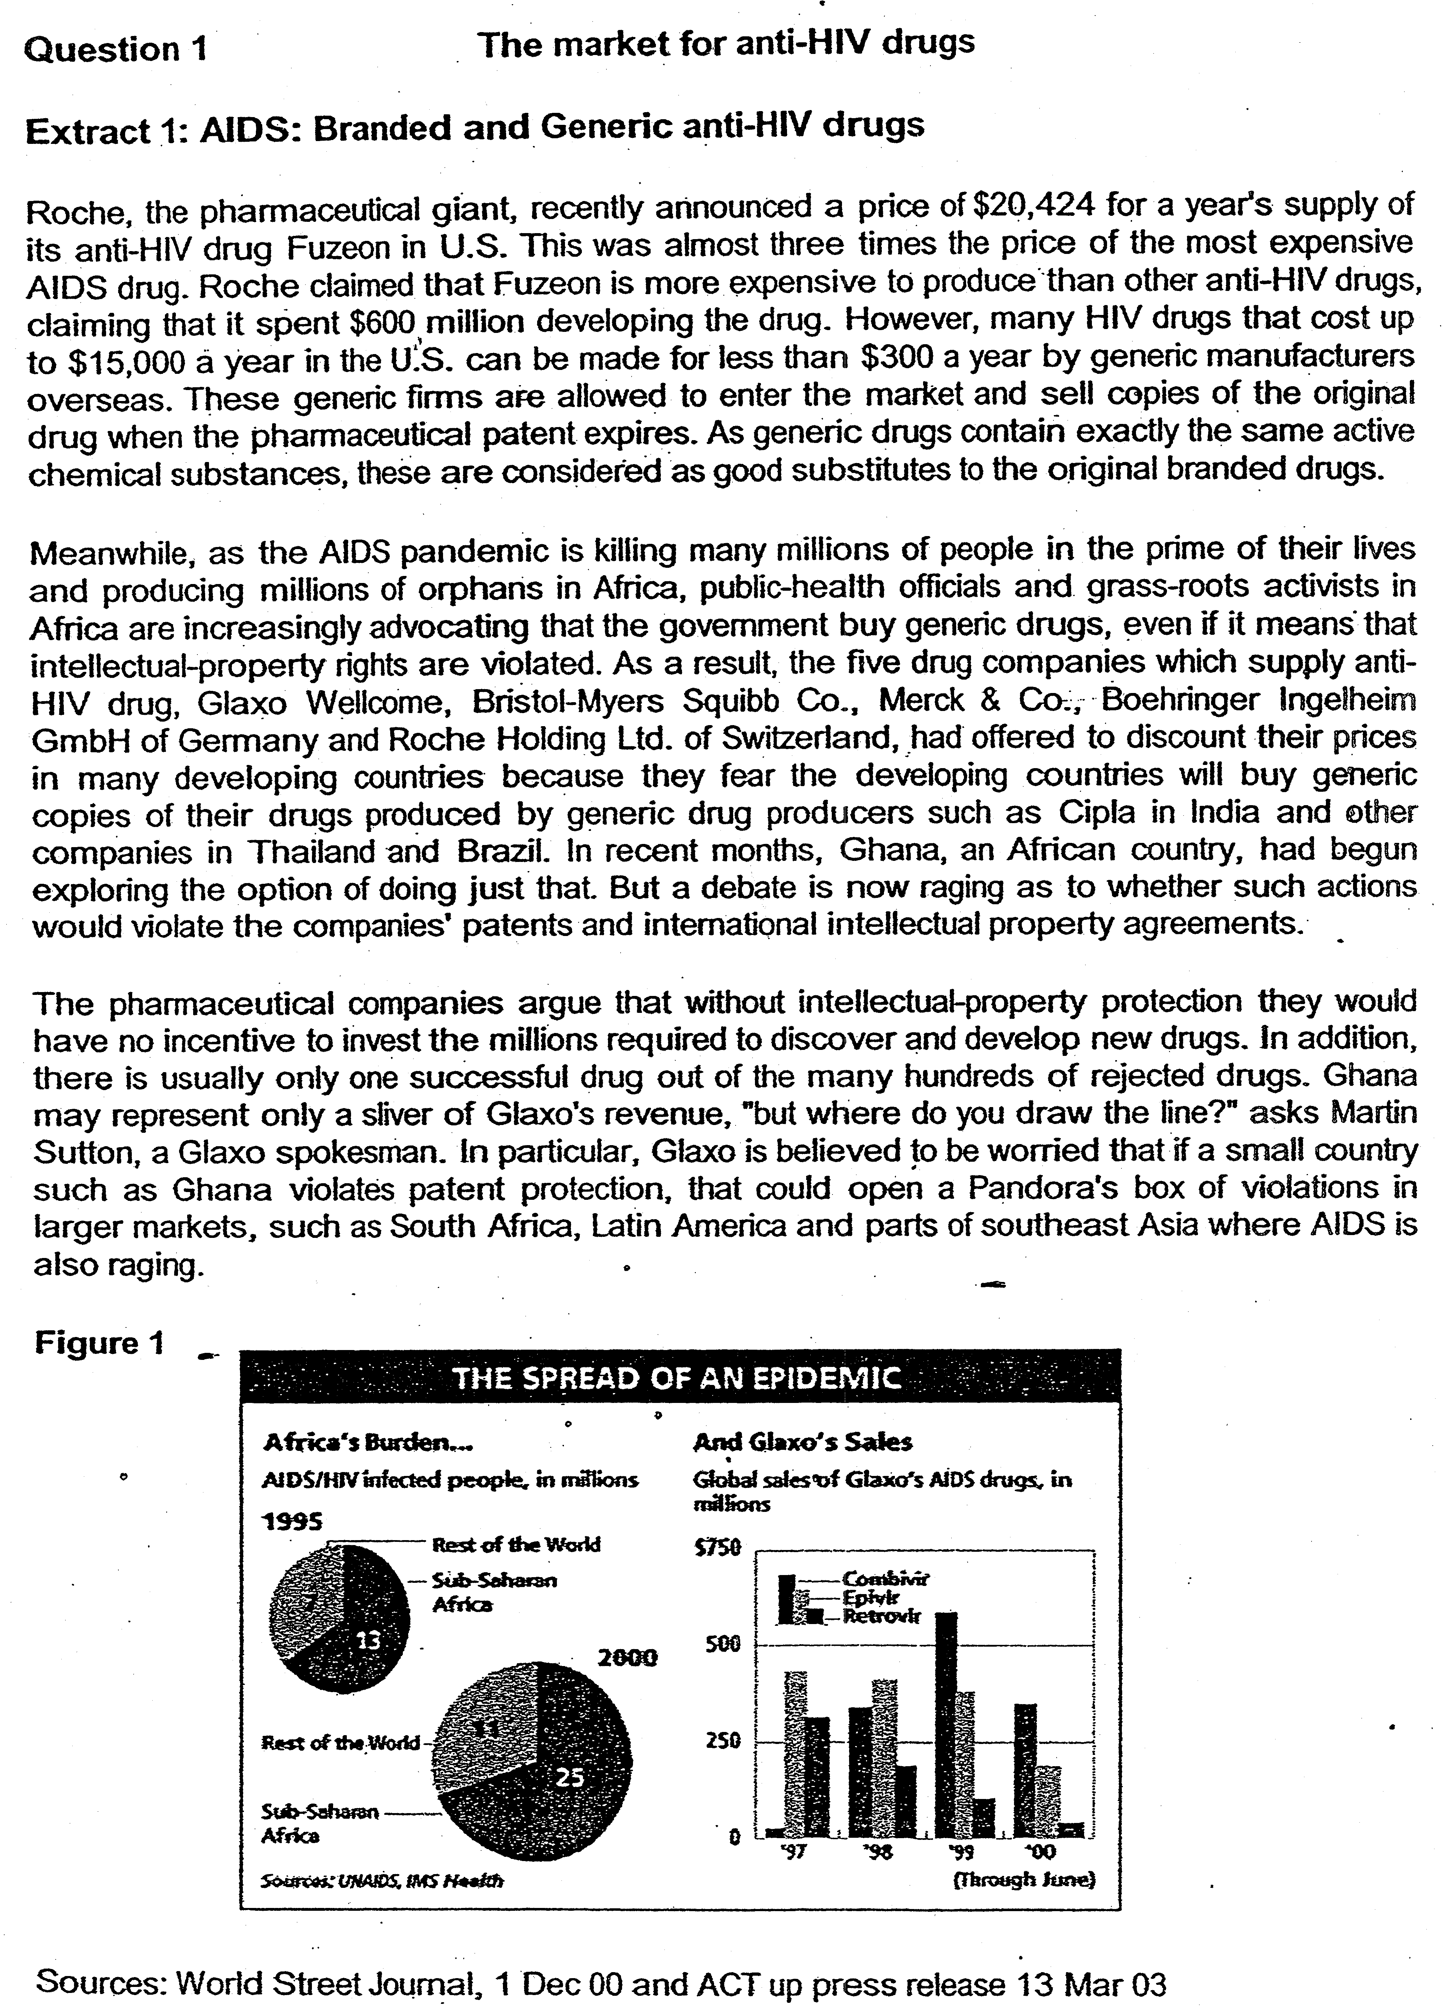

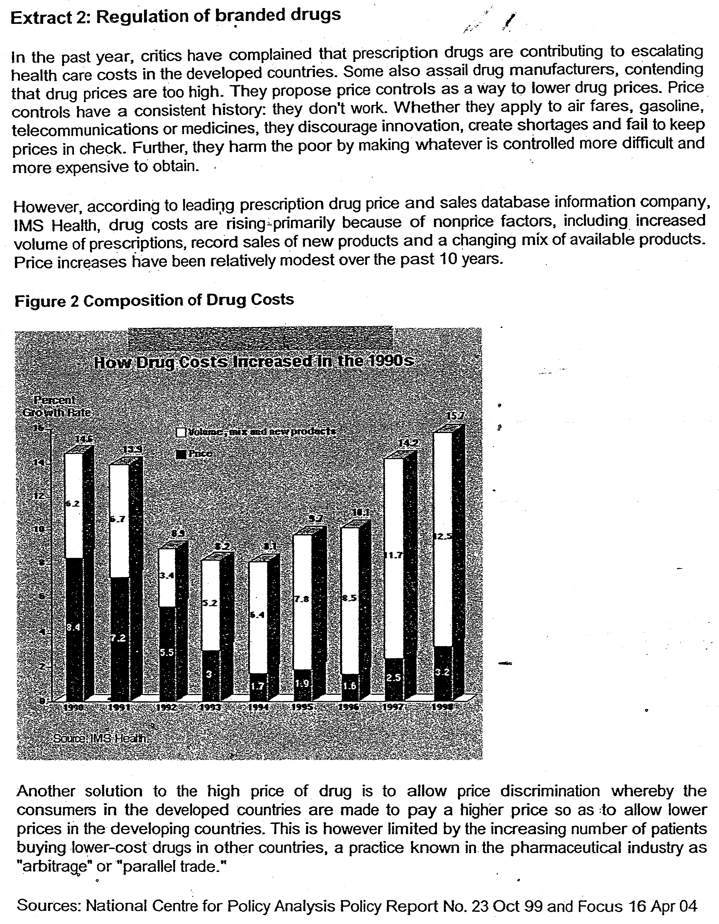

Questions
(a)(i) Describe the changes in sales of Glaxo's AlDS drugs from 1997 to 2000 using Figure 1. [2]

(ii) Using a diagram, explain how the change in number of AIDS patients and entry of generic AIDS drug producers affect the market for branded AIDS drugs.[4]

(b) (i)Drawing evidence from the data, identify and explain the type of market structure that the AIDS drugs producers operate in. [4]

(ii) With the use of data, assess whether government should implement price controls on AIDS drugs. [6]

(iii) Explain how price discrimination works in the market for AIDS drugs and analyse whether price discrimination can be effectively carried out in this market. [6]

(c) Evaluate the desirability of an intellectual property regime for all markets. [8]

