H1 Economics 2018 – CSQ – Demand and Supply – Q4

The market for milk in Canada
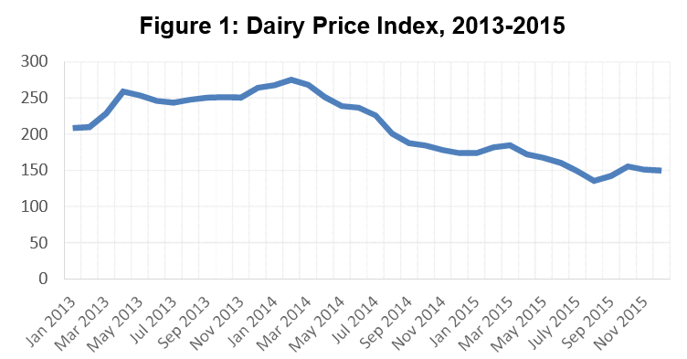
Source: Food and Agriculture Organisation of the United Nations

Extract 1: The dairy industry - Turning sour

Little over a year ago, New Zealanders were still talking about a “white-gold rush”. Strong prices for milk were prompting cattle ranchers who produce beef to convert to dairy farming, and Chinese firms were coming in to buy up agricultural land and milk processors. Inevitably, influx has led to glut. Prices have fallen to their lowest in more than ten years. Farmers in France, Britain and Belgium have recently been staging protests against low milk prices, but few places are as badly affected as New Zealand, whose dairy industry produces a quarter of its export earnings. Facing sliding incomes, New Zealand’s dairy farmers are expected to cull one-in-six cows this year.

There are two main reasons why the milk trade has turned sour. One is the economic slowdown in China, a giant market where consumption for dairy produce had until now been growing strongly. Another is the removal of the European Union’s (EU) dairy-production quotas earlier this year, which does away with limits on the amount of milk each farm could produce, encouraging big producers in Germany, the Netherlands and elsewhere to boost their output and exports.

Source: The Economist, 13 August 2015

Extract 2: Protectionism in Canada’s dairy market

Critics of Canada’s dairy sector highlight that the protection of the industry via sky-high tariffs ensures that the Canadian market remains closed to all but a tiny wedge of dairy imports. Advocates of opening Canada’s dairy market to global competition from foreign firms insist it would be a boon to the farmers with potential to be more efficient, allowing them to grow by exporting their products internationally. But that fails to justify the painful fate that would likely await the vast majority of Canada’s 12,000 dairy farms. Having been sheltered from competition for so long, the relentless demands for lower costs and higher productivity would overwhelm most family-run dairy farms.

Those demands are only growing fiercer. The European Union’s move earlier this year to abolish milk production quotas is expected to lead to a surge in production in countries with the most efficient dairy sectors. Then there’s the United States, where industrial-sized dairy farms with more than 10,000 cows are not uncommon. (The average Canadian dairy farm has 77 cows.) At the Trans-Pacific Partnership talks, the United States is pushing harder than any other country for access to the Canadian dairy market. New Zealand’s dairy sector rode the Chinese boom until growth there flinched. China now has big stockpiles of whole-milk powder, leading most analysts to predict that low global milk prices will be around for a while.

That is likely good news for most of the world’s consumers, provided processors and retailers pass on those savings. But it’s bad news for large dairy-exporting countries such as New Zealand, which bet that China’s thirst for its milk would be unquenchable. Not only are European producers now eyeing the Chinese market. Domestic production is growing fast in China – one particular operation has 140,000 cows.

Were Canada to finally join the global milk market, consumers here (particularly the poorest ones) would benefit most. Dairy farmers, not so much. But that is what free trade is all about. As Adam Smith wrote in The Wealth of Nations: “It is the maxim of every prudent master of a family never to attempt to make at home what it will cost him more to make than to buy.” Countries prosper by focusing on what they do best.

Source: The Globe and Mail, 29 July 2015

Extract 3: Should the government intervene in the dairy market?
Until quite recently, the production of many agricultural goods was local. But technology, including ultra-high temperature treatment, means milk can be kept for up to a year and shipped without refrigeration, turning milk from local into a global tradable commodity. Thus, it may be that Canada would be a better place if milk production moved to the countries that could produce it most cheaply allowing them to cut their costs so they could go head to head with global producers from China and New Zealand.

But knowing how markets work, it may be likely that losing much of the dairy industry to overseas competitors by removing tariffs would not bring food cost down much in the long term. The cost difference would merely be absorbed by some other part of the production chain. Meanwhile, the advantages of having a strong domestic industry are about more than the price of milk. Canadian dairy farmers remain in the country and don't move overseas so government’s tax revenue is not affected. In the current global shakeout in the dairy industry, it might be worthwhile hanging on to that industry at least until the shakeout is over. Maybe well-made Canadian milk products, without hormones, with love, will soon sell overseas at a premium.

Source: CBC News, 27 November 2015

Questions
(a) (i) Using the data in Figure 1, describe the trend of dairy prices from 2013 to 2015. [2]

(a)(ii) With reference to Extracts 1 and 2, assess the relative importance of demand
and supply factors in accounting for the overall trend of dairy prices. [6]

(b) With the aid of diagrams, explain the impact of “strong prices for milk” (Extract 1) on the resource allocation between the market for beef and the market for dairy. [4]

(c) Explain how the development of “ultra-high temperature treatment” technology (Extract 3) might change the price elasticity of supply for milk. [2]

(d) “It is the maxim of every prudent master of a family never to attempt to make at home what it will cost him more to make than to buy.” Countries prosper by focusing on what they do best. (Extract 2)

Using the concept of opportunity cost, explain why Canada is likely to import milk while countries like the United States and New Zealand export it. [6]

