.J2 H2 Economics CSQ – Market Failures – Q2 (University Education)

The Higher Education Market

Table 1: Government expenditure per student (S$) in Singapore

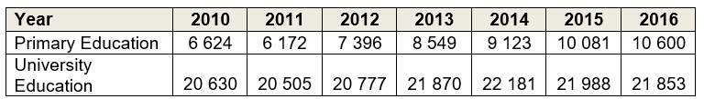

Source: data.gov.sg, accessed August 2018

Table 2: Gini Coefficient (2017)
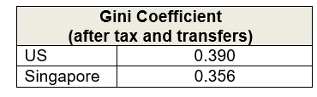
Source: The Straits Times, August 2018

Table 3: GDP per capita (US$)
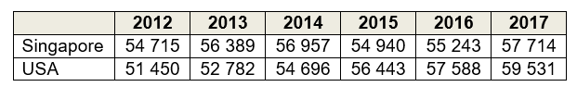
Source: World Bank, accessed August 2018

Figure 1: Government budget balance of Singapore and USA (as % of GDP)

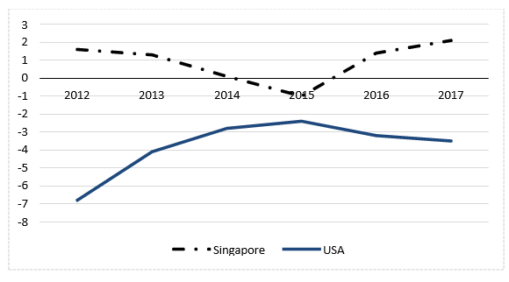
Source: Singapore Budget 2018; Congressional Budget Office, April 2018

Extract 1: Rise in price of university education in Singapore

The price of attending university in Singapore has jumped 38% on average since 2007. Official data showed that Singaporeans are spending more on higher education. Singapore's median household income grew 10% over the period and Consumer Price Index (CPI) rose 25%, yet university tuition fees were up 38%.

Increased labour costs in Singapore could have been a large contributing factor in the big jump in university costs, besides the cost to universities of owning and maintaining buildings, covering utilities and buying research equipment.

Government subsidies play a role in increasing education affordability in Singapore. And Singapore's increases in higher education tuition fees were, in fact, relatively tame when compared to other countries. College tuition in the U.S. increased by 50% between 2001 and 2015. However, rising demands from provisions for the ageing population, healthcare and other social needs in Singapore may threaten the sustainability of the government spending on higher education.

Adapted from: CNBC, October 2016

Extract 2: Returns from pursuing higher education

Unlike primary education, higher education provides individuals with concrete skills and capabilities, which in turn allow them to command a substantial wage premium when they enter the labour market. An increasing number of young Singaporeans are furthering their studies for this reason. There is a desire to learn more specialised skills, or secure a better job and higher pay check. Youths today also have a greater desire for personal fulfilment, which spurs them on to learn more about a subject they are interested in.

Nonetheless, there are compelling reasons to heavily subsidize higher education. There are social returns to higher education. Private returns – such as higher employability and wages – have positive social effects as well, in terms of lowering poverty and crime rates. Numerous productivity benefits also arise from higher education. For instance, economists hypothesise that a city with more human capital would be able to generate more knowledge capital, and the productivity gains from that would then spill over and raise incomes for the whole economy.

Moreover, even if the returns to higher education were completely private, there is a case for government to intervene to ensure that there are equal opportunities. While it is generally feasible for individuals to fund their own tertiary education through loan schemes, the lower- income may face credit constraints because of their lack of collateral. Evidence from abroad also suggests that the lower-income tend to underestimate the returns to education due to lack of information. Hence, a key component of government expenditure on higher education is channelled towards ensuring that higher education remains affordable for the population at large.

Adapted from: Singapore Budget 2010

Extract 3: Budget cuts in higher education in the United States

Almost a decade since the Great Recession hit in 2008-2009, US government spending on public colleges and universities remains well below historic levels. The recession led to record- breaking declines in government revenue, and the slow recovery prolonged its impact.

The funding decline has contributed to higher tuition and reduced quality on campuses as universities have had to balance budgets by reducing faculty and limiting course offerings. At a time when the benefit of a university education has never been greater, policymakers have made going to university less affordable and less accessible to the students most in need. This has jeopardized the ability of many to afford the higher education that is key to their long- term financial success and led to rising student debt levels for those who still pursue higher education. High school students who cannot afford the rising fees in universities are opting to start work earlier instead.

To help more young people reach their full potential — and, in turn, boost the economy and quality of life — it is necessary for policymakers to target financial aid at students on the margins and those most hampered by limited resources. This can be in the form of need- based financial aid which is awarded to students who have demonstrated financial need and might otherwise struggle to afford college.

Adapted from: www.cbpp.org, August 2017

Questions

(a)(i) With reference to Table 1, compare the government expenditure per student on primary and university education in Singapore between 2010 and 2016. [2]

(ii) Explain one possible reason for the difference observed in (a)(i). [2]

(b) With reference to Extract 2, explain how investment in human capital can ‘raise incomes for the whole economy’. [4]

(c) Use the concept of opportunity cost to explain one possible effect on each of consumers of education and the US government due to the ‘rising student debt levels’ described in Extract 3. [4]

(d) Assess whether supply factors, rather than demand factors, are the key cause of rising price of university education in Singapore. [8]

(e) Discuss whether Singapore should follow the US in lowering its higher education subsidies to better achieve the government’s microeconomic objectives. [10]

[Total: 30]

Suggested Answers
(a)(i) With reference to Table 1, compare the government expenditure per student on primary and university education in Singapore between 2010 and 2016. [2]

Similarity
- Government expenditure per student on primary and university education both increased overall during 2010 to 2016.

Difference
- Expenditure per student on primary education has always been lower than that on university education.
- The increase in expenditure per student on primary education is around 10 times more than that on university education.

(a)(ii) Explain one possible reason for the difference observed in (a)(i). [2]

The expenditure on university education on a per student basis has always been higher than that for primary education
The cost of university education has always been higher than that of primary education due to the need for research facilities and equipment, payment of salaries to professors (who are more highly trained/skilled and command higher wages), etc. However, university class sizes are smaller compared to primary schools, leading to a higher government expenditure per student on university education compared to primary education throughout the time period.

The increase in expenditure per student on primary education is more than that on university education
This may be because the government has perceived the extent of the market failure in primary education to be larger over the years. This is because the external benefit of primary education to the whole population is large compared to its private benefits, whereas the large private benefits of university education incentivise individuals to pursue higher education (Ext 2).

External benefits seen in terms of social education and development -low crime rate among the youths -reduce the cost in managing crime rate

Merit good like education – rise of positive externality like social stability and civic society – presence of external benefits like lower public expenditure on social security and harmony – reduce welfare loss to society seen in terms of social stability that will contribute higher level of investment

Draw diagram and explain how this will lead to market failures and calls for intervention.

(b) With reference to Extract 2, explain how investment in human capital can ‘raise incomes for the whole economy’. [4]

Investment in human capital would mean increased spending on education and training of labour, which increases quality of labour due to productivity gains (Ext 2). This leads to an increase in productive capacity of the economy. As a result, the LRAS increases, leading to potential growth as full employment level of output increases.

As the Singapore economy operates close to full capacity, AD is high enough. Moreover, the rise in G on education and training in the short run will cause AD to rise and be high as well. This causes the potential growth to be actualised. The increase in real output leads to firms hiring more labour and hence wages rise in the economy, leading to an increase in real incomes, which ‘raises incomes for the whole economy’.

Draw increase in AD and increase in LRAS – raise real national income in short run and long run.

(c) Use the concept of opportunity cost to explain one possible effect on each of consumers of education and the US government due to the ‘rising student debt levels’ described in Extract 3. [4]

Interpret rising student debt level
The increase in price of university education in US has led to more students taking loans to fund their education.

Define opportunity cost
Opportunity cost refers to the highest valued alternative that is sacrificed when an option is chosen.

Effect of rising student debt levels on consumers of education:
With rising student debt levels, consumers of education (high-school students) have to make a choice between pursuing higher education or going to work, as suggested in Extract 3. If they choose to pursue higher education, the opportunity cost would be the income earned from working (next best alternative) that is foregone. - plus the interest rate from saving
Effect of rising student debt levels on US government:
Rising student debt levels would mean that the government would need to raise the amount of financial aid to keep higher education affordable, as suggested in Extract 3. Thus, with a limited budget, the government would have less to spend on other sectors such as healthcare (next best alternative) when they choose to spend more on financial aid for university students. The opportunity cost would thus be the benefit to society from spending more on healthcare that is foregone.

(d) Assess whether supply factors, rather than demand factors, are the key cause of rising price of university education in Singapore. [8]

Identify supply factors
- Ext 1: Increased labour costs, cost to university of owning and maintaining buildings, covering utilities and buying research equipment. These would lead to a rise in unit COP, lowering profit per unit and hence causing producers to reduce qty supplied at every price. This leads to a fall in supply of university education. (cost of the manpower – lecturers)
- Ext 1: subsidies on university education This leads to a fall in unit COP, thereby causing an increase in SS.
- Overall, supply of university education is likely to have fallen since the ‘large’ rise in labour costs along with other costs stated above may outweigh the effect of subsidies on university education, which are most likely increasing marginally by around 6% over the years based on the increase in govt spending per student (Table 1). – infrastructures – building are paid by the government and donation

Identify demand factors:
- Ext 1: Singapore's median household income grew 10%.
- Table 2: increase in Singapore’s GDP per capita These suggest an increase in incomes and hence purchasing power of consumers, increasing the demand for university education, assuming it is a normal good (YED>0).
- Ext 2: A greater desire for personal fulfilment and increased desire to learn specialised skills These would lead to a further rise in demand due to increased preference for higher education.
- Population and demographics – seen in terms of foreigners who apply for entrance – define a percentage of graduates

Supply factors are more important than demand factors
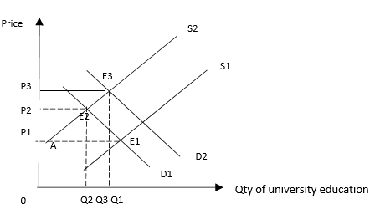
[Fall in SS & MAP] As seen from the diagram, with the overall fall in supply of university education from S1 to S2 (Fig 1), at the initial price P1, there is a shortage of E1A . This leads to an upward pressure on price. As price rises, quantity demanded starts to fall and quantity supplied starts to rise until a new equilibrium is reached at E2 where the shortage is eliminated. At the new equilibrium, price has increased from P1 to P2 and quantity has fallen from Q1 to Q2.

[Rise in DD] At E2, with the rise in demand for university education from D1 to D2, the resultant shortage at P2 leads to an upward pressure on price. At the new equilibrium E3, price has risen further from P2 to P3 and quantity increased from Q2 to Q3.

[Overall impact of both shifts on price] Both the fall in supply and rise in demand reinforce each other and lead to a rise in price of university education from P1 to P3. This explains the ‘jump’ in price of university education mentioned in Ext 1.

SS factors are more important in causing this increase in price because Ext 1 suggests increase in labour cost is a ‘large’ contributing factor, despite the subsidies. Coupled with the increases in other costs stated above, this would have caused a large fall in SS, leading to a large rise in price.

EV: However, the PED< 1 for education as it may be deemed as a necessity. With the fall in supply, the price of university education would rise to a larger extent compared to a situation whereby PED>1. Hence, there is a sharp increase in price with the fall in supply. This implies that the demand factor of PED<1 is a very important cause of the rise in price, rather than the supply factor.

Moreover, 0<YED<1 for education since it is considered a normal necessity. Thus, the rise in income leads to a less than proportionate increase in DD, implying that the fall in supply may be a more important factor that is driving the price up.
Demand factors may be more important than supply factors
Ext 2 suggests there is a large increase in DD for higher education as there is a greater desire among young Singaporeans to opt for higher education. Coupled with the rise in demand due to the rise in incomes, the increase in demand may have played a large role in driving up the price of university education.

EV: However, PES<1 for higher education in the short run as it takes time to gather the necessary factor inputs such as skilled professors, land for building new campuses etc to respond to rising prices. Hence, compared to a situation where PES>1, the increase in dd will lead to a sharp rise in price due to the PES<1. This implies that the supply factor of PES<1 is a very important cause of the rise in price, rather than the demand factor.

Conclusion
Overall, both demand and supply factors account for the large rise in price of university education by 38% (Ext 1).

[Ranking of supply and demand factors] However, Ext 1 suggests that ‘large’ rise in costs have led to the large rise in prices. Moreover, real incomes actually fell in Singapore as rise in household income of 10% is less than the rise in CPI of 25% (Ext 1), suggesting that supply factors in the form of rise in costs and PES<1 may have played a key role in causing the large rise in price of university education compared to the demand factors.

(e) Discuss whether Singapore should follow the US in lowering its higher education subsidies to better achieve the government’s microeconomic objectives. [10]

Introduction
- Clarify “micro-economic objectives”
  - Efficiency in the allocation of a country’s limited resources – efficient resource allocation – maximization of resource allocation – absence of DWL
  - Equity in the distribution of a country’s resources -equal share of the net social benefit gain

Singapore should not follow US in lowering higher education subsidies
1. Need to subsidise due to inefficiency in market for higher education (merit good)
The price mechanism fails to allocate resources efficiently in the market for university education as it is considered to be a merit good. Merit goods are goods that the government believes consumers will buy too few units if provided by the market because of information failure (under-estimation of the private benefits in consumption) and positive externalities in consumption.

Information failure occurs in the consumption of university education as consumers underestimate the private benefits of consuming the good. For example, university education increases the productivity of individuals and leads to increases in employability and wages (Ext 2). Such increases in future income are uncertain and difficult to estimate accurately. Hence, this lack of information causes individuals to underestimate the private benefits of consuming education, as mentioned in Ext 2 as well. The perceived benefits of consuming the good (MPBif in Fig 2) are less than the true benefits of consuming the good (MPBpk).
Consumption of higher education also generates positive externalities. Besides the private benefits, with productivity gains from higher education (Ext 2), there are also external benefits on third parties such as citizens who are neither producers nor consumers of university education but benefit from the raised incomes for the economy (as explained in (b) above) which help to create more jobs, lower poverty and crime rates (Ext 2), without compensation. As consumers are only concerned about their private benefits and costs, they ignore such external benefits and under- consume the good. Hence, as social benefit = private benefit + external benefits, the marginal social benefit curve (MSB) lies above the marginal private benefit curve (MPBpk) in Fig 2 below.

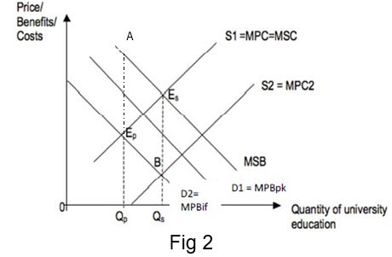
Assuming no externalities in production, S=MPC=MSC. The social optimum occurs where MSB = MSC at output level 0Qs where society’s welfare is maximized. The market equilibrium occurs where MPB = MPC at output level 0Qp where private welfare is maximized. Hence, there is an under-production and under-consumption of university education of QsQp units. This under-allocation of resources to the market leads to a loss of welfare to society, or a deadweight loss of area AEpEs. Thus, there is market failure.

[Analyse how subsidy works] As a result, there is a need for the govt to subsidise to ensure efficient allocation of resources. A subsidy per unit of EsB (the divergence at the social optimum output level) provided by the government will lead to a fall in unit cost of production and hence a rightward shift in the supply curve from S1 to S2, causing the new market equilibrium level of output (where MPBif = S2) to coincide with the social optimum level at 0Qs. The under-allocation of resources is corrected and the deadweight loss is eliminated, thereby eliminating the market failure.

EV: However, the extent of market failure is smaller for university education compared to primary education. As seen in part (a), the external benefit of primary education to the whole population is large compared to its private benefits, causing the government to spend more to make it more accessible. On the other hand, the large private benefits of university education incentivise individuals to pursue higher education (as suggested in Ext 2) and hence less government spending is required compared to primary education. Thus, the govt may not need to intervene as much in higher education through such large subsidies.
Net private benefit gain is larger than the external benefit gain for tertiary education – not to subsidize

Why government should subsidize tertiary education?
- Promote high-valued industry – high-valued economic growth – more taxes
- Promote other -related jobs – need more security guards
- Higher consumer income base – generate further growth

2. Need to subsidise due to inequity
Access to university education is a major issue in many countries and is subsidised for equity reasons as most countries consider education as a basic right or necessity. As income is unequally distributed, households with lower income may have problems affording basic education and especially university education, given that university education is usually more expensive. Given rising price of higher education in Singapore (as explained in part d), and US facing high student debt levels due to education being unaffordable (Ext 3), this leads to inequity. Hence, the market fails to allocate resources in a fair and just manner. This further justifies the need to subsidise to lower the market price rather than reducing subsidies.

EV: Ext 1 shows that price of university education has shot up. Besides equity concerns, given the nature of Singapore’s economy where investing in human capital is essential for boosting competitiveness and ensuring higher growth and employment, higher education needs to be made affordable. Hence, it may not be appropriate for Singapore to follow the US in further reducing university subsidies in the midst of the rising price of university education.

EV: However, Gini coefficient is lower in Singapore than USA (Table 2). This shows that Singapore suffers from less income inequality and therefore less inequity in society as compared to the US and hence Singapore need not subsidise education as much.

Singapore should follow the US in lowering higher education subsidies
1. Possibility of over-subsidy due to information failure of government
It is justified to lower higher education subsidies in US and Singapore if there is a possible case of over-subsidy in the market for university education due to information failure of the government. Overestimation of positive externalities and imperfect information leads to over subsidised university education. This would lead to a situation of overproduction where the market produces at an output level that is higher than the social optimum, leading to an over-allocation of resources and hence allocative inefficiency. If this intervention by the government creates a greater welfare loss compared to the initial situation before intervention, government failure ensues. In such a scenario, it may be justified to reduce higher education subsidies as it would lead to a more efficient outcome.

EV: [Comparison of likelihood of information failure of govt in US and SG] US is a much larger country compared to Singapore in terms of geographical area. This may lead to a higher possibility of info failure of govt leading to inaccurate estimation of the amount of positive externalities and information failure generated in society, leading to inaccurate estimation of the amount of subsidy per unit to provide for higher education. Singapore being a smaller country may not face such a big issue of over-subsidy as compared to the US, making the above scenario less likely to occur.

2. Opportunity cost of spending on higher education
Ext 1 suggests that there is a need to spend on other areas besides university education due to ageing population in Singapore. Spending on large subsidies on university education may therefore lead to an opportunity cost in the form of the benefits to society of spending on other areas, such as healthcare and infrastructure for the elderly, that has to be sacrificed. This may lead to a possible misallocation of resources if the loss in benefits from spending on healthcare outweigh the benefits gained from spending on university education.

EV: However, Singapore has mostly faced a budget surplus (Fig 1) unlike the US which faced budget deficits. Thus, the above opportunity cost of spending more on university education despite such a budget constraint may be larger in the case of US. Hence, this may not be as big of a concern to the Singapore government.

Conclusion
Overall, there are definitely benefits of subsidising university education in terms of efficiency and equity. The extent of market failure and budget position in US could be the main reason why US is lowering higher education subsidies. Singapore is not facing the same budget constraint since we have budget reserves. Hence, the decision on whether Singapore should follow the US in reducing university subsidies requires us to weigh the possible benefit and cost that could arise as a result.

However, keeping in view that income inequality is relatively lower in Singapore compared to the US and the extent of market failure at university level may be considered smaller compared to lower levels of education, reduction of university subsidies in Singapore may be justified on the whole. Moreover, given the increasing needs in other sectors especially with the ageing population (Ext 1), it may be more appropriate to use needs-based subsidies such as those mentioned in Ext 3 so as to achieve greater equity while ensuring the government is able to allocate its resources to other areas that are in urgent need of attention.

(direct provision, subsidy (to producers or consumers), provision of information, quota)

Factors affecting the decision on choice of solution for tertiary education

- Population and demographics
- Efficiency of the government – government failures
- Cost of financing
- Degree of imperfect market information
- Constraints of the government polices

Is education a public good?
Education is excludable and rivalrous
Education has positive externality

