CSQ 2010 – Demand and Supply – Q1
Extract 1: Titanic struggle between supply and demand
(Apr 6th 2005, The Economist Global Agenda)

Oil hit another new high this week and OPEC promised to raise its production by another 500,000 barrels per day to help ease the pain. But with capacity tight and demand continuing to grow, high oil prices may be here to stay.
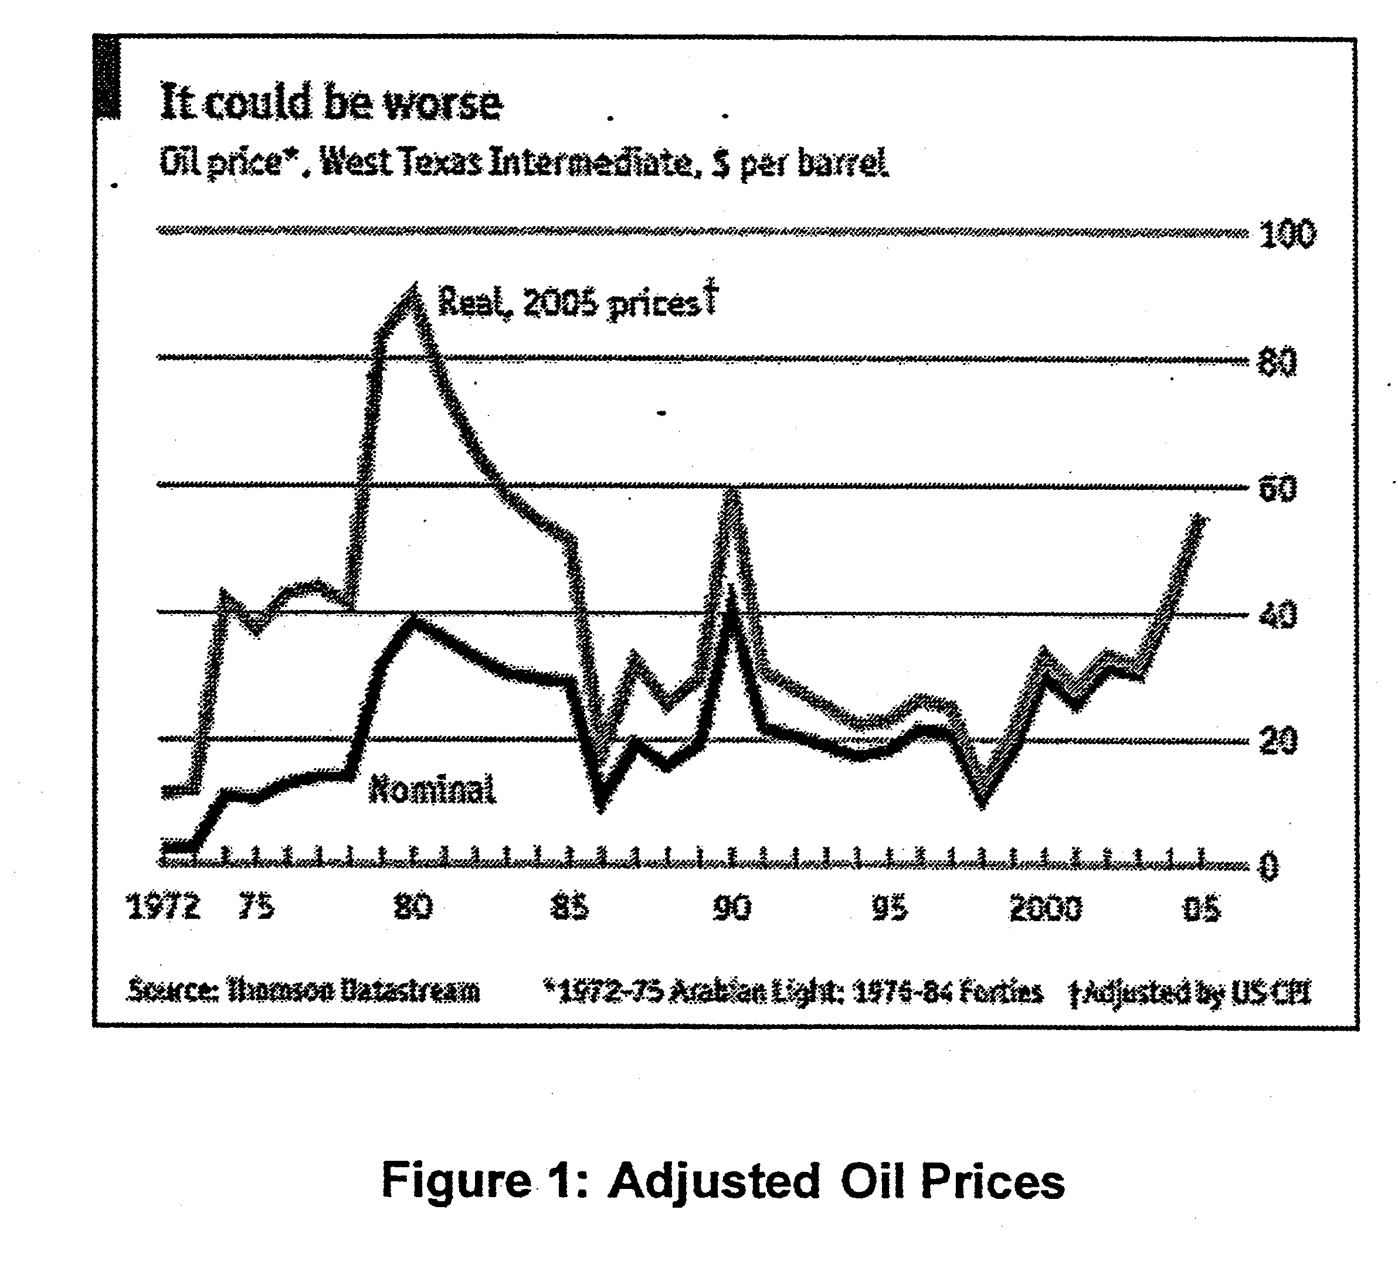
Talk about record oil prices is beginning to get a bit tedious; oil seems to be hitting new highs with the regularity of a metronome. This is, naturally, more than a bit tedious for consumers, who are having to dig ever more deeply into their pockets. More frightening still, it might get worse before it gets better. Last week, Goldman Sachs released a report predicting that oil prices may stay above $50 per barrel for several years. Oil prices obliged by jumping. The market may have been somewhat reassured by comments on Tuesday from Alan Greenspan, most notably that a big enough increase in crude inventories would "damp the current price frenzy". But the Federal Reserve chairman also expressed concern that the world did not have enough oil-refining capacity.

OPEC responded to the latest oil-price record by promising to open the taps. The oil cartel's acting secretary-general, Adnan Shihab-Eldin, said on Monday that it was ready to produce another 500,000 barrels per day (bpd) if prices stay high. But according to experts, the market is so tight that this may be of little help. Oil prices, remember, barely paused for breath following OPEC's last production hike, of 500,000 bpd, on March 16th.

There is barely any excess capacity in the oil industry, which makes it hard for the market to meet new demand. Russia, the producer to whom markets have been looking for salvation, has seen its rapid production growth level off in recent months, and the other non-OPEC nations are thought to be producing about as much as they can. Meanwhile, even OPEC has little margin to spare: by one estimate, the cartel can pump only another 1.5m bpd—a small fraction of its members' current quotas of 27.5m bpd—before it smacks up against its production ceiling. With the International Energy Agency (IEA) forecasting oil demand to grow by 1.81m bpd in 2005, supply and demand would seem to be heading for a showdown.

The analysts at Goldman Sachs think the only thing that can restore equilibrium in the market is a sustained period of high prices that forces a cutback in consumption. This would give producers time to build more capacity, which could sate demand and cushion supply shocks, such as the Iraq war. With big producers like Nigeria, Venezuela and Iraq looking unstable, people selling contracts to deliver oil in the future are demanding a hefty premium to cover the risk that the contract may mature in the middle of a shortage.

So far, however, that premium does not seem to be translating into lower consumer demand. When oil spiked in the 1970s and early 1980s, consumers responded by using a lot less of it. This time, however, they seem blithely unconcerned. Economies have become a lot more fuel- efficient over the past 20 years; as a result, spending on petroleum products is a smaller percentage of income.

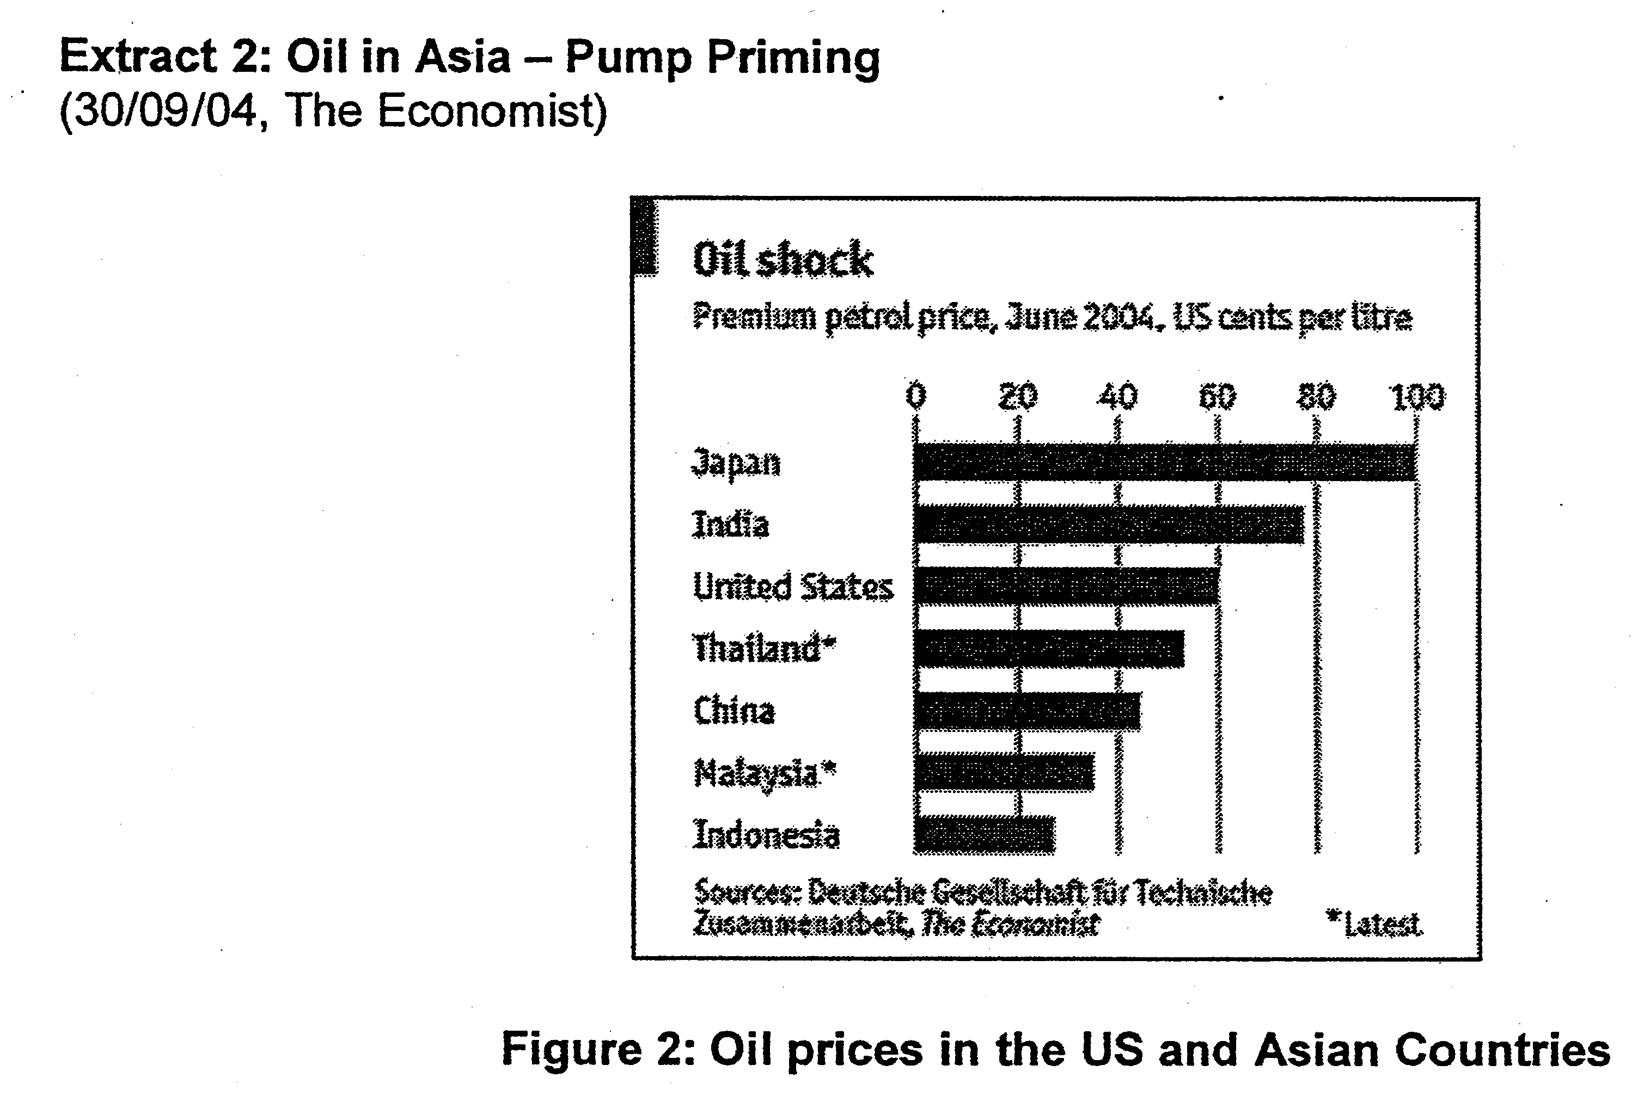

The high price of oil is taking a serious toll on Asia, in more ways than you might think. The economies of Asia, like those of most developing countries, are oil-intensive. In other words, Asians consume more oil per unit of output than Europeans or even gas-guzzling Americans. Thailand and China, for example, use more than twice the rich-country average, while India burns through almost three times as much, according to the International Energy Agency. So they naturally suffer more when the oil price rises.

One reason Asian countries get through so much oil is that many of them subsidise it in one way or another. Since the beginning of the year, the Thai government has fixed the retail price of diesel at below market rates, at its own expense. Indonesia has long done the same for all types of petrol. In August, the Indian government cut excise and import taxes on oil, to add to the direct subsidies it already pays on liquefied petroleum gas (LPG) and kerosene. Malaysia, too, keeps petrol prices low through direct subsidies and tax breaks. The government of China sets discounted prices, but leaves it to refiners and distributors, which are largely state-owned, to absorb the shortfall.

Needless to say, all this costs a fortune. The Indonesian government originally planned to spend 14 trillion rupiah ($1.5 billion) on fuel subsidies this year. But as the oil price has risen, the bill has more than quadrupled, to 63 trillion rupiah. That is almost as much as Indonesia's total budget for development. In Malaysia, fuel subsidies and forgone taxes account for roughly half this year's budget deficit of 20 billion ringgit ($5.3 billion).

To make matters worse, artificially low prices encourage waste, along with all the concomitant costs in terms.of pollution, traffic congestion and misallocated capital. Thaksin Shinawatra, Thailand's prime minister, claims he is determined to reduce his country's energy bills. To save electricity, he has asked shops to close early and that big buildings should switch off their flood lights. Yet since January, he has capped the price of diesel—on which most Thai vehicles run— at about three-quarters of the market rate. Motorists, naturally enough, are buying more. Thailand's oil imports have duly surged in volume, as well as just price.

Higher import bills, in turn, have sent Thailand's trade balance into the red. That has depressed the baht, making imported fuel more expensive still, and feeding the inflation the subsidies are supposed to curb. Most Asian nations import at least some of their oil; of all the countries mentioned, only Malaysia is a net exporter. Indeed, Asia as a whole (excluding the Middle East, but including Central Asia) produces only 11% of the world's oil, but consumes about 21%. Oil alone accounts for almost a third of India's imports, for example.

Furthermore, most oil subsidies do not go to the people in whose name they are paid: the poor. Cheap petrol, for example, benefits most those who drive the biggest, most inefficient cars, namely the rich. The poorest have no motor vehicles at all. Indonesia effectively subsidises its richer neighbours, thanks to a roaring trade in smuggled petrol. Singapore does not allow locally registered vehicles to leave the country with less than three-quarters of a tank of gas, to prevent them from taking undue advantage of the subsidised stuff across the border in Malaysia. Even targeted subsidies can end up in the wrong hands. Many countries subsidise kerosene, since the poor often cook with it. But so do lots of well-to-do restaurateurs.

Extract 3: Electricity prices to go up next quarter

THE price of electricity will go up by an average of 7.4 per cent or 1.45 cents per kilowatt-hour from January to March. Home users will pay 21.02 cents per kWh compared to 19.57 cents in the current quarter. SP Services, a subsidiary of Singapore Power, said in a statement yesterday that the increase is due to higher fuel prices and added that fuel costs make up 50 per cent of the cost of electricity.

30/12/05, The Straits Times

Questions
(a) With reference to Figure 1 and 2,

(i) Describe the trend in oil prices from 1995 to 2005. [2]

(ii) Compare oil prices between Asian countries and the United States. [2]

(b) Identify two factors that account for the rising oil prices. [2]

(c) Discuss the effects of high oil prices on the economy. [8]

(d) Using demand and supply framework, explain possible reasons why "high oil prices are here to stay." [6]

(e) With reference to the case material, evaluate the extent to which government policies that a
address rising oil prices are desirable and effective? [10]

