Essay Question 6

"A RECESSION in the United States and Europe would badly hurt Asian economies, especially Singapore's, which still rely heavily on these two export markets for growth, according to economists."
Source: The Straits Times 23/01/2008

(a) Explain the effects of the US slowdown on the Singapore economy. [12]
(b) Assess the effectiveness of the current policies adopted by the Singapore government to improve the economic performance in this current downturn. [13]

(a)
Introduction:
Define US slowdown: Recession or Falling economic growth rates.
Effects on the economy: Economic Growth, unemployment rate, inflation rate and balance of payments

Body:
Explain the effects on US slowdown in Singapore
- Recession in US - Falling national income - Falling incomes
- This will cause a fall in the demand for Singapore's exports - "rely heavily on these export markets for growth" - Link to factor affecting exports.
- This will also cause a fall m investments and FDI into the countries due a fall in export growth and weak business sentiments (link to factors affecting investments)
Fall in the demand for exports and investments will cause a fall in net exports and I – Fall in AD

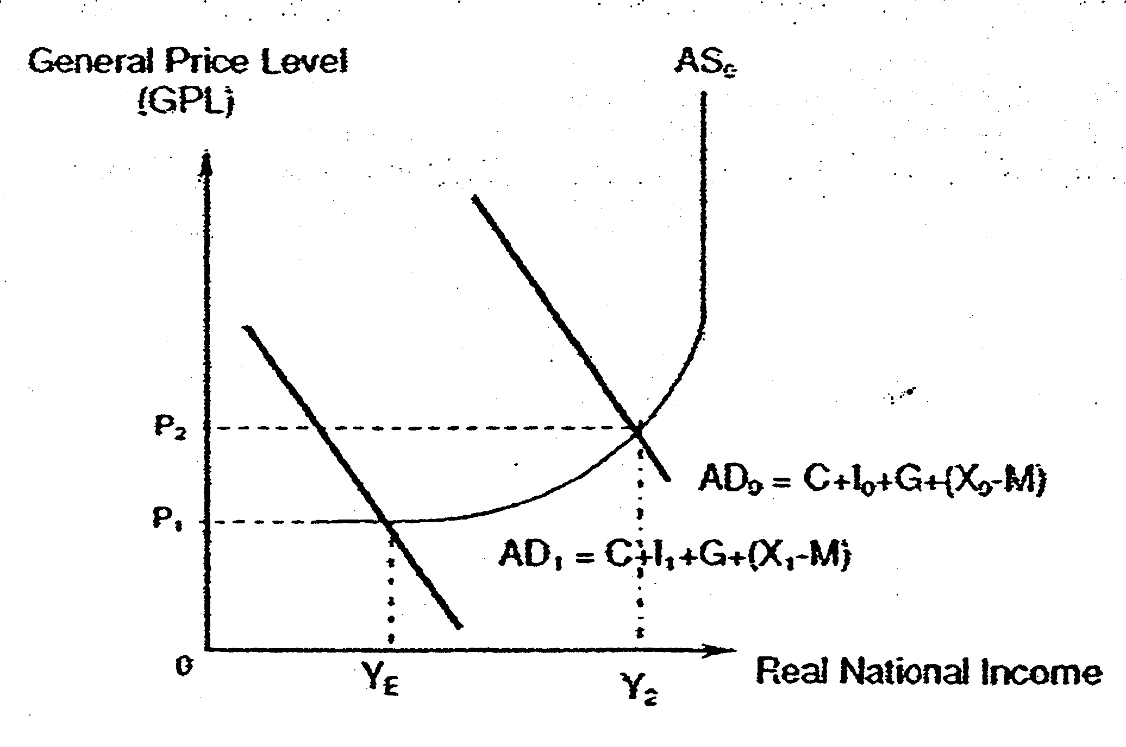
Effects on the economy
- Economic Growth: Fall in AD will lead to a more than proportionate fall in NY through the reverse multiplier process as the reduction in aggregate demand leads to a fall m national income, and the fall in national income causes a further fall in aggregate demand.
- Unemployment: unemployment rate will increase as production falls and labour is a derived demand.
- Inflation: inflation rate will fall as the economy moves away from full employment level of national income - spare capacity in the economy.
- Balance of payments: Balance of trade will worsen as exports fall. Imports may also fall but the extent of fall will not be large.
- Exchange Rate: S$ will depreciate against other currencies as the demand of S$ falls.
Conclusion
Singapore will be negatively affected by the US slowdown. The extent of the detrimental effects will depend on the degree of the openness of the economy and reliance of US economy on the performance on the economy. Singapore will be adversely affected given the large export sector and US as a major trading partner

(b)
Introduction
Context: current downturn brought about by the global financial crisis.
Macroeconomic Problems: Negative Economic Growth and High unemployment
Identify the current policies adopted by the Singapore government demand side policies-expansionary fiscal policy, supply side policies

Body

1) Explain the workings of the policies used by the government:

Expansionary Fiscal Policy: government set a budget deficit through increasing G and reducing corporate taxes (taking effect only next year).

- Context: Government increased development expenditure (infrastructure - roads and
- railwork; hospitals construction) and operating expenditure (education and security), special transfers (job credits scheme, loan programmes for businesses). Government reduced corporate taxes and give income tax rebates.

- Supply side implication - reduction of COP (through the Job credits scheme), building of infrastructure and investing in education and R&D increases the productive capacity of the economy.
- Expansionary FP and SS-side policies will lead to a more than proportionate increase in national income, prevent further job losses. (rise in Ad and AS )

- Illustrate the effects diagrammatically.

- Effective: short implementation lags, mat lead to redundancy in the development of public facilities, no trade-offs on long term objectives, no crowding out effect.

2) Exchange Rate Policy: Zero-appreciation policy stance (compared to previous gradual appreciating stance before the recession) – prevent the exchange rate from rising excessively to hurt export demand – (the condition of low export demand exists

- Explain the workings of Exchange rate policy: allow for depredation of S$ due to the fall in DD for SS.
- Depreciation of ER will cause prices of exports (in terms of foreign currency) to fall
- (improve the competitiveness of exports) and prices of imports (in terms of domestic currency) to increase.
- Assuming the Marshall-Lerner condition holds (PEDx + PEDm >1), this will lead to an increase in net exports.
- This will help to dampen the fall in net export brought about current downturn.

2) Explain the limitations of the current policies:

Fiscal Policy:
- Singapore has small multiplier and hence the impact of fiscal stimuli on the economy is small. (Evaluation: spending is targeted 4 will increase size of k)
- Fall in corporate taxes may not be effective as during recession due to pessimistic business sentiments and firms will not invest even if there is a fall in corporate tax. - Large export sector; increase in G will not be able to offset fall in X completely, (unless the world economy recovers, the increase in G is not sustainable)
- Burden on government budget (evaluate: measures are temporary and Singapore has sufficient reserves)
- Sustainability of the policies: will world economy recover soon?

Exchange Rate Policy:
- The policy is limited as the recession is caused by a global recession and not due to a fall in the country's competitiveness.
- Also, the policy will not be sustainable over time as Singapore is dependent on imported factor inputs and/or final goods, if currency depreciates, it will lead to imported inflation and hinder economic growth.

Conclusion
The current policies used by the Singapore government to improve the economic performance is effective to the extent that it dampens the fall in national Income brought about by fall in exports and improves business expectations. This will reduce the extent of unemployment which could prevent the worsening of the current recession.
However, as the root cause of the recession in Singapore is due to external factors, unless the world economy recovers, there's a limit to what the government can do to improve the economic situation.

Although the current policies are unlikely to prevent a recession, it does mitigate the impact and avert an even sharper downturn.

