Term 3
CSQ – Lesson 3 – Cost of Production, Market Structures Q1

Oil and Energy Prices

Figure 1: UK’s Brent oil* and petrol prices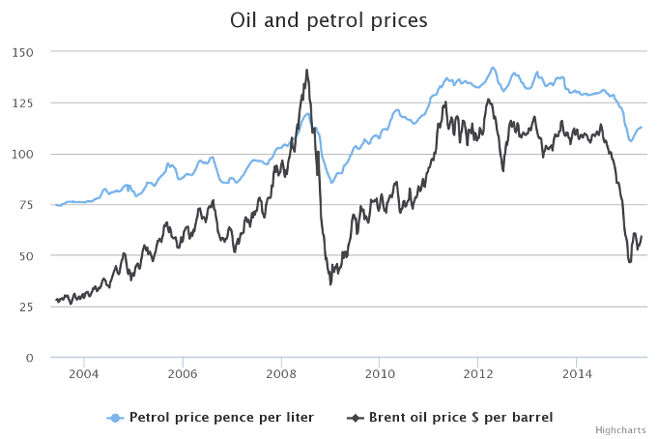
*Brent blend is a light crude oil (LCO), and is suitable for production of petrol.
Source: Business reporter.co.uk

Extract 1: Oil price crash
The UK Chancellor, George Osborne, has said the government will be watching petrol distributors "very carefully" to ensure they pass on oil price reductions to customers. So why is it that the consumer fails to see the full benefits of cheap oil? It’s simply a matter of the companies setting their price – they’re not always willing to pass on their own savings to their customers. Electricity prices should have gone down dramatically as well, with the government urging the Big Six energy suppliers to pass the savings to households.

The trend in UK’s energy market prices is part of a wider fall in global oil prices, which have plummeted by more than 50 percent this year. The drop is driven by an unprecedented global surplus in oil, caused by the shale revolution in America, and the country has ever since become the world’s largest oil producer, combined with the decision by other major oil producers such as Saudi Arabia and the rest of OPEC to maintain their production levels. Weak economic activity has dampened oil consumption and a growing switch away from oil to other fuels has also affected the picture.

Source: Adapted from the Economist, Dec 2014

Figure 2: Market supply number for the
Big Six Energy suppliers in UK (in millions)

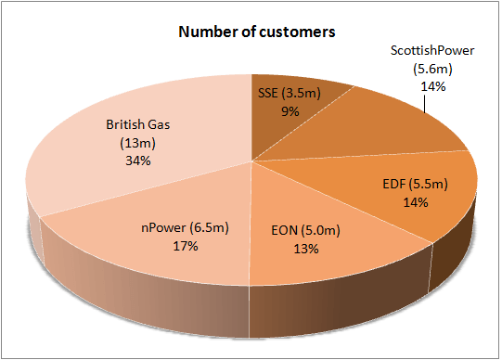
Source: http://www.businesselectricityprices.org.uk/suppliers/

high degree of market concentration ratio – more than 51% of market share held by top 10 firms – oligopolistic market structure
Extract 2: Energy firms accused of profiteering
The Big Six energy firms will double their profit margins in the next year increasing accusations that they are profiteering while millions of households are struggling to be able to afford to heat their homes. Ofgem, UK’s energy regulator has told suppliers to explain to consumers why, when oil prices are falling, they are not seeing cuts in energy prices, which was one of the main reasons why Ofgem referred the energy market to the Competition and Markets Authority (CMA) for investigation earlier this year.
price collusion – abide price set by market / price rigidity – no advantage to increase or decrease price – high degree of mutual interdependency
Ofgem said that its review had found that the behaviour of energy suppliers and the structure of the market were "acting against consumers' interests." Ofgem’s review also found that tariffs are far too complicated, making comparisons between companies extremely difficult. It has found ‘possible tacit co-ordination’ on prices (price collusion – abide to price set by the market), with the Big Six firms apparently moving tariffs up and down at the same time.
(barometric leadership – share the same type of resources – lead markets because of cost-saving in raw materials)

Ofgem proposed that the Big Six be broken up, to allow more independent suppliers to compete on prices. The Federation of Small Businesses has also called for the Big Six energy companies to be broken up, adding pressure on regulators to refer the energy companies to competition authorities this week.

Source: The Independent, July 2014

Extract 3: Ofgem defends record of reform over Big Six energy firms' high prices

Ofgem has hit back at claims that it may be partly to blame for high prices, after a group of former regulators said it had presided over a weakening of competition in the energy market. The energy regulator said it had introduced the "most radical set of reforms" to protect consumers in the retail energy market since competition began. Among its regulations, Ofgem has banned differential pricing in a bid to stop customers of the same energy company paying much higher tariffs in different parts of the country. Extra layers of complexity such as discount structures will also be removed altogether. (remove price differentiation)

Ofgem has been fighting accusations as to the appropriateness and effectiveness of a number of these interventions. The submission also goes on to raise the concern that regulation could instead increase costs for consumers; the lack of meaningful competition would mean many families and pensioners are paying as much as £250 a year too much, with a risk of suppliers cutting back on investment in the long term. (higher consumer exploitation – higher degree of market power – set higher price – MR and AR are both price-inelastic)
Source: The Guardian, August 2014

Extract 4: Lower oil prices on Singapore’s economy
Singapore was supposed to have emerged as a winner from the low oil prices, with 5 per cent of its gross domestic product coming from the oil industry. Lower global oil prices should stimulate global economic growth, according to the International Monetary Fund, in particular, countries which are net importers of oil, such as Singapore. Businesses and factories enjoy lower costs of input, especially industries heavily reliant on oil, gas and others such as airlines, transport companies and manufacturers of plastics. Consumers spend less on petrol and other energy-related expenses and thus saw an increase in their disposable income, contributing about 0.2 to 0.4 per cent in Singapore's economic growth.
- export refined oil – lower price of oil – increase in export demand
- need oil for production – lower cost of production - lower price of production – increase competitiveness
However, initial cheer from energy cost savings appears to be turning into fear over a global economic slowdown. Dr Walter Theseira, senior lecturer at SIM University explained: “Rapidly declining oil prices suggest that global economic growth is slumping. That in turn has an effect on the economy that extends beyond the oil industry. ( lower world production therefore demand less oil – global reduction in production – indicate global recession)
Source: Adapted from The Straits Times, Jan 2015
Questions
(a) | (i) | Compare the change in UK’s Brent oil price with that of petrol price between 2010 and 2014. [2]
 | (ii) | With the aid of a diagram, account for the change in petrol prices from 2014 onwards. [5]
(b) | (i) | Describe the type of market structure operating in the UK energy market.  [2]
 | (ii) | Explain why firms in the UK energy market are inclined to engage in “possible tacit co-ordination on prices”. [3]
(c) | Discuss the view that Singapore “was supposed to have been a winner from the low oil prices”. [8]
(d) | Discuss whether the set of reforms recommended by Ofgem in the energy market is justified. [10]

Suggested Answers
(a) (i) Compare the change in UK’s Brent oil price with that of petrol price between 2010 and 2014. [2] - similarity and difference

Overall, both prices of Brent oil and petrol rose but start to fall in 2014. However, Brent oil prices rose as well as fell more than that of petrol price.

(a) (ii) With the aid of a diagram, account for the change in petrol prices from 2014 onwards. [5]
(Economic Causation / diagram / description of diagram / analysis)

The fall in petrol prices from 2014 onwards was due to a dampened demand and a rise in world supply of oil.

A weakened global demand for petrol has led to a fall in petrol prices.
- Given the economic slowdown especially in China and the Europe reeling from the Eurozone crisis, as income growth dampened, demand for transportation of goods will fall, leading to a fall in demand for petrol.
- Extract 1 supports that weak economic activity is one of the few factors causing the slowdown in demand for petrol.

A shift in preference for cleaner energy source has led to a fall in petrol prices.
- Due to the availability of renewable energy and the awareness to reduce carbon footprints, more firms and households are slowly switching from traditional fuel to cleaner energy. As such, demand for oil, thus petrol will be dampened.
- Extract 1 mentioned the trend of growing number switching to other forms of cleaner energy source.

A rise in US oil production has led to a fall in petrol prices.
- US’s shale revolution means that US is using innovative techniques to unlock vast quantities of oil from shale rocks, causing excess supply to the rest of the world. Since marginal cost of production of petrol has fallen, supply of petrol would have increased.
- Extract 1 supports the success of US’s shale revolution to allow US to overtake Saudi Arabia as the largest oil producer.

Given a rise in supply and a fall in demand on petrol, petrol prices will fall.

(decrease in demand > increase in supply0

As seen from the diagram, the rise in supply to S1 for petrol and the fall in demand to D1 for petrol will cause a surplus at existing equilibrium price P, leading to a downward pressure on price. Given the price inelasticity of both demand and supply, the fall in price is significant. (PED and PES – the extent of increase or decrease in price / direction of change in demand and supply)

(b) (i) Describe the type of market structure operating in the UK energy market. [2]
The UK energy market is operating as an Oligopoly market structure. The industry consists mainly of a few large producers. With reference to the Figure 2, the market place is being dominated by Britain's six largest energy companies.

(how the market structure will change from oligopoly to MC market)
expiration of patent rights – weakened BTEs – low degree of market power – change the market structure from oligopoly to MC market

(b) (ii) Explain why firms in the UK energy market are inclined to engage in “possible tacit co-ordination on prices”. [3] (reasons for price collusion) – abiding to the price set by the market – reduce market unpredictability (about price setting – lack of knowledge on price level)

- price collusion – higher degree of market power (standardization of price) – consumer reduces their choice – buy at higher price – consumer exploitation
difference between price rigidity and price collusion
- price rigidity – no adv or disadv to increase or decrease price – price is set at one level – kinked demand curve
- price collusion – set price to the market price or agreed to a price level to raise market power so to conduct consumer exploitation – pED inelastic demand curve or AR
Being in an oligopolistic market structure where there are a few large firms each with substantial market share and they are of close rivals, the UK energy firms tend to avoid price competition because they are mutually interdependent and there is no incentive to do so. Any form of price cutting would mean an erosion of revenue as competitors will match such price cuts to prevent a loss of market share and any attempt to raise price will likewise see a fall in total revenue as competitors are unlikely to follow suit.

On the other hand, given the market power the firms have, they are able to collude as a cartel to fix price at a level close to the level that would be expected from a monopoly.
what are the factors that make it easy for firms to collude:

similar product with similar cost of production
lesser firms make it easy for price setting
ease in agreeing to the terms for setting price

the total market concentration is high as 6 firms occupy the total market share.

(c) Discuss the view that Singapore “was supposed to have been a winner from the low oil prices”. [8]
Approach
Falling oil prices seem to bring about positive impact on Singapore’s economic growth since Singapore is a net importer of oil. However, as mentioned in Extract 4, Singapore’s oil industry with oil-related firms such as oil rig and marine companies involved in oil exploration (inferred) may be directly affected by the falling oil prices. The use of AD-AS model will be needed to explain the effect of falling oil prices on economic growth and thereby conclude if Singapore would have been a winner from the low oil prices.

Thesis: Falling oil prices can have positive impact on Singapore’s economic growth
[Extract 4, Para 1] Many industries in Singapore such as airlines, transport and shipping companies and manufacturers of chemical products use crude oil to process many types of manufacturing goods, and these sectors contribute much to the economic growth in Singapore via exports. The lower crude oil prices cause cost of production to fall as input prices fall, promoting more of such industrial production in the economy. As Aggregate supply rises due to the lower cost of production, prices of goods and services from these sectors will fall, leading to a rise in quantity demanded for exports of goods and services. Given Ep>1, this will lead to a rise in export earnings, resulting in a rise in national income.

[Extract 4, Para 1] suggested that for the end consumer, relief has come through in the form of smaller electricity bills and petrol costs.

As price of crude oil falls, cost of producing electricity and petrol will fall. This will lead to cost savings passed to end users of electricity in houses and individuals who drive for instance. Given that Ep < 1, a price drop in electricity and transport will cause a less than proportionate rise in quantity demanded, resulting in a fall in consumer expenditure. As mentioned in Extract 4, the cost savings from electricity and petrol spending will enable consumers to have more disposable income for domestic consumption of other goods and services. As induced C rises, it leads to a movement along AD as well and therefore national income rises.

The effect on national income via increased in C is not very significant [Extract 4: higher spending resulted in an increase of about 0.2-0.4 per cent in Singapore's economic growth].
Anti-thesis: falling oil prices may have adverse impact on Singapore’s economic growth
If the rapidly declining oil price is evident slower growth/recession in the global economy [Extract 4, Para 2], then the current slump in oil prices may not prop up consumer spending in the manufacturing sectors. In this case, the slump in global trade is likely to negate the benefits of cheaper oil.

As Singapore is hit by weaker global economic condition, industries such as the petrochemical industry has seen a decline in export revenue due to lower global demand. Therefore, even with cheaper input prices leading to such industries offering their goods more price competitively, the gains may be offset by a fall in demand for their goods. Instead of seeing a rise in national income, the fall in demand for overall exports would have contributed to a fall in AD, thus a fall in national income via multiplier.

Singapore's economy is exposed to the entire supply chain of oil, from marine industry to the petrochemical sector. [Inferred evidence]. Sustained lower oil prices have dampened oil related activities such as oil exploration and rig-building in the oil industry in Singapore [Extract 4] As demand for crude oil falls, the demand for oil exploration and oil rig building will fall since these are derived demand. With a fall in demand for export of these services, AD will fall, causing a fall in national income via multiplier. Job losses are expected as well, mentioned in Extract 4, since labour is demand derived.

Conclusion
In Singapore itself, businesses and households outside of the oil and gas sector have on the whole benefited from lower cost of living from lower utility and fuel-related costs. For example, those in the chemicals sector, airline and shipping companies have benefitted from cheaper fuel, which on the whole has helped to spur the economy.

As to whether Singapore will emerge as a winner from low oil prices depends largely on what leads to the falling oil prices. If the falling price of oil is largely due to a lower demand for energy, then Singapore may not benefit to the full extent due to the sluggish economy. Ultimately, falling oil prices is seen as a mixed bag for Singapore’s economy but with more believing that a supply-driven drop in oil prices would then render Singapore a winner, particularly to net oil importers like Singapore.

(d) Discuss whether the set of reforms recommended by Ofgem in the energy market is justified. [10]
(reasons for and against intervention)
(sources of info – eos, allocative efficiency, dynamic efficiency, degree of competition affected by BTEs)
Introduction
The set of reforms recommended includes i) breaking up of the Big Six ii) to ban differential pricing in terms of 3rd degree price discrimination and getting rid of pricing complexity such as discounts to allow more transparency. In the context of UK’s energy market, it is dominated by 6 largest firms which highlight the presence of huge market power thus the accusation of profiteering and consumers paying more for energy power despite falling oil and fuel prices. Therefore, the justification is centered mainly on consumer welfare.

Thesis: Breaking up the Big 6 and introducing more competition will help to lower prices for consumers
Figure 2 suggests that the UK energy market is oligopolistic and also from Extract 2, it also suggest the presence of cartel formation through price fixing. Therefore, breaking up the Big Six in order to reduce market power is justified.
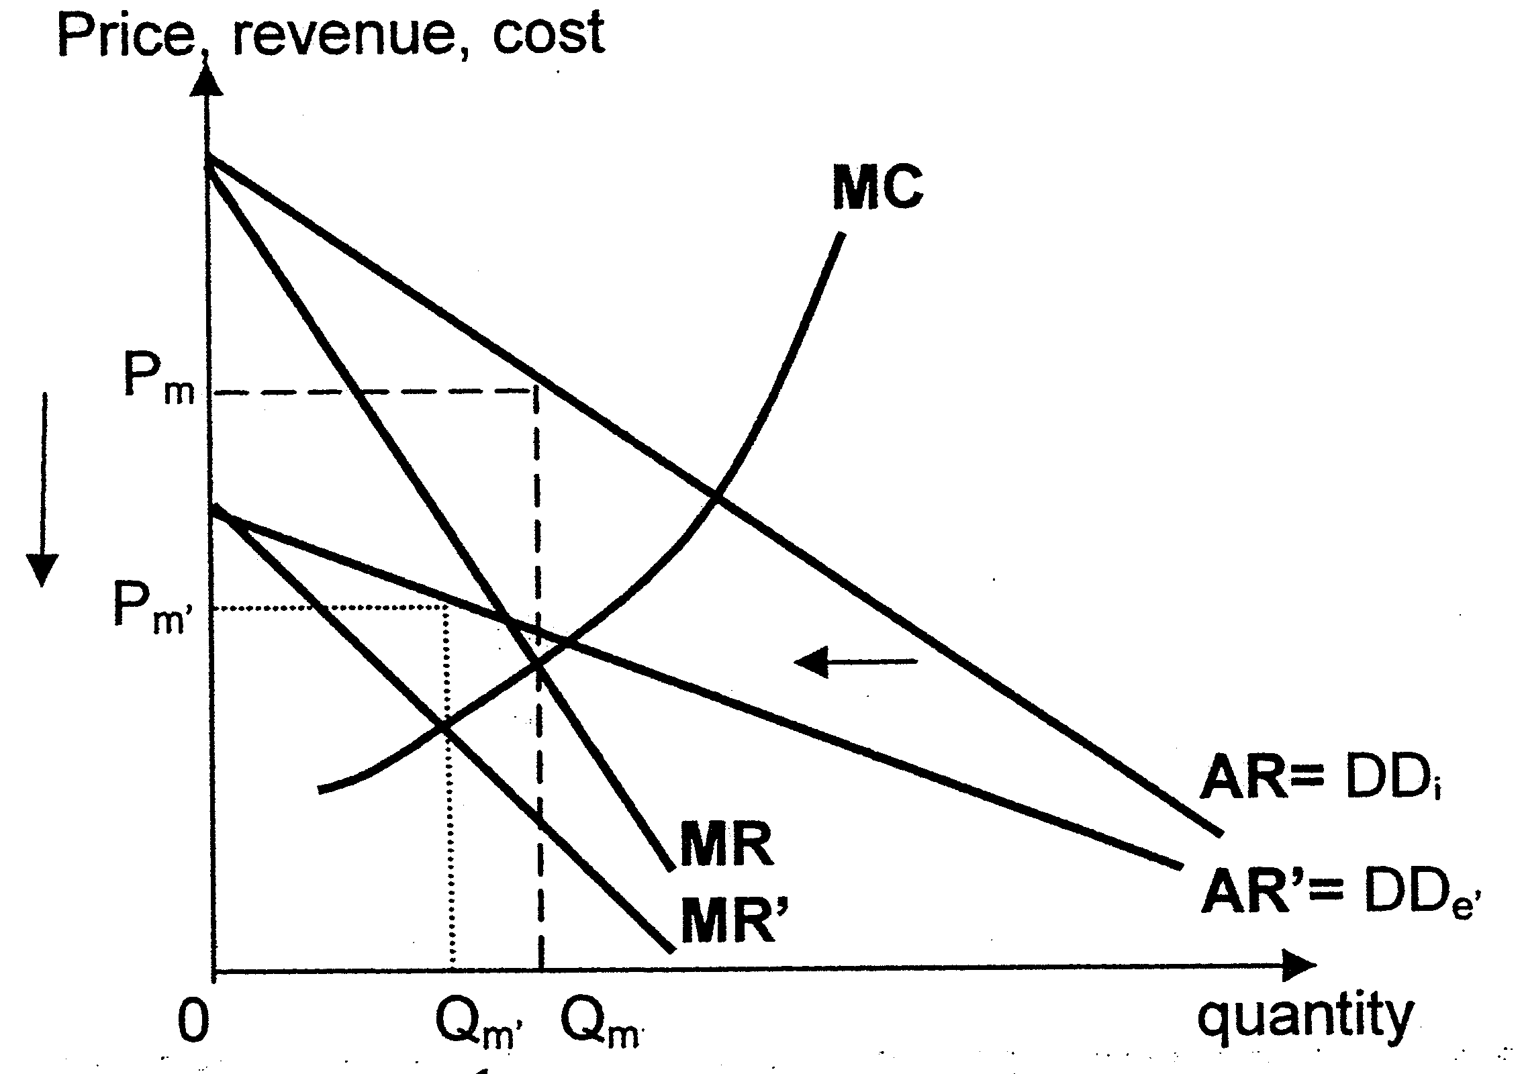

As seen in Figure A, a profit maximising UK energy firm will produce at the point where the rising marginal cost (MC) will intersect with marginal revenue (MR) curve at Qm and therefore charge at Pm, way above the marginal cost. Given the inelastic demand for energy, the price charged to consumers will be much greater. Despite the falling fuel prices, it is very likely that energy companies will continue to charge at Pm through forming a cartel [Extract 2] and behaving as close as a monopoly in terms of pricing. At Qm, total revenue will therefore be given by 0PmQm while total cost is 0PcCQm. This explains the huge profits enjoyed by energy companies as mentioned in Extract 2.

As a result, Ofgem recommends that the deregulation will allow greater competition to protect consumer welfare. Having more competition will bring the market closer to monopolistic competition market outcome by making the demand for energy power more elastic and therefore reducing the price from Pm closer to Pc.

Thesis: Breaking up the Big 6 will help to improve productive and dynamic efficiency
Greater competition will also ensure greater discipline in managing costs rather than remaining complacent therefore reducing productive inefficiency as well. This drives energy prices down and thereby increasing the level of consumer welfare. Greater competition may also motivate energy producers to conduct more R&D to develop more environmentally friendly and efficient sources of energy as part of product differentiation, leading to better and more energy choices for consumers, raising their level of consumer welfare.

[Anti-thesis for breaking up the Big 6]
The extent to which consumer welfare can be increased via lower prices is limited in the context of energy market because as the top 6 UK energy firms are able to reap substantial amount of economies of scale (EOS) compared to the smaller energy retailers in the market, which allows them to enjoy lower average costs of production. By breaking up the Big Six, these firms may not be able to reap much EOS as before hence with a higher marginal cost, the consumers may end up paying more for now despite the greater competition in the market.

In the energy industry, MES is usually high relative to market share hence competition could result in wastage of resources. (the individual firm will not be able to produce at the optimal capacity of production which is at the lowest AC)
Eventually, some especially the smaller energy firms will have to exit unless the government covers the losses but then this will further lead to the wastage of resources. The top 6 UK energy firms will regain their market share, providing them with greater ability to restrict output and control prices once again.

Furthermore, the loss of market share due to the entrance of more firms may dampen profit margins, reducing the ability of energy providers to engage in R&D and in the process leading to possible lower consumer welfare in the long run. The lack of incentive and ability to engage in R&D may result in productive inefficiency, causing cost of providing the electricity to increase.

This is supported in Extract 3, whereby the lack of meaningful competition could mean many of them are paying as much as £250 a year too much and also with a risk of suppliers cutting back on investment in the long term.

Removing the complex pricing will help consumers make more informed choices
Ofgem also decided to get rid of the complex pricing structure that each energy firm has implemented so that imperfect information can be reduced. [Extract 3] By helping consumers making more informed choices in terms of choosing the tariff contract that best suit their needs, consumer welfare can be increased.

Removing differential pricing means the energy firms can no longer practice 3rd degree price discrimination. With firms no longer being able to earn higher profits from 3rd degree PD, it will result in improved equity.
(price discrimination- help the lower income to get cheaper price of oil – charge the higher group higher price of oil)
Conclusion
The claims of Big Six profiteering through market dominance may be valid for Ofgem to intervene mainly to protect consumer’s interest, and through these short-term measures, consumers would be well protected by paying too much for electricity despite the falling fuel prices. However, it is important to note that the very nature of this industry requires a firm to be large to enjoy substantial EOS; in order to offset the high fixed cost hence breaking up the Big 6 could backfire. Given the context of global warming, the country may need the existence of larger energy firms in order to have the capacity and resources to develop renewable energy and perhaps better technology that could help lower prices in the long run. By recommending this set of reforms can be seen as justified in terms of increasing consumer welfare in the short run but more needs to be thought out carefully to justify them for better long run outcomes.

1)Using a diagram, explain how the impact of recession will affect one of the firms in this crude oil industry.
MR and MC diagram – impact is on one firm – MR and AR will shift inwards or leftwards – lower price and output

Using a diagram, explain how the rise in price of oil would affect a firm’s price and output level of the firm in a transport company. 1)Using a diagram, explain how the impact of recession will affect one of the firms in this crude oil industry.
MR and MC diagram – impact is on one firm – MR and AR will shift inwards or leftwards – lower price and output

- Using a diagram, explain how the rise in price of oil would affect a firm’s price and output level of the firm in a transport company

Tariffs in electricity market means electricity prices consumers pay.

