J2 H2 Economics CSQ – Market Failures – Q4 (Waste Recycling)

Waste Recycling

Figure 1: Plastic Waste and Recycling Rates in Singapore

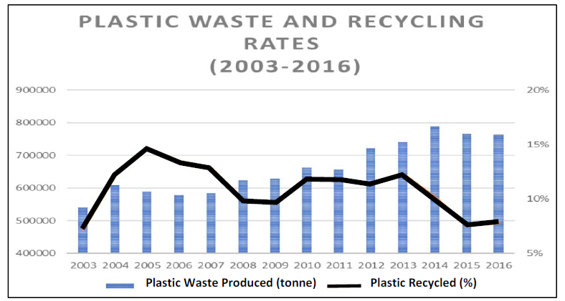
Source: National Environmental Agency (n.d.).
Waste Statistics and Overall Recycling

Figure 2: Change in environmental impacts of

Pre- and Post-Ban Bag-use in San Diego

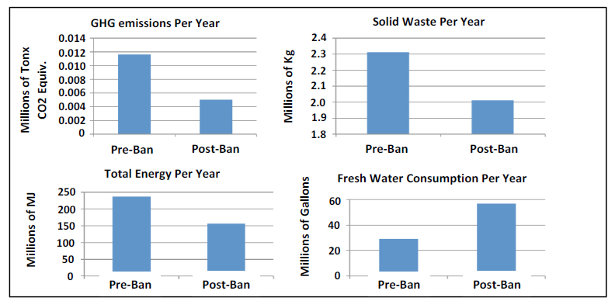
Footnote: GHG – Greenhouse gas; MJ – Megajoule; Fresh Water consumption due to paper bag production and washing of reusable bags

Source: Center for Sustainable Energy, Plastic Bag Bans:
Analysis of Economic and Environmental impacts, 23 October, 2013

Extract 1: A War the World Must Win

Kathmandu alone uses around 4,700,000 to 4,800,000 plastic bags daily. In Nepal, 16 per cent of urban waste is comprised of plastic, which is 2.7 tons of daily plastic garbage production.

Besides the sheer quantity of plastic waste being produced, one of the major problems with plastic is its resistance to degradation. A conservative estimate puts the average time for one single plastic bag to completely biodegrade at 500 years. This means that not only most of the plastic we use during our lives will outlive us, but that our plastic footprint also will affect the generations to come.

The Hindu Kush Himalaya covering the connected mountains of eight countries — Afghanistan, Bangladesh, Bhutan, China, India, Myanmar, Nepal and Pakistan — are the source of ten great rivers that provide drinking water, irrigation, hydropower and life, and eventually reach the oceans. The flow of water from the Himalayas to the oceans also carries plastics and solid waste, posing a threat to both ecosystems and people in the mountains, plains and seas. In Nepal, plastic waste is well known for clogging the rivers and streams in the mountains and hills, resulting in flash floods.

Source: A War the World Must Win, The Statesman, 3 July 2018

Extract 2: England's plastic bag usage drops 85% since 5p charge introduced

The number of single-use plastic bags used by shoppers in England has plummeted by more than 85% after the introduction of a 5p charge last October, early figures suggest.

More than 7bn bags were handed out by seven main supermarkets in the year before the charge, but this figure plummeted to slightly more than 500m in the first six months after the charge was introduced, the Department for Environment, Food and Rural Affairs (Defra) said. This shows that plastic bag consumption can be price-sensitive to UK consumers.

Retailers with 250 or more full-time equivalent employees have to charge a minimum of 5p for the bags they provide for shopping in stores and for deliveries, but smaller shops and paper bags are not included. There are also exemptions for some goods, such as raw meat and fish, prescription medicines, seeds and flowers and live fish.

Source: Adapted from England's plastic bag usage drops 85%
since 5p charge introduced, The Guardian, 30 July, 2016

Extract 3: Designing a solution to plastic bag waste that fits

Plastic bags are given out freely with purchases at supermarkets. Approximately 3 billion plastic bags were used in Singapore in 2011, resulting in an average of 1.6 plastic bags used per person on a daily basis. This high annual usage of plastic bags has been cause of much concern from environmentalists and concerned members of the public alike.

Several countries and cities around the world have already introduced legal measures such as plastic bag levies and taxes, to put an end to the practice of shoppers receiving an unlimited amount of plastic bags at no charge. These financial disincentives take two main forms – taxes that are enforced on plastic bag manufacturers or importers for the plastic bags sold by them and levies that are imposed on consumers at the point of sale. On a worldwide scale, more than 75 countries have taken steps to reduce the consumption of single-use plastic bags. About one- third of these have instituted bans, approximately one-third have instituted fees. A tax on plastic bags would be the most direct and effective way of correcting this market failure.

On the other hand, environmental advocates, while encouraging the recycling of plastic bags, propose several alternatives to traditional plastic bags, including biodegradable or compostable bags for single-use purposes, paper bags for single-use purposes, reusable bags made from low density polyethylene (LDPE) or non-woven polypropylene, and cotton tote bags. However, in the real world, recycling carries costs that are often overlooked. For example, recycling paper could cause more severe water pollution or soil contamination as the removal of ink from paper requires harsh chemical treatment, with the resultant sludge needing to be disposed of somehow. The process of recycling could also be more energy intensive than the extraction of raw materials.
Source: Multiple sources

Questions
(a) Describe the trend of plastic waste production and plastic recycled from 2010 to 2016. [2]

(b) Explain the probable price elasticity of demand for plastic bags in the UK. [3]

(c)(i) Explain the source of market failure for the plastic bag market mentioned in Extract 1. [2]

(ii) With the use of a diagram, illustrate how free provision of plastic bags worsens the issue of market failure identified above. [5]

(d) With reference to Extract 3 and any other data, comment on the effectiveness of the solutions proposed by the environmental advocates to reduce consumption of
plastic bags in Singapore. [8]

(e) Assess the factors the Singapore government should consider when deciding between imposing a ban and a tax on plastic bags. [10]

[Total: 30]

Suggested Answers
(a) Describe the trend of plastic waste production and plastic recycled from 2010 to 2016. [2]

Plastic waste production has been generally increasing from 2010 to 2016 and the rate of plastic recycled has been generally decreasing from 11% to less than 5%.
(there is an increase in the production of recycled waste)

(b) Explain the probable price elasticity of demand for plastic bags in the UK. [3]

Definition: PED measures the responsiveness of the quantity demanded to a change in the price of the good, ceteris paribus.

Identification: PED of plastic bags in the UK is price elastic.

Justification: As mentioned in Extract 2, UK consumers are price sensitive (or the significant fall in 85% of plastic usage due to the 5p charge). This shows that UK consumers are very responsive to any change in plastic bag price. Hence, an increase in price of plastic bags will lead to a more than proportionate fall in quantity demanded of plastic bags in the UK.

(c)(i) Explain the source of market failure for the plastic bag market mentioned in Extract 1. [2]

Identify source of Market Failure: Negative externality due to consumption.

Evidence with analysis: From Extract 1, the damage to irrigation system and dam; contamination of drinking water, causing farmers living near the damaged dam to lose their livelihood and people who consumed the contaminated water to suffer from deteriorating health and incurring medical costs.

(c)(ii) With the use of a diagram, illustrate how free provision of plastic bags worsens the issue of market failure identified above. [5]

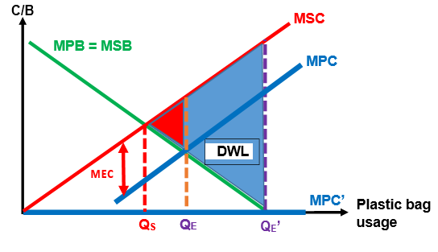
MPB: Convenience of using the plastic bags to carry goods and can be used for other purposes, such as trash bags.

MPC: Price of purchasing the plastic bag (in a free market, there should be a price for plastic bag) and the opportunity costs of using plastic bags

When plastic bags are provided for free, MPC = 0 (assuming no opportunity cost), market output @ QE’ with the DWL shaded in blue, which is greater than before.

- How the presence of waste will cause market failures
- How the free provision of plastic bags causes market failures
- How the charge of 5p will solve the market failures
- Draw diagrams
- Description of diagram

(d) With reference to Extract 3 and any other data, comment on the effectiveness of the solutions proposed by the environmental advocates to reduce consumption of plastic bags in Singapore. [8]

Solutions proposed by environmentalist (Ext 3):
Encourage recycling of plastic bags and use of alternative carrier such as biodegradable or compostable bags for single-use purposes, paper bags for single-use purposes, reusable bags made from low density polyethylene (LDPE) or non-woven polypropylene, and cotton tote bags

Objective: Provide environmentally friendly solution to encourage the public to reuse the plastic bags or/and replace the use of plastic bags with compostable/paper bags/cotton tote bags.

How it works: This will reduce the demand (fall in MPB) for plastic bags due to the availability of alternative carrier bags to substitute plastic bags, causing consumers to switch to these alternatives, effectively reducing the market output to QS.

However, for recycling (‘reused’) of plastic bags, figure 1 shows declining recycling rate in Singapore. Possibly due to poor public education on recycling and weak government effort to encourage recycling.

For paper bags for single-used, figure 2 shows the increase in fresh water consumption due to paper bag production and extract 3 mentions the harm to environment when these paper bags are recycled.

For reusable bags made from LDPE, and cotton tote bags, figure 2 shows the increase in water consumption due to the washing of reusable bags.

Given that water is a scarce resource, especially in Singapore, the increase in water consumption might pose a greater challenge to the Singapore government than the negative externality caused by plastic bags.

Effort to encourage recycling should step up to minimise impact of plastic bag usage on the environment.

(e) Assess the factors the Singapore government should consider when deciding between imposing a ban and a tax on plastic bags. [10]

Synopsis: Adopt the decision-making model to answer this question. As such, the objective of the Singapore government in relation to the issue of over-usage of plastic bags must first be established. The factors to consider in ascertaining which policy works better in Singapore should take into account of the costs and benefits of each policy, constraints faced by the government and unintended consequences of the respective policies, all in Singapore context.

Weigh the costs and benefits of a ban and taxation

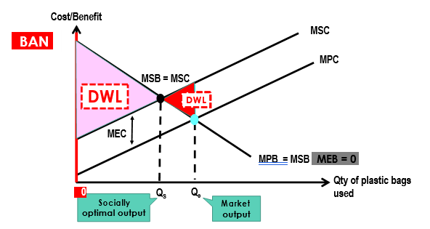

Indirect tax that is equivalent to the MEC will increase the MPC of consumers in the usage of plastic bags, reducing the market level of consumption from Qe to QS.

In this case, the use of ban will create a larger deadweight loss on society and taxation (= MEC) might be a better solution to reduce usage of plastic bags to QS and the tax revenue collected could be diverted to public education on recycling.
(loss of net social benefit gain is greater the DWL)
In this case, the use of a ban might be a better solution due to the large MEC involved and the benefit of its implementation will most likely outweigh the administrative costs involved. The use of taxation in this case would be dependent on the government’s ability to accurately measure the MEC, and would most probably involve some trial and error before socially optimal level of plastic bags usage could be achieved. As such, the size of the MEC will determine whether a ban or taxation is a more appropriate measure.

In Singapore context, the size of MEC is unlikely to be too large as compared to countries that focus on agricultural productions and are dependent on domestic water sources. As such, given a generally low MEC, taxation might be a better solution for Singapore.

Constraints:
Due to the implementation costs of taxation and ban, government’s budget in the implementation of both measures must be considered. For governments with budget constraint, the policy with a relatively higher costs of implementation will incur significant opportunity costs which might undermine the economic development of an economy. Hence, the policy with a lower implementation costs might be chosen. However, given the accumulated surpluses from the Singapore government, funding for its implementation would not be an issue.

Information:
The choice of appropriate policy measure and the amount of taxation required to achieve socially optimal outcome is dependent on the MEC. However, MEC is difficult to measure due to the intangible costs involved which make it difficult to monetise the effects on third party. As such, the ability of Singapore government to accurately measure the value of MEC is paramount to her decision in choosing the policy measure or/and amount of taxation to ensure maximum social welfare.

It is also important to determine the PED of consumers on plastic bags as it would affect the effectiveness of taxation in reducing plastic bag usage. For example, if Singaporeans are not responsive to any price change for plastic bags (inelastic PED – due to habit of using plastic bags when purchasing groceries), the tax imposed will not be effective in reducing plastic bag usage significantly unless the amount of taxation is significantly large.

However, if Singaporean consumers are to behave similarly as UK consumers (extract 2), PED for plastic bags will be price elastic. In this case, taxation will be effective to curb consumption of plastic bags.
Unintended consequences:
Issues of switching to paper bags or reusable bags

Conclusion
In conclusion, the most important factor to consider might be the accuracy of information collected on the monetary value of MEC. If the Singapore government believe that the MEC of plastic bag usage is large, a ban might be an appropriate measure as the benefits of implementation will outweigh any costs involved. However, if the MEC is considered to be low and only refinement to consumers’ consumption habit is needed, a tax might suffice. If Singapore government is to implement a tax on plastic bag usage, consumers’ PED for plastic bag has to be taken into account to ascertain the amount of taxation required to achieve the socially desired level of plastic bag consumption.

