Chapter 2 Elasticity of Demand and Supply

Content Teaching
1. Concept of Cross Elasticity of Demand
2. Factors affecting Cross Elasticity of Demand
3. Concept of Income Elasticity of Demand
4. Factors affecting Income Elasticity of Demand
5. Explain and evaluate how XED and YED can be used to help Starbucks increase Total Revenue.
6. UK Air Travel Market (Explain how change in price and income affect the total revenue)
7. Facets of the Entertainment Industries (explain how the relationship of goods are classified)
8. Jeans – How the value of PED and XED changes

Chapter 2 Elasticity of Demand and Supply

1. Concept of Cross Elasticity of Demand

- Cross elasticity of demand measures the responsiveness of change in quantity demanded as a result of change of price of other goods.

- Formula

2. Factors affecting Cross Elasticity of Demand

2.1 Relationship of the Goods
- The nature of usage of the goods and relation to each other will affect the relationship of the goods.
- If goods are complementary (e.g. Ipod and Beatsä headsets), XED is negative.
- If goods are substitutes (e.g. Asics and Nike shoes), XED is positive.

2.2 Market Classification
- Market classification affects the nature of usage of the goods and relation to each other will affect the relationship of the goods.
- The broader the market classification, the more elastic, the value the cross elasticity of demand.

2.3 Uses of Cross Elasticity of Demand

To Determine the Relationship of Goods
- To assess whether the goods are complementary or substitute in nature and in using these information to devise a suitable marketing strategy.
- Firms can adjust their outputs when faced with a change in rival’s pricing. Same applies for pricing in tandem with complementary product
- Complementary à Bundle sales (e.g. Bread and Kaya)

To Help to Determine the Degree of Competition and Develop Nature of Competition
- By measuring the degree of competition in the industry and assess whether to conduct price strategy or not (the other choice would be to conduct product differentiation through advertising).
- In short run, the firm will conduct extensive price reduction to raise competitiveness in the market but may conduct product differentiation and promotion in the long run to cultivate brand loyalty. This will make the product more price inelastic, allowing the firm to raise price and avoid price competition which is not feasible in long run due to market saturation and profit reduction.
2.4 How to interpret the value of XED to interpret the relationship of the good?
- Complements
- XED is negative
- ↑P_{Y}→↓Q_{X}

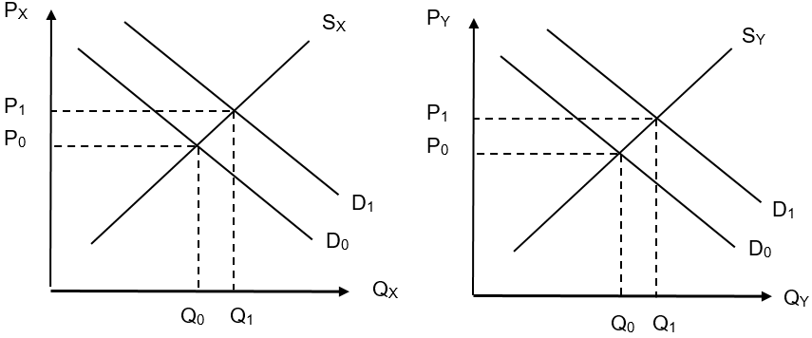
- Substitutes
- XED is positive
- ↑P_{Z}→↑Q_{X}
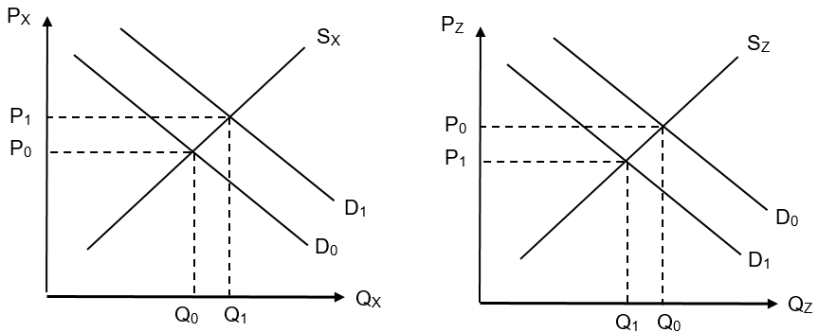

3. Concept of Income Elasticity of Demand

- Income elasticity of demand measures the responsiveness of change in quantity demanded due to a change in the income of the consumer.

- Formula
4.

4. Factors affecting Income Elasticity of Demand
(Value is distorted by social background)

4.1 The Proportion of Income Spent on the Good

- If the proportion of income spent on the good is small, the value of income elasticity of demand will be negative as it is an inferior good implying that the consumer is price insensitive. (Yed is price-inelasticP)
- If the proportion of income spent on the good is large, the value of Yed will be positive as it is a normal or luxury, good implying that the consumer is price sensitive (Yed-elasticP)

4.2 The Price of the Good and the Level of Consumer Income

- The proportion of income spent on the good depends on the price level of the good and the level of the consumer income – average income earners.

4.3 Uses of Income Elasticity of Demand

- Provide information on how the firm can respond in relation to the change in economic growth of the country.
- This will help the firm to understand the types of goods the consumer will want to buy under the current economic condition so that it will improve the efficiency of stock management.
- E.g. In good times, firms should increase production of normal goods with positive YED as consumers are willing to spend on goods which occupies large proportion of income.

- Provide information about the consumer’s degree of price sensitivity and thus help to determine the price strategy.
- As income changes with the economic climate, firms can use the information from YED to derive the appropriate price strategy to maximise profits. For example, the firm can introduce instalment payment plan (e.g. Holiday packages/electrical products) to reduce the portion of income spent on the good so as to reduce its price sensitivity.

5. Explain and evaluate how XED and YED can be used to help Starbucks increase Total Revenue.

5.1 Explain how XED can be used to help Starbucks increase TR
Cross-elasticity of demand (XED) measures the responsiveness of change in quantity demanded of the Starbucks coffee in relation to the change in price of other related goods, either substitutes or complements. This concept is useful as it can help Starbucks in formulating price and marketing strategy in relation to the competitive market.

If the value of the XED with the related good is negative and large, the good is said to be a complement and is highly related. In this situation, Starbucks can conduct joint promotion or bundle sales to raise the demand for Starbucks coffee and other related products which will raise the total revenue for Starbucks.

If the value of XED with the related good is positive and large, the good related to Starbucks is a substitute as the good is in a competitive market. In this case, Starbucks will conduct price reduction in the short run to raise the price competitiveness of Starbucks in this market to prevent the loss of customers when there is intense competition and capture more consumers for Starbucks so as to raise total revenue.

However, in the long run, Starbucks may need to resort to product differentiation through branding and advertising to reduce the market competition, shaping the product to become price-inelastic, which will enable Starbucks to raise price and avoid price competition. This will help Starbucks to raise total revenue despite the presence of a competitive market.

5.2 Explain how YED can be used to help Starbucks increase TR

Income elasticity of demand (YED) measures the responsiveness of change in quantity demanded in relation to the change in the income level. The income elasticity of demand is useful in helping Starbucks on how to conduct their product classification in relation to the change in income which is affected by economic growth. It is also helpful to Starbucks in the formulation of a discount package to increase the total revenue.

As the income elasticity of demand for Starbucks is considered normal or luxury since the proportion in income spent on the good occupies a large proportion of income for most consumers. When income falls due to an economic recession, the demand for normal or luxury goods like Starbucks will decrease. Thus, it is imperative that Starbucks needs to devise an inferior product like regular coffee to suit the demand for inferior goods where there is a fall in income. Starbucks may introduce a discount package for students who are price sensitive since the coffee of Starbucks occupies a large proportion of their income. This will ensure Starbucks can retain their demand and thus sustain the total revenue.

6. The UK air travel market

Extract 4: The rise in flights to visit friends or relatives
In recent years, an increasingly globalised world economy has led to a rise in labour mobility and migration, particularly within Europe. At the same time, there has been a relaxation of regulatory restrictions on aviation markets and this has encouraged increases in flights.

There is a subset of leisure passengers who travel for the purpose of Visiting Friends or Relatives' (VFR). Between 2000 and 2007, whilst total passengers to and from the UK grew by one-third, those travelling for the purpose of VFR increased by over three-quarters, much more than the growth in business and holiday travel.

Looking forward, the current worldwide economic downturn is likely to impact upon VFR traffic, both through falls in UK GDP and changes in migration patterns. For these people, travel for VFR purposes is an indication of the desire to build and maintain relationships. The analysis in this study has been carried out using data which cover a period of significant change in terms of the increase in the number of countries belonging to the EU, the migration flows this has enabled and the liberalization of the EU air travel market (giving rise to more affordable air travel). In the light of these one-off developments, it may not be realistic to assume continued growth of the same magnitude.

Source: UK Civil Aviation Authority Report: International Relations –
The Growth in Air Travel to Visit Friends or Relatives, 2009

Table 1: Estimates of elasticities for flights from UK airports
 | Price elasticities of demand | Income elasticities of demand
Business flights to  UK destinations | n/a | 1.4
Leisure flights to  UK destinations | -1.0 | 1.5
Business flights to  non-UK destinations | n/a | 0.6
Leisure flights to  non-UK destinations | -0.2 | 0.7

n/a = not available
Source: UK Department for Trade, 2009

(a) With reference to the data in Table 1, explain the effect on the total revenue from leisure flights to UK destinations of
(i) a fall in price. [2]
(ii) a rise in income. [2]

(i) As stated in the table, the value of price elasticity of demand is equal to -1. Thus, when the price of the leisure flights to the UK destination decreases, the total revenue remains the same. The fall in the price of the flight leads to a same proportion of increase in quantity demanded of the flight of the ticket, implying that the gain in revenue due to an increase in quantity demanded is the same as the loss in the revenue due to the fall in the price of the flight.
P of flight
Qty of flight

D
100
50

5
10
(ii) As stated in Table 1, the value of income elasticity of demand for the leisure flights to the UK destination is equal to 1.5 which means that it has positive income elasticity of demand and it is a normal good. When there is a rise in income, the proportion of increase in the demand for the ticket is greater than the proportion of increase in income. Therefore, an increase in the demand for the fight leads to an increase in total revenue for the airline as there is an increase in the price and quantity in the flight market.
Price of air ticket
Qty of air ticket
D0
P0
P1
Y0
Y1
D1
S0

7. Facets of the Entertainment Industries

Extract 2: How Hasbro Is Winning the Toy Game
Hasbro, the largest toymaker in the US surprised the market on Tuesday with its second- quarter earnings in just the way that shareholders like to be surprised: Its net revenue (i.e., profits) rose 9%, well outpacing analysts' original 6% estimate.
The more obvious drivers of that growth include the release of the Avengers: Endgame movie which drove sales of the Avengers: Endgame merchandise.
There are also less obvious tailwinds, such as Hasbro’s moves to diversify sourcing away from China in the wake of the US-China trade disputes where both sides had adopted tit-for- tat retaliatory measures. Using non-Chinese sources of raw materials has helped to improve the profit margins.
Source: The Motley Fool, 2019

Extract 3: Netflix’s Movie Blitz Takes Aim at Hollywood’s Heart
Moviegoers may not know Scott Stuber, but he is fast becoming one of the most important – and disruptive – people in the film business. A former Universal Pictures vice chairman, Mr Stuber, 50, is Netflix’s movie chief. His mandate is to make the streaming service’s original film lineup as formidable as its television operation, which received 112 Emmy nominations this year, the most of any network.

Mr. Stuber’s cinematic onslaught is forcing old-line studios that produce movies and multiplex chains that show them to audiences to confront a panic-inducing question: Will the streaming company that prompted many people to cut their cable TV services now cause people to stop going to movie theatres? Having disrupted the television and music businesses, the internet is finally threatening the heart of Hollywood – the movie industry.
Until now, moviedom has been relatively protected from the digital forces that have reshaped the rest of media. Most films still arrive in the same way they have for decades: first in theatres, for an exclusive run of about 90 days, and then in homes. Multiplex chains (e.g., Golden Village in Singapore), have fought off efforts to shorten that period. They worry that people will be reluctant to buy tickets if they can see the same film in their living rooms just a few weeks (or days) later. Netflix mostly bypasses theatres.
Source: The New York Times, 2018

(c) Based on Extracts 2 and 3, compare the likely cross elasticity of demand values between movies and toys, and between movies and Netflix subscriptions. Justify your answer. [4]

Cross elasticity of demand measures the responsiveness of change in quantity demanded as a result of change of price of other goods. The classification of the type of cross elasticity of demand as complementary or substitutes depends on the nature of usage of the goods and relation to each other. if goods are complementary, the value of XED is negative. If goods are substitutes, XED is positive.

In the case of the movies and toys, there are complementary goods as the nature of usage is related to usage as the value of satisfaction from the movie, Avenger Endgame can lead to their needs to have the merchandise. Thus, the decrease in price of the Avenger merchandise leads to the increase in quantity demanded of the movie as the consumers see a related usage as the satisfaction of one good brings satisfaction of another good. This leads to the classification of the value of cross elasticity of demand for movies and toys to be negative and stated as complementary goods for both goods.

As for the movie and Netflix subscriptions, the two types of goods are classified as substitutes as they serve the same usage as the same nature of entertainment but can be purchased in different ways by the consumers. Thus, the price of the Netflix subscription decreases, the increase in quantity demanded for Netflix will lead to fall in demand for the movie. This leads to the classification of the the value of cross elasticity of demand for movies and Netflix to be positive and stated as substitute for both goods.

8. Jeans
The price of a pair of jeans can be as little as S$20 or as much as S$500.

(a) Explain what might cause price elasticity of demand and cross elasticity of demand to be different for different products. [10]
(b) Assess the likely effects of a rise in price of one brand of jeans on the revenue earned by both retailers of that brand of jeans and those who sell other related goods. [15]

