J2 H1 Economics – Final Revision 2019 – Lesson 6

Lessons from Japan and the United States

Table 2: 2016 Selected Economic Indicators
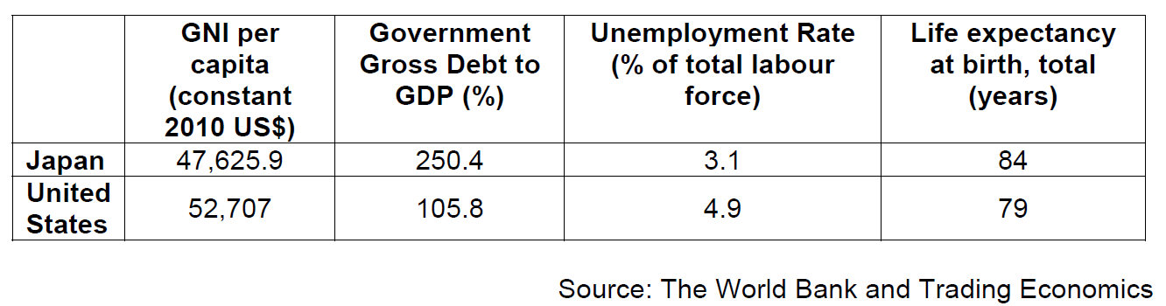
Extract 4: Quantitative Easing Around the World
Central banks use quantitative easing (QE) to inject money into the financial system, hoping to boost business spending and stop inflation from falling too low.

The Bank of Japan’s most recent QE programme began in April 2013, when central bank boss Haruhiko Kuroda promised to unleash a massive QE programme worth $1.4tn (£923bn). It formed part of a set of policies known as Abenomics, which hoped to pull Japan out of the deflation it had long suffered and stimulate the economy. Yet statistics show that Abe's economic policies have not achieved the desired results. Japan's GDP only grew 0.4 percent in 2015. With inflation worryingly low and consumer spending floundering, the Bank of Japan went even further last October, introducing negative interest rates for the first time. The move is designed to encourage commercial banks to use excess reserves they keep with the central bank to lend to businesses.

At the same time, the US Federal Reserve (Fed) was spending only a little more per month at $85bn, compared with $70bn by the Bank of Japan. But the US economy is almost three times the size of Japan’s. As the US economy steadily improved in the aftermath of the Fed’s cash injection, the central bank gradually slowed its bond-buying programme. US unemployment fell sharply after QE started and the US economy proved relatively solid. The economy is forecast to grow 3.6% this year by the International Monetary Fund. In 2016, the US central bank is expected to announce two to three interest rate hikes after it increased rates in December for the first time in nearly a decade.

The Bank of England launched QE in March 2009, announcing £75bn of newly created money to buy bonds, when it also cut interest rates to a new record low of 0.5%. However, the Bank later admitted that the richest 10% of households in Britain had benefited the most from QE. The strategy has been criticised by groups representing savers and pensioners because savings rates, have all fallen.
Adapted from: The Guardian, 2016
Extract 5: Japan's credit rating cut as S&P deals blow to Abenomics' credibility

Standard & Poor's (S&P) downgraded Japan's credit rating by one notch from A+ to AA- as it warned that the country's performance would not be "strong enough" to justify a higher grade. The decision will reignite doubts about the efficacy of Prime Minister's Shinzo Abe's three-pronged package of measures intended to lift the Japanese economy out of deflation.

Dubbed Abenomics, Tokyo's policymakers have sought to fend off weak inflation with a combination of monetary and fiscal stimulus, and supply-side reforms.

But S&P suggested that the much-heralded economic revival had failed to materialise. Its downgrade reflects "our expectations that modest growth and stabilisation of price levels will slow an increase in government indebtedness over the next two years and eventually stabilise it", it said. Japan's rating could be cut further if there was an indication "that the government debt burden could rise more significantly than we currently expect", S&P added.

Source: The Telegraph, 16 September 2015

Extract 6: Reduce long working hours to maintain economic vitality: The Japan News

To maintain economic vitality in society amid a declining population, it is essential to improve the environment so women and elderly people can better exhibit their ability and more actively participate in society. The biggest challenge is to address long working hours. Working hours of regular employees in Japan remain high, at around 2,000 hours a year. The ratio of workers with long working hours is also conspicuously high when compared with Europe and the United States. Current labour practices, under which overtime has become normal, have prevented women - whose time is limited because of child-rearing and nursing care of elderly people - from actively participating in society. This has made it difficult for them to balance their work and family life, which has also become a major factor in the declining birth rate. In moving ahead with work style reforms, it is vital to enhance the productivity of every worker.

Non-regular workers must be helped to develop their competence by improving vocational training programs for them or expanding opportunities for them to pursue continuing education at colleges. The bill to revise the Labour Standards Law has, as its central pillars, proposals introducing an employment pattern under which wages will be decided based on work results rather than by number of hours worked.
Source: The Straits Times, 30 September 2016
Extract 7: What’s wrong with Japan’s Economy

Japan’s economy has been in trouble for decades. Massive monetary and fiscal stimulus have so far failed to spur faster growth. This week, the Bank of Japan meets to decide whether to apply yet more economic shock therapy. Here’s the situation the country’s leaders face:

Table 3
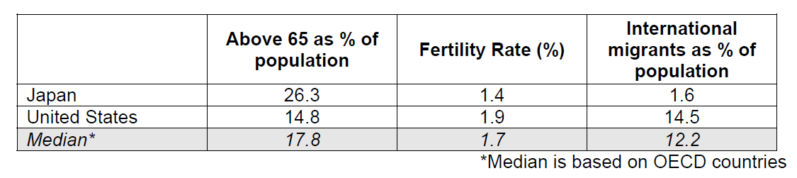

Japan has the world’s oldest population, as well as a low birth rate and little immigration, but its growth problems go far deeper.

With the Japanese unwilling to spend, companies are increasingly investing overseas rather than at home. Wages are stagnant and growth has stayed low, with frequent recessions.

Japan’s debt burden far outstrips that of other countries, largely a result of the stimulus introduced to help fix the economy. Higher debt led the government to consider a sales tax increase for revenue. Abenomics, Prime Minister Shinzo Abe’s rescue plan, which initially relied too much on financial and fiscal measures, has run short of solutions for tackling the structural problems facing Japan's economy. Issues such as an aging population, a weak domestic market and erosion of Japanese firms' competitiveness in the global economic system have not been fundamentally addressed. Given that the real economy has not substantially improved, persisting with monetary easing policies can only be counterproductive. Abenomics has helped to weaken the yen and boost corporate profits but wages and domestic spending have remained fragile.

The monetary stimulus weakened the yen, and until earlier this year exporters felt the benefit but consumer spending hasn’t followed and—with the central bank still far from its 2 percent target—neither has inflation.

The Bank of Japan says it will keep taking whatever action is needed to meet its targets and Abe has pledged “bold” measures this fall. Yet with stimulus failing so far to spur growth, economists and policy makers say broader, more dramatic strategies are needed.

Adapted from: Bloomberg and Guardian, 2016

Questions

(a) Using Table 2, explain why any one indicator might have been a concern to the Japanese government. [2]

(b) Extract 5 mentions that there is a cut in Japan’s credit rating.

(i) Explain why Japanese yen fell in value after the cut in credit rating. [2]

(ii) Using a diagram, explain how this fall in the value of Japanese yen might affect prices of goods and services in Japan. [3]

(c) Using Extract 4, discuss the factors that central banks should consider when deciding whether to extend quantitative easing. [7]

(d) Explain why the Bank of Japan introduces negative interest rates while US’s Fed raises its interest rates. [6]

(e)(i) How is the rate of inflation and standard of living related to each other? [1]

(ii) With reference to the data where relevant, explain and comment on whether Japan will have a higher standard of living than US. [8]

(f) With reference to Extract 7, explain possible reasons why Japanese are unwilling to spend. [4]

(g) Using evidence from the case study and/or your own knowledge, discuss the policy options that Japan could adopt to address its economic challenges. [12]

[Total: 45 marks]

Suggested Answers
(a) Using Table 2, explain why any one indicator might have been a concern to the Japanese government. [2]

Percentage of government debt to GDP is high (twice of that of US) Ext 5, Para 2: Japan's rating could be cut further if there was an indication "that the government debt burden could rise more significantly than we currently expect", S&P added.”

Cut in credit rating investors lose confidence I falls AD falls fall in RNY fall in actual growth

(b) Extract 5 mentions that there is a cut in Japan’s credit rating.
(i) Explain why Japanese yen fell in value after the cut in credit rating. [2]

Extract 2: “The decision will reignite doubts about the efficacy of Prime Minister's Shinzo Abe's three-pronged package of measures”

Cut in credit rating people lose confidence in the currency and sell Yen supply of Yen rises value of Yen falls depreciation

Alternatively, demand for Yen falls as (foreign) investor and business confidence falls

(b)(ii) Using a diagram, explain how this fall in the value of Japanese yen might affect prices of goods and services in Japan. [3]

Depreciation price of exports falls in foreign currency → rise in demand for exports → rise in price and quantity of exports → rise in export revenue

Price of imports rise in Yen → assuming demand for imports is price elastic since there substitutes available quantity falls more than proportionately → fall in import expenditure
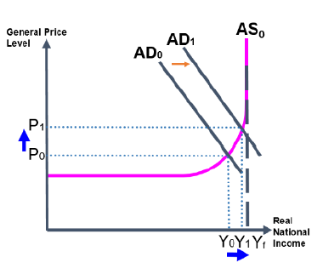
Rise in net exports → rise in AD (diagram) → rise in GPL from P0 to P1 → rise in prices of goods and services in Japan
OR
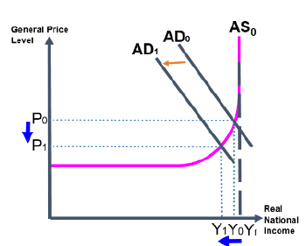
Depreciation rise in price of imported inputs in Yen rise in COP fall in SRAS r ise in GPL from P0 to P1 rise in price of goods and services

(c) Using Extract 4, discuss the factors that central banks should consider when deciding whether to extend quantitative easing. [7]

Introduction
Explain purpose of QE inject money into the financial system i/r falls boost spending C&I rises AD rises boost growth and prevent inflation from being too low

Main Body
Factors to consider
- Benefits: AD rises RNY rises economic growth, fall in unemployment
  - “US unemployment fell sharply after QE started and the US economy proved relatively solid” beneficial for US
- Costs: AD rises rise in GPL demand-pull inflation
- Unintended consequences: With lowered i/r → saving rates fell → disadvantaged pensioners and savers
  - “The strategy has been criticised by groups representing savers and pensioners because savings rates, have all fallen”

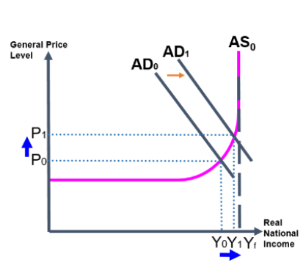

Evaluation
- Which factor is the most important factor and provide reason depending on country
  - E.g. “benefits” as the most important factor – central banks need to consider whether extension of QE will really bring in the intended benefits (whether there has been some results to signal that the policy is a step in the right direction)
  - US has been seeing some results (Extract 4 para 2: US unemployment fell sharply after QE started) vs abysmal results in Japan (Extract 4 para 1: GDP only grew 0.4 percent despite pumping in $1.4 trillion)
  - US can consider extending QE further but Japan might perhaps consider other policies instead of extending QE since the economy does not seem to be responding well
- “costs” as the most impt factor – US has been seeing results after implementing the QE but is afraid that it might result in demand-pull inflation if QE is too extensive (afraid that cost may outweigh the benefits) may want to pull back and not consider extending QE (Extract 4 para 2: In 2016, the US central bank is expected to announce two to three interest rate hikes after it increased rates in December for the first time in nearly a decade)

(d) Explain why the Bank of Japan introduces negative interest rates while US’s Fed raises its interest rates. [6]

Reason(s) why Japan introduces negative interest rates
1) Abenomics unsuccessful in pulling Japan out of deflation
2) “Japan's GDP only grew 0.4 percent in 2015…With inflation worryingly low and consumer spending floundering…” Japan could experience a further contraction in the economy and a deflation if nothing is done

Negative i/r
“encourage commercial banks to use excess reserves they keep with the central bank to lend to businesses.” makes cost of borrowing cheaper rise in investment expenditure rise in AD (diagram) rise in RNY (actual growth) and GPL (inflation)

Reason(s) why US raises its interest rates
“US economy steadily improved… unemployment fell sharply… economy is forecast to grow 3.6% this year” substantial rise in AD rise in GPL inflation

Raise i/r
Cost of borrowing falls C&I falls AD falls GPL falls lower inflation rate ensure price stability
(e)(i) How is the rate of inflation and standard of living related to each other? [1]

Rising inflation rate is inversely related to the standard of living.
OR
Rising inflation due to AD rising will also result in RNY to rise, raising income and purchasing power and thus SOL.

(e)(ii) With reference to the data where relevant, explain and comment on whether Japan will have a higher standard of living than US. [8]

Introduction
- Define SOL

Japan will have a higher SOL than US
- Table 1: Japan’s unemployment rate is lower than US more are employed greater access to goods and services higher material SOL
- Table 1: Japan has a longer life expectancy indicating better healthcare and quality of life higher non-material SOL

Japan will not have a higher SOL than US
- Table 1: GNI per capita is greater for US than Japan greater income accrued to one person in US than Japan Americans are able to buy more goods and services higher material SOL in US than Japan
- Extract 3: “The biggest challenge is to address long working hours. The ratio of workers with long working hours is also conspicuously high when compared with Europe and the United States.” lesser leisure time than in US lower quality of life lower non-material SOL
- Extract 4: Greater percentage of the aged in Japan than US & Lower fertility rates in Japan than US percentage of people contributing to the economy is lower and with little immigration, Japan has to depend on their own population lowers production of goods and services material SOL falls [Up to 5 marks for above]

Comment
- Make a stand which country will have a higher SOL US will have a higher SOL than Japan. Despite Japan having a lower unemployment rate than US, it is not comparable since US’s economy is three times that of Japan (Ext 4). US’s unemployment also fell sharply and economy proved relatively solid after QE (Ext 4) showing that the policy used for US worked and this enabled a rise in RNY and therefore material SOL.
- Data is insufficient to make a conclusion: need other data Although data points to Japan having a lower quality of life due to long working hours, this data on US is not provided as well as other indicators such as level of pollution more data is needed to make a conclusion.
(f) With reference to Extract 7, explain possible reasons why Japanese are unwilling to spend. [4]

Consumer confidence is low C falls or Expectations of future fall in prices C falls

Sales tax hike rise in COP fall in SRAS fall in RNY fall in income fall in purchasing power unwilling to spend

(g) Using evidence from the case study and/or your own knowledge, discuss the policy options that Japan could adopt to address its economic challenges. [12]

Introduction
Identify economic challenges:
- Ageing population
- Declining birth rate
- Deflation
- Few immigrants shortage of workers
- Stagnant wages
- Low growth, frequent recessions
- Weak domestic market
- Higher debt

Main Body
Policy Options to address the various challenges (Explain any 2 policies):

(i) Higher debt
- Raise sales tax Rise in COP fall in SRAS rise in GPL counters deflation
- Limitation reduces RNY slows growth even further

(ii) Stagnant wages (low growth, frequent recessions)
- Revenue from taxes could be used to finance education and training (improving vocational training programs) to improve the productivity of workers raise income
- Productivity of workers increase quality of labour rises LRAS rises actual and potential growth
- Limitation effect takes time

(iii) Weak domestic market
- Fall in direct tax rise in C&I rise in AD rise in actual growth, rise in GPL
- Limitation Fall in revenue since tax rates fall does not help to reduce government debt

(iv) Few immigrants shortage of workers, ageing population
- Encouraging immigration policy rise in quantity of labour rise in LRAS rise in actual and potential growth
- Encourage more women to join the workforce labour reforms increase in quantity of labour
- Limitation: Cultural workforce traditions are rigid limits the effectiveness of this policy

Conclusion
- Most concerning economic challenge: Stagnant wages (+low growth, frequent recessions)
- “Abenomics…which initially relied too much on financial and fiscal measures, has run short of solutions for tackling the structural problems facing Japan's economy. Given that the real economy has not substantially improved, persisting with monetary easing policies can only be counterproductive.” ss-side policies more important
- The policy options may have addressed the economic challenges of Japan but it comes at a cost. Japan has a lot of economic issues that this is inevitable. Therefore, rising sales tax must be accompanied by efforts to restructure the economy – in terms of investing in capital and labour to improve productivity or to attract firms to do so.
  - This will ensure that with the greater income and profits generated from workers and firms respectively, they will be able to contribute greater revenue from paying income and corporate tax.
  - This will then also mean that Japan’s issue of higher debt can be resolved.
  - Simply increasing the sales tax will not be a good option since it only seems to address the problem of higher debt at face value and later on result in consumers spending even lesser, contracting the economy further.
  - The structural issues such as long working hours and difficulty of integrating women in the workforce also contributes to the falling productivity which needs another set of structural reforms and changing mindset of employers, and not just the policy options mentioned above.

