Notes for Reference
1. Demand and Supply
2. Price Elasticity of Demand and Supply
3. Government Regulation

1. Price Ceiling
1.1 Explain the mechanism of Price Ceiling
A maximum price set artificially by the government of firms so that goods are bought and sold at that price level which is below the market equilibrium price level. The purpose in setting the price ceiling is to prevent excessive increase in price so that consumers will not pay a higher price at the market price level which may be controlled by the seller to exploit the consumer. In doing so, the government is trying to allocate goods in a more equitable approach to ensure that there is no unequal distribution of the benefits of the goods especially for scarce resources during a crisis.

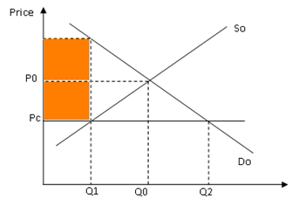

As seen from the diagram, the price is lowered from Po to Pc when there is the imposition of price ceiling and this causes an increase in quantity demanded from Qo to Q2 while the quantity supplied decreases from Qo to Q2. This creates an excess demand condition between Q1 to Q2 that may lead to a rise in black market condition where the price rises from Pc to Pm at the quantity level at Q1.
1.3 Difficulties in imposing price ceiling
- May create an excess demand condition which cannot be resolved if there is no buffer stock.
- may give rise to black market price if the market cannot have excess supply from buffer stock to meet demand
- It contradicts the market principles which will undermine the efficiency of the economy. (shift and costless adjustment of resources)
- The price ceiling may lead to the failure of the business as the fixed price level cannot accommodate the rise in average cost of production
- It undermines the producers as there will be a loss of producer surplus but the consumers will gain as the consumer surplus becomes bigger

2.1 Explain the mechanism of Price Floor
A minimum price is set by the government where the goods are bought and sold at the price level which is above the market equilibrium price level. This is applied to ensure that the producers can sell the goods at a higher level than the market price level so that the resource owner receives a reasonable level of revenue to keep them to continue production

A minimum wage scheme is the same as a floor price to ensure that the workers who are the resource owner for their work can get a certain level of income that enables the workers to cover their cost of living. This enables the workers to maintain their livelihood and have a reasonable level of income to counter inflation which may erode their purchasing power.

2.2 Explain how the price ceiling works

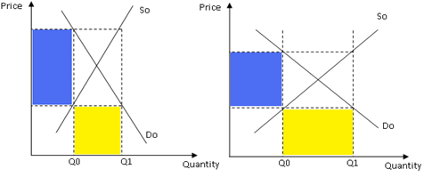

As seen from the diagram, the imposition of the price ceiling set the price at Pf which is above the market price at Po. This leads to a fall in quantity demanded from Q* to Qo while there is an increase in quantity supplied Q* to Q1, creating an excess supply condition at Pm. This means that there is a need to stock up the excess stock and keep as storage and used later. However, stockpiling can only be done if the product is non-perishable and the cost of storage is low.

2.3 Effects of Price floor
- The floor price creates excess supply condition which may require storage to prevent wastage but this causes the government a sum of expenditure to stabilize the price and ensure no wastage of the resources
- The high price may undermine the consumers as this high price reduces the purchasing power of the consumers
- The increase in price may induce the buyer of the resources to buy the cost of resources and this increases the cost of production. As a result, this may lead to price-wage spiral which can lead to inflationary condition

Question for Discussion

Qn. The imposition of floor price on the rice market in Thailand (max 2 pages)
1. some description of this issue by Ying Luck
After Thailand Prime Minister Yingluck Shinawatra gained office in 2011, her government started Thailand’s Rice Pledging Scheme to buy rice from farmers, in order to boost their incomes. This raised prices for unmilled paddy rice from as low as $271 a ton to $500 a ton.

2. How Floor price works
When the Thai government sets a price floor in the rice market, it means implementing a lowest minimum price that rice can be sold for. The rice cannot be sold for a price that is any lower than the price floor. A price floor is usually implemented in agricultural markets when the equilibrium price is too low and the government wants to protect farmers. In addition, the price floor should be set above the equilibrium price, because if it is set below the equilibrium, producers would just sell their output at the equilibrium price.

2.1 mechanism

2.2 draw graph
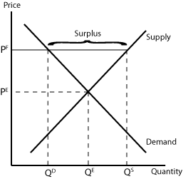

2.3 describe graph

3. Intended impact (benefits to the Thai people)
The intended impact of this price floor policy was to protect farmers from low prices in the rice market as the prices were too low for farmers to support themselves. With the increase in price from PE to PF and quantity from QE to QS, the farmers will enjoy a higher revenue, and increase their standard of living.

4. Unexpected impact
4.1 increase cost of expenditure to government
This increased the cost of expenditure to government as it had to buy over the large surplus of rice in order to maintain the price at PF.

4.2 Feasibility of the floor price
- Other farmers will want to also enjoy this floor price

4.3 exchange rate
When the price of rice increased, the Thai rice lost its price competitiveness in the international market to other exporters of rice such as India and Vietnam. As such, demand for Thai rice fell and exports decreased. In addition, the Thai people also turned to imports of rice from other countries which were cheaper priced, increasing Thailand’s imports. Since Thailand was the world’s largest exporter and fifth largest cultivator of rice in the world, a lower demand for the Thai Baht caused the exchange rate to weaken.

4.4 corruption
There was also the issue of corruption. Millers smuggled rice in from other countries and claimed that it was Thai rice to enjoy the higher domestic price of rice. When the government sold its rice stockpiles at a price lower than the market price, rice traders bought them and then pledged this rice back to the scheme to earn profit from the difference in prices.

4.5 perishability and cost of storage of rice
Since the government had to buy up the surplus of rice, it soon accumulated rice stockpiles. It had to pay a huge amount to preserve the quality of these stockpiles. In addition, there was corruption concerning the quality of rice as well, and the stockpiles contained bad-quality rice that came from neighbouring countries. As such, Thailand was left with millions of tonnes of rotting rice.

4.6 budget strain
This policy put a massive strain on the Thai government’s fiscal budget. It had to continuously channel resources from other sectors of the economy or even dip into its fiscal budget to buy up the surplus and ensure that rice is being sold at the price floor, which left it with less revenue to spend on other sectors of the economy.

4. Subsidy

4.1 Explain the mechanism of Subsidy
- Subsidy is a transfer payment to the producers by the government to lower the price of the good concerned. The effect of this subsidy either raises the consumer benefit or producer benefit, depending on the value of price elasticity of demand
- Specific subsidy causes a parallel shift downwards and to the left.
- Ad valorem subsidy causes a pivoted shift in the clockwise direction.

4.2 Explain how the provision of subsidy affects the consumers and producers
4.2.1 - Diagram

4.2.2 - Description of the diagram

3.2 Indirect Tax (Types of Indirect Tax)

Indirect tax is imposed on the price of the good concerned based on the benefit of consumption where the tax burden is imposed on the seller or buyer.

3.2.1 Explain the mechanism of Specific Tax.
- Graphical Description

- Description of the graph

3.2.2 Explain the mechanism of Ad Valorem tax.

Price of good X
Quantity of good X
S_{tax}
D₀
P_{tax}
Q_{tax}
Q₀
P₀
S₀
Consumer tax burden
Producer tax burden
tax (20%)
Deadweight loss
Description of the graph

3.3.3 Explain the mechanism of Lump Sum Tax.

Price
Quantity
Q₀
MC
ATC₁
AR = DD
ATC₀
MR
P₀
Loss in revenue
t
A lump sum tax will raise the fixed cost of production. This is represented in the diagram above by a parallel upward shift of the ATC curve from ATC0 to ATC1. Price and quantity will remain at the production equilibrium level P0 and Q0 respectively. However, the revenue of the firm is reduced by the amount of shaded area above.

Why do the government impose tax indirect tax?

