J2 H1 Economics – Final Revision 2019 – Lesson 5

Seeking Sustainable Growth:
Short-Term Recovery; Long-Term Challenges

Extract 6: Global Prospects

The global upswing in economic activity is strengthening. Global growth, which in 2016 was the weakest since the global financial crisis at 3.2 percent, is projected to rise to 3.6 percent in 2017 and to 3.7 percent in 2018. Broad-based upward revisions in the euro area, Japan, emerging Asia, emerging Europe, and Russia—where growth outcomes in the first half of 2017 were better than expected—more than offset downward revisions for the United States and the United Kingdom.

But the recovery is not complete: while the baseline outlook is strengthening, growth remains weak in many countries, and inflation is below target in most advanced economies. Commodity exporters, are particularly hard hit as oil prices fall.

The welcome cyclical pickup in global activity provides an ideal window of opportunity to tackle the key policy challenges—namely to boost sustainable output and to build resilience against downside risks.

Source: International Monetary Fund, October 2017

Table 1: Annual real GDP growth (%) in selected countries

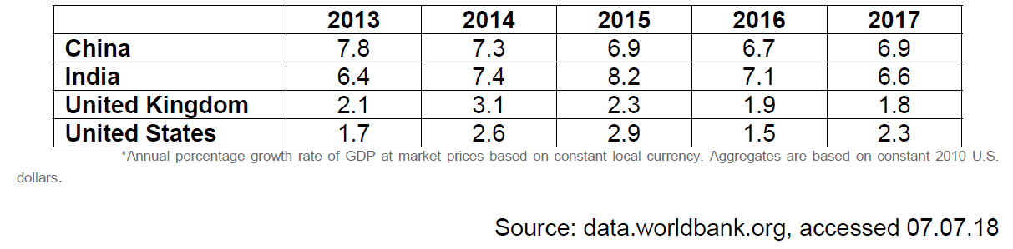

Table 2: Annual population growth (%) in selected countries
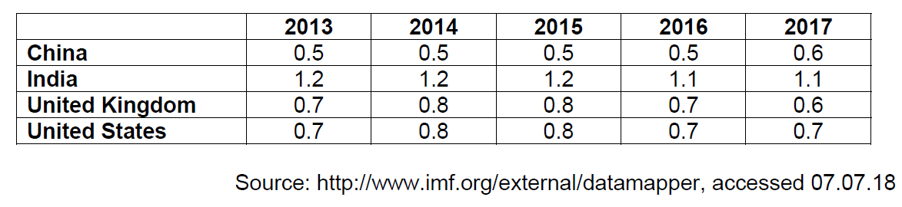

Figure 2: Annual CO₂ Emissions per capita (Metric tons)

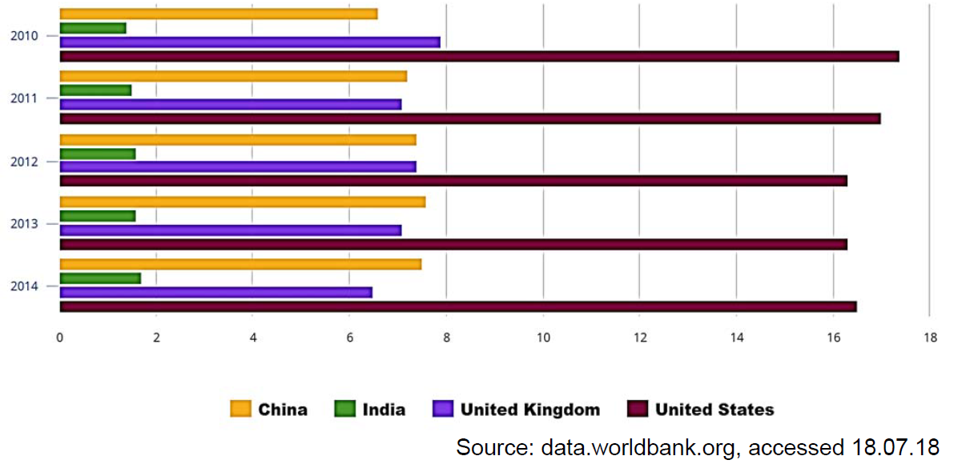

Extract 7: UK economy lags behind after 2017 growth rate cut

Britain’s economy was weaker than previously thought in 2017, official data showed on Thursday, leaving the country lagging further behind the global recovery as it prepares to leave the European Union. Gross domestic product growth slowed to a quarterly 0.4 percent from a previous estimate of 0.5 percent, reducing 2017 growth as a whole to 1.7 percent, its lowest since 2012. However, this was still stronger than most economists feared immediately after Britain voted to leave the EU in June 2016.

But the country has relied heavily on the unexpectedly robust global economy to sustain its economic growth while consumers have been squeezed by higher inflation caused by the fall in the pound after the Brexit vote.

The downgrade of the full-year and fourth-quarter growth rates also raised questions about the strength of the economy as the Bank of England prepares to raise interest rates. Alan Clarke, an economist at Scotiabank, said the figures showed Britain’s economy was growing at roughly the pace the Bank of England sees its new, lower speed limit, meaning a rate hike was still on the cards.

But Samuel Tombs, at Pantheon Macroeconomics, said the data showed the central bank should delay any action for now. “The latest GDP data suggest that the economy remains in a fragile state and does not need to be cooled with another rate rise as soon as May,” he said in a note to clients.

Source: Reuters, 22.02.2018

Extract 8: China's 2017 GDP growth accelerates for first time in seven years

China’s economy grew faster than expected in the fourth quarter of 2017, as an export recovery helped the country post its first annual acceleration in growth in seven years, defying concerns that intensifying curbs on industry and credit would hurt expansion. China’s gross domestic product grew 6.8 percent in the October to December period from a year earlier. That was better than the 6.7 percent growth forecast by analysts

A synchronized improvement in the global economy over the past year, driven in part by a surge in demand for semiconductors and other technology products, has been a good news to China and much of trade-dependent Asia, with Chinese exports in 2017 growing at their quickest pace in four years. Investment by private firms also rose.

The official growth figures released on Thursday are welcome news for Beijing policymakers who are looking to cut debt and pollution in older industries without stunting growth in the world’s second-largest economy. But there could be rising headwinds to further expansion of China’s net exports in 2018.

China’s excess production capacity has emerged as a major trade irritant for the world’s leading economic powers, prompting them to consider new steps to protect domestic industries and jobs from a flood of Chinese imports. U.S. President Donald Trump’s administration is considering several unilateral tariff actions on steel, aluminium and China’s intellectual property practices likely to draw disputes from WTO members.

There were some positive signs in the household sector in 2017, however, with disposable income growth picking up to 7.3 percent from 6.3 percent in 2016, and final consumption playing a bigger role in driving overall growth last year versus investment than in 2016.

Economists also say growth momentum in the economy is likely to weaken as firms face higher borrowing costs, the government tries to rein in credit and policymakers step up a war on pollution that has hurt the industrial sector in many parts of the country.

Source: Reuters, accessed 18.01.2018

Extract 9: The effects of weather-shocks on economic activity: How can countries cope?

Global temperatures have increased at an unprecedented pace over the past 40 years, and significant further warming could occur, depending on our ability to restrain greenhouse gas emissions, of which has been strongly coupled with increasing economic activities. The greenhouse gas emissions that cause climate change are emitted mainly from burning fossil fuels such as coal, oil and natural gas, which is the most important source of greenhouse gas emissions.

The rise in temperature over the past century has been broad based. No country has been spared from the warming of the Earth’s surface, and no country is projected to be spared. Increases in temperature have uneven macroeconomic effects, with adverse consequences concentrated in countries with relatively hot climates, such as most low-income countries. Extreme weather events, such as heat waves, droughts, and floods, are likely to become more frequent, and sea levels will rise, all of which in both the short and medium term, reduces output, suppresses the productivity of workers exposed to heat, slowing investment, and damaging health.

Strategies that reduce specific climate change effects and risks could also be part of the toolkit for reducing the economic damage caused by climate change. Countries negatively affected by climate change will need to increase their resilience to rising temperatures and extreme weather events, both by enhancing their ability to smooth out shocks, which could become more frequent, and by investing in strategies, such as activity diversification, infrastructure investment, and technology innovation, that reduce the harm they do. Populations may also respond to changing climatic conditions by relocating geographically, which could have important cross-border impact. But putting in place the right policies will be particularly difficult in low-income countries, which have huge spending needs and limited ability to mobilize the resources necessary for adaptation in a challenging economic environment.

Source: International Monetary Fund, October 2017

Questions:

(a)(i) Explain what is meant by real GDP per capita. [2]

(ii) With reference to data, compare the likely changes in living standards of China and United States during the period 2013 to 2017 and comment on the validity of the conclusion base on the data given. [7]

(b) Using Extract 6, explain why commodity exporters, are particularly hit hard
as oil prices fall. [3]

(c) Using an AD/AS diagram, explain how the fall in the pound after the Brexit vote could have led to higher inflation in the UK. [5]

(d) Extract 7 suggest that the Bank of England is preparing to raise interest rates as the Britain’s economy recovers.

Explain two possible factors that would affect the Bank of England’s decision to raise the interest rates. [4]

(e) With reference to Extract 9, explain the market failure associated with increasing economic activity. [4]

(f) “The rise in temperature over the past century has been broad based. No country has been spared from the warming of the Earth’s surface, and no country is projected to be spared.”

Discuss the macroeconomic impact of the rise in temperatures on different countries. [8]

(g) Using evidence from the case study and/or your own knowledge, discuss the policies governments can take to boost sustainable growth. [12]

[Total: 45 marks]

Suggested Answers
(a)(i) Explain what is meant by real GDP per capita. [2]

Average output of the economy per person measured in a base year prices/ after adjusted for inflation.

(a)(ii) With reference to data, compare the likely changes in living standards of China and United States during the period 2013 to 2017 and comment on the validity of the conclusion base on the data given. [7]

Both China and US are likely to have experienced an increase material SOL between 2013 to 2017. This is with reference to Table 1 where positive real growth has been achieved by both nations throughout the years. The annual real GDP growth rates are also higher than the annual population growth rate across the years for both countries. When real GDP growth rates are higher than annual population growth rates, it can be estimated that the real GDP per capita has increased.

An increase in real GDP per capita suggests an increase in real purchasing power of the average citizen which increases the ability of one to consume more goods and services to satisfy more wants and improve material SOL. However, given that increase in real GDP per capita is constantly higher than that of US’s, China will experience a faster increase in material SOL for an average citizen.

Extract 8 also reaffirmed the quick rise in material SOL in China as with Chinese exports in 2017 growing at their quickest pace in four years and investment by private firms rising, this suggests expansion in output and rise in demand for labours, reducing unemployment. With higher wages, Chinese citizens are likely to be able to consume more goods and services to satisfy more wants and improve material SOL.

Comments on validity of conclusion on material SOL
The change in real GDP per capita is likely to be an accurate estimate for the change in material SOL. Some limitations however, includes size of hidden economy or rising income inequality.

With large size of hidden economy, real GDP per capita which excludes the hidden economy may underestimate the increase in real GDP per capita and hence the increase in material SOL in both US and China. This however, does not change the outcome of an increase in material SOL for both countries. China is also likely to still experience a higher increase in material SOL compared to US as the difference in real GDP growth rates between the 2 countries is large. It is unlikely for US to have such a large hidden economy for it to actually have a higher real GDP growth per capita compared to China. Hence, the conclusions on material SOL base on the data is likely to be valid.

For non-material standard of living which measures the quality of life including intangible aspects such as pollution levels, access to sanitation and education etc, it can be seen from Fig 2 that US has the highest Annual CO2 Emissions per capita from years 2010 to 2014. This suggests that air pollution is a rising issue in US and could increasingly adversely affect the quality of air for her citizens. High level of externalities could cause third party costs as citizens experience poorer health and higher medical costs, resulting in lower non-material SOL.

There is also a need to consider rising income inequality in China and US. China (0.467 in 2017) has higher rising inequality compared to US (0.415 in 2016). It suggests that the rise in real GDP in China is not equal among her citizens. Hence, even with a higher rise in real GDP per capita, the data is not accurate in reflecting change in MSOL in average citizen.

Comments on validity of conclusion on non-material SOL
On air pollution, concentration of emissions is an important consideration as rising emissions usually leads to increasing MEC on the society. If the contribution of emissions in China is concentration in only a few cities, there rapid fall in non-material SOL with higher MEC incurred. Hence, it’s not sufficient to only consider Annual CO2 Emissions per capita but also its concentration.

Lack of information on other aspects of non-material SOL from data is also another consideration. The data lack information on other aspects such as access to sanitation and leisure time etc. Should China have lower leisure time over the years compared to US, non-material SOL could also be considered to have decreased in China. Hence, conclusion on non-material SOL is inconclusive.

(b) Using Extract 6, explain why commodity exporters, are particularly hit hard as oil prices fall. [3]

Demand for commodities are price inelastic.

Price of oil falls less than proportionate increase in quantity demand for oil

Total revenue of commodity exporters falls thus, they are hit hard

(c) Using an AD/AS diagram, explain how the fall in the pound after the Brexit vote could have led to higher inflation in the UK. [5]

Fall in pound depreciation Rise in price of imported factor inputs in pounds SRAS falls from SRAS0 to SRAS1 GPL increases from P0 to P1

(d) Extract 7 suggest that the Bank of England is preparing to raise interest rates as the Britain’s economy recovers. Explain two possible factors that would affect the Bank of England’s decision to raise the interest rates. [4]

Consideration on conflict between economic growth and inflation. Raising interest rates (contractionary monetary policy) will reduce C and I reduce demand pull inflation but may compromise on actual growth as AD falls.

Limitations of the (contractionary monetary policy) policies such as interest elasticity of demand for investments will affect the choice of contractionary monetary policy as a tool by the Bank of England to tackle the potential inflation problem.

(e) With reference to Extract 9, explain the market failure associated with increasing economic activity. [4]

Increasing economic activity has led to greenhouse gas emissions that cause climate change emitted mainly from burning fossil fuels such as coal, oil and natural gas. This has led to negative externalities due to the over-production of electricity from burning of fossil fuels.

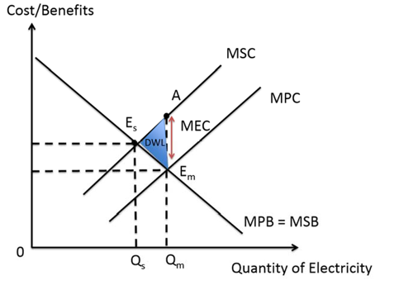

Negative externalities in production which are the external cost borne by others in society who are not directly involved in the production or consumption of electricity. E.g., the production of electricity in coal-fired power plants results in the emission of greenhouse gases such as carbon dioxide, which could lead to higher temperatures, cause the melting of polar ice caps and flooding of low-lying regions.

With negative externalities in production, the marginal social cost (MSC) is higher than the marginal private cost (MPC). Hence the MSC curve is above the MPC curve.

Assuming that there is no positive externality (Figure 3), the marginal private benefit (MPB) equals to marginal social benefit (MSB), hence MPB = MSB.

In the free market, producers only consider the marginal private costs and benefits such as labour costs and other operating costs and the profits from selling electricity. Similarly, consumers only consider the marginal private costs and benefits such as the cost of their electricity bill against the benefit of powering their appliances and electronics. The free market equilibrium is at Em where the equilibrium quantity is at Qm, where MPC =MPB.

However, allocative efficiency occurs at the socially optimal equilibrium where MSB=MSC, such that the socially optimal quantity is at Qs. This is because when MSB<MSC, there is a nett decrease in social welfare from additional production of electricity.

Since Qm is more than Qs, there is an over-production of electricity. The over-production of electricity results in social welfare loss (deadweight loss) of area AEmEs. This is because for QsQm units that are over-produced, the marginal social benefit (MSB) is less than the marginal social cost (MSC) of producing it. Hence the over-allocation of resources into electricity has resulted in a partial market failure and society’s welfare will not be maximized.

(f) “The rise in temperature over the past century has been broad based. No country has been spared from the warming of the Earth’s surface, and no country is projected to be spared.” Discuss the macroeconomic impact of the rise in temperatures on different countries. [8]

Rise in temperatures reduces output, suppresses the productivity of workers exposed to heat, slowing investment, and damaging health. The rise in temperature over the past century has been broad based. Macroeconomic goals of all countries are affected.

Firstly, rise in temperature slows investments. This reduces AD in countries and as AD falls from AD0 to AD1, RNY falls from Yo to Y1, reducing actual economic growth. With fall in actual growth, there could be a fall in demand for workers and a rise in cyclical unemployment results.

Also, productivity of workers exposed to heat are affected as their health are damaged. Health impact could include rise in skin problems and in severe cases, dehydration issues. This has impact both on the SRAS and LRAS of the economies. Fall in productivity results in rise in unit COP as more workers are needed to produce the same level of output. SRAS falls from SRAS0 to SRAS1, with RNY falling from Y0 to Y1 and GPL increasing from P0 to P1, bring potential stagnation problem to the country. LRAS could also fall as potential capacity of the economy falls with fall in quality of labour. Potential economic growth falls.

However, increases in temperature have uneven macroeconomic effects, with adverse consequences concentrated in countries with relatively hot climates, such as most low-income countries. The above arguments are more likely to occur in low-income countries with hot climates as these countries are likely to have large agricultural sectors as key drivers for the economy. Extreme weather events, such as heat waves, droughts, and floods brought about by the climate change will destroy crops and have them to lose their comparative advantage when land resources are altered. As farmers, the workers are more exposed to the change in climatic conditions and hence higher impact on health. AD and AS of these countries are likely to fall by a large extent.

However, strategies that reduce specific climate change effects and risks could also be part of the toolkit for reducing the economic damage caused by climate change. This depends on effectiveness of government policies to increase their resilience to rising temperatures and extreme weather events. If the governments of the low-income countries invest in strategies, such as activity diversification, infrastructure investment, and technology innovation, the government could effectively divert resources from agricultural sectors to the new growth sectors which are less vulnerable to climate changes.

Governments may also invest in green sectors as a potential growth sector to mitigate the risks and yet achieve sustainable economic growth through successful exports of green technology.

In conclusion, highest impact on goals is felt in low-income countries with hot climates as these countries are worse hit by the change in climate conditions and lack resources to implement effective policies to mitigate the risks. That said, this does not mean developed countries are not affected many of them also have strong agricultural sectors. Changes in climatic conditions are not restricted to heat waves but also extreme winter conditions which countries such as Japan and US are vulnerable to. Output and productivity in these countries could similarly be affected.

(g) Using evidence from the case study and/or your own knowledge, discuss the policies governments can take to boost sustainable growth. [12]

Sustainable economic growth means a rate of growth which can be maintained without creating other significant economic problems, especially for future generations.

To achieve higher economic growth, especially in countries such as US, UK as well as commodity exporting countries where growth remains weak, a variety of demand and supply side policies can be adopted.

Explain how UK should continue its expansionary monetary policy by keeping interest rates low (Extract 7)

Low Interest rates encourage C and I and cost of borrowing is kept low firms’ expected profitability increases where consumers’ opportunity cost to spending falls rise in AD actual growth results

However, this may worsen the inflation problem in the economy due to the weaker pound. With final consumption playing a bigger role in driving overall growth in China in 2017, China, similar to UK may also continue to adopt expansionary monetary policy to further encourage increase in C so as to increase AD.

This policy is appropriate as potential unilateral tariff from the US to protect her domestic industries will affect exports of China negatively. To prevent a fall in exports demand which affects China’s growth, transforming the economy to be more internally driven, i,e relying on domestic sectors can avert such risks.

On the other hand, China may consider adopting expansionary monetary policy as her policymakers step up a war on pollution that has hurt the industrial sector in many parts of the country. To achieve sustainable economic growth, China needs to look into curbing the emissions problem in the country. With large agricultural sectors and majority of the country still low-income, rising emissions in the country greatly contributes to extreme weather events and productivity in workers due to the rise in negative externalities generated.

China could adopt expansionary monetary policy to develop sectors on renewable energy. Rise in G on technologies in renewable energy could develop comparative of china in this area leading to rise in investments in the sector. In 2015, China was the largest investor in domestic renewable energy, investing $102bn in 2015. This not only contributes to actual growth in China but also potentially reduce emissions in the country when renewable energy replaces traditional energy sources such as fossil fuels. With fall in MEC, environment improves and sustainable growth results.
However, not every country could engage in the same policy as the country may not have a strong sector in renewable energy. Also, the policy is not a SR policy and could prove to be ineffective in reducing current problems brought by emissions problems. Hence, in the SR, policies to curb negatives externalities must be implemented. For example, in US where annual CO2 emissions per capita is the highest, she may consider the implementation of carbon taxes on firms. Carbon taxes of the size of MEC raises the cost of production for firms and force firms to internalize the MEC in the production. MPC increases to MSC and a socially optimal output of Qs results. The over-production problem is resolved and DWL eliminated. This protects the environment from further deterioration and productivity of workers can be prevented from falling.

As rapid economic growth often incurs costs on the environment, governments need to consider the pacing of growth to avoid rapid deterioration to the environment. Depending on the current economic priority of the government, this then affects the policies the governments can take. In the SR, policies to curb negative externalities are important. In the long run, supply side policies that look into new technology to contribute production without cost on environment is the key to sustainable economic growth.

