CSQ 2010 – Q6 – Demand & Supply
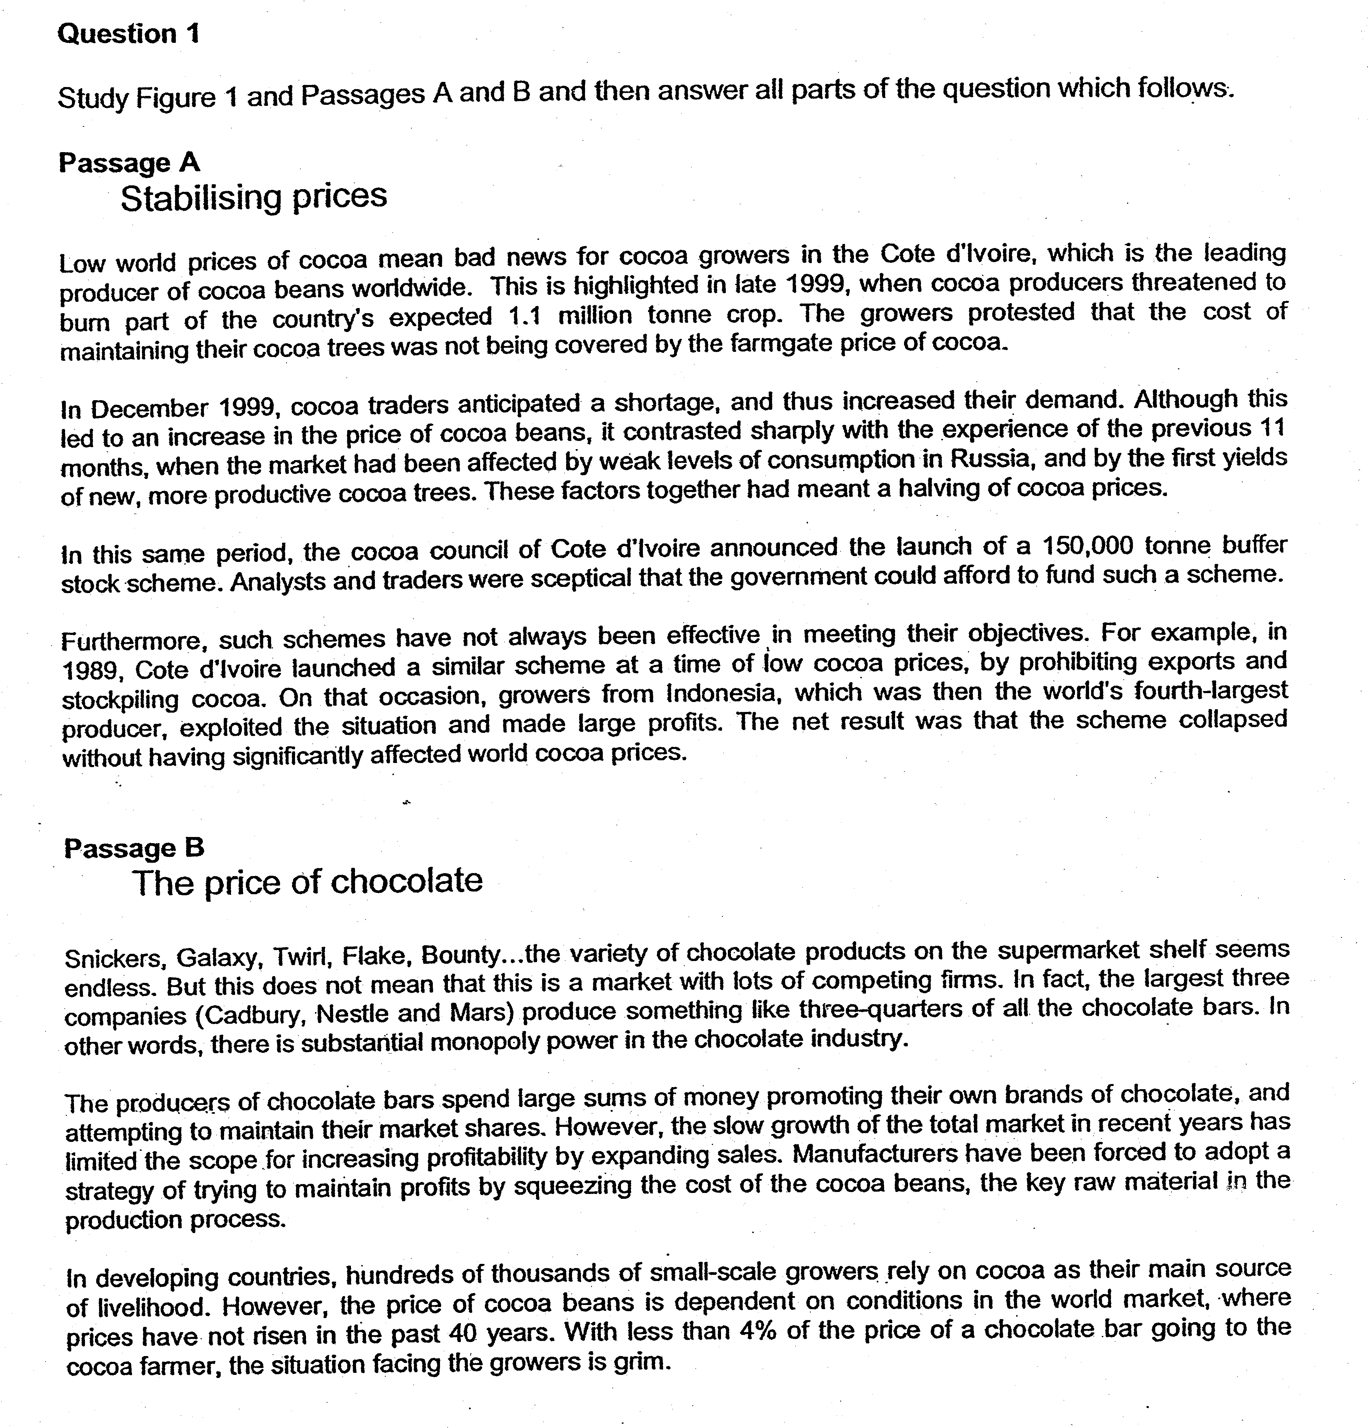

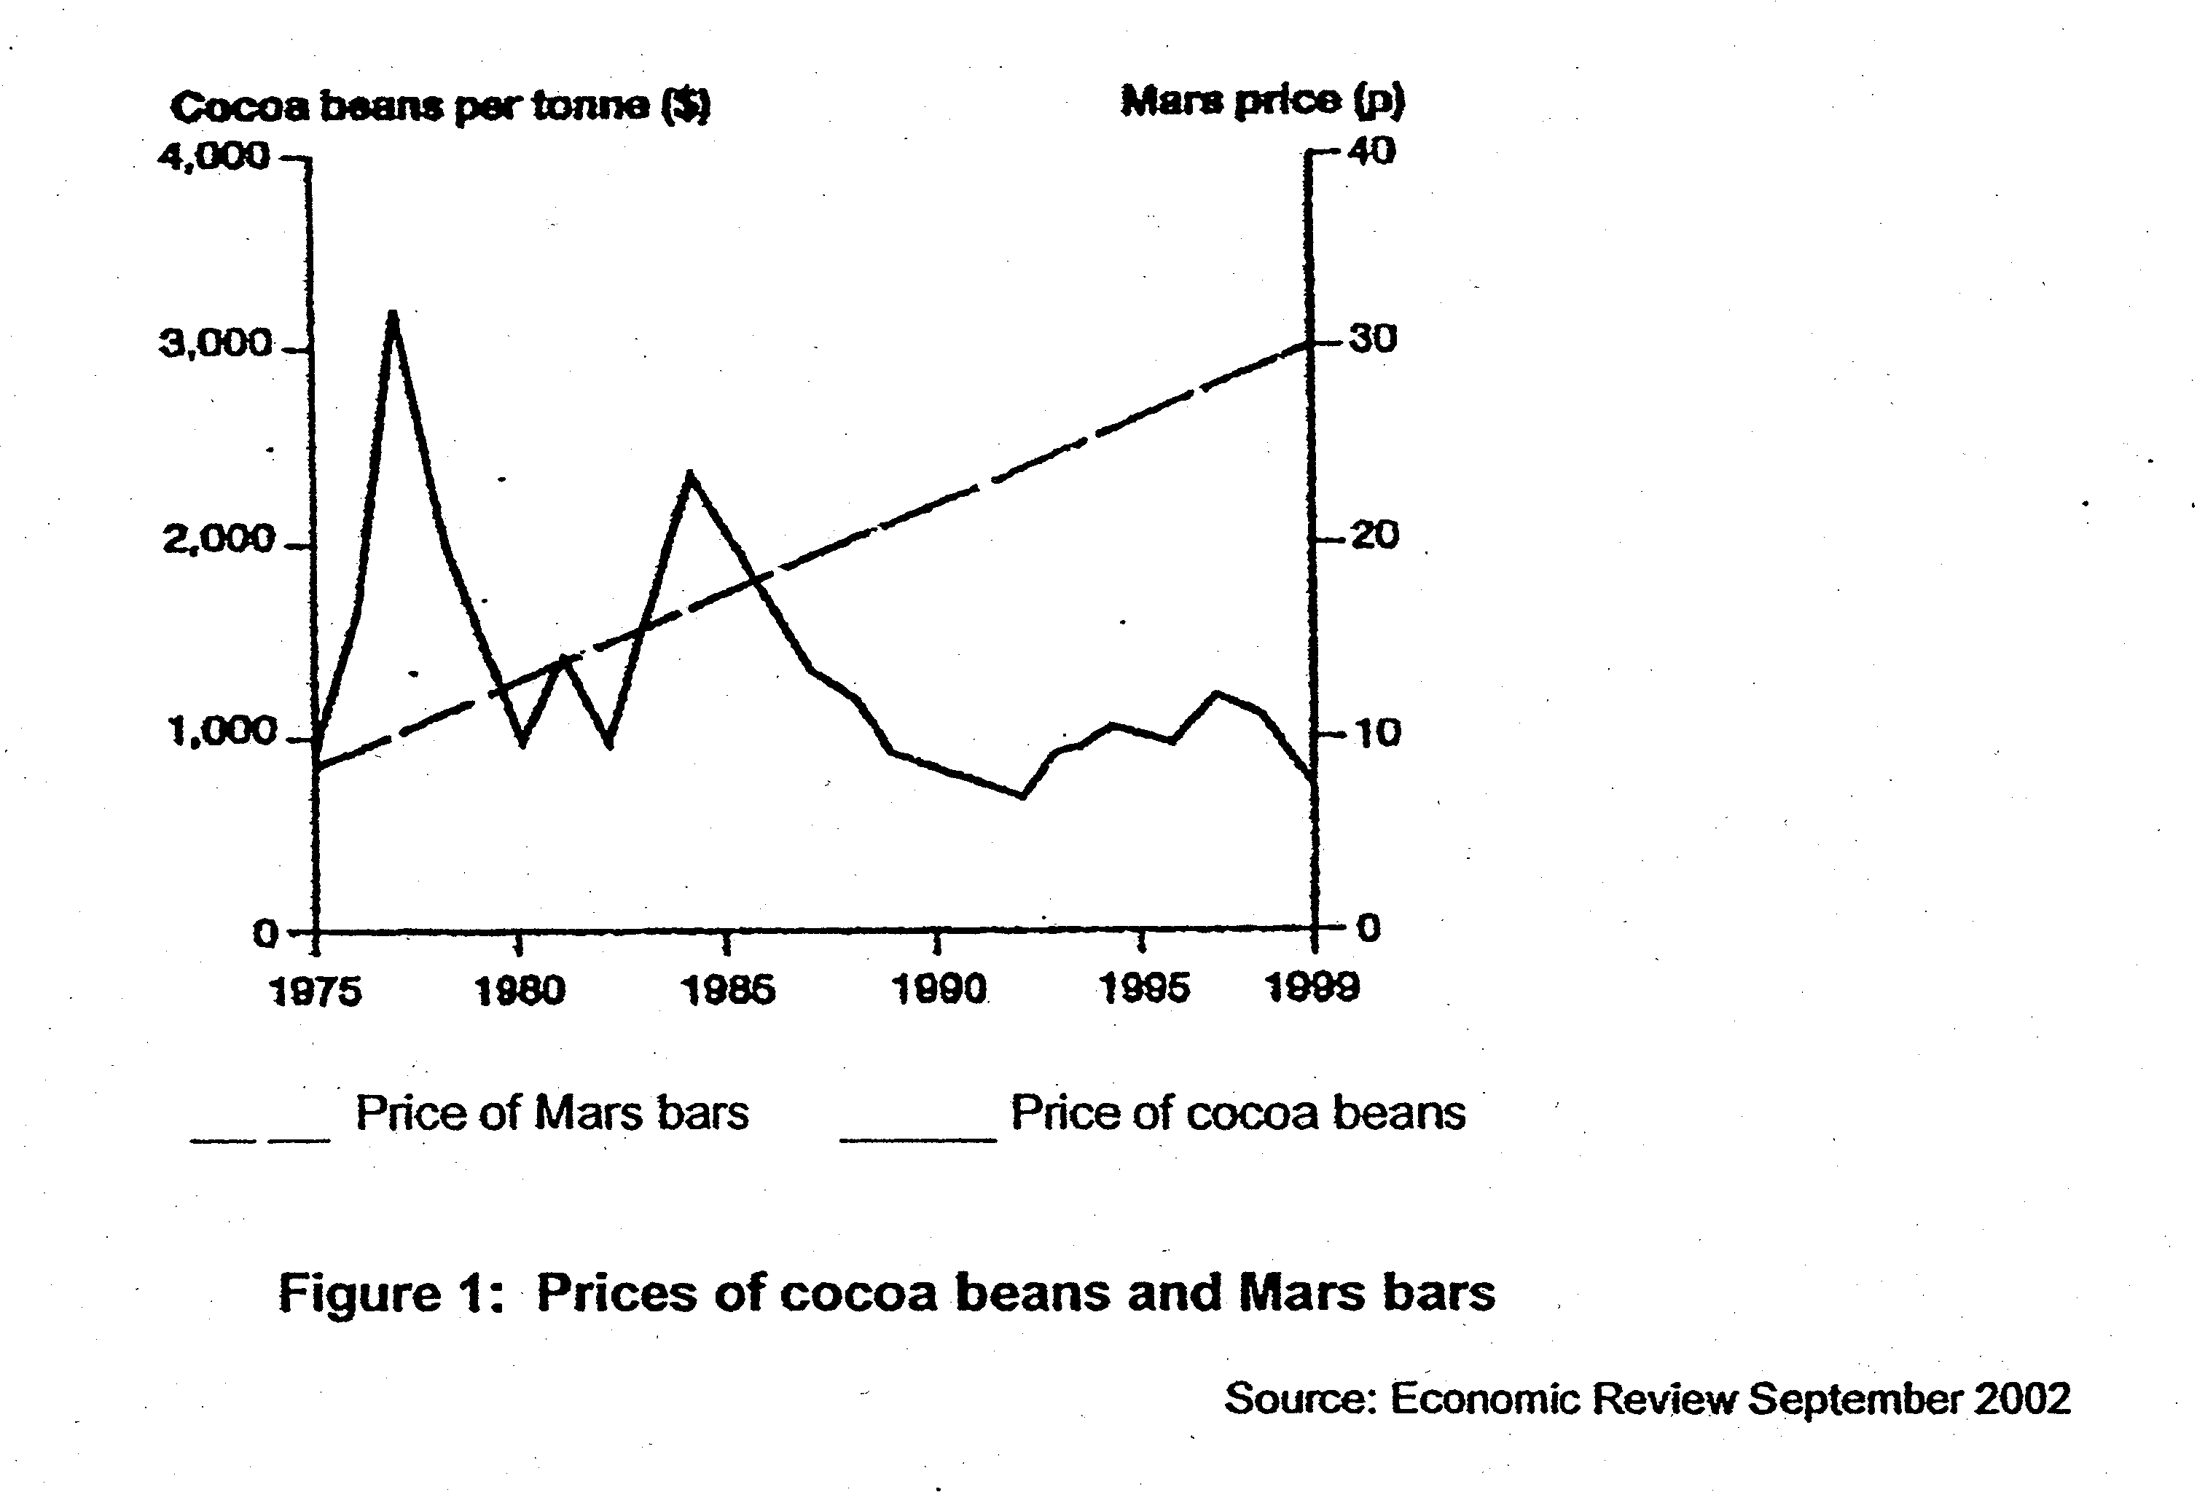

Questions:
(a) (i) Figure 1 shows the price of cocoa beans per tonne, and the price of Mars bars between 1975 and 1999. Compare the trends in the prices of cocoa beans and Mars bars over this period. [2]
(ii) Account for the price trends of mars bars and price of cocoa beans. [4]

(b) In Passage A, there is reference to the changes in the price of cocoa beans during 1999, and a proposed scheme to stabilise the price of cocoa beans.

(i) With appropriate supply and demand diagrams, explain the fall in the price of cocoa beans during the first 11 months of 1999. [4]
(ii) With reference to the information in the passage, comment on the need to stablise the price of cocoa beans. [4]

(c) Explain and evaluate the use of floor price in aiding the stabilising of price in the cocoa bean market. [6]

