Promotional Prep – Lesson 1

Type II – CSQ Test Question

Car population and pollution

Extract 1: Road pricing makes good economic sense. But voters hate it

Britain’s sclerotic roads learned that the recent global financial catastrophe had slightly improved their lives: traffic volume has fallen by about 3% since the start of the recessions. But the Confederation of British Industry (CBI), warned drivers that it would not last: traffic has risen remorselessly and a return to growth seems inevitable as the economy recovers. Congestion does more than irritate drivers. It makes employees and deliveries late, it snarls up modern “just-in-time” supply chains and it clogs up labour markets by making commuting difficult. The cost of all this is almost impossible to measure. But a big review of transport put the cost between £7 billion and £8 billion a year.

To fix the problem, the CBI offers a couple of ideas. First, it wants to see more flexible working, with employees staying at home or staggering their hours, spreading the traffic load over more hours in the day. Second, it wants to see more money spent on building new roads and widening existing ones. Third, it wants to encourage better use of existing roads. All these will help, but at best they merely chip at the edges of the problem. The CBI's big idea is to match supply with demand using a system of nationwide road tolling. To economists the case for road charging is simple. The problem is not a lack of capacity, but a failure to allocate it properly. A system of charges would be fairer than the current means of paying for roads from a mixture of fuel duties and general tax revenue. For the politicians, though, road charging is lethal. The public's first suspicion is that pricing would be just another tax, an interpretation that would seem plausible with today's eye-watering budget deficits.

Source: The Economist, 15 March 2010
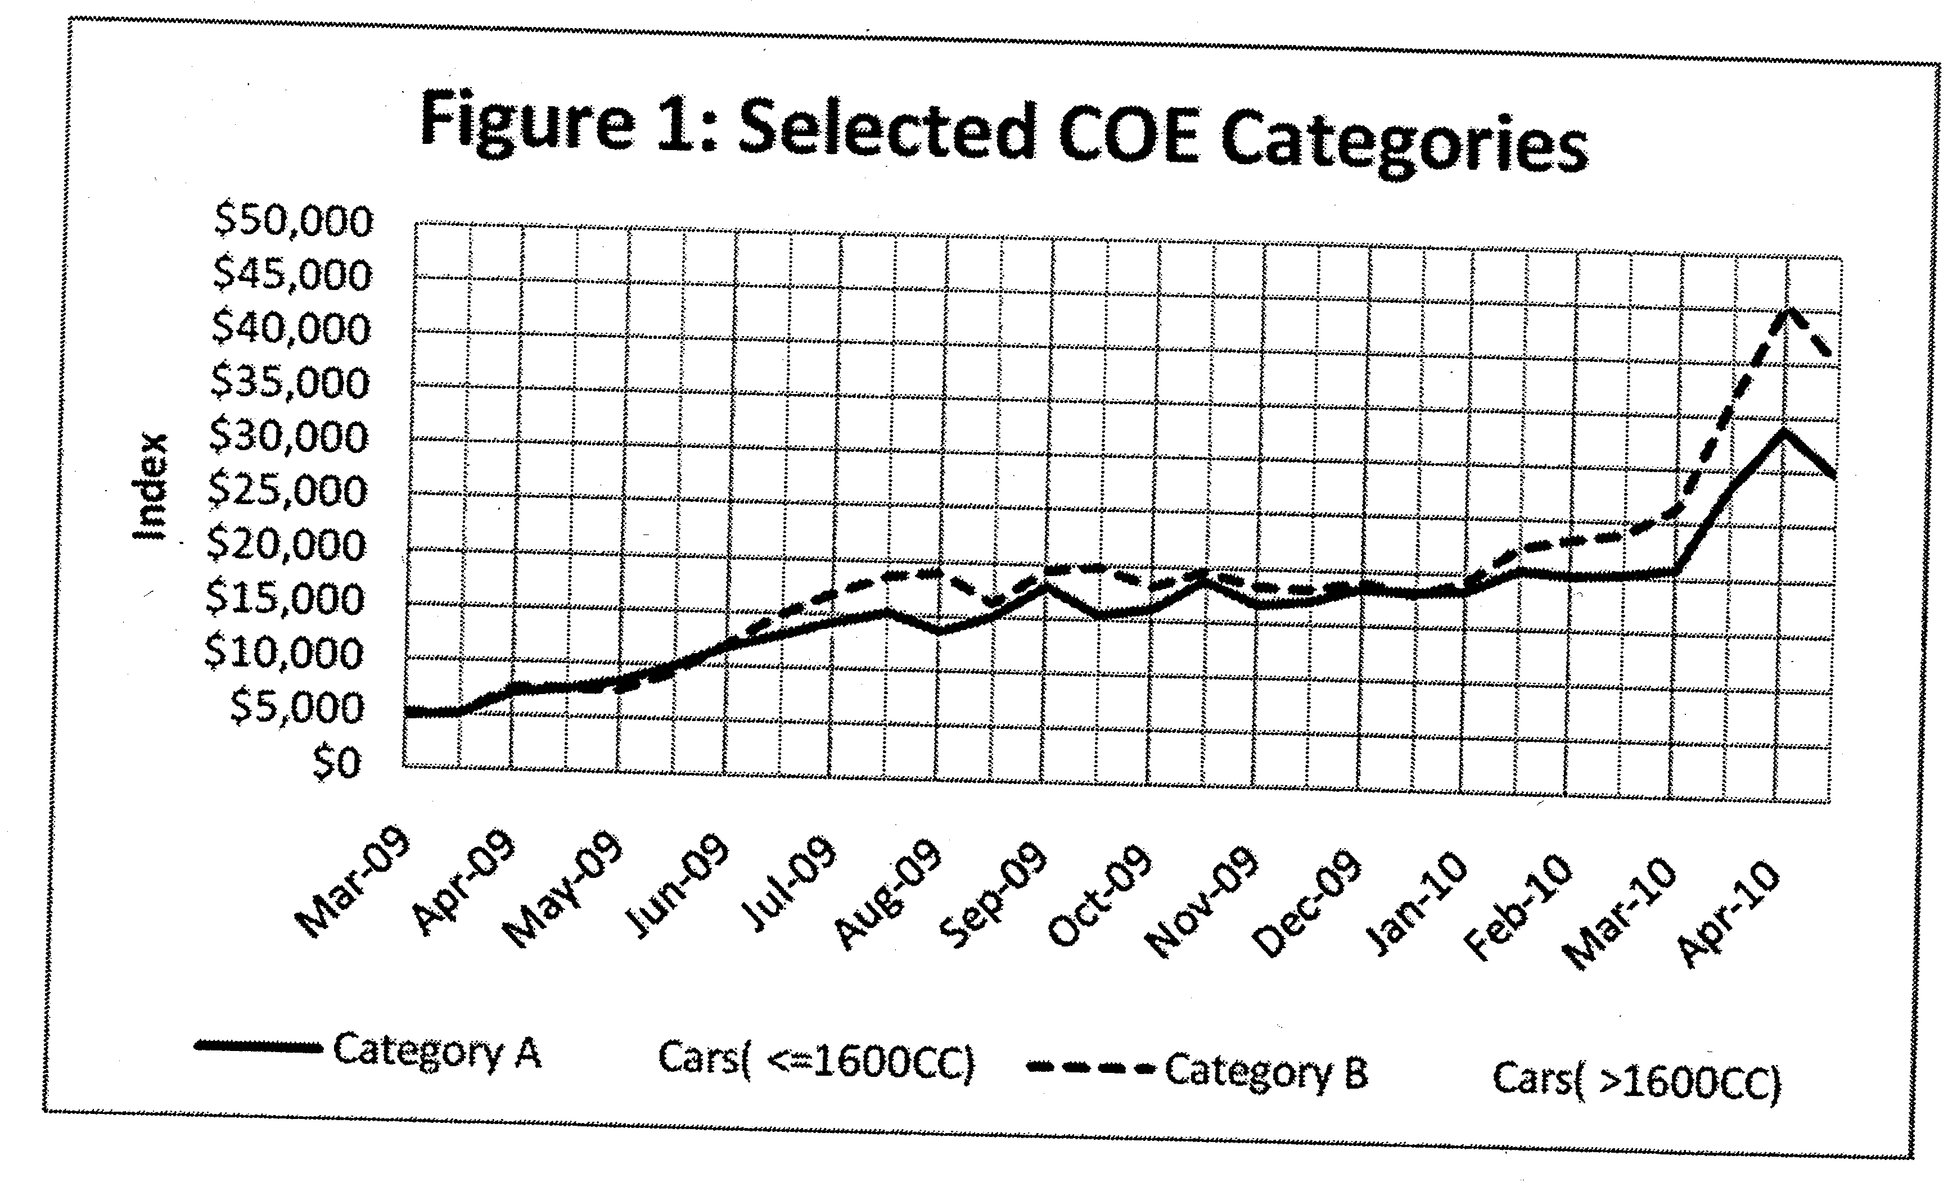
Source: Land Transport Authority, Singapore

Extract 2: Panic over likely quota cut sends COE prices north

Premium for commercial vehicles hits 10-year high. Making a dash before a foreseeable and sizeable cut in quota size next month, bidders sent certificate of entitlement (COE) premiums higher across the board again yesterday.

Motor traders said the anticipation of a reduction in COE supply from next month was the main cause of yesterday's price spikes. The number of bids submitted rose by only 6.5 per cent to 4,753, a sign that sales in hand had not risen by much since two weeks ago. Motor traders said the premium increase in COE for cars up to 1,600cc remained modest because bidders in this segment typically have thinner margins. Rising demand from businesses on the back of an improving economy drove the commercial vehicle premium to its highest level in a decade.

Source: The Straits Times, 11 March 2010

Extract 3: COE, ERP and the question in between

It is not often that Singaporeans hear of differences in opinion within the highest ranks of Government, but there was a hint last week. Senior Minister Goh Chok Tong was at a dialogue with Marine Parade residents when he revealed an interesting divide over transport policy. He said Minister Mentor Lee Kuan Yew was in favour of making car ownership very expensive so that fewer people would own cars hence, leading to less congestion on the roads. Prime Minister Lee Hsien Loong, on the other hand, wanted more people to be able to own cars and to control congestion by applying more stringent usage measures like Electronic Road Pricing (ERP).

The PM believes it's fairer if you can spread car ownership. Philosophically, the PM is right. In a practical sense, the MM is right,' he said. 'But then the problem is, the middle class can't own cars, only the rich can. So the PM is right philosophically, and I think it's the fairer approach. But then, more road congestion, and so ERP.'

It has always been a tricky balance, getting the right mix of ownership and usage measures to work, to ensure not just free-flowing traffic but also meet the growing aspiration of people to have their own set of wheels. Which is the more effective method for Singapore? Which is the fairer? Is it possible to be both effective and fair? This is not just a matter of transport policy. It is also highly political nature, especially when questions of fairness are raised. Or to put it bluntly, as SM Goh did, should only the rich be able to own cars? You cannot get more political than that.

Source: The Straits Times, 5 September 2008

Extract 4: Centre mulls over pollution permits

In what could be the first step towards a market-based system of pollution permits, the government plans to roll out a Rs.500-crore online pollution monitoring system across 6,000 industrial sites across the country. The Central Pollution Control Board (CPCB) has been asked to prepare a national action plan for online pollution monitoring based on the model being implemented in Tamil Nadu, according to Union Minister of State for Environment and Forests Jairam Ramesh.

The Tamil Nadu Pollution Control Board launched its Care Air Centre last month to assess real time emissions from factories in the Manali industrial area. Censors have been put in place in the smokestacks, as well as to measure the ambient air around nine plants at Manali, to measure the levels of sulphur dioxide and nitrogen dioxide. The data is transmitted every ten seconds to the Care Air Centre. Mr. Ramesh said that while the system would cover 202 sites in Tamil Nadu by the end of the year, it will be expanded across the country to cover the entire organised industrial sector. It is still being debated who will pay the Rs. 500 crore cost of setting up the system.

However, this system could then be used to power a system of pollution permits, the Minister said. "An inspection-based system is simply not sustainable," said Mr. Ramesh. "If we think we're going to create more and more laws, and put in more and more inspectors on the field and expect companies to comply, it's just not going to happen. In my view, a market-based system is the only solution in the long run."

Michael Greenstone, an Economics professor at the Massachusetts Institute of Technology, suggested that giving companies permits for allowable amounts of pollution and allowing them to trade it would result in much larger reductions at much lower costs. "Since some industries face much higher costs of reducing pollution, they can buy pollution permits in the market from other industries that have a lower cost," he said.

Source: The Hindu, New Delhi, 24 July 2010
Questions
(a) (i) Using Figure 1, compare the trend of COE prices for Category A and Category B between June 2009 and April 2010. [2]

(ii) With the help of a diagram, explain the impact of the imposition of COE on the price of cars. [4]

(b) With reference to Extract 1, using economic analysis, comment on how traffic congestion affects the allocation of resources within Singapore. [6]

(c) With reference to the data where appropriate, assess the effectiveness of the different policies implemented to solve the problem of traffic congestion and the possibility of government failure in implementing these policies. [10]

(d) With reference to Extract 4, discuss whether Singapore should adopt Michael Greenstone's suggestion to address pollution. [8]

