June Intensive Revision

Market Failures (Type II) – Q2

Ensuring Smooth Flowing Roads

Chart 1 Public Bus Fleet/ millions person (2006)
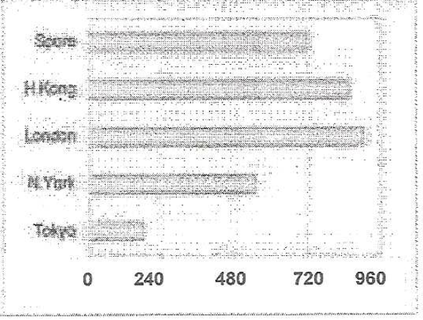
Source: Ministry of Transport, Singapore
Chart 2
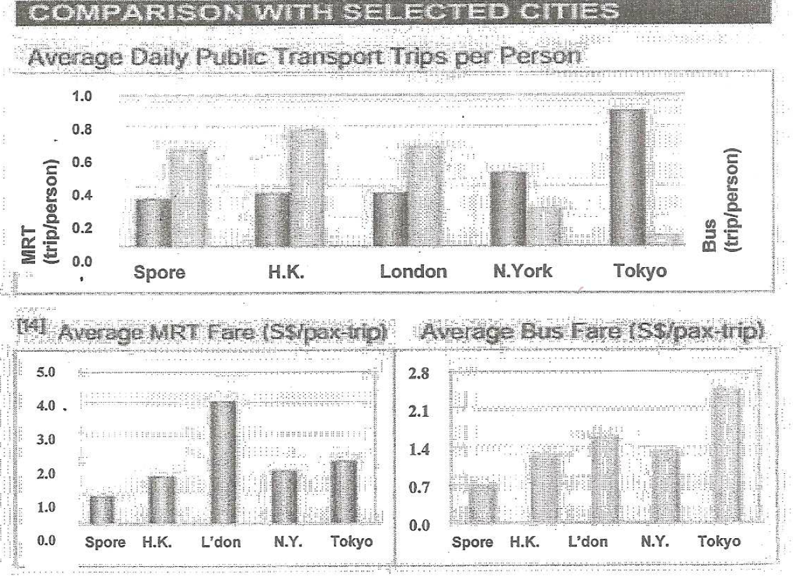
Note: The MRT system is-compared with MTR in Hong Kong, London Tube, Subways in New York City and Tokyo. Figures are for year 2005, converted to Singapore dollars using average exchange rate in year 2005.
Source: Ministry of Transport, Singapore

Extract 1
Increasing road capacity and deploying traffic engineering measures will not in themselves guarantee smooth flowing roads. Additional lanes and new roads attract more traffic and congestion soon returns.

The insatiable appetite for more cars has led to an uphill battle against gridlock in many cities. In fast growing economies like China, the car population grows at more than 20% a year and peak-hour traffic in mega-cities like Beijing and Shanghai crawls at 5km an hour. In the United States, motorists spent more than 4.2 billion hours stuck in jams, enough time to use up enough extra fuel to fill 58 super tankers. The "congestion invoice" in the US stands at some S78 billion each year while congestion costs are estimated to be about 1% of GDP in European countries such as Britain and France.

Singaporeans desire to own cars and policies like the use of Electronic Road Pricing (ERP) to manage traffic have made it possible for many Singaporeans to do so. The vehicle population has grown steadily to the 850,000 vehicles today. With rising affluence, not only are more Singaporeans owning cars, they are also using them more intensively. While the number of cars increased by 10% between 1997 and 2004, the number of car trips increased by 23%. Congestion levels have increased by about 25% since 1999, with more roads congested during the peak hours.

The reality of Singapore's situation is that it is a compact city state with 12% of its land already used up for roads. While roads continue to be built, the pace of road expansion will slow down from 1% a year over the last 15 years, to 0.5% a year over the next 15 years.

Extract 2
There are three inescapable conclusions:
- As more Singaporeans own cars, it is clearly not possible for all of them to drive their cars to and from work every day.
- The more cars Singaporeans own, the more extensive ERP coverage and the higher the charges would have to be.
- Even with more extensive ERP, the current vehicle growth rate of 3% is not sustainable, given the already large vehicle population and the slowdown in road growth. The vehicle population growth rate will be decreased from the current 3% to 1.5% from May 2009.

These are not easy issues but there is a need to act decisively to manage car growth and usage to ensure that Singaporeans will continue to enjoy a quality living environment. The bus priority measures such as bus lanes to be implemented by June 2008 will help reduce waiting and journey times. In addition, we will (i) increase frequencies of basic bus services, including feeder services; (ii) allow basic bus services to duplicate parts of the rail network and (iii) expand premium bus services to provide more choices.

Frequency and capacity of our trains will also be improved for a more comfortable ride and a reduction in waiting time by about 10-15% during peak hours. The rail industry will also be strengthened to enhance efficiency and cost competitiveness. There are currently two rail operators and this enables the regulator to benchmark the operators against each other in terms of service standards and cost efficiency. There have been suggestions to merge the separate rail operations to reap greater economies of scale. Others see value in retaining the existing structure. A key step-in enhancing contestability is to have shorter operating licenses, say 10 to 15 years, compared to the existing 30-year license periods. This policy does not increase the number of operators but the existing ones are subjected to renewals of their licences. A new operator may take over the existing one(s), if the latter does not perform according to government's standards.

Besides vastly improving public transport, the ERP system will also need to be enhanced. Many other cities such as London and Stockholm are coming to the same conclusion that there is no choice but to introduce congestion charging on heavily used roads. Without ERP, Singaporeans would be spending many hours in traffic snarls, just like people in Tokyo, Los Angeles and many other US cities, who pay for congestion with the time that they have lost, stuck in traffic gridlock.

Our ERP system has served us well, but it is coming under strain. We often hear feedback that ERP has not helped to ease congestion on the highest demand roads like the CTE beyond a temporary respite; that ERP rate increases have little impact on travel behaviour; and that even though people pay ERP, they still face congestion on priced roads. There is some truth in this. The reason is that rising affluence has led to a greater propensity to drive which in turn has caused a dramatic rise in traffic volumes; so much so that the scale and intensity of traffic congestion today is far different from what it was a decade ago. Increasingly, given the more pervasive congestion today, the emphasis must be on encouraging motorists to shift to public transport, rather than drive on alternative roads to their destination. This is why the Government is spending billions of dollars to improve our public transport system to make it a viable alternative to the car.

Source: Adapted from Speech by Mr. Raymond Lim, Minister for Transport, 18 Jan 2008 and 30 Jan 2008

Questions:
- Using demand and supply analysis, explain why road congestion will worsen in Singapore. [4]

  - Explain the type of externality mentioned in Extract 1.[2]

  - Explain why congestion may be viewed as a source of market failure. [4]

- With reference to the data, account for the difference in public transport ridership in Singapore and Tokyo. [4]

- Evaluate the effectiveness of only using electronic road pricing as a means of controlling congestion levels on existing roads. [8]

  - Is public transport a public good? (2)

  - The government should intervene in the provision of public transport. Do you agree? [6]
[Total: 30m]

