H1 Economics 2018 – CSQ – Demand and Supply & Market Failures – Q1

Future of Public Libraries
DWL for merit good – seen from the external benefit that society fails to reap
Extract 5: The economic value of public libraries (external benefit)
The economic contributions of public libraries are twofold – direct and indirect. The direct economic contribution that public libraries can make includes educational benefits and improved wellbeing for individuals from reading. On the other hand, there are wider educational and social impact of libraries. Public libraries can contribute to long term processes of human capital formation and social cohesion of communities.
Source: Information Today,
Europe, 5 June 2014
Extract 6: Libraries are changing
As technology advances into every aspect of modern life, traditional public libraries are experiencing a major shift, from being housed strictly in buildings and having physical books, to moving onto the internet. There are four main ways by which libraries are changing:
Problems in providing free merit good
Libraries are being shaped by fiscal budget cuts - Public libraries have continued to struggle in many countries, like in US, particularly since the 2008 Global Financial Crisis. In many cases, governments have scaled back on the opening of new branches and library services so that the money could be used for alternative purposes. And yet, during the recession, more people rely on libraries for entertainment, employment opportunities, and as a resource for internet access.

In fact, the public library saw a rise in the loans for the books about technical knowledge to upgrade and how to better write resumes to find jobs. Computer terminals were constantly used to search for jobs available.

Libraries are becoming technological hub - As the internet becomes the main means to obtain information, public libraries are transforming themselves from mere physical buildings into technological spaces. When looking at technology use in public libraries, researchers have found that patrons are increasingly thinking of libraries as community spaces that allow access to technology and as a source of digital literacy for various demographics.

Expanded access through information sharing - Digital Libraries provide useful interactions between information and users - easing the global dissemination of information. Information sharing has the power to bolster educational equality across the world. For instance, the United Nations Educational, Scientific and Cultural Organization’s (UNESCO) “Information for All Programme” (IFAP) is providing access to over 25,000 titles and is equipped with on-line connections to a worldwide network of libraries.( demand and supply factors)
Printed books still dominate reading despite the growth of e-books - The popularity of electronic books (e-books) is rising, but printed books remain the foundation of many people’s reading habits. The number of e-book users is growing, but, surprisingly, not to the extent that e- books have replaced printed versions. This trend is expected to change as e-reader ownership expands, but the love affair with an actual book is not expected to vanish completely. Nothing quite compares to the smell of a book.
Source: The Global Citizen Organization, 15 January 2015
Figure 1: Government Subsidy for Public Libraries in Singapore (SGD)
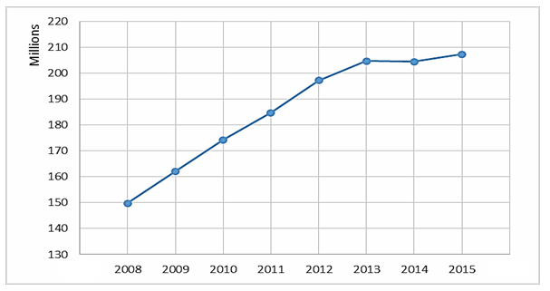

Source: National Library Board, Singapore

Extract 7: Singapore redesigning library spaces
National Library Board (NLB) of Singapore had been redesigning library spaces where books, programmes and cafés co-existed to create a seamless learning environment for library users. NLB also introduced a digital library to make learning borderless. At Pixel Labs at Jurong Regional Library, a “tinkering lab”, visitors use the facilities for free and are allowed to take home the 3D models they make. Launched last year by NLB and Infocomm Media Development Authority (IMDA), the lab is the first such dedicated venue in a library for exploring new technologies.

At Woodlands Regional Library and Bedok Library, seniors aged 50 and above can sign up for digital media courses run by librarians from the library board. The courses teach basic computing skills, as well as how to access the board's e-resources and e-books. Seniors also learn the functions of mobile devices such as iPads and popular apps such as Facebook. The affordable course fee ranges from $4 to $10. For early childhood educator Tavana Zulliani-Ramachandra, 60, who signed up for several digital media courses at the Woodlands Regional Library and Bedok Library, from an e-entertainment course, she was really happy to learn to book air tickets and overseas accommodation online and learn how to connect with her grandchildren with WhatsApp.
In 2014, smart work centres or flexible mobile workstations were launched at Jurong Regional Library, Toa Payoh Library and Geylang East Library. Next year, another centre will come up at the revamped Tampines Regional Library. These come with a whole suite of business functions and resources such as Wi-Fi, meeting rooms and high-definition video-conferencing services. Ms Catherine Lau, assistant chief executive of public library services, says the library board has been moving away from a cookie-cutter approach to make sure each library caters to its community.
Source: The Straits Times, 20 November 2016
Questions
(a)(i) Explain the two characteristics of a public good. [2]

(a)(ii) Explain why public library is not a public good. [2]

(b) Extract 6 mentions that “the number of e-book users is growing, but, surprisingly, not to the extent that e-books have replaced printed versions”.

With the help of a demand and supply diagram, explain the extent of change in the equilibrium quantity of the printed books in these circumstances. [4]

(c)(i) With reference to Extract 5, use a PPC diagram to explain how public libraries can affect long-term economic growth of a country. [2]

d) Discuss the view that direct provision of public library is a better solution than subsidy for public library. (10)

(e)(i) With reference to Figure 1, summarise the trend of subsidies for public libraries in Singapore over the period 2008-2015. [2]

(e)(ii) Discuss the view that a government should allocate more resources to public libraries to bring about a more efficient allocation of resources. [8]

[Total: 30]

Suggested Answers
(a)(i) Explain the two characteristics of a public good. [2]

Non-excludable in consumption is when it is impossible or prohibitively expensive to exclude non-payers from consuming it.

Non-rivalry in consumption is when the consumption by one does not reduce the amount available to or affect the quality for others.

(a)(ii) Explain why public library is not a public good. [2]

The public library is a private good because:
How the public library is excludable:
It is possible to charge for the entrance to the library by means of having a membership system since it prevents non-paying people from entering into a traditional public library with a physical building and an entrance gantry. Payers could be check via their membership card for access of the place and services.
How the usage pf library is rival
The service is rivalry as when one person borrowed the physical book or use a space for reading newspaper or a book or sitting to study in a seat in the library, the quantity and quality is diminished. Too many people in the library may also result in higher noise level which might affect the quality of the experience.
To prove that public library is a merit good.
(b) Extract 6 mentions that “the number of e-book users is growing, but, surprisingly, not to the extent that e-books have replaced printed versions”.

With the help of a demand and supply diagram, explain the extent of change in the equilibrium quantity of the printed books in these circumstances. [4]

It is expected that printed books and e-books are substitutes / in competitive demand.
- Evidence: ‘electronics books have replaced printed versions’

However, the extent of fall in demand of printed books are surprisingly small as the two are actually not good substitutes as people still enjoy the tangible feel of a printed version.
- Evidence: ‘nothing compares to the smell of a book’ / ‘print remains the foundation of many people’s reading habits’
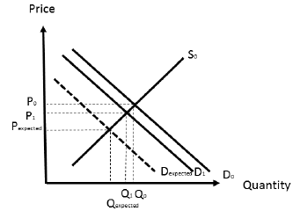
As such, instead of demand falling to Dexpected, demand only fall to D1. The fall in equilibrium quantity is also only at Q1 compared to Qexpected
(c)(i) With reference to Extract 5, use a PPC diagram to explain how public libraries can affect long-term economic growth of a country. [2]
1. Economic causation
Funding public library is like a form human capital investment. This will help to improve the quality of human resource in the long run i.e. better and more educated workforce, more creative workforce e tc. As such it will contribute to potential growth and thus shift the PPC outwards. (expanded the production capacity because of higher mobility of workers and efficiency of production) – potential growth

2. Evidence:
- Extract 1: ‘contribute to long term processes of human capital formation, the maintenance of mental and physical wellbeing for adult and children’
- Extract 3: ‘dedicated venue in a library for exploring new technologies’

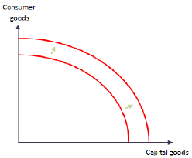

As seen from the diagram, there is outward shift of the PPC from PPC1 to PPC2, indicating that there is expansion of production capacity of resources due to more productive and creative workers, enabling greater production in the long run.

(e)(i) With reference to Figure 1, summarise the trend of subsidies for public libraries in Singapore over the period 2008-2015. [2]

Overall, the subsidies for public libraries in Singapore increase at a decreasing rate.

d) Discuss the view that direct provision of public library is a better solution than subsidy for public library. (10)

(e)(ii) Discuss the view that a government should allocate more resources to public libraries to bring about a more efficient allocation of resources. [8]

Government should help as these issues of positive externalities and income inequality which will bring about market failures if there is no government intervention. However, there may be limitations in government intervention seen in terms of government failures or limitations of government policies.

Thesis 1: Government should allocate more resources to public library because public library is a source of positive externalities (can identify that it is also a merit good)
The Private Marginal Cost (PMC) measures the cost to producers from an additional unit of library services produced such as the cost of rental for the library, cost of purchasing the books or subscription to the various news providers (print or online), the cost of the tables and chairs and bookshelves etc.

The Private Marginal Benefit (PMB) measures the benefit to consumers from an additional unit of library services consumed such as the knowledge and leisure gained from the reading of books and also when the individual makes use of the library and its services.

However, consumption of library service generates external benefits to third parties who are not part of the consumption process.

For each unit of library services consumed, individuals will be more productive in the workforce with the acquiring of new technologies, there will be growth of SMEs that will strengthen the domestic economy for example Singapore, cultivation of a culture of creativity and innovation. The library services also help to close the inter-generational gaps and foster social cohesion from the promotion of interaction. This also positively translates into a more productive and creative workforce for the economy with a stable macroeconomic environment.

Evidence:
- Extract 5: “Public libraries can contribute to long term processes of human capital formation and social cohesion of communities. “
- Extract 6: “libraries as community spaces that allow access to technology and as a source of digital literacy for various demographics”
- Extract 7: “At Pixel Labs at Jurong Regional Library, a “tinkering lab”, visitors use the facilities for free and are allowed to take home the 3D models they make.”
- Extract 7: “can sign up for digital media courses run by librarians from the library board. The courses teach basic computing skills, as well as how to access the board's e-resources and e-books.”
- Extract 7: “learn how to connect with her grandchildren with WhatsApp.”
- Extract 7: “smart work centres or flexible mobile workstations were launched ……These come with a whole suite of business functions and resources such as Wi-Fi, meeting rooms and high-definition video-conferencing services.”

Hence in this case of a positive consumption externality, library services consumers are not concerned about the external benefits to others but only their own private benefits as the external benefits are unpriced by the price mechanism and not included in the private benefits. As such, the free market has “over-priced” the consumption of library services which will lead to an inefficient allocation of resources and hence market failure.

For each additional unit of library services, the social marginal benefit (SMB) includes the private marginal benefit (PMB) of the benefits consumed plus the external marginal benefit (EMB) to third parties. Hence the actual benefit borne by the society is represented by the SMB, which takes into account the full benefits to society of an extra unit of library services. SMB = PMB + EMB.

External benefit from consuming library services
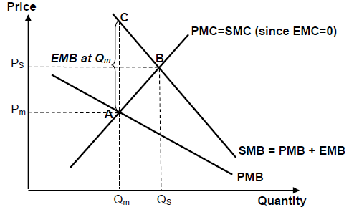

As seen from the diagram, the level of consumption of the services without government intervention by the government is at Qm where PMB is equal to PMC = SMC under perfect knowledge and there is no consideration of positive externalities. However, the presence of an external benefit causes a divergence between private and social benefits, with SMB above PMB as SMB = PMB + EMB. Thus, the socially efficient quantity of library services should be at QS where SMB=SMC, where the full costs and benefits and costs to society are considered. Qs is more than the market equilibrium quantity, Qm where PMB = PMC. Thus, there is underconsumption of library by the quantity QS – Qm. Since total social benefits forgone exceeds the total social costs not incurred for underconsumption QS – Qm, area ABC represents the deadweight welfare loss due to underconsumption of QS – Qm. This indicates that there is market failures and the government should intervene to correct market to a social efficient level. (maximization of net social benefit gain)

Thesis 2: Government should allocate more resources to public library because public library is can help to reduce income inequality issues.
In a market economy, the ability of individuals to consumer goods depends on their income and wealth. The market system will not respond to the needs and wants of those with insufficient economic (dollar) votes to have any impact on market demand because what matters in a market-based system is effective demand (willingness and ability to pay) for goods and services. Consequently, goods and services do not necessarily flow to those who need them the most e.g. food for the starving poor or homes for the homeless. It favours those with the buying or purchasing power. The free market system thus fails to provide for those without the means to pay for goods and services. However, whether this is fair is a normative issue and depends on the individual’s value judgement.

Thus, the presence of public library is a way to help the people with less income to be able to access the same amount of knowledge as the others who are able to afford subscription for private libraries or able to purchase books for private collection.

Evidence: “Information sharing has the power to bolster educational equality across the world.”

For the case of Singapore, the library also allow for free access to new technologies or affordable IT course.

Evidence: “visitors use the facilities for free” and “The affordable course fee ranges from $4 to $10” in extract 7.

Antithesis: However, there might be budgetary constraints. Given that the government budget is finite, government may have to shift the budget away for other purpose.
Evidence Extract 6: “Public libraries have continued to struggle in many countries, like in US, particularly since the 2008 Global Financial Crisis. In many cases, governments have scaled back on the opening of new branches and library services so that the money could be used for alternative purposes.”

The government might need to conduct expansionary policies in order to revive the economy in times of recession or even spend on other aspects like more on healthcare on an aging population like SG. These other objectives might have more priority over the public library. As such, a trade off may be necessary.

Conclusion
Government should continue to fund the public libraries to provide their services especially for the reason of positive externalities. Yet given that there might be more important objectives in considerations, the respective governments may not increase in amount of funding to the public library due to their own current conditions. However, there should not be a decrease in the amount of funding at least.

