J2 H1 Economics – Final Revision 2019 – Lesson 2

The Decline of Food Prices and Sustainable Agriculture

Table 1: Annual Food and Crude Oil Prices

The table below shows an index of international food prices and crude oil prices over the period 2007-2016. The Food Price Index is a measure of the change in international prices of a basket of food commodities consisting of meat, cereals, dairy, edible oil and sugars.

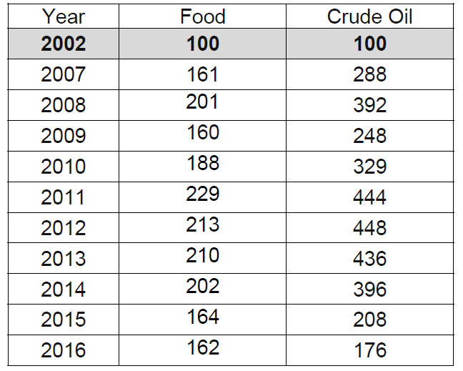
Sources: imf.org and fao.org

Figure 1: Annual Dairy and Sugar Price Index

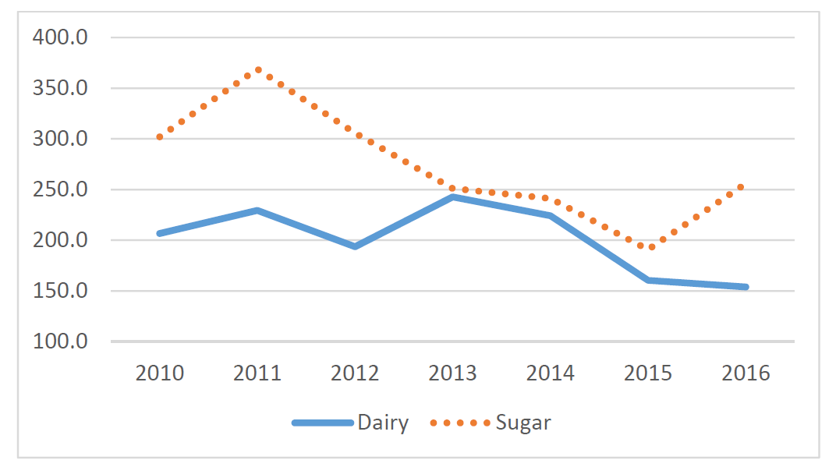
Source: fao.org

Extract 1: Food prices on a decline?

A decade after the food price spikes of 2007-8, conditions on world agricultural markets are very different. Production has grown strongly across commodities, and in 2017 reached record levels for most cereals, meat types, dairy products, and fish, while cereal stock levels climbed to all-time highs.

At the same time, demand growth has started to weaken. Much of the impetus to demand over the past decade came from rising per capita incomes in China, which stimulated the country’s demand for meat, fish and animal feed. This source of demand growth is decelerating, yet new sources of global demand are not sufficient to maintain overall growth. Moreover, per capita consumption of many commodities is expected to be flat at a global level. This is notable for staple foods such as cereals and roots and tubers, where consumption levels are close to saturation levels in many countries. By contrast, demand growth for meat products is slowing due to regional variation in preferences and disposable income constraints.
Source: FAO Agricultural Outlook 2018

Extract 2: The end of the biofuel boom?

Starting in the early 2000s, biofuels emerged as a major ‘consumer’ of several crops. The US, the EU and Brazil, among other countries, encouraged the growth in biofuels as a way to reduce greenhouse gas emissions and/or achieve energy security. This stimulated global demand for maize and sugarcane, as well as vegetable oils, which in turn contributed to the robust demand growth in global agriculture. However, in recent years, biofuels have gradually disappeared as a source of demand growth and, as a result, the growth in demand for maize and vegetable oils will slow down significantly.

Source: CEPR Policy Portal, 28.02.18

Extract 3: Brazil releases maize from state reserves

The Government of Brazil announced in late April the sale of 1 million tonnes of maize from its state reserves. The measure aims to support livestock producers, amidst high domestic prices of yellow maize.

Source: fao.org, 15.05.18

Extract 4: Malawi bans maize exports

In early February, the Government reintroduced a ban on maize exports, which was lifted in late October following the bumper crop in 2017. The re-implementation of the trade measure reflects an expected fall in the 2018 output from last year’s above-average level, mainly due to dry weather during the growing season. The ban aims to preserve national grain reserves and stem the impact of tighter domestic supplies.
Source: fao.org, 15.05.18
Extract 5: True cost of food

In many countries there is a worrying disconnect between the retail price of food and the true cost of its production. As a consequence, food produced at great environmental cost in the form of greenhouse gas emissions, water pollution, air pollution, and habitat destruction, can appear to be cheaper than more sustainably produced alternatives.
Source: FAO Agricultural Report 2015

Extract 6: Developing nations face challenges in achieving food security

Agriculture remained a key sector for developing countries, which contributed immensely to economic growth and well-being. Technology and innovation were urgently needed, especially for developing countries, to sustainably increase agricultural production to meet rising demands, improve the global supply chain and decrease food loss and waste.

Further, unsustainable agriculture and food systems, particularly food loss and waste, were major contributors to climate change whose adverse impacts of climate change had undermined the ability of all countries to achieve food security and sustainable growth.
Source: Inter Press Service, 19.12.16
Extract 7: China to deepen reform in agricultural sector

The gist of supply-side reform in China's agricultural sector is to increase the output of high- quality products based on green and innovative production.

The country will maintain its zero increase in the usage of pesticides and fertilizers and vigorously control water usage in the sector. For better farm produce, a group of innovation centres and alliances will be created, and outstanding research will be enhanced. The reform also aims to refine the quality supervision and standard system for farm produce, control soil pollution and encourage agricultural businesses to gain international certifications. China will promote the export of competitive farm produce, cross-border operation of agricultural enterprises and the establishment of global leaders in the sector.

Source: China Daily, 05.02.17
Questions

(a) With reference to Table 1:

(i) Compare the change in food prices and crude oil prices over the period 2007- 2010. [2]

(ii) Identify the relationship between food prices and crude oil prices over the period 2007-2016 and account for the relationship. [4]

(b) Using Figure 1, compare the change in the prices of dairy and sugar over the period 2010-2016. [2]

(c) With reference to Extracts 1 and 2, use supply and demand analysis to explain the trend of food prices in recent years. [6]

(d) Explain how exchange rate depreciation may impact food importing countries. [2]

(e) Extracts 3 and 4 refer to government intervention in agricultural markets.

(i) With the use of a supply and demand diagram, explain how the differing government policies in the maize market seek to help the target groups in the two countries, and discuss briefly whether success is guaranteed. [7]

(ii) Analyse the effect of the export ban on the consumer expenditure on maize and the long-term effect on the allocation of resources between maize and other crops. [7]

(f) There exists a divergence between private costs and social costs in the production of food.

Explain why there is a ‘worrying disconnect between the retail price of food and the true cost of its production’, as stated in Extract 5. [5]

(g) Using Extracts 6 and 7, evaluate the implementation of agriculture reforms by the Chinese government to achieve sustainable growth. [10]

[Total: 45]

Suggested Answers
(a) With reference to Table 1:

(i) Compare the change in food prices and crude oil prices over the period 2007- 2010. [2]

Food: ( ¹⁸⁸⁻¹⁶¹ x 100 = 16.8% )
161

Crude Oil: (²⁸⁸⁻³²⁹ x 100 = 14.2%)

It should be observed from Table 1 that both the prices of food and crude oil experienced an increase over the period (given by the increase in the price indices: 161 to 188 for food and 288 to 329 for crude oil).

By expressing the price in a period as a percentage of the price in a base year (indicated by 2002=100), the use of a price index allows for a measurement of how much prices have changed over different periods.

(a)(ii) Identify the relationship between food prices and crude oil prices over the period 2007-2016 and account for the relationship. [4]

There is a positive/direct relationship between food prices and crude oil prices.

According to Table 1, the change in crude oil prices is largely consistent with the change in food prices. For example, apart for the period 2011-2012, periods in which crude oil prices increased observed a similar increase in food prices; periods in which crude oil prices decreased saw a similar decline in food prices.

Crude oil is used as a factor input (FOP) in the production and distribution processes of agricultural commodities – meat, cereals, dairy, edible oil and sugars – that make up food. Higher production costs due to an increase in crude oil prices contribute to an increase in food prices, ceteris paribus.

An increase in crude oil prices will drive up the demand for biofuel that will consequently add to the demand for agricultural produce, the effect of which is to cause the prices of food commodities to increase.

(b) Using Figure 1, compare the change in the prices of dairy and sugar over the period 2010-2016. [2]

Both dairy and sugar prices observed an overall decline over the period 2010-2016.

Sugar prices peaked in 2011 and thereafter fell sharply while dairy prices experienced a more gradual decline, characterised with periods of falling and rising prices.

(c) With reference to Extracts 1 and 2, use supply and demand analysis to explain the trend of food prices in recent years. [6]

[Diagram Illustration]
- Diagram should illustrate a global market for food and a rightward shift in the demand and supply curves, with a larger magnitude of shift for the latter.

Explain that factors to do with the waning effect of rising per capita income on food demand, the consumption of staples reaching a saturation point, the disappearance of biofuels as a source of demand growth (due likely to a trend of falling crude oil prices) would have caused a slowdown in the increase in demand for food.

Explain factors to do with technological progress, improved farming methods etc. that enabled production to reach ‘record levels’ would have caused supply to increase.

Explain the increase in supply would have outpaced the demand growth to create a surplus at the original equilibrium price that would eventually cause a resultant fall in the equilibrium price of food.

(d) Explain how exchange rate depreciation may impact food importing countries. [2]

Explain that exchange rate depreciation will result in an increase in the prices of food commodities in terms of the domestic currency of a country since more units of the currency have to be given up to purchase the same quantity of food.

Given that the demand for food commodities is price inelastic, this will cause the expenditure on food to increase, ceteris paribus. The impact of this may be to cause living standards in food importing countries to stagnate or worsen.

Explain how exchange rate depreciation will result in imported inflation that adds to the average price level in food importing countries. Agricultural commodities are used as factor inputs to manufacture or produce processed food. The increase in production costs due to higher prices of food commodities will eventually be passed on to consumers.

(e) Extracts 3 and 4 refer to government intervention in agricultural markets.

(i) With the use of a supply and demand diagram, explain how the differing government policies in the maize market seek to help the target groups in the two countries, and discuss briefly whether success is guaranteed. [7]

[Diagram Illustration]
Represent the domestic market for maize in Brazil and Malawi, with a rightward shift in the supply curve and a resultant increase in equilibrium quantity and decrease in equilibrium price.

Explain that the release of stocks and imposing a ban on exports will cause domestic supply in the two countries to increase and bring about a fall in price in the market for maize.

Consider how the policies might be able to stem the fall in domestic supply owing to adverse factors (e.g. dry spell in Malawi), in which case the resultant shift may be one of supply falling by a smaller magnitude, thereby moderating the resultant increase in price. This will benefit both producers and consumers in the two countries (e.g. livestock farmers in Brazil who rely on maize as a source of cattle feed or producers of processed food that use maize as a factor input).

Evaluation should focus on factors that determine the extent to which the intended outcomes may be achieved.

Possible issues or factors include:
- the amount of stocks or reserves that the Brazilian government holds and its ability to sustain the supply of maize to prop up domestic supply or the extent to which quantities of maize made available through the export ban may be able to shore up domestic supply.
- the duration and severity of the dry weather in Malawi that limit the amount of relief provided by the ban on exports.
- the possibility of unintended consequences arising from the policies.

(ii) Analyse the effect of the export ban on the consumer expenditure on maize and the long-term effect on the allocation of resources between maize and other crops. [7]

[Diagram Illustration]
Illustrate a rightward shift in the supply curve and the change in consumer expenditure.

Explain, with reference to a diagram, that a fall in the price of maize will result in a reduction in consumer expenditure, given that demand is price inelastic. The fall in the domestic price of maize will result in a less than proportionate increase in quantity, ceteris paribus, to the extent that consumer expenditure will reduce.

Explain that a fall in the price of maize will cause the marginal revenue to decrease relative to marginal cost such that the marginal profit (difference between marginal revenue and marginal cost) from an additional unit of maize produced will reduce. Holding the marginal profit of other crops unchanged, the profitability of maize as a cash crop will fall relative to other crops. In the long term, self-interested farmers seeking to maximise profits will be incentivised to cut back the production of maize and switch to other crops, resulting in an allocation of resources away from maize to other food crops.

(f) There exists a divergence between private costs and social costs in the production of food. Explain why there is a ‘worrying disconnect between the retail price of food and the true cost of its production’, as stated in Extract 5. [5]

Cost/benefit diagram with correctly labelled axes and curves, to illustrate a divergence between marginal private cost and marginal social cost and identify correctly equilibrium positions.

Explain that the use of ineffective or environmentally unfriendly or detrimental farming methods, which may be potentially destructive in some instances, in some countries, creates external costs in the form of pollution, habitat destruction that give rise to resource depletion and degradation.
In the context of developing countries, the most important cause of environmental destruction may be due to the overexploitation by poor people of their scarce environmental resources. Poor people lack modern agricultural inputs, and being too poor to buy inputs that preserve the soil’s fertility, they deplete the soil’s natural minerals, making soils less productive. In richer economies, the external costs may be caused by intensive large-scale farming reliant on chemicals. Such costs are not taken into account by self-interested producers in the production process and consequently will not be factored into the retail prices of food.

On the other hand, sustainable food production that delivers a wide range of benefits may require the use of relatively more expensive equipment or methods of production that add to production costs which contribute to higher retail prices.

(g) Using Extracts 6 and 7, evaluate the implementation of agriculture reforms by the Chinese government to achieve sustainable growth. [10]

1. Explain the meaning of sustainable growth
Sustainable growth refers to growth that can be maintained without creating other significant economic problems (such as depleted resources and environmental problems), particularly for future generations.

2. Outline issues relating to agriculture that China is confronted with in achieving sustainable growth
- Much of the increased food production through agricultural intensification in the past decades had been undertaken at the expense of significant environmental damage that has taken a toll on the country’s resources (high intensity of resource use has caused the environment to exhaust its carrying capacity).
- Rising land and labour costs that reduce competitiveness and pose concerns on food security amid an expanding population.
- Widening rural-urban income divide that may hamper growth.

3. Outline the key characteristics of China’s agriculture reforms
Agriculture reforms in China seek to increase the quantity and improve the quality and efficiency of resources in agriculture markets with the aim of reducing environmental pressures, while meeting the demands of a growing population and continuing to improve the lives of the rural population. They include:

- providing incentives for sustainable resource use and promotion of green (or ‘clean’) technologies (apart from market-based policies that internalise production externalities),
- setting standards and adopting internationally recognised best practices or processes,
- expanding productive capacity through technological utilisation and investment (in agricultural enterprises), and
- improving China’s competitiveness as a food exporting country.

4. Explain the impact of the reforms in terms of reducing negative externalities and expanding productive capacity
- The introduction of green methods of production and processes promotes environmental preservation and minimises the external costs associated with agricultural production. This effectively reduces the toll that environmental externalities have on the resources of the country. Cuts in spending on health care costs, pollution clean-up, etc. can be diverted to other areas of the economy. Cost and benefit diagram to illustrate.
- Investments in capital goods, research, developing expertise and technology will raise agricultural productivity and contribute to the country’s potential growth. This is crucial in meeting the consumption needs of an expanding population. AD/AS or PPC diagram to illustrate.
- Promoting the ‘export of competitive farm produce, cross-border operation of agricultural enterprises’ as well as encouraging ‘agricultural business start-ups’ will help develop and sustain the agricultural sector as an engine of rural development that contributes to higher farmer incomes. This has the effect of improving income distribution and brings about inclusive growth.
- Competitive markets allow for efficiency in resource allocation as consumers and producers respond to price signals. Reliance on the price mechanism will also ensure that farm products can be sold at reasonable prices. This goes toward encouraging exports as a source of growth.

5. Explain possible limitations, problems, disadvantages
- Huge fiscal outlay.
- Opportunity cost of farming labour in terms of wages that workers can earn in manufacturing or other sectors of the economy.
- Long and demanding process that requires close coordination between the government and various stakeholders for the intended outcomes of the reforms to be realised.
- Possible short-term impact on production cost.
- The need to rely on international expertise and technology as well as gain access to global agricultural resources and food trade infrastructure

