Final Preparation for 2020 GCE A level

Question 1
Examine the relative impact of a deep recession and a government subsidy on total consumer expenditure in different markets such as food and the Arts and Cultural events. [25] (SRJC Prelim 2012 Q2)

Question 2
As a matter of national policy, MOM does not prescribe minimum wages for all workers in Singapore, whether local or foreign. Whether wages should increase, or decrease is best determined by market demand and supply for labour.

MOM Website

Discuss how the minimum wage works to curb inflation and evaluate whether it is suitable for SIngapore use as a policy to maintain the interest of workers and as a ‘matter of national policy’ for the benefits of the economy. (25)

Question 3
Demand for the Olympic tickets was so high that more than 50,000 people were waiting in queue at one ticketing office selling part of the last batch 250,000 tickets that was released. Beijing police have already detained 60 touts accused of selling tickets for up to 100 times their face value.
Times Online, 25th July 2008

(a) Using demand and supply analysis, account for the emergence of the black market for Olympics tickets. [10]

b) Discuss the usefulness of the concepts of price elasticity demand and income elasticity of demand to a supplier of Olympic merchandise. [15]

Question 4

For 2018, the Singapore economy is expected to grow by 3%. MAS also expects food prices to rise on the back of higher oil prices and concern over weather conditions affecting thr production of Singapore’s key food import sources.

Source: Adapted from Today, 26th Oct 2018

a) Use demand and Supply analysis to analyse the impact of the above on consumers’ expenditure on food in Singapore. (10)

b) Discuss the policies that might be used by Singapore government to address rising food price. (15)

Essay Question 1
Examine the relative impact of a deep recession and a government subsidy on total consumer expenditure in different markets such as food and the Arts and Cultural events. [25] (SRJC Prelim 2012 Q2)

Introduction
To examine the impact of a deep recession and a government subsidy on the total consumer expenditure, we need to analyse its influence on the demand and supply of these markets as a result of the change. In doing so, we need to understand how the two goods are classified which will affect the elasticity of demand for these goods and thus affect the prices and output level which will affect the consumer expenditure, given that consumer expenditure is the product of price and quantity.

Main Body
- Explain how a deep recession would affect the demand for the demand for inferior and normal good

Deep recession fall in income decrease demand for normal good which are goods that occupy a large proportion of income spend increase in demand for inferior goods which are goods that occupy a small proportion of income spent

- Explain how the consumer expenditure for goods like food will change as a result of the deep recession

a. Economic Causation
↓Y↓dd for food which are classified as normal good – dining out at restaurant / ↓ dd for art and cultural events ↓dd for food at hawker centre (inferior)

b. Diagram and Description of Diagram (2 diagrams)
P
P
Q₁
P₀
P₁
D₀
D₁
S_{o}
Q₀
↓Y
S_{o}
P_{o}
D_{o}
P₁

D₁
Q_{ty}
Q_{ty}
Q₁
Q_{o}
Inferior Good (Hawker food)
Normal Good

As seen from the diagram, the decrease in demand for normal good from D₀ to D₁ will lead a supply demand condition, contributing to fall in price and quantity from P₀ to P₁ and Q₀ to Q₁. The total consumer expenditure will also decrease as total expenditure falls from P₀ X Q₀ to P₁ X Q_{1.}
c. Evaluation

- Explain how the consumer expenditure on Arts and Cultural events will change as a result of the government subsidy

a. Economic Causation
↑govt subsidy ↓COP↑SS for food / Art and cultural events

b. Diagram and Description of Diagram
S_{o}
D_{o}
P
Q_{ty}
S₁
Q₁
Q₀
P₀
P₁
S_{o}
D_{o}
P
Q_{ty}
S₁
Q₁
Q₀
P_{o}
P₁

Price falls slightly for the normal good such as art and cultural events ↑(gain>loss)
Why? – large proportion of income spent on these goods availability of substitutes – many
Price falls sharply but increase in quantity is less than proportional total consumer expenditure ↓ (loss >gain)
Why? Staple consumption

S_{o}
D_{o}
P
Q_{ty}
S₁
Q₁
Q₀
P₀
P₁
S_{o}
D_{o}
P
Q_{ty}
S₁
Q₁
Q₀
P_{o}
P₁

Subsidy per unit

Producer benefit more for Arts and cultural events when dd is price-elastic help producers to cover huge cost of events
Consumer benefit more for food items as it is essential to them when dd is price-inelastic

c. Evaluation
i. Extent of change in demand and supply
Subsidy↑SS or recession (↓dd for normal good / ↑ dd for inferior good)
in dd >↑SS
-↑dd>↑SS(Inferior good) ↑P, ↑Qty
-↓dd>↑SS (normal good)↓P,↓Qty
Conclusion

Essay Question 6
Examine the relative impact of a deep recession and a government subsidy on total consumer expenditure in different markets such as food and the Arts and Cultural events. [25]

Introduction
- State that the market is determined by demand for and supply of the product.
- State that total consumer expenditure is derived by multiplying price per unit and total quantity bought by the consumer.

Main Body
1. Explain the impact of a deep recession on the market for food as a broad category

A deep recession will affect the market and cause a fall in the total consumer expenditure for food items.

Q₀
Q₁
P₀
P₁
Price per unit ($)
SS
Quantity of food

D₀

D₁

As seen in the diagram, the downward sloping demand (D) and upward sloping supply (S) curve for a normal good such as food items, for example rice. Ceteris paribus, the lower the price, the higher the quantity demanded by the consumer. Conversely, the higher the price, the greater the incentive for the profit maximising producer to increase quantity supplied. The original market equilibrium is determined where demand equals to supply at point E. The equilibrium price and quantity exchanged is at OP and OQ respectively. The total consumer expenditure is represented by area 0PEQ.

A deep recession would mean that there will be a great fall in the income earned by the citizens of the country. This reduces the disposable income and spending power of the citizens. Ceteris paribus, for example, price of the good remaining unchanged, there will be a fall in the willingness and ability of households to demand for a normal good.

As food as a broad classification are necessities needed for basic survival Hence, other factors remaining unchanged, when there is a fall in income, households will reduce the quantity consumed only by a small extent. Hence, the demand curve will shift to the left by a smaller extent to D₁.

As a result, a surplus arises which exerts a downward pressure on equilibrium price. As price falls, the quantity demanded increases causing a movement along D₁. At the same time, producers seeing the drop in price will reduce quantity supplied until a new equilibrium is re-established at E₁. With a lower equilibrium price at OP₁ and lower quantity bought at OQ₁, total expenditure of consumers falls to 0P₁E₁Q₁.

However, as at the same time, the government grants a subsidy e.g. on the production of rice and other basic food items. Hence, there will be a further influence on food consumption during the recession.

A subsidy on rice production, for example, reduces cost of production and enables rice farmers to produce more rice. The change in total expenditure will depend on the degree of responsiveness of quantity demanded given this price fall. The demand for a necessity like food items is not very sensitive to price changes, so a cheaper price will only bring about a smaller percentage rise in quantity demanded. Hence total expenditure by consumers on food shrinks.

Services like Arts and Cultural events are normal goods which are likely to be luxury items. These are leisure activities and could include pop concerts, museum and other theatre performances either by local or foreign acts.

Hence, like food which is a normal item, during recession where income falls, there will also be a fall in the demand for Arts and Cultural events. However, as these are luxury goods which households can forgo during hard times and will spend on after basic needs are met, there will a greater percentage drop in demand compared to the fall in income. Hence, the demand curve for Arts and Cultural events shifts to the left by a greater extent. Assume supply remaining unchanged, the surplus causes the same automatic market adjustment process through a downward pressure on price as explained earlier in the food market. Ceteris paribus, the bigger surplus will cause a greater fall in equilibrium price and quantity exchanged for such events. Hence with a smaller price and quantity bought, the impact is a greater fall in total expenditure to area 0P_{A}E_{A}Q_{A} compared to food expenditure of area OP_{F}E_{F}Q_{F} as seen in the figure below.
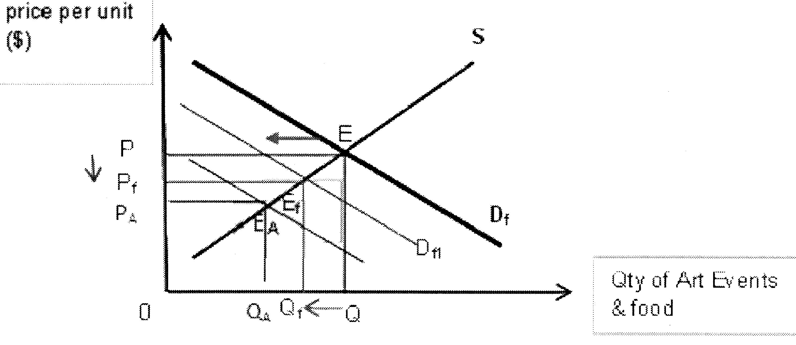

Comparison of the impact on food and arts and cultural events
Hence we can see that the impact on the expenditure on both goods work through a shift in demand and a movement along the demand curve. There are 3 possible final impact of the 2 triggers: Both will see a fall in total expenditure. Both work to reduce consumption expenditure where a deep recession is concerned. Assuming PED<1 for both, then both fall. If PED=1 for Arts, there will be a net fall in total expenditure.

In view of the fact that food items are necessity with low income and price elasticity of demand, the final impact of both a deep recession and a subsidy may cause a bigger fall in total expenditure in food items than for the arts and cultural events. This is because both the recession and subsidy bring about a fall in total expenditure for food.

However, there are the limitations this examination as it hinges on the ceteris paribus assumption. Other factors like changes in lifestyle and taste and preference could have changed at the same time. These can affect the degree of change in the willingness and ability of households to consume a good when income and price changes.

Conclusion
Hence, a closer examination suggests that the relative impact depends on the nature of the good. A strong consideration is the fact that the recession is deep and is likely to cause a fall in total expenditure for both goods. Hence if government wishes to increase total expenditure to boost an economy, it may have to find other ways of doing so, for example by reducing taxes and increase their disposable income.

Essay Question 2
As a matter of national policy, MOM does not prescribe minimum wages for all workers in Singapore, whether local or foreign. Whether wages should increase, or decrease is best determined by market demand and supply for labour.

MOM Website

Discuss how the minimum wage works to curb inflation and evaluate whether it is suitable for SIngapore use as a policy to maintain the interest of workers and as a ‘matter of national policy’ for the benefits of the economy. (25)

Essay Question 3
Demand for the Olympic tickets was so high that more than 50,000 people were waiting in queue at one ticketing office selling part of the last batch 250,000 tickets that was released. Beijing police have already detained 60 touts accused of selling tickets for up to 100 times their face value.
Times Online, 25th July 2008

(a) Using demand and supply analysis, account for the emergence of the black market for Olympics tickets. [10]

Introduction
Market equilibrium is achieved at the intersection of demand and supply curve for Olympic tickets. Black market refers to the emergence of illegal sale of certain goods at high prices as a result of the lack of supply. Black market for Olympic emerged as the market demand for tickets exceeds the supply for the tickets at the price level which is fixed by the government.

Main body
1. Explain how market equilibrium occurs
Market equilibrium is attained when the market demand is equal to market supply whereby the demand curve intersects the supply curve. At market equilibrium, it will reflect the level of quantity and price level set by the market forces. Any changes in demand and supply will lead to a change in market equilibrium, indicating the new price and output level.

2. Explain how the price level is determined by the organising committee
Due to the presence of a fixed capacity of production for the Olympic events, the supply curve is fixed a particular level of quantity of supply and thus the supply curve is vertically sloped. As for the demand curve, it is horizontally sloped or is a perfectly-elastic demand since the consumer can only purchase from the organiser at a prevailing price which means that there is a perfect market condition about the price level. Any price below this level, the producer will not sell the tickets and any price above this level, the consumer will not buy it.

As seen from the diagram, the price and quantity level at market equilibrium will be at P₀ and Q₀ where the horizontal demand curve intersects the vertical demand curve.
Price
P₀
P₁
Q₀
D₀
D₁
S₀
Quantity

3. Explain how the black market will emerge
As the demand for the Olympic ticket is much higher than the official level determined by the official price level, the black market will emerge as a result of the excess demand. When this occurs, the demand curve will be downward-sloping, reflecting the law of demand that shows an inverse relationship between the price and quantity demand of the tickets. It will also intersect the supply curve at a higher price level than the official price level due to a large consumer market which has the purchasing power to pay at a higher price level.

As the individuals who bought the tickets from the organiser can resell these tickets to the larger consumer market, the price level for the black market will be determined at P₁ where the black market demand curve D₁ intersects with the supply curve S₀. This will allow the resellers to gain extra revenue as indicated by the shaded portion.

In conclusion, it can be observed that the price level set by the official committee will be lower than the black market price level. This black market price level will exist as long as there is a greater demand for the Olympic tickets and there is control of the re-sale of the ticket.

Essay Question 4
Demand for the Olympic tickets was so high that more than 50,000 people were waiting in queue at one ticketing office selling part of the last batch 250,000 tickets that was released. Beijing police have already detained 60 touts accused of selling tickets for up to 100 times their face value.
Times Online, 25th July 2008

b) Discuss the usefulness of the concepts of price elasticity demand and income elasticity of demand to a supplier of Olympic merchandise. [15]

Elasticity of demand refers to the responsiveness of quantity demanded in relation to the variables related to it. These variables include price of concerned good and income of consumer group. A supplier of Olympic merchandise can use the concepts of elasticity of demand to increase the revenue of Olympic merchandise sold.

PED measures the degree of responsiveness of the quantity demanded of a good to a change in its price, ceteris paribus. Based on PED, the supplier can determine the price strategy to be used to increase total revenue. The demand for the Olympic merchandise is price inelastic which means that the increase in price for the tickets will lead to less than proportionate decrease in quantity demanded of the merchandise. As a result of the increase in price of the merchandise, there will be an increase in total revenue because the gain in revenue due to increase in price is greater than the loss in revenue due to decrease in quantity demanded of the good. This is illustrated in the diagram below whereby the increase in price from P₀ to P₁ will lead to less than proportional fall in quantity demanded from Q₀ to Q₁, and the total revenue will increase as shown by the shaded portion.

Diagram: Price inelastic in demand
gain in revenue due to ↑price
loss in revenue due to ↓quantity demanded
P_{X}
Qty X

PED<-1
Q₀
Q₁
P₁
P₀

The Olympic merchandise is considered to be price-inelastic because the availability of substitutes are limited, degree of necessity is high, proportion of income spent on purchasing the products is small and time period for consideration of purchase is short.

The availability of substitutes for Olympic merchandise is limited as this is a first time China is hosting the Olympics. This is a very rare occasion for such merchandise to be made and there was no Olympic merchandise produced in the past before by China, reducing number of choices to purchase the merchandise from little.

The degree of necessity is high for both the locals and tourists. As it is a milestone for China to host the Olympics, this occasion is very prestigious, Olympic merchandise which captures this prestige event proves iconic to the locals. As a result, they will purchase and keep Olympic merchandise as a souvenir to symbolise this prestigious event. For the tourists, they would also want to purchase and keep Olympic merchandise as souvenirs to symbolise the Beijing Olympics. After all, the Beijing Olympics has an iconic status as it recognises the rise of China in modern world.

The proportion of income spent on purchasing the Olympic merchandise is low as the target consumers of these merchandise are the tourists who are well-to-do and are able to afford to purchase the Olympic merchandise since they can afford to travel to other countries.

Finally, the time period of consideration of purchase is also short as the Olympic merchandise do not require the consumers to think for a long time to purchase the goods. In fact, most tourists visit China with the intention to buy these goods.
Secondly, a supplier of Olympic merchandise can use the concepts of income elasticity of demand (YED) to increase the total revenue. YED measures the degree of responsiveness of quantity demanded of a good to a change in consumers’ income, ceteris paribus.

The YED is helpful in determining how the consumer will view the good in relation to his income level. As the proportion of income spent on the good is small, the value of the YED is negative which means that it is an inferior good to the consumer whereby the consumer is price insensitive since the expenditure on this good is insignificant to him. Therefore, this will influence the value of PED which will then determine the price strategy.

(how the value of YED will affect the value of PED)
Under the impact of an increase in price, there will be a substitution effect whereby the consumer will reduce the quantity demanded of purchase for the good concerned and an income effect whereby the consumer will increase the quantity demanded since the relative income has decreased and the good is an inferior good. Subsequently, the increase in price of the Olympic merchandise which is classified as an inferior good will not have a larger percentage reduction in quantity demand as the reduction in quantity demanded due to the substitution effect is dampened by the negative income effect which will increase quantity demanded in the price effect when price decreases, implying that it is price-inelastic demand. Hence, it justifies the rationality to increase price for the Olympic merchandise which will have a price-inelastic demand as determined by the income effect as indicated by YED.

In sum, it is observed that the YED and PED are useful to help the supplier of Olympic merchandise in the determination of the price strategy to ensure revenue maximisation. However, it is important to take note of other factors such as time period will affect the estimation of the value of elasticity of demand and cost of production which will affect the pricing strategy.

Essay Question 5
Amidst rising income, the Malaysian government implemented Goods and Services Tax (GST), which is a broad-based 6 percent tax on goods and services.
Source: Adapted from The Straits Times and The Star Online, 2015

Assess the impact of the above-mentioned changes on the market for different goods in Malaysia. [25] (Outline & Full Essay)

Introduction
State that the demand and supply analysis and the concept of PED and PES will be able to analyse the impact of the above changes in rising income and GST or various types of goods and services
The impact will be seen in terms of change in price and output and the total consumer expenditure and consumer and producer tax burden

Main Body

- Explain how the various types of good will be classified
- Explain how the rise in income will affect the various types of goods and services
2.1 impact on normal good
2.2 impact on inferior good
3. Explain how the GST will affect the different types of good
3.1 impact on goods with price elastic demand
3.2 imoact on goods with price inelastic demand
4. analysis for part 2 and part 3

Conclusion

Amidst rising income, the Malaysian government implemented Goods and Services Tax (GST), which is a broad-based 6 percent tax on goods and services.
Source: Adapted from The Straits Times and The Star Online, 2015

Assess the impact of the above-mentioned changes on the market for different goods in Malaysia. [25]
impact – change in price and quantity, total revenue and expenditure (consumer surplus and producer surplus)
different goods – normal, inferior, necessity
economic principles – dd and ss analysis, Impact on TR due to PED and PES

Introduction
To analyze the impact of the abovementioned changes on the market for different goods, I would make use of the demand and supply model along with elasticity concepts to aid in the analysis of what happens to the markets in terms of price, quantity, and expenditure, which is equals to price multiplied by quantity. The impact on different markets would differ based on the type of goods they are.

Main Body
(If the explanation of the demand-supply model and elasticity is weaved into the explanation in the body paragraphs below, it’s also acceptable)

The demand and supply model enable us to determine the equilibrium price and quantity of the market.

Demand is the willingness and ability of consumers to purchase a given good at a given price in a given time period, ceteris paribus. Supply is the willingness and ability of producers to provide a good for a sale at a given price, in a given time period, ceteris paribus. The intersection of the demand and supply curves will give us the equilibrium price and quantity.

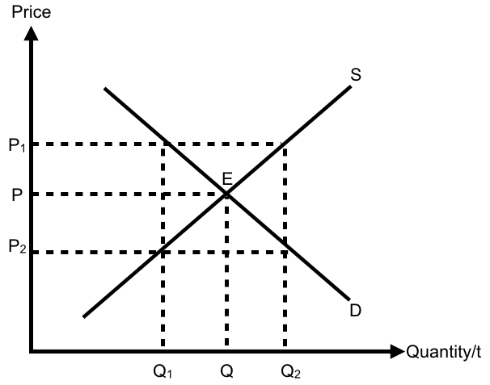

In the above diagram, the market equilibrium point is at point E, where demand curve D intersects supply curve S, giving us equilibrium price P and quantity Q. If price is at P₁, quantity demanded will be Q₁ and quantity supplied will be Q₂, causing a surplus of Q₁Q₂. This will lead to a downward pressure on price, until equilibrium is obtained again where demand equals supply. Similarly, if price is at P₂, quantity demanded will be Q₂ and quantity supplied will be Q₁, causing a shortage of Q₁Q₂. This will lead to an upward pressure on price, until equilibrium is obtained again where demand equals supply.
In order to analyse the impact on different markets, we will also make use of elasticity concepts, namely price elasticity of demand and income elasticity of demand.

Price elasticity of demand (E_{P}) measures the responsiveness of quantity demanded of a good to a change in itwfg c s price, ceteris paribus. Demand for a good can be price inelastic or elastic. The main factors affecting price elasticity of demand of a good are firstly number and closeness of substitutes, and secondly, proportion of income spent on the good. The greater the number and closeness of substitutes, the more price elastic the demand for the good. Similarly, the greater the proportion of income spent on the good, the more price elastic the demand for the good.

Income elasticity of demand (E_{Y}) measures the responsiveness of demand to a change in income, ceteris paribus. There can be 3 types of goods, which are inferior, necessity and luxury goods. For inferior goods, an increase in income will lead to a fall in demand. For necessities, an increase in income will lead to a less than proportionate increase in demand. For luxury goods, an increase in income will lead to a more than proportionate increase in demand.

Market 1: Branded bags (Luxury good)
When GST is implemented, it will affect the market through the supply curve. GST will cause the marginal cost of production for branded bags to increase, represented by an upward shift of the supply curve, which will cause equilibrium price to increase and equilibrium quantity to fall. The impact on total expenditure will depend on the price elasticity of demand for branded bags. The demand for branded bags is price elastic as it takes up a relatively huge proportion of consumers’ income.
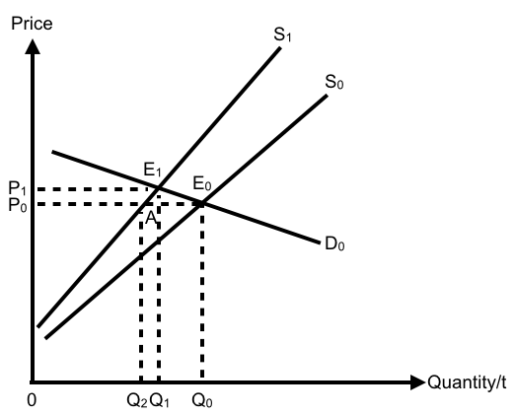

The initial equilibrium was at point E₀, where equilibrium price was P₀ and quantity Q₀. Implementation of GST will cause supply to shift leftwards from S₀ to S₁. At the initial equilibrium price of P₀, quantity demanded is Q₀ and quantity supplied is Q₂, resulting in a shortage of Q₀Q₂. Frustrated consumers will be willing to pay higher prices and quantity demanded will fall, as fewer consumers are willing and able to pay a higher price. This price signal to the producers will cause them to increase the quantity supplied. Quantity demanded will fall and quantity supplied will increase until demand meets supply again at point E₁, where equilibrium price is P₁ and quantity is Q₁. Given the price change of P₀P₁, we can see from the diagram that there is a more than proportionate change in quantity demanded of Q₀Q₁. The decrease in total expenditure resulting from a fall in quantity demanded (Q₁AE₀Q₀) is greater than the increase in total expenditure resulting from an increase in price (P₁P₀AE₁). Thus, total expenditure has fallen.
When there is an increase in income, it will lead to a more than proportionate increase in demand for branded bags, which are items that Malaysian consumers can do without during periods of falling income.

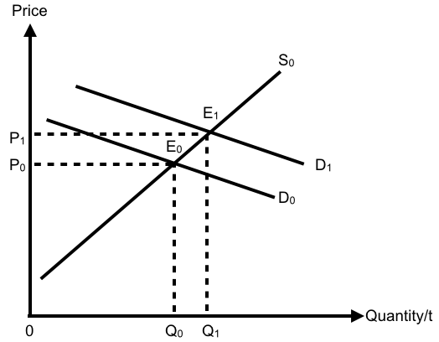

Initial equilibrium is at point E₀, with equilibrium price P₀ and quantity Q₀. An increase in demand is represented by a rightward shift of the demand curve from D₀ to D₁. This will cause a shortage and upward pressure on price, causing price to increase to P₁ and quantity to Q₁. The resultant impact will be an increase in total expenditure from 0P₀E₀Q₀ to 0P₁E₁Q₁.

Implementation of GST has caused expenditure to fall while increase in income has caused expenditure to rise. If the extent of increase in demand (from D₀ to D₁) is greater than the extent of fall in supply (from S₀ to S₁), then we will see an increase in total expenditure from 0P₀E₀Q₀ to 0P₂E₂Q₃

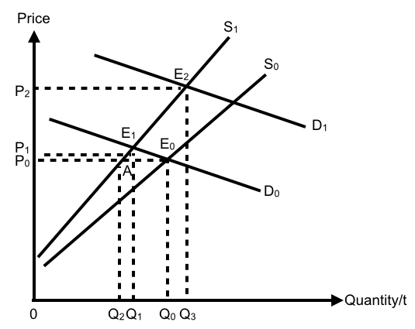

Market 2: Canned Food (Necessity good)
Similar to the market for branded bags, implementation of GST will cause the marginal cost of production for canned food to increase, represented by an upward shift of the supply curve, which will cause equilibrium price to increase and equilibrium quantity to fall. The impact on total expenditure will depend on the price elasticity of demand for canned food. Canned food has limited substitutes that offer as much convenience and therefore, its demand is price inelastic.
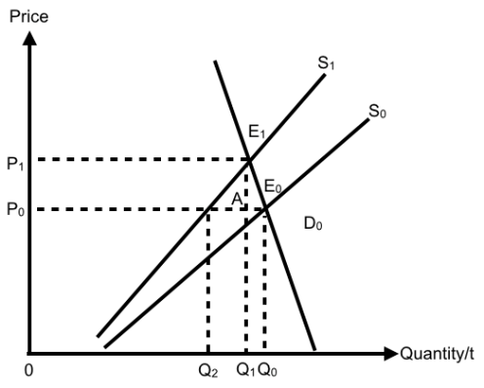

The initial equilibrium was at point E₀, where equilibrium price was P₀ and quantity Q₀. Implementation of GST will cause supply to shift leftwards from S₀ to S₁. There will be a shortage of Q₀Q₂ and prices will increase from P₀ to P₁. Given the price change of P₀P₁, we can see from the diagram that there is a less than proportionate change in quantity demanded of Q₀Q₁. The decrease in total expenditure resulting from a fall in quantity demanded (Q₁AE₀Q₀) is smaller than the increase in total expenditure resulting from an increase in price (P₁P₀AE₁). Thus, total expenditure has risen.

When there is an increase in income, it will lead to a less than proportionate increase in demand for canned food, which is deemed a necessity by Malaysians.

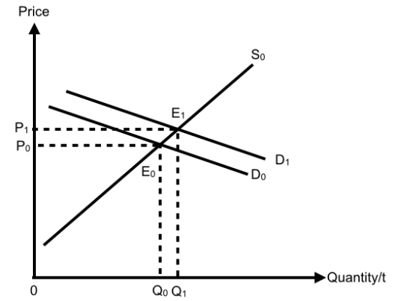
Initial equilibrium is at point E₀, with equilibrium price P₀ and quantity Q₀. An increase in demand is represented by a rightward shift of the demand curve from D₀ to D₁. This will cause a shortage and upward pressure on price, causing price to increase to P₁ and quantity to Q₁. The resultant impact will be an increase in total expenditure from 0P₀E₀Q₀ to 0P₁E₁Q₁.

The combined effect of GST and increase in income on the market for canned food is that total expenditure will definitely increase.

Market 3: Non-smart phones/TVs (Inferior good)
Implementation of GST will cause the marginal cost of production for non-smart phones/TVs to increase, represented by an upward shift of the supply curve, which will cause equilibrium price to increase and equilibrium quantity to fall. The impact on total expenditure will depend on the price elasticity of demand for non-smart phones/TVs. Non-smart phones/TVs takes up a relatively smaller proportion of consumers’ income so the demand is relatively price inelastic.

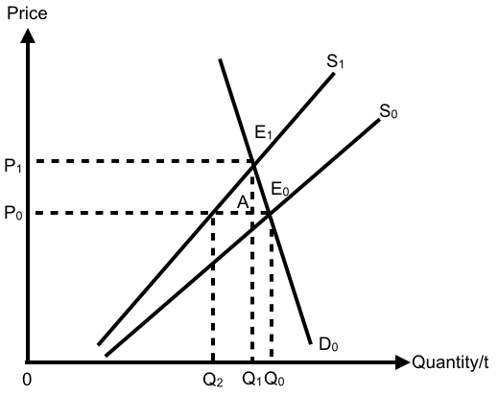

The initial equilibrium was at point E₀, where equilibrium price was P₀ and quantity Q₀. Implementation of GST will cause supply to shift leftwards from S₀ to S₁. There will be a shortage of Q₀Q₂ and prices will increase from P₀ to P₁. Given the price change of P₀P₁, we can see from the diagram that there is a less than proportionate change in quantity demanded of Q₀Q₁. The decrease in total expenditure resulting from a fall in quantity demanded (Q₁AE₀Q₀) is smaller than the increase in total expenditure resulting from an increase in price (P₁P₀AE₁). Thus, total expenditure has risen.

When there is an increase in income, it will lead to fall in demand for non-smart phones/TVs, which is deemed an inferior good by Malaysians.

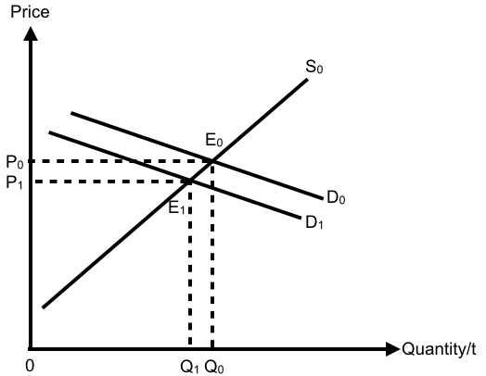

Initial equilibrium is at point E₀, with equilibrium price P₀ and quantity Q₀. A decrease in demand is represented by a leftward shift of the demand curve from D₀ to D₁. This will cause a surplus and downward pressure on price, causing price to decrease to P₁ and quantity to Q₁. The resultant impact will be a decrease in total expenditure from 0P₀E₀Q₀ to 0P₁E₁Q₁.

Implementation of GST has caused expenditure to rise while increase in income has caused expenditure to fall. If the extent of decrease in demand (from D₀ to D₁) is bigger than the extent of fall in supply (from S₀ to S₁), then we will see an increase in total expenditure from 0P₀E₀Q₀ to 0P₂BQ₃

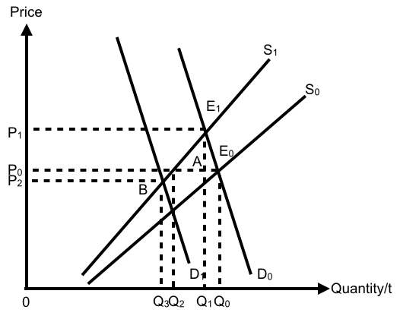

Conclusion
In conclusion, the impact on the different markets will differ, depending on price and income elasticity of demand of the various goods. With more information about the impact on supply due to GST and impact on demand due to increase in income, we will then be able to draw a more substantial conclusion about the extent of change in revenue.

With the implementation of GST, we would see that the standard of living for the lower income might decrease. For this group of people, the Malaysian government could implement other policies like grants to aid this group of consumers, in order to maintain their current standard of living. This is especially important for Malaysia because there might exist a large group of people who will be affected quite substantially due to the changes

economics terms – taste and preference, normal good, price of price of other goods

make your description procedural

