J2 H1 Economics – Final Revision 2019 – Lesson 3

Market for Timber

Extract 1: Logging halt would boost economy

Victoria’s central highlands is the catchment for the majority of Melbourne’s water storage reservoirs and it also contributes to the tourism economy in the most populous city of the Australian state of Victoria. It is estimated that the central highlands adds $310 million worth of economic value to the state's water supply and $260 million to tourism.

On the other hand, the central highlands is home to trees which have been logged for hardwood production. A study last year found native logging and processing helped generate more than $500 million for the state's economy supporting more than 2,000 jobs. Opponents of native timber logging, much of which is used as pulp for paper and for furniture production, said the industry could be supplied with plantation timber instead of trees from the highlands.

Furthermore, some analysts reported that moving away from harvesting of native forest would contribute to improved economic, social and environmental benefits for the people of Victoria. By stopping logging, the water catchment would be improved and would maximise "water yield and quality" and increase the amount of water available to Melbourne. A young forest after logging soaks up most of the water, dries out the water catchments and reduces the amount of water that flows into the dams for the city of Melbourne. These dams are meant to power hydroelectric power stations that generate cheap, renewable electricity and hence provide sustainable and reliable source of energy.

Tourism is a major employer in the region and it would be boosted by ending logging. Local tourism operators say a national park would boost domestic and international tourism with some of the world's oldest trees and forests in the region.

Source: ABC News, 10 Sep 2017 and Melbourne Water.

Extract 2: First UK company to be fined under illegal logging laws

Designer furniture retailer Lombok has become the first UK company to be prosecuted and fined under illegal logging rules designed to stop the import of timber linked to widespread deforestation around the world. Environmental groups said the prosecution was likely to be the “tip of the iceberg” as many firms, particularly in the furniture sector, still don’t have a grip on where their raw materials come from.

According to the Department for Business Energy and Industrial Strategy (BEIS), authorities twice warned Lombok in 2015 after it failed to exercise the required due diligence to ensure that items it had sourced from India were made out of wood from legal logging sites, but the company continued to sell those items. BEIS is a governmental department in UK that aims to promote competitive markets and responsible business practices, and actively take actions against climate change. In October 2016, BEIS enforcement officers visited Lombok’s central London showroom and found the company had again not made checks on an imported sideboard it was selling. The company was then prosecuted and fined £5,000 plus costs.

World Wildlife Fund’s (WWF) research has found that many businesses do not have policies on how they buy their timber, four years after the European Union Timber Regulations (EUTR) were introduced. This often goes hand in hand with failure to carry out due diligence on suppliers and their sources. The EUTR requires importers or sellers of timber and wood products to keep records of the sources of their supplies. The rules are intended to slow the global trade in illegal timber which Interpol estimates to be worth between $30 billion and $90 billion every year.

“Deforestation, which illegal logging leads to, is not just about habitat loss – forests are of fundamental importance to life on Earth,” a representative for WWF said. “They are vital resources for local communities, but the impact of their loss can also be far reaching. Computer modelling has shown that deforestation in Asia could lead to changes in the route storms take over Europe, and Amazon deforestation could increase annual rainfall in northern Europe. The EUTR and efforts by BEIS will therefore ensure that consumers of timber products are well informed of the true cost of buying timber products that come from illegal sources.

Table 1: Production data on selected products using forest woods in Europe

 | 2013 | 2014 | 2015 | 2016 | 2017
Production of Industrial Roundwood  (1000 meter cubic)1 | 366,929 | 383,446 | 388,422 | 396,055 | 400,973
Production of Paper-based Products (million tonnes)2 | 98,656 | 98,085 | 97,769 | 97,663 | 97,870

Note: Both industrial roundwood and paper-based products are alternative products of logging.

¹ Industrial roundwood is a term used to refer to a range of wooden products such as pulpwood and wood residues, that are commonly used in the construction industry or the production of furniture.

² Paper-based products refer to a range of products such as writing papers and paperboard (cardboard).
Source: Various

Extract 3: Chinese demand for rosewood timber drives towards its extinction

The purchasing power of China’s burgeoning middle class is the stuff of dreams for retailers, but is increasingly causing nightmares for conservationists. The robust pace of China's economic growth between 1978 and 2012 created a massive middle class of 480 million people in 2018, a figure projected to increase to 780 million by the mid-2020s.

For these consumers, previously unaffordable products like rosewood timber furniture have become status symbols. Known in Chinese as hongmu, rosewood timber is a fragrant, richly hued timber native to the tropics, from Southeast Asia to Africa. Rosewood furniture derives value from both its “beautiful lustrous qualities” and its rarity, since rosewood timber is “difficult to harvest and mostly found outside China”. The rosewood tree is slow-growing, with a lifespan of several hundred years, and the rapid rise in demand has driven numerous species of rosewood timber towards commercial extinction.

Furniture-makers have turned to Siamese rosewood timber in Southeast Asia, but as these timber supplies fell as well, they have ventured ever farther afield for related species – to Africa. Currently, between 40 and 50 percent of rosewood timber in the Chinese market originates in African countries, such as Kenya.

Source: South China Morning Post, 17 Sep 2018

Extract 4: Kenya’s industry hit hard after logging ban and a rise in minimum wage

Kenya’s Deputy President suspended logging in all forests in the country for the next three months as water levels in major rivers continue to drop at alarming levels. This move is part of the efforts by the country’s government to respond to the drought that is sweeping across the country. The logging ban has triggered a 36 percent and 11 percent rise in timber and furniture prices, respectively. According to the official estimates, acute shortage of logs hit saw millers’ ability to meet demand from builders and carpenters, pushing up prices.

The latest logging ban is a hit to the construction industry in Kenya, which is still reeling from the announced increase in the minimum wage for Kenyan workers recently. Kenya’s President said the increment had been made in view of the current inflation rate. “In recognition of the good work done by our workers and taking into account the rate of inflation of 4.8% this year, I hereby declare a corresponding increase of 5% on the minimum wage,” the government statement read.

In response, the Kenyan businessmen sounded a warning against an increase of the minimum wage, saying such a measure would be a big blow to the industry. “A ceremonial wage increase will not help us to tackle the subject of poverty eradication and will be costly for industry players,” said the chief of a business association.

Source: Various

Extract 5: Forest tax in Washington

Washington State encourages sound forestry practices so that present and future generations can enjoy the many benefits they provide. In addition to scenic and recreational spaces, healthy forests provide an enhanced water supply, reduced soil erosion, storm and flood damage. Forest tax – sometimes called timber tax – is an excise tax that began in 1971, when the Legislature excluded timber from property taxation. In place of a property tax on trees, timber owners pay a 5 percent excise tax on the value of their timber when it is harvested.

In 1982, the Forest Tax was extended to timber harvested from state and federal land, in addition to private land. The person who owns the timber at the time of harvest is responsible for paying forest tax. The timber is taxed at 5 percent, with 4 percent going to the county where the harvest occurred and 1 percent going to the state general fund. Under this scheme, timber owners will have to apply for an official permit before they can start harvesting timber. The owners will then register and pay the necessary forest tax.
Source: Department of Revenue, Washington State.
Questions

(a) From Extract 1, identify two unintended consequences of logging. [2]

(b)(i) Explain whether the service provided by an organization such as the Department for Business Energy and Industrial Strategy (BEIS) is likely to be a public good. [5]

(ii) With reference to Table 1, compare the trends in the production of industrial roundwood and paper-based products in Europe and hence explain the economic relationship between industrial roundwood and paper-based products. [4]

(c)(i) Given the information contained in Extract 3, explain the likely value of price elasticity of supply for rosewood timber. [2]

(ii) Using Extracts 3 and 4 and with the help of a diagram, explain one demand and one supply factor that jointly lead to a rise in the equilibrium price in the world market for rosewood timber, and comment on the likely impact on the change in equilibrium quantity. [8]

(d) Discuss the likely impact of a rise in minimum wage on the workers and producers in Kenya. [8]

(e)(i) Explain how the presence of externalities could lead to an over-allocation of resources in the market for timber. [4]

(ii) Discuss the factors that a rational government should consider when deciding whether to implement taxation or a total ban to achieve a more efficient allocation of resources in the market for timber. [12]

[Total: 45]

Suggested Answers
(a) From Extract 1, identify two unintended consequences of logging. [2]

Loss of $310 million worth of economic value to the state's water supply and loss of $260 million of tourism revenue.

(b)(i) Explain whether the service provided by an organization such as the Department for Business Energy and Industrial Strategy (BEIS) is likely to be a public good. [5]

Yes, service provided by BEIS is non-excludable and non-rivalrous in consumption.

It is non-excludable in consumption since society at large will benefit from the enforcement service including better environment/climate/more competitive market. And, it is impossible for the producers to prevent non-payers from enjoying these benefits once the enforcement service has been provided by BEIS.

It is non-rivalrous in consumption since an additional citizen benefitting from a better environment/climate/more competitive market due to the enforcement service provided by BEIS, does not diminish the amount of these benefits available to other citizens.

(b)(ii) With reference to Table 1, compare the trends in the production of industrial roundwood and paper-based products in Europe and hence explain the economic relationship between industrial roundwood and paper-based products. [4]

The production of industrial roundwood generally increased while the production of paper-based products generally decreased in Europe.

This is because industrial roundwood and paper-based products are competitive in supply [1] since they are both derived from the same resources, trees. Hence, an increase in the production of industrial roundwood will lead to a fall in supply, hence production of paper-based products.

(c)(i) Given the information contained in Extract 3, explain the likely value of price elasticity of supply for rosewood timber. [2]

It is likely that PES<1 for rosewood timber due to long production time. Extract 3 mentions that rosewood trees are “slow-growing”.

(c)(ii) Using Extracts 3 and 4 and with the help of a diagram, explain one demand and one supply factor that jointly lead to a rise in the equilibrium price in the world market for rosewood timber, and comment on the likely impact on the change in equilibrium quantity. [8]

Demand factor
Extract 3 mentioned that the “robust pace of China's economic growth between 1978 and 2012 created a massive middle class of 480 million people in 2018, a figure projected to increase to 780 million by the mid-2020s.” This has led to a higher income and hence purchasing power of the middle-class consumers in China.

“For these consumers, previously unaffordable products like rosewood furniture have become status symbols”, hence the rosewood furniture is likely to be a normal good. As the demand for rosewood furniture increases, the derived demand for timber in Kenya increases too since timber that originates from “African countries such as Kenya” (Extract 3) are raw material / factor input for rosewood furniture. The demand increases from D0 to D1 in Figure 1.

[Alternative demand factor]
Positive taste and preference towards consumption of rosewood furniture as rosewood furniture have become “status symbols”

Supply factor
The suspension of logging in all forests in Kenya for the next three months (extract 4) will reduces the supply of timber drastically as no trees can be felled to produce timber for the next 3 months. This will cause the supply to decrease from S0 to S1 in Figure 1.

[Alternative supply factor]
Increase in minimum wage in Kenya increases the cost of production of rosewood timber (if we consider a rise in wage of rosewood timber loggers)

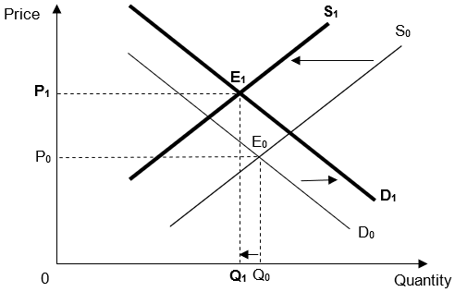
As seen from the diagram, the final equilibrium output is theoretically indeterminate and depends on the relative shift of demand and supply shift. If the supply curve shifts more than the demand curve, final equilibrium quantity is likely to fall from Q0 to Q1.

Extract 3 mentions that currently, “between 40 and 50 per cent of rosewood timber in the Chinese market originates in African countries such as Kenya”. There are also other sources of rosewood timber in Southeast Asia, Latin America and other African countries other than Kenya. Hence the demand for timber from Kenya is unlikely to increase a lot since rosewood furniture producers can procure the timber from other sources. Conversely, the fall in supply of timber is likely to be drastic due to the 3 months ban of logging. Hence, the supply is like to fall more than the increase in demand for timber in Kenya, leading to a fall in equilibrium quantity of timber in Kenya.

(d) Discuss the likely impact of a rise in minimum wage on the workers and producers in Kenya. [8]

A minimum wage is a legally established minimum wage above the market equilibrium wage. The minimum wage law is a regulation that makes hiring labour below a specific wage illegal.
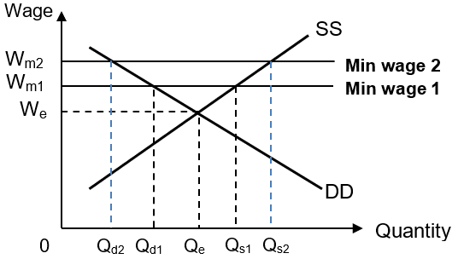

As seen from the diagram, the initial minimum wage is at W_{m1,} where Q_{d1} units of labour are hired at a wage rate of W_{m1}. There is a surplus of (Q_{s1}-Q_{d1}) units of labour at the initial minimum wage level of W_{m1}.

Impact on Workers
When the minimum wage in Kenya is raised to W_{m2} for instance, less workers, Q_{d2} units of labour are hired but they will earn a higher wage rate of W_{m2}. Extract 4 mentions that the 5% increase in minimum wage will allow workers to keep up with the 4.8% inflation rate in Kenya. Since the growth in nominal wage is higher than the inflation rate, the real wage of the Kenyan workers will increase, which will increase their material SOL.

However, there will be a retrenchment of (Q_{d1}-Q_{d2}) units of labour since Q_{d1} were hired initially before the rise in minimum wage. There is also an increase in the surplus of labor from (Q_{s1}-Q_{d1}) to (Q_{s2}-Q_{d2}), hence higher unemployment rate. The new surplus of (Q_{s2}-Q_{d2}) units of labour is made up of (Q_{d1}-Q_{d2}) who are retrenched and (Q_{s2}-Q_{s1}) who join the market seeking for a job due to the rise in minimum wage but are unable to find a job. These workers who are retrenched or remain unemployed will experience a fall in material and non-material SOL.

The retrenchment of workers due to a rise in minimum wage will be significant as demand for workers who earn low wages is likely to be price elastic. This is because low wage earners are typically unskilled or low skilled workers who can be more easily substituted by machines. Hence, the rise in minimum wage will lead to a more than proportionate fall in quantity demanded of labour in Kenya.

Impact on Producers
Producers in the construction and manufacturing industry will face a rising cost of production since labour is a major factor input. As Extract 4 mentions, a rise in minimum wage will not help to “tackle the subject of poverty eradication in a sustainable way” as it will be costly for the producers. The producers will suffer a fall in profit levels since Profit = Revenue – Cost.

Evaluation
A rise in minimum wage is likely to bring more harm than benefit, especially in the long run. While a rise in minimum wage increases income, purchasing power and hence material SOL, this only benefits those Kenyan workers who remain employed in the relevant industries. Producers will suffer as a result of the rise in minimum wage due to a rise in cost of production. A rise in minimum wage is not sustainable and if firms were forced to shut down due to them not been able to keep up with rising cost, more Kenyan workers will be retrenched and find themselves unemployed. Hence, a rise in minimum wage is likely to bring negative impacts on workers and producers in the long run.

(e)(i) Explain how the presence of externalities could lead to an over-allocation of resources in the market for timber. [4]

Negative production externalities occur when the production of a good negatively affects the well-being of third parties. According to Extract 4, excessive logging to produce timber can lead to external cost such as drought, which will adversely affect the livelihood of third parties such as residents who are not involved in the production and consumption of timber. This results in a divergence between SMC and PMC. The market equilibrium quantity is at Qm where PMB=PMC. The social optimal quantity is at Qs where SMB=SMC. There is an over-production of timber (Qm – Qs) and hence over-allocation of resources in the market for timber.

Other possible EMC:
- Drought (extract 4)
- Soil Erosion (Extract 5)
- Flood damage (Extract 5)
- Less tourism revenue (Extract 1)
- Less water supply (extract 1 and 5)
- Climate change (extract 2)

(e)(ii) Discuss the factors that a rational government should consider when deciding whether to implement taxation or a total ban to achieve a more efficient allocation of resources in the market for timber. [12]

Introduction
A rational government should consider the cost, benefit and unintended consequence of the two policies in deciding which one to implement to achieve the best outcome.

Government should consider the benefit of implementing taxation
Imposition of an indirect tax on producers that corresponds to the external marginal cost i.e. Tax = EMC at Q_{S} (distance BD) on each unit of timber shifts the PMC upwards so that the new PMC, which equals PMC + tax, coincides with the PMB at Q_{S}. Hence, the new market equilibrium quantity where PMB = PMC + tax, now coincides with the socially efficient quantity Q_{S}, where SMB = SMC. If the tax accurately reflects the external marginal cost, timber producers and consumers are now in effect paying for the use of the environment. The externality has then been internalised or priced in. Deadweight loss is then eliminated as Q_{m} is reduced to socially optimal level, Q_{S.}

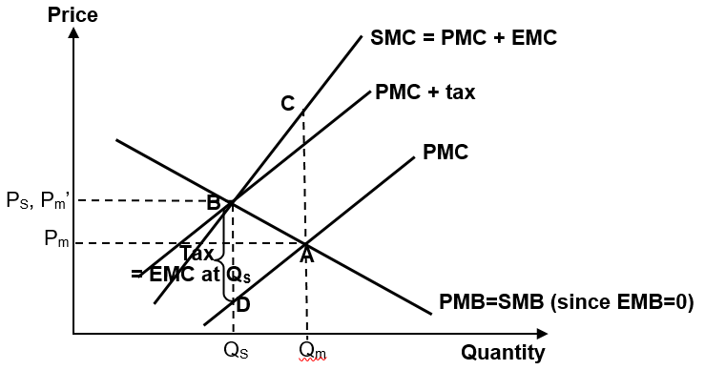

Government should consider the limitations of taxation
Lack of information
Even if a government decides to impose a tax equal to EMC, there will still be a problem of measuring those costs and apportioning blame as it is difficult to quantify the EMC due to soil erosion and droughts and give a monetary value to them

To correct the negative externality, the tax must accurately reflect the external costs. In reality, this is easier said than done. If the government over-estimate or under-estimate the external costs, then the problem of resource misallocation in the market for timber is still not fully resolved.

Administration and compliance cost
According to Extract 5, timber owners in Washington will have to apply for a permit from the Department of Natural Resources before they can start harvesting timber. They will have to fill up tax reporting forms in order to register and pay the necessary forest tax. This process might be costly and require a lot of manpower to oversee, incurring high administration and compliance cost.

Impractical to use different tax rates
To correctly internalise the externality, the tax should accurately reflect the external costs. However, timber owners produce varying amounts of externalities based on method of harvest timber. But it is administratively impractical to imposes different tax rates for timber owners. Logging activities can take many forms, from selective harvesting to limited, small-scale clear-cutting, which, in temperate forests, can mimic natural disturbances such as fires or landslides. Timber owners who engage in such sustainable way of harvesting timber might incur lower EMC than others. However, it would be extremely difficult to measure and ascertain how much EMC each timber owner incurs.

Government should consider the benefits of a total ban in resolving negative externality
A total ban represents an extreme form of regulation in which the authorities prohibits the production of timber.
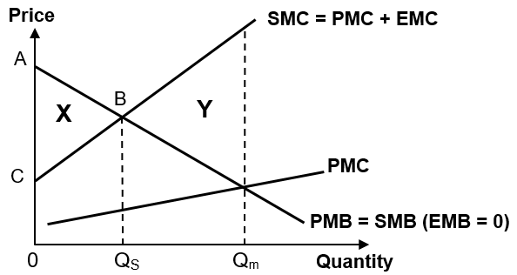

The above diagram compares the welfare loss caused by the negative externality from producing timber with the welfare loss brought about by a total ban of timber.

The market equilibrium quantity is at Qm where PMB = PMC, compared to the socially efficient quantity QS where SMB = SMC. Hence there is an overproduction of electricity from coal by quantity Qm - QS, which results in a deadweight welfare loss of area Y.

When there is a total ban, zero quantity of electricity is generated. In such a situation, there would be a loss of Area X (0ABQs – 0CBQs) measured in terms of potential net welfare benefit forgone if the socially efficient quantity of good was produced.

On the other hand, a stoppage of production would result in a welfare gain of Area Y caused by overproduction. Hence, final outcome on welfare would depend on the relative size of Area X and Area Y. According to the above diagram, a total ban is beneficial since Area Y > Area X and hence there would be a net welfare gain from imposing the ban.

Government should consider the other benefits of a total ban to the economy
Logging ban will lead to actual growth of Melbourne’s economy.
Victoria's central highlands is essential to contributing to the tourism economy in the most populous city of the Australian state of Victoria. It is estimated that the central highlands add $260 million to tourism. Given that “tourism is a major employer in the region” (extract 1), this will lead to a substantial increase in the X component of AD, causing AD to shift to the right. Actual growth results as the equilibrium NI increases.

Victoria's central highlands is also essential to protecting Melbourne's water supply. By stopping logging, the water catchment would be improved and would maximise "water yield and quality" and increase the amount of water that “flows into the dams for the city of Melbourne.” (extract 1) These dams will power hydroelectric power stations that generates “cheap, renewable electricity”, hence lowering cost of production and shifting SRAS to the right, leading to actual growth as the equilibrium NI increases.

Government should consider the limitations/unintended consequences of a total ban
Government intervention in the form of total ban may be costly to administer and enforce. The administrative costs of administering and enforcing a ban to correct market failure in the market for timber may outweigh the social benefits from the correction. For example, the cost of monitoring the entry of banned products for a large country would be high. Also, it may work against the welfare of the society if the ban (a regulation) results in greater welfare loss (i.e. Area X > Area Y).

According to Extract 1, native logging and processing in Victoria has helped generate more than $500 million for the state's economy supporting more than 2,000 jobs. A total halt/ban on logging can lead to loss in jobs and national income.

According to Extract 5, the logging ban in Kenya has triggered a 36 percent and 11 percent rise in timber and furniture prices, respectively, in the past year, hitting the local construction industry hard.

In conclusion, a rational government should consider the cost, benefit and unintended consequence of the two policies in deciding which one to implement to achieve the best outcome. Both total ban and taxation will face the same problem of high administrative and compliance cost. While taxation aims to bring the equilibrium quantity of timber nearer to the social optimal level, a total ban is a more extreme form of regulation that brings the equilibrium quantity to zero, eliminating any welfare gain that timber can bring to society. Given the importance of timber in producing various products such as furniture and paper, and the number of jobs and national income that the industry supports, a total ban might not be the best policy to tackle market failure in the market for timber. In particular, it is likely that area X > area Y in the last diagram, meaning that a total ban on logging might lead to more cost than benefits. Hence, taxation would be a better policy to reduce inefficient allocation of resources in the market for timber.

