**J2 H1 Economics – Final Revision 2019 – Lesson 3**

**The Energy Market**

**Extract 1: US electricity industry's use of coal fell to historic low in 2015**

America’s use of coal for electricity dropped to its lowest point (just 34% of US electricity generation) in the historical record in 2015. Prices crashed, thousands of miners were laid off and big coalmining companies went bankrupt.

The biggest threat to coal last year remained cheap natural gas. There was also a spike in new wind and solar power. By the end of last year, wind and solar accounted for 5.4% of the energy mix, up slightly from 2014.

Some power companies opted to shut down old, coal-fired power plants, in advance of the clean power plant rules. These shutdowns represented about 5% of the entire fleet.

Source: The Guardian, 4 February 2016

**Figure 1: Cost of coal and natural gas for**

**electric generating plants in the US (2000-2016)**

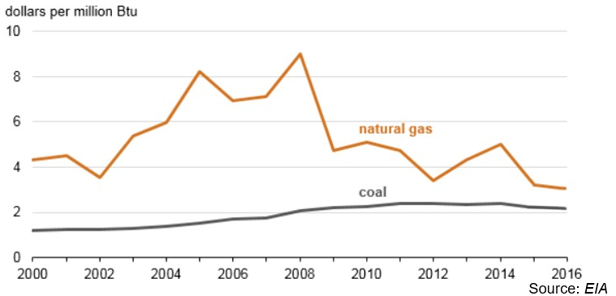

**Extract 2: Are energy regulations hurting economic growth?**

Energy is essential for economic development. Increasing its production by any means will boost the economy, and limiting it in any way, as through emission controls will hurt it. This is however wrong. Thanks to decades of innovation, smart regulation, and technology investment, the nation can grow and decarbonise at once. The key is to accelerate the move to low-carbon technology by strengthening not eliminating the rules and technology investments that are driving it.

Far from being a prohibitive drag on economic growth, decarbonisation, or making the way that we get energy less dependent on burning fossil fuels that release carbon emissions, has gone hand-in-hand with output growth in most of the United States, according to research by the Brookings Institution. From 2000 to 2015, US Gross Domestic Product grew by 30% though emissions declined by 10%.

The reduction in emissions has more to do with innovation-driven technology change, market forces, and industry restructuring. A recent Energy Information Administration analysis concludes that more than two-thirds of the country’s and individual states’ emissions reductions between 2005 and 2015 were due to fuel-use changes in the power sector - changes that reflect decades of government research and commercialization focus on low- carbon technologies.

Most notably, the nation’s recent ‘decoupling’ owes heavily to the advent of cheap natural gas, as well as to the plummeting prices of renewables. Innovation policies have expanded low-carbon energy options, pushed wholesale electricity prices to record lows, and accelerated the retirement of America’s aging coal plants. The Brookings analysis shows that coal plants’ share of state electricity generation declined in more than 43 states, thanks to technology change.

All of this makes obvious the best way forward. The government should increase low-carbon research and development and accelerate the development of new technologies that can allow further growth. For example, new grid scale energy storage technologies could enable intermittent renewable energy sources like wind and solar to take a greater share in the power generation mix by delivering their electricity to the grid even when the sun is not shining and the wind is not blowing. An era of abundant and inexpensive clean energy awaits.

Source: The Washington Post, 21 December 2016

**Extract 3: British doctors and health professionals call for rapid coal phase-out**

Air pollution from coal plants causes many serious health conditions including stroke, coronary heart disease and lung cancer. It disproportionally affects children and kills more people than road accidents. In the UK, burning coal is linked to 1,600 premature deaths, 68,000 additional days of medication, 363,266 working days lost and more than 1 million incidents of lower respiratory symptoms. The monetary cost is as much as £3.1bn each year in human health impacts.

Groups representing Britain’s 600,000 doctors and health professionals say it is ‘imperative’ to phase out coal rapidly to improve health and reduce National Health Service costs.

Source: The Guardian, 19 October 2016

**Extract 4: UK-wide carbon tax would have 'little impact' on consumers**

A ‘modest’ uniform carbon tax of £20 a tonne would have a negligible impact on consumer prices (increase by up to just 0.9%) according to a new study that attempts to make the case for wider adoption of carbon pricing policies.

However, the true cost impact on consumers is likely to be even lower, given the manner in which the carbon tax would incentivise green behaviour change, drive business innovation, and provide the Treasury with revenues that it could recycle back into the economy.

Opponents of carbon taxes argue they would impose costs on consumers and undermine the competitiveness of carbon intensive industries such as the Big Six electricity generators (British Gas, EDF Energy, E.ON, Npower, Scottish Power, and SSE). Last year the government moved to ease these concerns, exempting a raft of energy intensive industries such as steel and concrete manufacturing from existing carbon taxes and ‘green levies’.

Source: The Guardian, 11 January 2016

**Extract 5: Ways to reduce the usage of energy**

Traditional vehicles and energy sources will continue to hold a competitive edge against greener alternatives due to the vast amounts of subsidies they receive. Though subsidies are also provided to electric vehicles, they aren’t equal to the applied subsidies of gasoline vehicles. This weakens the economic forces in transition to sustainable transport and energy. Educating the public on climate issues will be essential.

Another way is by tradable permits used by some European countries. The Emissions Trading Scheme’s ‘cap and trade’ scheme creates a limited emissions market, within which 11,000 power stations and industrial plants can buy or sell allowances. It is lauded by supporters for a market-based approach that rewards greener firms with tradable credits, while encouraging dirtier firms to clean up their act, or offset their emissions by paying for accredited emissions cuts elsewhere.

Critics have raised questions about the veracity of some of these schemes, the over- allocation of free allowances to heavy polluters, and the extent to which current prices can help fuel switching.

The system does have a mechanism to gradually reduce the number of carbon credits available - and so raise prices but the note says that this will not be enough to cut emissions to at least 80% of 1990 levels by 2050, as the European Union has promised.

Source: The Guardian, 5 May and 29 Feb 2016

**Questions**

(a) Compare the cost of coal and natural gas for electric generating plants in the US between 2002 and 2016. [2]

(b) With reference to Extract 1 and using supply and demand analysis, explain the impact of cheap natural gas and the shutdown of coal-fired power plants on the market for coal. [6]

(c) With reference to Extract 2 and using a PPC diagram, explain and comment on the view that decarbonisation has gone hand-in-hand with economic growth. [8]

(d)(i) Explain two factors that a government should consider in making a rational decision to subsidise electric vehicles. [4]

(ii) Explain one possible unintended consequence of subsidising electric vehicles. [2]

(e) Extract 4 suggests that a ‘modest’ uniform carbon tax of £20 a tonne would have a negligible impact on consumer prices. Explain this claim, and comment

on whether it is valid. [7]

(f)(i) Explain how ‘the burning of coal’ results in market failure. [4]

(ii) Using Extract 5, discuss the view that the implementation of tradable permits is the best way to solve the market failure arising from ‘the burning of coal’. [12]

[Total: 45]