J2 H1 Economics – Final Revision 2019 – Lesson 5

Seeking Sustainable Growth:
Short-Term Recovery; Long-Term Challenges

Extract 6: Global Prospects

The global upswing in economic activity is strengthening. Global growth, which in 2016 was the weakest since the global financial crisis at 3.2 percent, is projected to rise to 3.6 percent in 2017 and to 3.7 percent in 2018. Broad-based upward revisions in the euro area, Japan, emerging Asia, emerging Europe, and Russia—where growth outcomes in the first half of 2017 were better than expected—more than offset downward revisions for the United States and the United Kingdom.

But the recovery is not complete: while the baseline outlook is strengthening, growth remains weak in many countries, and inflation is below target in most advanced economies. Commodity exporters, are particularly hard hit as oil prices fall.

The welcome cyclical pickup in global activity provides an ideal window of opportunity to tackle the key policy challenges—namely to boost sustainable output and to build resilience against downside risks.

Source: International Monetary Fund, October 2017

Table 1: Annual real GDP growth (%) in selected countries

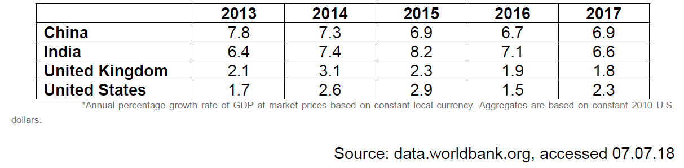

Table 2: Annual population growth (%) in selected countries
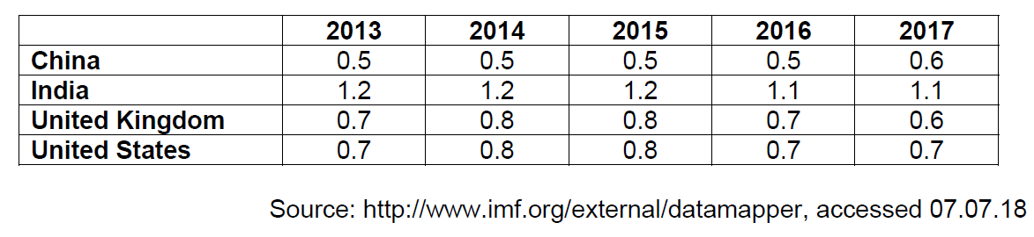

Figure 2: Annual CO₂ Emissions per capita (Metric tons)

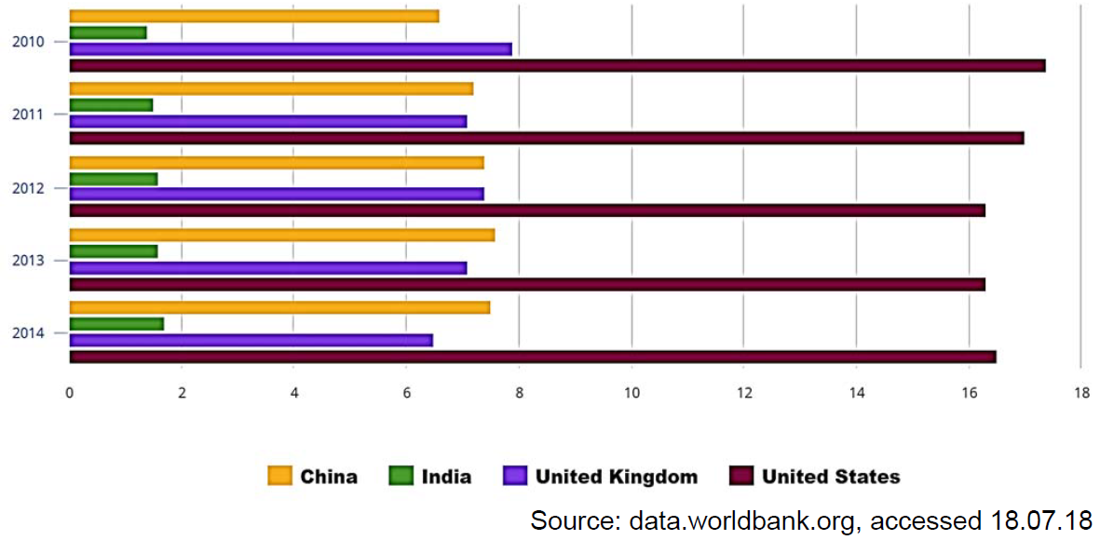

Extract 7: UK economy lags behind after 2017 growth rate cut

Britain’s economy was weaker than previously thought in 2017, official data showed on Thursday, leaving the country lagging further behind the global recovery as it prepares to leave the European Union. Gross domestic product growth slowed to a quarterly 0.4 percent from a previous estimate of 0.5 percent, reducing 2017 growth as a whole to 1.7 percent, its lowest since 2012. However, this was still stronger than most economists feared immediately after Britain voted to leave the EU in June 2016.

But the country has relied heavily on the unexpectedly robust global economy to sustain its economic growth while consumers have been squeezed by higher inflation caused by the fall in the pound after the Brexit vote.

The downgrade of the full-year and fourth-quarter growth rates also raised questions about the strength of the economy as the Bank of England prepares to raise interest rates. Alan Clarke, an economist at Scotiabank, said the figures showed Britain’s economy was growing at roughly the pace the Bank of England sees its new, lower speed limit, meaning a rate hike was still on the cards.

But Samuel Tombs, at Pantheon Macroeconomics, said the data showed the central bank should delay any action for now. “The latest GDP data suggest that the economy remains in a fragile state and does not need to be cooled with another rate rise as soon as May,” he said in a note to clients.

Source: Reuters, 22.02.2018

Extract 8: China's 2017 GDP growth accelerates for first time in seven years

China’s economy grew faster than expected in the fourth quarter of 2017, as an export recovery helped the country post its first annual acceleration in growth in seven years, defying concerns that intensifying curbs on industry and credit would hurt expansion. China’s gross domestic product grew 6.8 percent in the October to December period from a year earlier. That was better than the 6.7 percent growth forecast by analysts

A synchronized improvement in the global economy over the past year, driven in part by a surge in demand for semiconductors and other technology products, has been a good news to China and much of trade-dependent Asia, with Chinese exports in 2017 growing at their quickest pace in four years. Investment by private firms also rose.

The official growth figures released on Thursday are welcome news for Beijing policymakers who are looking to cut debt and pollution in older industries without stunting growth in the world’s second-largest economy. But there could be rising headwinds to further expansion of China’s net exports in 2018.

China’s excess production capacity has emerged as a major trade irritant for the world’s leading economic powers, prompting them to consider new steps to protect domestic industries and jobs from a flood of Chinese imports. U.S. President Donald Trump’s administration is considering several unilateral tariff actions on steel, aluminium and China’s intellectual property practices likely to draw disputes from WTO members.

There were some positive signs in the household sector in 2017, however, with disposable income growth picking up to 7.3 percent from 6.3 percent in 2016, and final consumption playing a bigger role in driving overall growth last year versus investment than in 2016.

Economists also say growth momentum in the economy is likely to weaken as firms face higher borrowing costs, the government tries to rein in credit and policymakers step up a war on pollution that has hurt the industrial sector in many parts of the country.

Source: Reuters, accessed 18.01.2018

Extract 9: The effects of weather-shocks on economic activity: How can countries cope?

Global temperatures have increased at an unprecedented pace over the past 40 years, and significant further warming could occur, depending on our ability to restrain greenhouse gas emissions, of which has been strongly coupled with increasing economic activities. The greenhouse gas emissions that cause climate change are emitted mainly from burning fossil fuels such as coal, oil and natural gas, which is the most important source of greenhouse gas emissions.

The rise in temperature over the past century has been broad based. No country has been spared from the warming of the Earth’s surface, and no country is projected to be spared. Increases in temperature have uneven macroeconomic effects, with adverse consequences concentrated in countries with relatively hot climates, such as most low-income countries. Extreme weather events, such as heat waves, droughts, and floods, are likely to become more frequent, and sea levels will rise, all of which in both the short and medium term, reduces output, suppresses the productivity of workers exposed to heat, slowing investment, and damaging health.

Strategies that reduce specific climate change effects and risks could also be part of the toolkit for reducing the economic damage caused by climate change. Countries negatively affected by climate change will need to increase their resilience to rising temperatures and extreme weather events, both by enhancing their ability to smooth out shocks, which could become more frequent, and by investing in strategies, such as activity diversification, infrastructure investment, and technology innovation, that reduce the harm they do. Populations may also respond to changing climatic conditions by relocating geographically, which could have important cross-border impact. But putting in place the right policies will be particularly difficult in low-income countries, which have huge spending needs and limited ability to mobilize the resources necessary for adaptation in a challenging economic environment.

Source: International Monetary Fund, October 2017

Questions:

(a)(i) Explain what is meant by real GDP per capita. [2]

(ii) With reference to data, compare the likely changes in living standards of China and United States during the period 2013 to 2017 and comment on the validity of the conclusion base on the data given. [7]

(b) Using Extract 6, explain why commodity exporters, are particularly hit hard
as oil prices fall. [3]

(c) Using an AD/AS diagram, explain how the fall in the pound after the Brexit vote could have led to higher inflation in the UK. [5]

(d) Extract 7 suggest that the Bank of England is preparing to raise interest rates as the Britain’s economy recovers.

Explain two possible factors that would affect the Bank of England’s decision to raise the interest rates. [4]

(e) With reference to Extract 9, explain the market failure associated with increasing economic activity. [4]

(f) “The rise in temperature over the past century has been broad based. No country has been spared from the warming of the Earth’s surface, and no country is projected to be spared.”

Discuss the macroeconomic impact of the rise in temperatures on different countries. [8]

(g) Using evidence from the case study and/or your own knowledge, discuss the policies governments can take to boost sustainable growth. [12]

[Total: 45 marks]

