J2 June Intensive Revision 2015
L1 – CSQ – Demand and Supply/Elasticity of Demand and Supply/Government Regulation – Q1
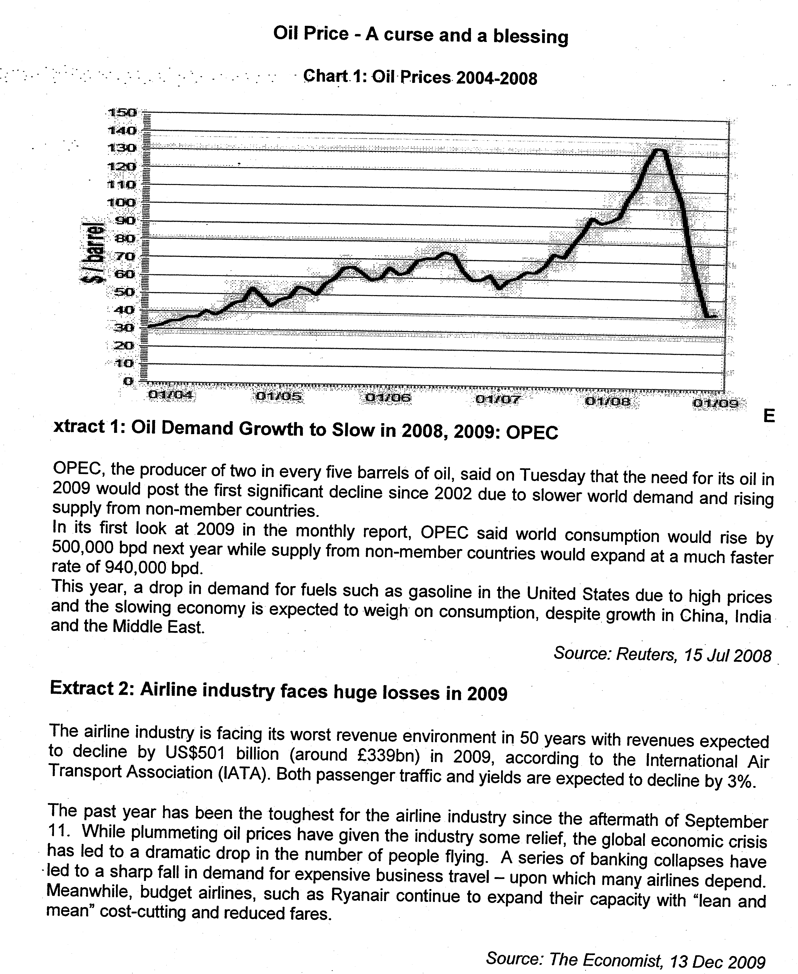

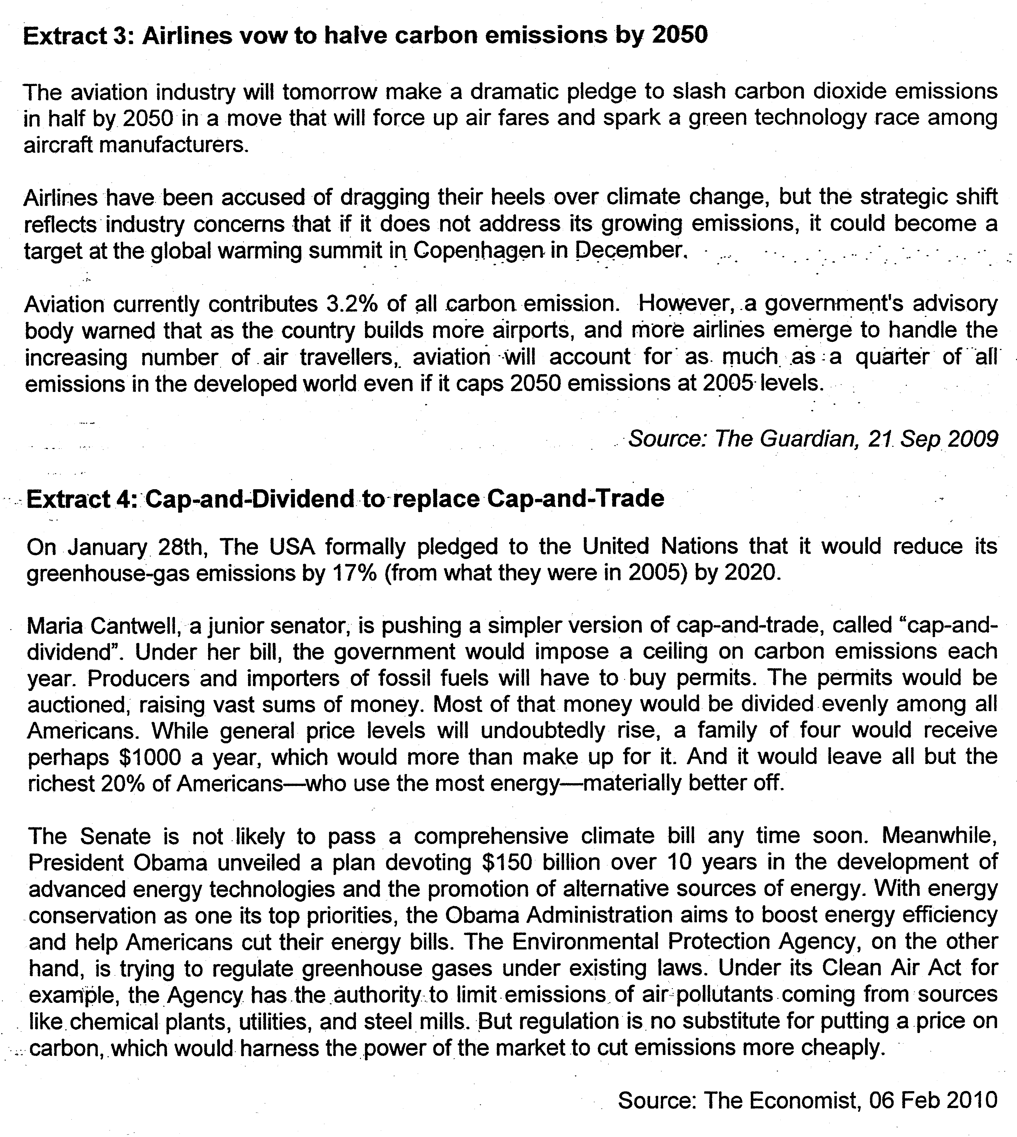Questions
(a)(i) Using Chart 1, describe the trend of oil prices from 2004-2008. [2]

(ii)Based on Extract 1, explain the possible reasons for the trend of oil prices in the second half of 2008. [5]

(b) Using demand and supply concepts, explain how passenger traffic would change in 2009 with the help of a diagram. [5]

(c)(i) With reference to Extract 3, explain if there is a heed for the government to intervene in the airline industry. [8]

(ii) Assume that you are the Minister for the Environment of Singapore. Taking into consideration the possible impact on the economy, justify which of the policies found in the extracts you would choose to curb carbon emission.

Suggested Answers
(a)(i) Using Chart 1, describe the trend of oil prices from 2004-2008. [2]

Oil price increased from 2004 to mid-2008 before falling sharply. The price of oil rises in a fluctuating pattern over this time period.

(a)(ii) Based on extract 1, explain the possible reasons for the trend of oil prices in the second half of 2008. [5]

SS was rising due to greater output from non-OPEC oil producers. DD rose too as indicated by demand growth slowing. However, SS was rising at a much after rate than DD. The increase in SS outweighed the increase in DD, exerting downward pressure on prices.DD for oil tends to be price inelastic, as oil is a necessity, being a major source of energy. Furthermore, there are few close substitutes for oil. The extent of price falls depends on the PED [and PES] of oil. For a given increase in SS, prices would fall more than proportionately [compared to the increase in quantity.] This explains the sharp fall in oil prices.

(b) Using demand and supply concepts, explain how passenger traffic would change in 2009 with the help of a diagram. [5]

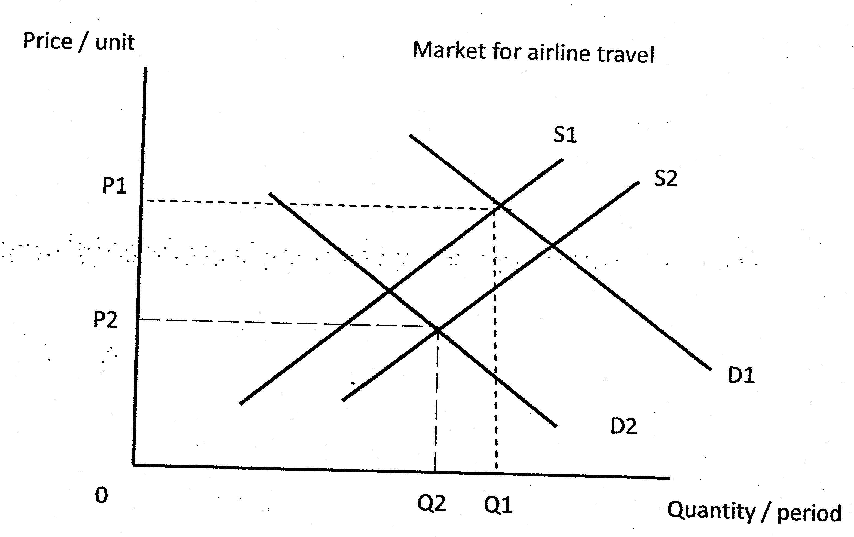
With the global recession, purchasing power fell. Particularly, the airlines were hit badly by the sharp decline in the business class. As such, demand for air travel decreased significantly [from D1 to D2].

Falling fuel prices led to a fall in cost of production, leading to higher production levels. Furthermore, as budget airlines "expand their capacity", supply further increased. As such, supply curve will shift rightwards from S1 to S2.

Overall, the impact on passenger traffic depends on the relative shift of DD and SS curves. According to Extract 2 Para 1, passenger traffic was expected to decline. As such, we could conclude that the fall in demand would outweigh the increase in supply, leading to a fall in air traffic volume.

(c)(i) With reference to Extract 3, explain if there is a need for the government to intervene in the airline industry. [8]

Air travel can be considered a demerit good as it generates high carbon emission (can reach a quarter of all emissions in developed countries in 2050) which worsens global warming/climate change. This third party spillover effect/negative externalities, given by the divergence between MSC and MPC, or MEC, is not taken into consideration by the airlines. The market equilibrium for air travel is obtained at MPB (demand for air travel) =MPC (operating cost to airlines). As the third party effects are not internalised, MSC is higher than MPC, leading to overconsumption/overproduction of air travel given by Q-Q*. Hence government intervention is needed to lower consumption/ production to bring air travel to the social optimal level where MSC=MSB to bring about allocative efficiency.

While "aviation currently contributes [only] 3.2% of all carbon emission," [Extract2 Para 3], its impact on the environment will become increasingly significant. Hence this warrants government intervention to nip the problem in the bud.

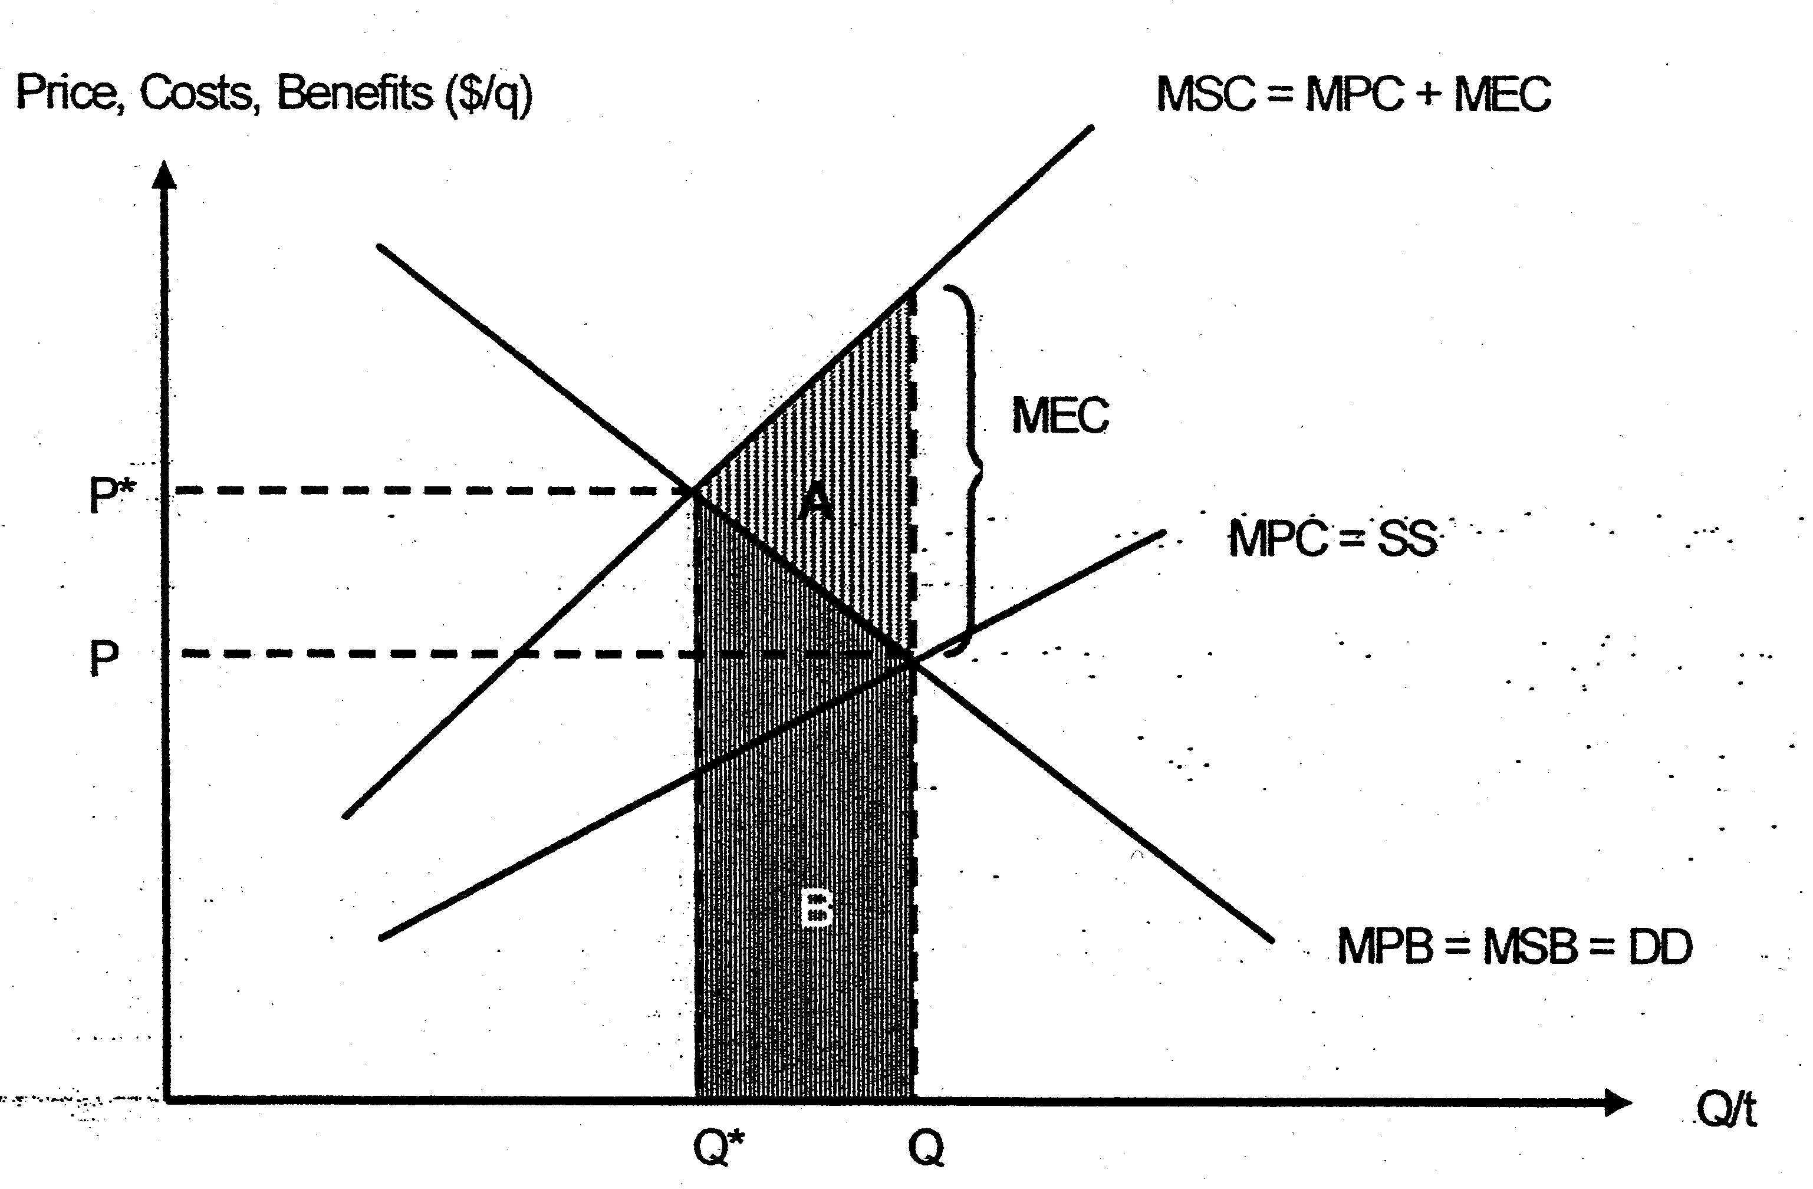

However, airlines are already contemplating slashing carbon dioxide emissions without any action from the state [Extract 2]. This means that the possibility that punitive measures would be imposed on the airline industry due to their inaction with regards to their emission would be sufficient incentive for firms to regulate themselves. As such, there might be no need for government intervention.

(c)(ii) Assume that you are the Minister for the Environment of Singapore. Taking into consideration the possible impact on the economy, justify which of the policies found in the extracts you would choose to curb carbon emission. [10]

Identify the policies:
- The 'cap and dividend' policy is to impose a ceiling on carbon emission each year. Producers and importers of fossil fuels will have to buy permits. This will make the firms internalize the third party costs they impose on the society, shifting MPC closer to MSC. This increase in production cost will lower consumption/production levels closer to socially optimal level where MSC=MSB. The revenue obtained is then distributed to families.
- Development and promotion green technology/ alternative fuels, [with "state investment"].
- Regulation of greenhouse gases under existing law.

Advantages/Limitations of policies:
The 'cap and dividend' is a market-based measure and hence gives firms greater incentive to cut down on carbon emission. This is because driven by profit motive, firms are inclined to reduce their COP by spending less on permits.

Emission can effectively be capped at desired levels relatively quickly.

In addition, it is equitable as the higher users of energy (numbering about 20%) have to pay more despite the payment of a dividend to all families.

However, higher production costs would lead to cost-push inflation. The cost of living will rise and offset the dividend payment they received. Standard of living may also be compromised.

Singapore may lose price competitiveness in its exports. Foreign firms are also less likely to invest in Singapore in view of lower expected profits. This may worsen economic growth, unemployment and current account. [This is especially so as Singapore is dependent on external market, and produces goods whose demand is price elastic]

Furthermore, pollution is not as severe a problem in Singapore as we have relatively fewer heavy industries. As such, in view of our small market and low pollution levels, such a "cap and dividend" policy may be cumbersome and less effective in Singapore compared to in the US.

The promotion of green technology/alternative fuels would result in firms switching to cleaner production methods and reduce their dependence on fuels that produces carbon emission. The impact on carbon emission would be more long-lasting compared to "cap and dividend" and regulations.

Government investment/subsidies will expedite the process by relieving private firms of expenditure on infrastructure and R&D.

In addition, this might reduce Singapore's dependence on oil and our vulnerability to external shocks such as supply cuts by OPEC. If Singapore successfully gains comparative advantage in this area, it could also be our new niche of growth.

However, the effects would only materialize in the long run, unlike the case of" cap and dividend" policy. It takes time to develop the technology and for firms to abandon old practices and adopt new production methods. In addition, in the short run, as green technology is less widely adopted, cost tends to be high given the limited scope of economies of scale. Such cost considerations may deter firms from switching. As such, the impact on carbon emission reduction is also less certain.

Regulation is comparatively easy to understand and implement. For it to be effective, it must be backed by clear rules and penalties high enough to serve as a deterrent Monitoring costs can be relatively low given the small size of our country. However, regulation is a blunt policy. Unlike "cap and dividend" policy, regulations do not give firms the incentive to cut emission beyond the standards set by the state. In addition, the government may not have sufficient knowledge to accurately determine the socially optimal level of carbon emission, and hence may worsen allocative efficiency. Furthermore, compared to the promotion of green technology, it is less effective in weaning firms off polluting production methods.

Conclusion:
While "cap and dividend' policy has merits in the reduction of carbon emission effectively, Singapore is less likely to adopt it as it might add to the cost of production of our manufacturing sector, which takes up a substantial component of our exports. This is too high a cost to pay to tackle pollution, which is not a serious problem in Singapore and has less repercussion on our economy. By contrast, in view of our aim to diversify our export base, and the potential of green technologies as a new niche of growth, development and promotion of the sector may appeal to the Singapore government. It may also provide a more lasting solution to pollution. As we have an efficient and corruption-free government, regulation may also be effective in Singapore. In addition, Singapore may complement its policies with education programme and subsidies to promote the adoption of cleaner production methods.

