J2 June Intensive Revision 2015

Micro – CSQ Test Question 1

Extract 1: Indian jewellery firm eyes global mart

Jewellery firm, Shrenuj acquired Diamond Trading Corporation's 50 per cent stake in Arisia Jewellery, a company that promotes the solitaire diamond jewellery brand Arisia. It is focusing on the luxury market with plans to launch diamond studded handbags, watches and mobile phones under its premium jewellery brand, Arisia. It plans to take Arisia into West Asia, Eastern Europe and China markets, which are emerging as lucrative markets. It was said that the company's entry in West Asia is a natural extension due to the presence of many Indian migrants there.

Shrenuj will make the Chinese debut with Joliesse, a Hong Kong-based jewellery chain, which it acquired in 2003. Pranava Bhargava, its group general manager, said, "We have re-positioned Joliesse as a mid-end fashion jewellery retailer. It plans to open two stores in China and 18 outlets in Hong Kong in the next two years.

Going forward, the company expects one-third of its revenues to come from the jewellery branding and retailing. "

Source: Rediff India Abroad, 11 January 2008

Extract 2: DeBeers

DeBeers, a South Africa-based holding company, is historically and currently the main driver of the diamond industry. It has proven itself in the market with revenues of US$7,958 million in 2005, an increase of 13% over 2004. Yet, DeBeers is seeing a gradual decrease in its market share to 43% in 2005 as other players are making a name for themselves and becoming a formidable threat.

Alrosa, a Russian state-owned diamond company produces nearly 100% of Russia's rough diamonds and more than 20% of the world's rough diamonds, making it the second largest producer, second only to DeBeers. The others are Rio Tinto and BHP Billiton, two major Australian firms in diamond mining, and Leviev, a Russian company which owns mines and is the largest cutter and polisher of diamonds in the world.

Source: Duke University Report, 2007

Extract 3: Why buy synthetic?

Laboratory diamond producers focused on the financial, environmental and political advantages that their product had over natural diamonds. Synthetic diamonds cost anywhere from 15% to 40% less than naturally mined diamonds and sometimes considerably less for coloured stones.

Compared to a natural diamond which required several hundred tons of earth be extracted for each carat often at the expense of both human and animal habitats, lab-grown diamonds were considerably more eco-friendly. According to the Canadian Arctic Resources Committee, as far as 200 kilometres downstream from the lake where Canada's Ekati diamond mine sat, environmental destruction, particularly of fish habitats, was seen in numerous lakes and streams. Diamond mining had also taken a toll on land-based wildlife habitats.

Source: David McAdams and Cate Reavis, MIT Sloan Management, 7 January 2008

Extract 4: The cartel isn't forever

On July 13th, DeBeers finally pleaded guilty to charges of price-fixing of industrial diamonds and agreed to pay a US$10m fine. DeBeers executives are at last free to visit and work directly in the largest diamond market, America.

For generations, the industry that sells $60-billion-worth of jewellery alone each year has been run by DeBeers as a cartel. The South African firm dominated the digging and trading of diamonds for most of the 20th century. It runs most of the diamond mines in South Africa, Namibia and Botswana that long produced the bulk of world supply of the best gemstones. For decades, if anyone had rough diamonds to sell on the sider DeBeers bought these toor A huge stockpile helped it to maintain high prices while it successfully peddled the myth that supply was scarce. DeBeers1 days of market dominance are clearly drawing to a close.

Price-fixers harm the entire economy. Consumers have to pay more for goods and services, and get less choice. Price-fixing also undermines faith in the benefits of markets. In America, authorities have been adopting fierce measures against price-fixing. Bosses are routinely sent to jail, and their companies can be forced to pay fines equal to three times the estimated damages.

Source: The Economist print edition, 15 July 2004

Figure 1: World GDP and Diamond Price, 1960 – 2008
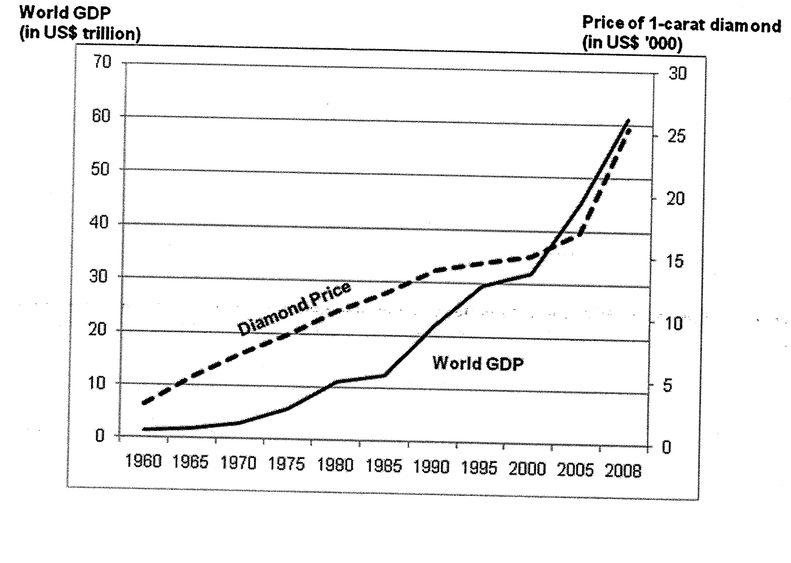
Sources: Antwerp World Diamond Trade Centre, 2010
World Bank, World Development Indicators, 2010

Questions
(a) Identify and explain the likely relationship between world GDP and the price of diamonds. [2]

(b) Assess the relevance of the concepts of elasticity of demand in explaining the strategies adopted by Shrenuj to increase its market share. [6]

(c)(i) Describe the type of market structure operating in the diamond industry. [2]

(ii) Using economic analysis and with an appropriate diagram, explain the effects of the entry of "other players" into the diamond industry on DeBeers' equilibrium price and output. [5]

(d) With reference to Extract 3, identify the type of externality that exists in the diamond industry and explain how it leads to inefficiency in resource allocation. [5]

(e) Evaluate the possible measures that a government could take to control a firm's market power, using both the case study and your own relevant knowledge. [10]
[Total: 30 marks]

Suggested Answers
(a) Identify and explain the likely relationship between world GDP and the price of diamonds. [2]

- From Fig 1, there is a positive/direct relationship between world GDP and the price of diamonds
- Higher GDP means higher incomehigher purchasing power higher demand for normal goods such as diamond shortage exerts upward pressure on price of diamond higher price of diamond

(b) Assess the relevance of the concepts of elasticity of demand in explaining the strategies adopted by Shrenuj to increase its market share. [6]

Direction: To explain the usefulness of PED, YED and XED concepts in helping the firm's owner increase its TR and consider the limitations of the Ed data; use of evidence.

Usefulness of YED concept:
- YED sign of diamond is positive which means it is a normal good [1/4m] and its absolute value is greater than one since dd for diamond is highly income elastic as it is a luxury good
- Shrenuj used this knowledge to determine its output decision. In times of economic boom when income rises, demand for diamond will rise more than proportionately, ceteris paribus greater rise in TR. To capture the greater increase in TR which translates to a significant rise in market share, Shrenuj has opened up more outlets which target at the higher end markets [1m] such as Asia, Eastern Europe and China markets

Usefulness of XED concept:
- Positive and high XED value for Shrenuj's diamonds and other retailers' diamonds as well as synthetic diamonds to indicate the close substitute relationship between these goods
- To make rivals' goods a weaker substitute of Shrenuj's diamonds so as to retain its own market share as well as to increase demand for Shrenuj's diamond branding and retailing marketing the product overseas since Shrenuj will make the Chinese debut with Joliesse broadens its consumer base and raises consumers' awareness of Shrenuj diamonds rise in demand rise in TR rise in market share
- Ed data is of limited relevance as Ed data is based on ceteris paribus assumption; in reality, more than one factors such as price of substitutes and income are changing continuously rendering the data inaccurate.
or
- Ed data is of limited relevance as in reality ceteris paribus assumption does not hold. Hence, firm used other strategies to increase market share acquisition which enables the firm to become larger and controlling a larger proportion of the diamond industry

(c)(i) Describe the type of market structure operating in the diamond industry. [2]

- Oligopoly - few dominant firms controlling the industry or high barriers to entry such as ownership of diamond mines and high capital outlay
- DeBeers, Alrosa, Rio Tinto and BHP Bilton possessing more than 63% market share

(c)(ii) Using economic analysis and with an appropriate diagram, explain the effects of the entry of "other players" into the diamond industry on DeBeers' equilibrium price and output. [5]

- More players into the industry means that there will be more close substitutes available in the industry
- De Beers will experience a fall in its demand illustrated by a leftward shift of the demand curve from DD_{i} to DD_{e} since some of the consumers would switch over to buying substitute goods as a result of change in taste and preference and face a relatively more price elastic demand as consumers would be more sensitive to price change due to the availability of more close substitutes in the market represented by a relatively more price elastic dd curve DD_{e}’
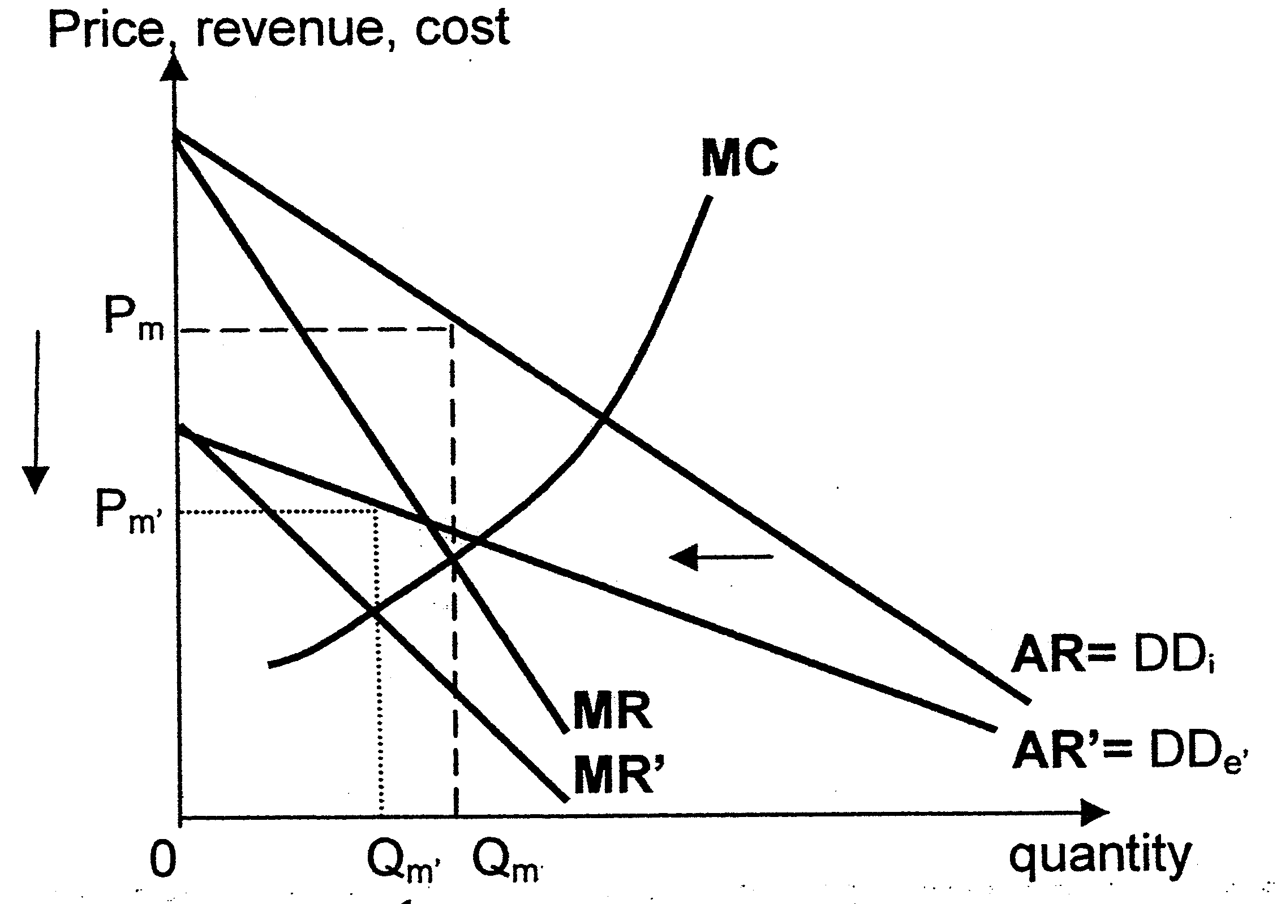

- DeBeers' profit maximizing output level MC=MR' would be at Qm' and its equilibrium price would be determined by the new DD curve DD_{e’} at P_{m}'
- Thus, there would be a fall in equilibrium price from P_{m} to P_{m’} and a fall in equilibrium output from Q_{m} to Q_{m’}

(d) With reference to Extract 3, identify the type of externality that exists in the diamond industry and explain how it leads to inefficiency in resource allocation. [5]

- Negative externality
- Negative externality gives rise to 3rd party cost which is the marginal external cost in this case for example, 3rd party would be the fishermen who live near the Ekati diamond mine and who were not directly involved in the production or consumption of diamond and the MEC would be the loss of fishermen's income as a result fish habitats being destroyed and these fishermen were not compensated

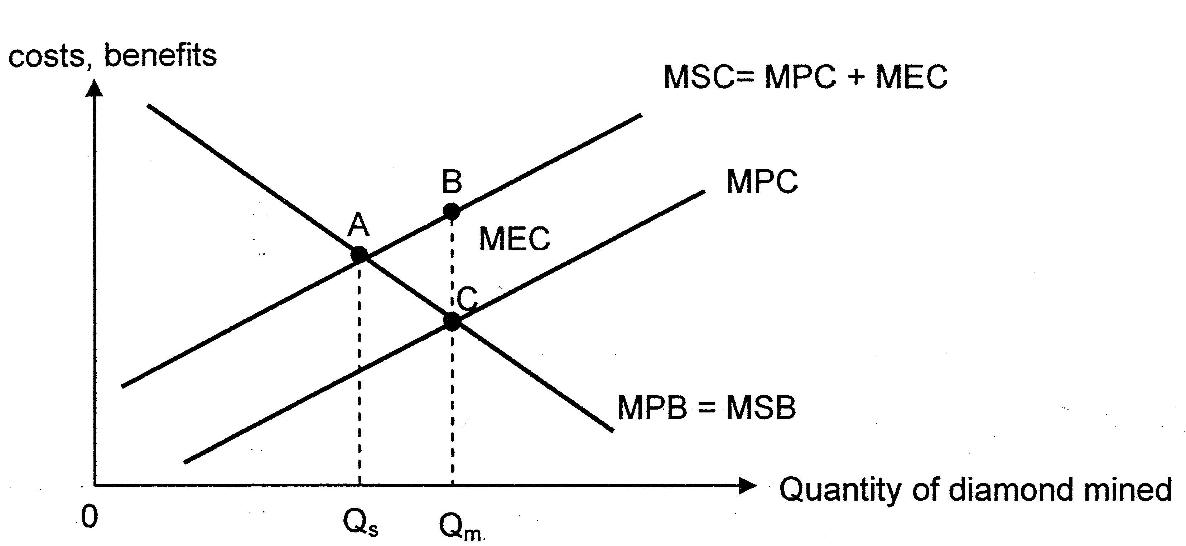
- Assume no MEB, MPB=MSB
- Due to presence of MEC, divergence of MPC and MSC [
- Explain private equilibrium is at attained in the pursuit of self-interest where MPB=MPC at Qm and social equilibrium is where MSB=MSC at Qs
- Overproduction of diamond as Qm > Qs
- Explain DWL: every additional unit of diamond mined adds more to MSC than to MSB summation of MSC> MSB over QmQs (area ABC)represents welfare loss as society could be better off if production of diamond were reduced since existing resource allocation can be changed to make someone better off without making someone else worse off, there is inefficiency in resource allocation at present

(e) Evaluate the possible measures that a government could take to control a firm's market power, using both the case study and your own relevant knowledge. [10]

i. Rules and Regulation
- Bosses are routinely sent to jail, and their companies can be forced to pay fines equal to three times the estimated damages
- By imposing penalties and fines on firms which are found guilty of abusing their .market power reduces the incentives of dominant firms to exploit the consumers by restricting output to push up the price of good, in this case diamond profits obtained from exploiting consumers via higher TR would be reduced as a result of the fines or any legal costs firms would be discouraged from growing larger to exploit the consumers.
- Evaluation
Costs incurred by govt to engage authorities to carry out checks to ensure that dominant firms have not abused their market power funds used to finance authorities in charge could be-used elsewhere to develop the economy such as build better healthcare system or educational facilities opportunity cost incurred compromises on future quality of life future SOL compromised

ii. Control / Regulation of Natural Monopolies - AC or MC pricing
Diagram
- A natural monopoly occurs in industries where a tremendous amount of capital is required to produce a product or service e.g. national postal network, telephone network etc.
- This huge capital requirement means that total fixed costs make up a very large part of the total cost. Hence, output level has to be very large for the firm to be operating efficiently. The industry will be better off with only one firm supplying the entire market as the producer can produce increasingly large quantities of output at lower cost.
- Because of the nature of a natural monopoly and the fact that the product is usually one that society feels is essential, it is necessary for the government to regulate the firm so as to ensure that the consumers benefit from the low per unit costs of production.

iii. Marginal cost pricing
- Since firms with monopoly power tend to be allocatively inefficient, one of the ways to control monopoly power is to ensure allocative efficiency is achieved by the firm can be done via me pricing
- Diagram
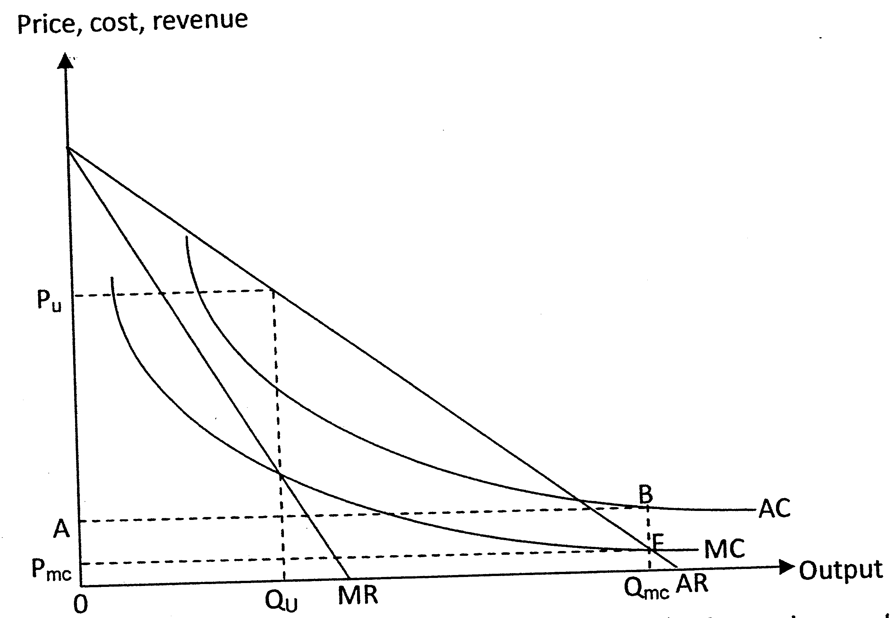

- Before regulation, the profit-maximizing monopoly produces at output 0Q_{u} and charges 0P_{u} for each unit of output.
- With MC-pricing regulation, it produces at higher output 0Q_{mc}, and charge lower price 0Pmc for each unit of output.
- Since the firm operates in the decreasing portion of the average total cost curve, average total cost must be higher than marginal cost. If price is set equal to marginal cost, price is less than average total cost, and the firm incurs a loss.
- Total output = 0Q_{mc}
- Total Revenue = 0P_{mc} x 0Q_{mc} = 0P_{mc}FQ_{mc}
- Total Cost = 0ABQ_{mc}
- Total loss incurred =P_{mc}ABF
Evaluation
- While the firm can continue to operate in the short run as long as price is above average variable cost; in the long run, the firm goes out of business and consumers will be deprived of the good or service.
- Therefore marginal cost pricing alone is not a viable solution if the good is to be produced in the long run.

iv. Legal restriction
- With a view to cut down on wasteful competition and recognizing that some degree of monopoly is inevitable, the government allows the monopolies fairly free to operate under private ownership. At the same time, to protect the consumers, the state must approve of any increase in price the monopolist charge for his product e.g the Public Transport Commission in Singapore must approve of any increase in public transport fares. This is to ensure that excessive profit is not made by the monopolist.
Evaluation
- Costs incurred by govt to engage authorities to carry out checks to ensure that dominant firms have not abused their market power funds used to finance authorities in charge could be used elsewhere to develop the economy such as build better healthcare system or educational facilities opportunity cost incurred compromises on future quality of life future SOL compromised

Conclusion
Given the range of policies to control monopoly power, there is no best method. The type of regulation used by the government depends very much on the objectives of the government. The government may need to use a combination of measures if it deems that monopoly power should be controlled.

