Chapter 3 Government Regulation

Content Teaching
1. Overview
2. Price Ceiling
3. Price Floor
4. Tax
5. Subsidies
6. The Market for Cotton
7. Agriculture, water crisis and poverty
8. Removal of Subsidy
9. Minimum Wage

Chapter 3 Government Regulation

Overview

When the market fails to attain its micro-economic aims, the government has to implement policies to ensure that the market satisfies the aims of equity and efficient allocation of resources. To achieve this, the government can affect the market by influencing the price level or output level through market or non-market solutions.

These solutions can be effective or ineffective, depending on the nature of the market situations and the limitations of the policies. The policies’ effectiveness is also examined based on the value of PED and PES, the nature of the goods, cost of financing, effectiveness of the government and the limitations of the policies.

1. Price Ceiling
1.1 Explain the mechanism of Price Ceiling
A maximum price set artificially by the government of firms so that goods are bought and sold at that price level which is below the market equilibrium price level. The purpose in setting the price ceiling is to prevent excessive increase in price so that consumers will not pay a higher price at the market price level which may be controlled by the seller to exploit the consumer. In doing so, the government is trying to allocate goods in a more equitable approach to ensure that there is no unequal distribution of the benefits of the goods especially for scarce resources during a crisis.

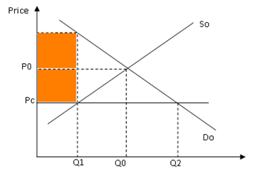

As seen from the diagram, the price is lowered from Po to Pc when there is the imposition of price ceiling and this causes an increase in quantity demanded from Qo to Q2 while the quantity supplied decreases from Qo to Q2. This creates an excess demand condition between Q1 to Q2 that may lead to a rise in black market condition where the price rises from Pc to Pm at the quantity level at Q1.

1.3 Difficulties in imposing price ceiling
- May create an excess demand condition which cannot be resolved if there is no buffer stock.
- may give rise to black market price if the market cannot have excess supply from buffer stock to meet demand
- It contradicts the market principles which will undermine the efficiency of the economy. (shift and costless adjustment of resources)
- The price ceiling may lead to the failure of the business as the fixed price level cannot accommodate the rise in average cost of production
- It undermines the producers as there will be a loss of producer surplus but the consumers will gain as the consumer surplus becomes bigger

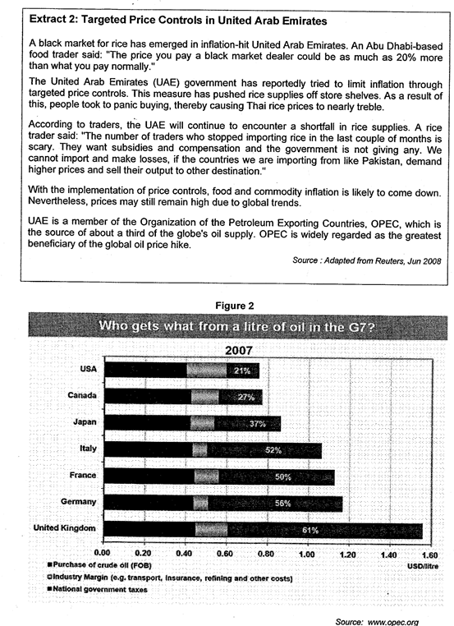

Practice Question 1
(b) With reference to Extract 2, explain, with the aid of a diagram, how price controls implemented by the UAE government may affect
(i) the market for rice. [3]
- Explain how the max price works to affect price of rice and the quantity transacted
Price Ceiling is the maximum legal price allowed by the government. To buy and sell goods at prices above this upper limit. In order for a price ceiling to be effective, the legal maximum price has to be below the market equilibrium.

b) Explain how this price ceiling affects the producers in the rice market

(b) With reference to Extract 2, explain, with the aid of a diagram, how price controls implemented by the UAE government in the oil market may affect
(i) the consumers. [2]
Explain how different groups of consumers are affected.
- Explain how a black market may arise.
Some consumers are able to purchase at a lower price P_{max} and they are better off now. However, others who were able and willing to purchase at P* are no longer able to do so. They may have to purchase from a black market at prices higher than P*. Quality of rice may be compromised.
(ii) the economy of UAE.
Their economic growth in the UAE is likely to shrink because of higher cost of production and reduced world demand leading to lower AD in each country. These, if allowed to persist, will lead to poor consumer confidence and bleak biz outlook. World production is likely to fall leading to fall in demand for oil from UAE. In the long run, world recession is likely and UAE will go down with the rest of the world.
1.5 Other forms of price discrimination in Singapore
1.5.1 Price Ceiling for HDB housing

1.5.2 Price Ceiling for University

2. Price Floor
2.1 Explain the mechanism of Price Floor
A minimum price is set by the government where the goods are bought and sold at the price level which is above the market equilibrium price level. This is applied to ensure that the producers can sell the goods at a higher level than the market price level so that the resource owner receives a reasonable level of revenue to keep them to continue production

A minimum wage scheme is the same as a floor price to ensure that the workers who are the resource owner for their work can get a certain level of income that enables the workers to cover their cost of living. This enables the workers to maintain their livelihood and have a reasonable level of income to counter inflation which may erode their purchasing power.

2.2 Explain how the price ceiling works

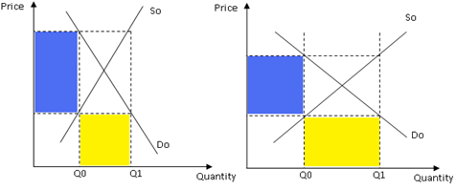

As seen from the diagram, the imposition of the price ceiling set the price at Pf which is above the market price at Po. This leads to a fall in quantity demanded from Q* to Qo while there is an increase in quantity supplied Q* to Q1, creating an excess supply condition at Pm. This means that there is a need to stock up the excess stock and keep as storage and used later. However, stockpiling can only be done if the product is non-perishable and the cost of storage is low.

2.3 Effects of Price floor
- The floor price creates excess supply condition which may require storage to prevent wastage but this causes the government a sum of expenditure to stabilize the price and ensure no wastage of the resources
- The high price may undermine the consumers as this high price reduces the purchasing power of the consumers
- The increase in price may induce the buyer of the resources to buy the cost of resources and this increases the cost of production. As a result, this may lead to price-wage spiral which can lead to inflationary condition

2.4 How price elasticity of demand and supply affects the cost of government expenditure when the government clears up the excess stock
- In setting up a stockpiling, the government needs a sum of money to stabilize the market. Hence, the government will attempt to use the method of price setting that will incur the least level of government expenditure. If the demand and supply are price-inelastic, the government will buy up the excess stock to create a buffer stock, assuming that the stock is non-perishable. (oil)
- If the demand and the supply are price-elastic, the government will subsidize every unit brought by the consumers at the level of quantity where the floor price is set with an amount equal to the difference in value of the market-clearing price and the floor price. This is also introduced when the goods to be regulated is perishable as the subsidy will encourage the consumption of the goods to ensure that there is market clearance at the floor price.

3. Tax

3.1 Direct Tax
Direct tax is directly levied by the government on the consumers/business entry where the tax is imposed based on the ability of the income earners to pay.

Real world examples of taxation:
- Personal Income Tax: Singapore’s personal income tax rates for resident taxpayers are progressive. This means higher income earners pay a proportionately higher tax, with the current highest personal income tax rate at 22%.
- Electronic Road Pricing: A usage-based tax mechanism served to complement COE

3.2 Indirect Tax (Types of Indirect Tax)

Indirect tax is imposed on the price of the good concerned based on the benefit of consumption where the tax burden is imposed on the seller or buyer.

3.2.1 Explain the mechanism of Specific Tax.
- Graphical Description

- Description of the graph

3.2.2 Explain the mechanism of Ad Valorem tax.

Price of good X
Quantity of good X
S_{tax}
D₀
P_{tax}
Q_{tax}
Q₀
P₀
S₀
Consumer tax burden
Producer tax burden
tax (20%)
Deadweight loss
Description of the graph

3.3.3 Explain the mechanism of Lump Sum Tax.

Price
Quantity
Q₀
MC
ATC₁
AR = DD
ATC₀
MR
P₀
Loss in revenue
t
A lump sum tax will raise the fixed cost of production. This is represented in the diagram above by a parallel upward shift of the ATC curve from ATC0 to ATC1. Price and quantity will remain at the production equilibrium level P0 and Q0 respectively. However, the revenue of the firm is reduced by the amount of shaded area above.

3.3 Impact of Taxation
3.3.1 Consumer Tax Burden
- Tax incidence that falls on the consumers (Ct).
- Consumers will take the entire tax burden if demand is perfectly inelastic and if supply is perfectly elastic. (change in price= tax amt100 % CTB)

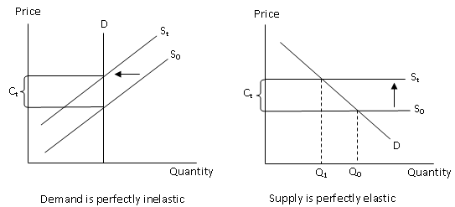

3.3.2 Producer Tax Burden
- Tax incidence that falls on the producers (P_{t}).
- Tax burden falls entirely on producers when supply is perfectly inelastic and when demand is perfectly elastic. (no. change in price- tax is 100%)
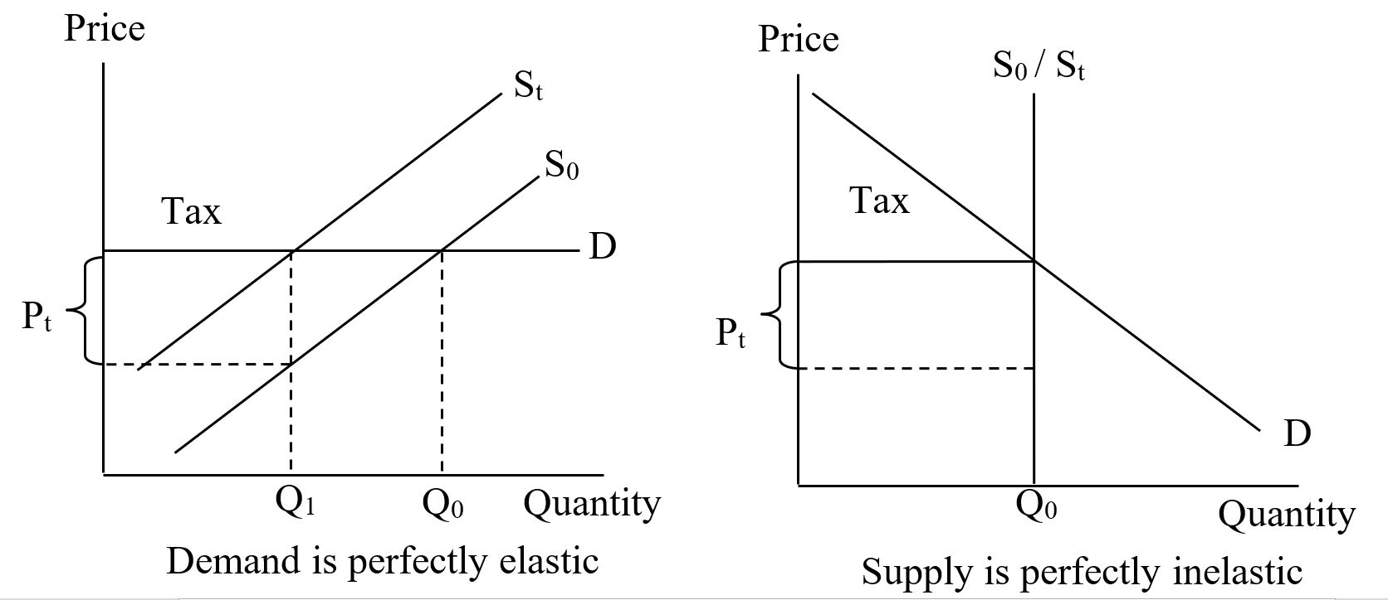

Real world examples of taxation:
- Goods and Services Tax: A broad-based value added tax levied on import of goods, as well as nearly all supplies of goods and services.

4. Subsidy

4.1 Explain the mechanism of Subsidy
- Subsidy is a transfer payment to the producers by the government to lower the price of the good concerned. The effect of this subsidy either raises the consumer benefit or producer benefit, depending on the value of price elasticity of demand
- Specific subsidy causes a parallel shift downwards and to the left.
- Ad valorem subsidy causes a pivoted shift in the clockwise direction.

4.2 Explain how the provision of subsidy affects the consumers and producers
4.2.1 - Diagram

4.2.2 - Description of the diagram

Question for Discussion

Qn. The imposition of floor price on the rice market in Thailand (max 2 pages)
1. some description of this issue by Ying Luck
After Thailand Prime Minister Yingluck Shinawatra gained office in 2011, her government started Thailand’s Rice Pledging Scheme to buy rice from farmers, in order to boost their incomes. This raised prices for unmilled paddy rice from as low as $271 a ton to $500 a ton.

2. How Floor price works
When the Thai government sets a price floor in the rice market, it means implementing a lowest minimum price that rice can be sold for. The rice cannot be sold for a price that is any lower than the price floor. A price floor is usually implemented in agricultural markets when the equilibrium price is too low and the government wants to protect farmers. In addition, the price floor should be set above the equilibrium price, because if it is set below the equilibrium, producers would just sell their output at the equilibrium price.

2.1 mechanism

2.2 draw graph
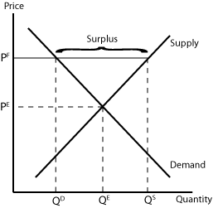

2.3 describe graph

3. Intended impact (benefits to the Thai people)
The intended impact of this price floor policy was to protect farmers from low prices in the rice market as the prices were too low for farmers to support themselves. With the increase in price from PE to PF and quantity from QE to QS, the farmers will enjoy a higher revenue, and increase their standard of living.

4. Unexpected impact
4.1 increase cost of expenditure to government
This increased the cost of expenditure to government as it had to buy over the large surplus of rice in order to maintain the price at PF.

4.2 Feasibility of the floor price
- Other farmers will want to also enjoy this floor price

4.3 exchange rate
When the price of rice increased, the Thai rice lost its price competitiveness in the international market to other exporters of rice such as India and Vietnam. As such, demand for Thai rice fell and exports decreased. In addition, the Thai people also turned to imports of rice from other countries which were cheaper priced, increasing Thailand’s imports. Since Thailand was the world’s largest exporter and fifth largest cultivator of rice in the world, a lower demand for the Thai Baht caused the exchange rate to weaken.

4.4 corruption
There was also the issue of corruption. Millers smuggled rice in from other countries and claimed that it was Thai rice to enjoy the higher domestic price of rice. When the government sold its rice stockpiles at a price lower than the market price, rice traders bought them and then pledged this rice back to the scheme to earn profit from the difference in prices.

4.5 perishability and cost of storage of rice
Since the government had to buy up the surplus of rice, it soon accumulated rice stockpiles. It had to pay a huge amount to preserve the quality of these stockpiles. In addition, there was corruption concerning the quality of rice as well, and the stockpiles contained bad-quality rice that came from neighbouring countries. As such, Thailand was left with millions of tonnes of rotting rice.

4.6 budget strain
This policy put a massive strain on the Thai government’s fiscal budget. It had to continuously channel resources from other sectors of the economy or even dip into its fiscal budget to buy up the surplus and ensure that rice is being sold at the price floor, which left it with less revenue to spend on other sectors of the economy.

Question for Practice
Question 1
As a matter of national policy, MOM does not prescribe minimum wages for all workers in Singapore, whether local or foreign. Whether wages should increase or decrease is best determined by market demand and supply for labour.

MOM Website

Discuss how the minimum wage works to curb inflation and evaluate whether it is suitable for SIngapore use as a policy to maintain the interest of workers and as a ‘matter of national policy’ for the benefits of the economy. (25)

Question 2
Explain how the removal of subsidy affects the consumers and producers. (10)

6. The Market for cotton
Extract 1: Brazil's cotton growers seek to boost output as India restricts exports

Cotton prices have soared 73% in the past year and reached a 15-year high of US$1,064 on 28 September 2010 after India, the world's second-biggest exporter after the United States, said it would limit exports. The Indian government will limit exports to 5.5 million bales in 2011, compared to 2010 when exports were 8,3 million bales. The price of cotton is expected to stay above US$1 until June 2011.

Cotton growers in Brazil, the world's fifth-largest exporter of the fibre, plan to increase output in 2011 after the rise in world prices. Planting for the 2011 harvest may rise to 1.1 million hectares from 830 000 hectares in 2010.

Brazil's government may consider increased financial support for cotton growers to encourage them to raise output in 2011, according to the Brazilian Agriculture Ministry. A four-month drought hurt the quality of the crop this year in Brazil, causing output to fall. In September the government temporarily eliminated a 10% tariff on cotton imports as domestic supplies fell short of demand.
Source: Bloomberg, 1 October 2010

(c) Explain the likely reason why the Brazilian government eliminated the 10% tariff on cotton imports and the Indian government restricted cotton exports. [3]

7. Agriculture, water crisis and poverty
Extract 3: Madhya Pradesh farmer protests

In June 2017, farmers in Madhya Pradesh, India, protested by demanding higher Minimum Support Prices (MSP), as well as a complete debt waiver. Farmers there had asked the central government to deliver on its promise of adjusting MSP to be cost of production plus 50 percent profit – a price that was declared impractical by the government in 2015.

After two years of drought resulting in successive crop failures farmers were finally relieved to receive abundant rainfall and a good harvest. Yet, they are still struggling to make a profit on their produce. Overproduction of food can push farmers into distress just as much as a failed harvest. A supply glut, such as the one presently faced by pulses, chili, potato, and onion cultivators in India, generally leads to a price crash, resulting in poor returns. But it is exactly for situations such as these that the MSP policy is in place in the country – to shield farmers from market volatility.

The MSP scheme forms part of India’s agricultural price policy. It is the price at which farmers’ produce in certain crops is bought by the government during the relevant seasons. When the market prices dip to a level that is below the MSP, the government agencies step up and buy over the produce in order to protect the farmers.

However, the states have either failed to procure most of the produce at MSP or are really slow in the process, forcing many farmers to sell far below the set price. There could also be exploitation by commission agents. They have been reported to have bought the farmers’ produce at much below the MSP.
Sources: 14 June 2017, YourStory Research and 1 August 2018, Citizen Matters

(e) Discuss the effectiveness of the minimum price support scheme (MPS) to improve the livelihood of farmers in India during a good harvest. [8]

