J2 Economics 2020

The healthcare services market

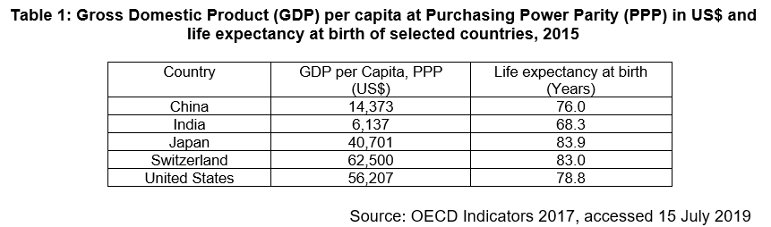

Extract 1: Health and the economy: A vital relationship

Investment in health is not only a desirable, but also an essential priority for most societies. However, our health systems face tough and complex challenges, in part derived from new pressures, such as ageing populations, growing prevalence of chronic illnesses, and intensive use of expensive yet vital health technologies.

Health performance and economic performance are interlinked. Wealthier countries have healthier populations for a start. And it is a basic truth that poverty, mainly through infant malnourishment and mortality, adversely affects life expectancy. The opposite is also true – improving the health of a nation’s citizens can directly result in economic growth, because there will be more people able to conduct effective activities in the workforce. The effects of health on development are clear. Countries with weak health and education conditions find it harder to achieve sustained growth. Indeed, economic evidence confirms that a 10% improvement in life expectancy at birth is associated with a rise in economic growth of some 0.3-0.4 percentage points a year.

Policy choices to improve healthcare access cannot be taken lightly. Health financing, through out-of-pocket expenditures, is inequitable and can expose whole populations to huge cost burdens that block development and simply perpetuate the disease/poverty trap. On the other hand, health systems need financing and investment to improve their performance, yet this need cannot in turn impose an unfair burden on national spending or competitiveness. This is a very delicate balance for policymakers to have to strike. In other words, if you want to raise investment in health spending, you may need to find cuts elsewhere in the economic system. As policymakers with public responsibilities, we must never forget that decisions taken in one sphere affect conditions, stakeholders and policies in another.

Source: OECD Observer, accessed 15 July 2019

Extract 2: Consumers and their demand for healthcare

Globally, healthcare demand is gradually rising. The increasing prevalence of preventable illness is contributing to this growth and this is influenced by choices consumers make. For instance, obesity, which can increase the risk of diabetes, stroke, and heart disease is on the rise in the United States. Though obesity is preventable, some patients do not take appropriate control of their health and seek treatment when conditions become chronic. The lack of initiative to lead a healthy life and prevent chronic illnesses such as obesity has led to the rise in demand for healthcare services.

Overall, healthcare is only valued to the extent that it improves health and the consumers’ ability to purchase healthcare is ultimately limited by the customers’ income, and consumers are likely to forgo spending on other products to purchase the medical care needed.

Source: Journal of Health and Medical Economics, accessed 15 July 2019

Extract 3: Gaining better control of rising healthcare prices

Prices of healthcare services are rapidly rising globally as populations age, chronic conditions become more prevalent and demand for healthcare services outpaces supply. In Asia, several developments continue to drive an upward trend in the prices of healthcare services today. The availability of advanced medical technology and the appeal of medical tourism are just some of the key factors behind an unabated rise. At the same time, research has found that a 10% rise in price of healthcare services leads to a 4.1% fall in quantity demanded.

In Singapore, beyond the demographic changes, the cost of running a medical practice has also gone up tremendously over the past few years. Two major hospitals started operations over the past two years. They are supposed to bring in more capacity and competition, and lower costs. But an unintended consequence is the acute shortage of skilled medical personnel. Nurses were offered a significant pay rise to join the new hospitals. In return, existing hospitals have had to match the pay rise to keep their staff. In addition, the resale prices of private medical clinics have also gone through the roof. All these increases in overheads will eventually lead to higher hospital facility fees.

Hoping to alleviate the issue in Singapore, the Ministry of Health recently appointed a committee to develop medical fee benchmarks for common clinical procedures, with a view of including less common and expensive procedures like X-rays and magnetic resonance imaging (MRIs) in the longer term. Other strategies include ensuring that people are aware of the significance and impact of healthy living. Despite oceans of clinical data, many people still aren't aware of how profoundly their everyday decisions from a young age - what they eat and drink, whether they smoke, how often they exercise - really do significantly impact their long-term health.

Source: The Business Times, 27 March 2018

Extract 4: Affordable healthcare for all

The Ministry of Health (MOH) is looking to make sure that healthcare remains affordable for all. MOH is simplifying the criteria for means-testing in the intermediate and long-term care sector. It will be changed to per capita household income, which only includes those family members that the elderly is living with.

Subsidies for nursing homes and clinics under the Community Health Assist Scheme (CHAS) will also be expanded to include the middle income. The per capita household income ceilings to qualify for these subsidies will be increased for intermediate and long-term care. These changes will help the low income significantly, but also signal a major shift towards help for the middle income. Drug subsidies will also be raised, especially those required to treat chronic conditions.

Source: Channel News Asia, 24 March 2017

Extract 5: Singapore Budget 2018: Spending needs to grow in healthcare

SINGAPORE will put aside some S$10.2 billion for healthcare expenditure, Finance Minister Heng Swee Keat said on Monday. Unveiling the Budget for 2018, Mr Heng said the government expects to spend more on healthcare.

"We will have to build new healthcare capacity to meet the rising demand, and also invest in new medical technologies to improve care quality," Mr Heng said.

He said within the next five years, Singapore will build six more general and community hospitals, four new polyclinics and more nursing homes and eldercare centres across the island.

Source: The Business Times, 19 February 2018

Questions

(a) With reference to Table 1 and Extract 1,

(i) State the relationship between GDP per capita (PPP) and life expectancy. [1]

(ii) Discuss whether the data suggests that the United States has a higher standard of living than Japan. [6]

(b)(i) Using a diagram, explain why there is a significant pay rise for nurses. [4]

(ii) With reference to Extract 3, account for the rising prices of healthcare services in Singapore and comment whether prices of healthcare services will continue to rise in the future. [8]

(c) With the aid of a diagram, explain why consumers, rather than producers will benefit more from a subsidy on healthcare services. [4]

(d) Explain what is meant by equity and why subsidies of healthcare services based on “means-testing” is likely to be equitable. [3]

(e)(i) Explain why the Singapore government intervenes in the market for merit goods such as healthcare services. [7]
Ppppp9
[Total: 45]

Suggested Answers
(a) With reference to Table 1 and Extract 1,
(i) State the relationship between GDP per capita (PPP) and life expectancy. [1]

Positive Relationship or GDP per capita is positively correlated with life expectancy.

(ii) Discuss whether the data suggests that the United States has a higher standard of living than Japan. [6]

Standard of living has two aspects, material and non material. The data provided GDP/Capita (in PPP) which allows us to compare the level on material SOL across countries and life expectancy with allows us to compare the level of non-material SOL.

GDP capita in PPP is higher in USA, suggesting that after controlling for the differences in cost of living across two countries, the residents in USA has a higher purchasing power and higher material SOL as they can consume more goods and services.

However, in terms of non material standard of living, Japan is said to be higher. The life expectancy is higher for Japan and this means that the residents in Japan are healthier and may lead a less stressful life. This means that the quality of life is higher in Japan.

Thus, in view of this, we may need additional data to conclude whether US has a higher standard of living than Japan as the data is inconclusive. While it does suggest that US has higher material SOL, we need to see other indicators of non-material SOL. In this case, we may need additional information such as crime rates and quantity of leisure hours to have a holistic comparison of the quality of life before we can make a judgement.

(b)(i) Using a diagram, explain why there is a significant pay rise for nurses. [4]

Due to aging population, there is a need for more healthcare services to be rendered and hence, there is an increase in DD for healthcare services. Therefore, the derived DD for nurses will increase because nurses is a factor of production of healthcare in the form of labour.
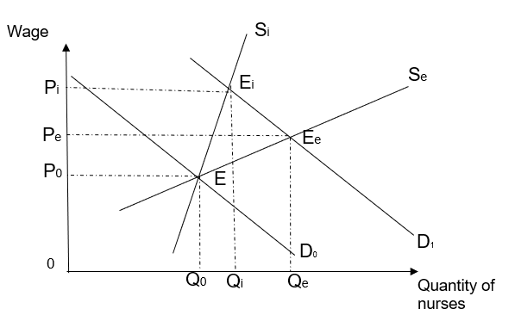
PES < 1 because it takes time to train and equip nurses with the necessary skills to provide an effective healthcare service.

Hence, an increase in DD, with PES < 1, would result in a shortage, which exerts an upward pressure on nurses’ wages. As the wages increase, the quantity supplied of nurses only increase less than proportionately. As such, wages need to rise sharply to clear the shortage. This is why there is a significant pay rise from P0 to Pi as illustrated in the diagram.

(ii) With reference to Extract 3, account for the rising prices of healthcare services in Singapore and comment whether prices of healthcare services will continue to rise in the future. [8]

An “appeal of medical tourism” (Ext 3) would mean that there is a change in taste and preferences towards healthcare services. Hence, there is an increase in DD for healthcare services from D0 to D1.

Furthermore, the “existing hospitals have had to match the pay rise to keep their staff” (Ext 3) which meant higher wages for healthcare workers. This would in turn increase the cost of production of healthcare services and make it less profitable for healthcare providers to provide the services. Hence there will be a fall in SS from S0 to S1.

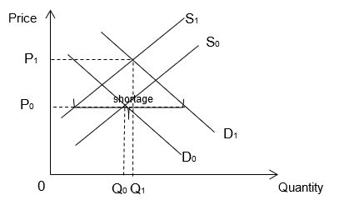
With an increase in DD and a fall in SS, this results in a large shortage which exerts an upward pressure on healthcare services’ price. Hence, there is rising price of healthcare services as price increased from P0 to P1.

Price of healthcare services may not continue to rise in the future as the ceteris paribus assumption may not hold. As in the “next five years, Singapore will build six more general and community hospitals, four new polyclinics and more nursing homes and eldercare centres across the island” (Ext 5). This means that there will be a future increase in SS of healthcare services which would help to lower healthcare services prices.

(c) With the aid of a diagram, explain why consumers, rather than producers will benefit more from a subsidy on healthcare services. [4]

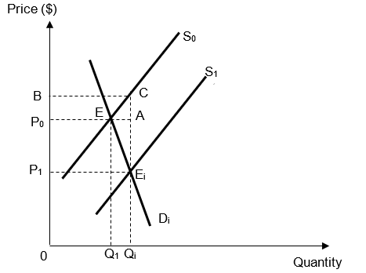

With a subsidy on healthcare services, there will be a fall in the cost of production of the services and it will be more profitable for firms to produce the service. Hence, there will be an increase in SS of healthcare services from S0 to S1, resulting in a fall in price from P0 to P1.

Demand for healthcare services is relatively more price inelastic as it is deemed as necessity. This is further backed up by the data which shows a 10% rise in price, would only result in a 4% drop in quantity demanded (a less than proprotionate fall in quantity demanded).

Furthermore, in order for consumers will enjoy a larger share of the subsidy, the demand for healthcare services has to be more price inelastic compared to the supply.

From the diagram, the subsidy expenditure is denoted by Area BCEiP1. Out of this entire area, the consumer’s share of the subsidy is represented by Area P1CEiP1. This is in comparison to producer’s smaller share of the subsidy represented by BACP0.

(d) Explain what is meant by equity and why subsidies of healthcare services based on “means-testing” is likely to be equitable. [3]

Equity is defined as the fairness in distribution of economic welfare, and that there is an equitable (i.e. fair) distribution of goods and services.

Subsidy Fall in price more affordable for lower income groups more people from lower income groups can enjoy healthcare services

This is an equitable outcome as healthcare is an essential service which consumers should have access to regardless of their income level.

(e)(i) Explain why the Singapore government intervenes in the market for merit goods such as healthcare services. [7]

Merit goods are goods which the government deems as socially desirable but consumers are perceived to undervalue their benefits due to imperfect knowledge. These goods also generate positive externalities. The consumers will under-consume these goods and services and results in deadweight loss for the society, and hence, government will intervene to achieve allocative efficiency.

Consumers suffer from imperfect information and positive externalities are generation from the consumption of healthcare services.

Consumers will consume up to the quantity where MPB=MPC to maximise its own utility. The private benefit from consuming healthcare services is the satisfaction from being healthy while the private cost is the cost of healthcare services like cost of vaccinations and checkups. However, in the case of healthcare, consumers suffer from imperfect information as they tend to underestimate the benefits from regular checkup and vaccinations as these benefits only happen in the long run. For example, the protection from flu virus is only evident when there is a flu season going on and consumers tend to underestimate the benefit from this protection. Thus, there is a divergence between MPBperceived and MPBactual, and consumers will consume at Qm where MPBperceive=MPC.

The consumption of healthcare also gives rise to third party effects which are often ignored by the consumers. For example, when a worker consumed vaccination and pay for the cost, the employer will benefit from a more productive worker due to lower rate of absenteeism. In this case, employer, who is not directly involved in the production or consumption of vaccination, benefits from the higher profits due to productive workers and he does not pay for this benefit.

The existence of positive externalities leads to a divergence between MPBactual and MSB and the social equilibrium output is Qs where MSB=MSC. Due to the existence of positive externalities and imperfect information, there is underconsumption of education by QmQs amount.
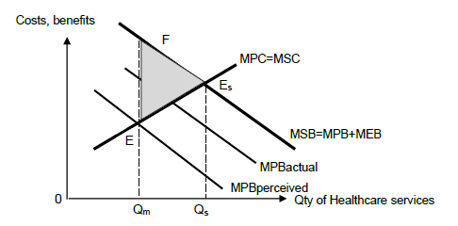
Between QmQs, the total benefit to the society is QmQsEsF and this is greater than the total cost cost to the society, QmQsEsE. Hence, if these additional QmQs units were produced and consumed, society’s welfare would be higher but they do not. Thus, underconsumption of QmQs unit give rise to a monetary measure of total deadweight loss of area EFEs to the society if consumption were determined by the market, and government will intervene to improve the society welfare.
(ii) As a consultant economist, what policies would you suggest to the Singapore government to address the inefficiency in resource allocation for healthcare services and which would you most recommend? Justify your answer. [12]

A government can respond to the issue of underconsumption with policies such as subsidy, rules and regulation, and education and campaign to increase the level of healthcare consumption. The recommendation will depends on the severity of the problem and the characteristics of the Singapore society.

Subsidy:
To account for the presence of imperfect information and positive externalities, Singapore government can provide a subsidy is equal to the divergence between MPBperceived and MSB at Qs. This will increase the consumption to the socially optimal amount.

When a subsidy equal EsA is given, it reduces the cost of production of producing healthcare services and this leads to a rise in supply of healthcare and a fall in the price of healthcare services. In turn, this reduces the private cost of consumption healthcare to MPC+subsidy and this increase the level of consumption of healthcare to Qs, eliminating the deadweight loss of EEsF.

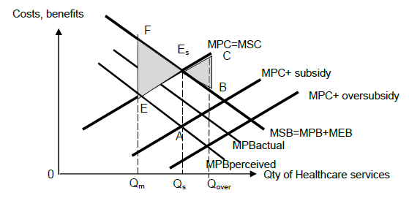
Subsidy is one of the recommended solution because it allows the market to continue to operate and consumers to exercise some sovereignty in the choice of healthcare services they wish to consume and producers will get to choose how they want to produce the different types of healthcare services.

However, it is likely that government may not estimate the extent of MEB correctly. As explained earlier, the extent of external benefit will differ depending on who consumes the vaccination and the different types of vaccination. Thus, Singapore government may oversubsidies the production of healthcare and and the greater fall in fall in price leads to overconsumption healthcare at Qover and this could lead a deadweight loss of EsBC.

Moreover, the demand for healthcare is price inelastic as highlighted in extract 3. This means that the fall in price leads to a less than proportionate rise in quantity demand. As a result, Singapore government may need to increase the level of subsidy to lead to a rise in Qm to Qs. This could lead to greater government subsidy and caused a strain on Singapore government budget. Moreover, there is also an opportunity cost incurred. Singapore government may have to reallocate resources from pre-school and post-university education to fund healthcare subsidy. Considering that Singapore is facing structural changes in the economy and that social mobility is becoming an issue, the opportunity cost incurred from the government spending could be too big to ignore. In this case, subsidy may not be the most recommended.

An alternate policy is to implement education and campaign for the public to raise the awareness of the true benefits to consumers. This help to address the problem of imperfect information. As consumers are aware, they will change their taste and preferences towards healthcare services and this leads to a rise in demand for healthcare services and the consumption level will increase to Qs, eliminating deadweight loss. For example, there are advertisements and roadshows to encourage people to go for medical check-ups more often and the importance of different vaccinations.

This policy can be effective for Singapore as Singapore consumers are relatively highly educated and they may understand the message from the campaign. In addition, it is cost effective to do such campaign in Singapore because of the high density of the consumers, and access to TV and Internet. As such, the spread of information can be achieved at relatively lower cost than subsidy.

However, this policy may not be the best on its own due to the issue of inequity. The poor may lack access to healthcare services even if they are aware of the benefits and they may not consume healthcare services. Moreover, it requires a long time to change the perception of vaccinations or healthcare services among the consumers. Even though the consumers are aware of the benefits, there is a lack of urgency to consume these services as they may prioritise their spending on other goods and services as highlighted in extract 1. In the event of a severe epidemic, this policy will not be the most recommended.

In view of the limitations, Singapore government may legislate the consumption of healthcare services. For example, in Singapore, there are compulsory vaccinations at birth and when young. This ensure that the quantity of healthcare services consume is socially optimal and eliminate the deadweight loss.

However, Singapore government may need to review the different sets of vaccinations required due to the changing information on the true benefits of different healthcare checkups and the vaccination. For example, as Singapore population ages, the focus would be more on checkups for age-related illnesses. HPV vaccine is also recommended for certain groups of consumers to reduce the risk of cancer. Thus, the effectiveness of this policy depends on the ability of the government to enforce and monitor.

Conclusion
There should be a mixture of policies to tackle the problem as there are two sources of market failure. Considering that Singapore still have sufficient budget, she would able to allocate resources to finance the subsidy of healthcare services and supplement this policy with education and campaign such that that the consumers are aware of the true benefits and take responsibility of their own health, by going for appropriate checkups and vaccinations. Moving forward, the policy of education and campaign will help to reduce the burden on the government expenditure and ensure that Singapore has sufficient resources to support other areas of the economy such as education.

