H1 Economics: A Level Revision
Microeconomics CSQ – Demand & Supply and Market Failures

Influenza: A Perfect Storm

Extract 1: Flu season deaths top this year in the U.S.

Influenza, commonly known as flu, is a contagious respiratory infection caused by influenza viruses.

An estimated 80,000 Americans died of flu and its complications last winter, according to the U.S. Centers for Disease Control and Prevention. This means it was the highest fatalities season in more than four decades since 1976.

"One hundred and eighty kids - this really hit me hard as the father of three kids - died last year from the flu. And the majority of them were unvaccinated," said U.S. Surgeon General Dr Adams. Additionally, the nation experienced a record-breaking estimated 800,000 hospitalisations last flu season. The 2017-2018 season was also marked by high severity across all age groups. Adams said that getting the flu shot by the end of October is not just about keeping yourself safe and healthy, it's also about community. It's your "social responsibility to get vaccinated," he said, since it protects others around you, including family, friends, co-workers and neighbours.

Adapted from CNN Health, 27 September 2018

Table 1: Estimated Influenza Disease Burden, by Season
United States, 2010-11 through 2018-19

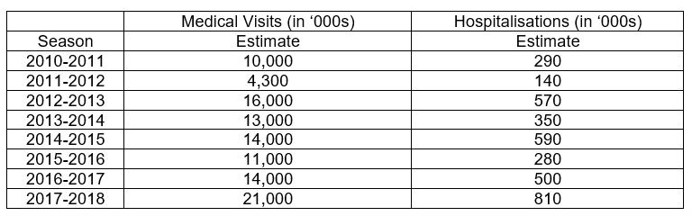
Source: Centers for Disease Control and Prevention, 2018

Extract 2: Getting vaccinated is important

As a new flu season gets underway, public health officials say last year’s toll underscores the importance of getting a flu vaccine each year. So getting the flu vaccine is better than getting the flu. The shot can prevent infections and reduce the severity of complications from the disease. An annual seasonal flu vaccine is the best way to help protect against flu. Vaccination has been shown to have many benefits including reducing the risk of flu illnesses, hospitalisations and even the risk of flu-related death in children.

Flu vaccines cause antibodies to develop in the body about two weeks after vaccination. These antibodies provide protection against infection with the viruses that are used to make the vaccine. There are many vaccine options to choose from, but the most important thing is for all people 6 months and older to get an influenza vaccine every year. People should get a flu vaccine before flu viruses begins spreading in their communities, since it takes about two weeks after vaccination for antibodies to develop in the body and provide protection against flu.

Despite last year’s dreadful season, overall vaccination take-up remained lower than desired by the government. As in previous years, less than half of the U.S. population was vaccinated. But most concerning to officials was a drop in vaccination coverage among the youngest children and elderly who are at highest risk for serious flu complications. Officials and clinicians speculate that some people decided that flu vaccines, which are thought to be not as effective, aren’t worth the effort.

Adapted from Centers for Disease Control and Prevention, 18 September 2019

Extract 3: Global influenza vaccines market

According to the World Health Organization (WHO), annually, 3 to 5 million cases of severe illness due to influenza are recorded worldwide. Increasing prevalence of influenza epidemics and seasonal outbreaks are expected to expand the sales of influenza vaccines in the forecast period. The key factors that drive the growth of the global influenza vaccine market include advancements in existing vaccines that minimises side effects, and development of new vaccines as seen from an upsurge in R&D activities. However, longer timelines are required for vaccine production. Vaccines are trickier to produce. Several peculiarities of the influenza virus itself and its production process make flu vaccine production especially complicated. There are numerous points at which the process could fail.

Adapted from PRNEWSWIRE, 2 January 2019

Figure 1: Flu Vaccination Take-Up Among Adults,
by Season, United States, 2010-2018
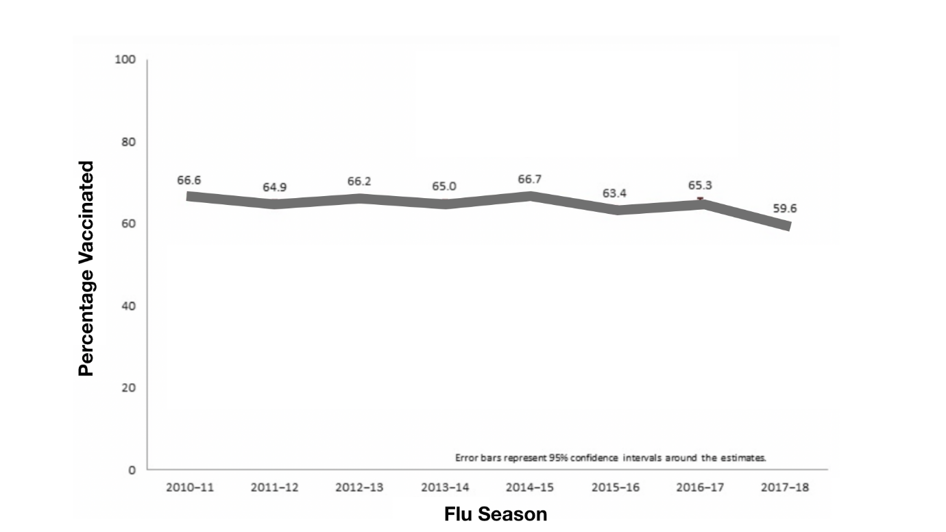
Source: Centers for Disease Control and Prevention, 2018

Extract 4: Vaccines shortage frustrates everyone in the U.S.

Government administrators cap prices of influenza vaccines at low levels to provide vaccines to people who lacked health insurance or who could not otherwise afford the vaccines. However, as the flu season is beginning, physicians and patients are scrambling to make the most of a scarce resource -- only having about half of the total anticipated U.S. vaccine available for fall and winter months. As a result, physicians are facing another frustrating year of influenza shot shortages. Family physicians are waiting for vaccine that may not arrive in West Virginia. Similar scenarios of vaccine shortages and distribution woes have played out from New England to the West Coast as the influenza virus spreads nationwide. The government are considering to lift price cap on influenza vaccines that aims to encourage the production of influenza vaccines.

Adapted from Amednews, 16 July 2018
Extract 5: When vaccination rates dip, government intervention is often strengthened

Earlier this year, the WHO named hesitancy to vaccinate as one the ten gravest threats to global health. As a result, governments around the world are considering policies that would make vaccinations free and mandatory. Singapore provides some free-of-charge vaccines. Over the past 5 years, legislators in Australia, France and Italy have restricted school access for children who haven’t received the country’s recommended panel of vaccinations. Some U.S. states are doubling down on existing vaccination requirements for school children by removing the ability for parents to legally refuse vaccines for non-medical reasons. A variety of incentives and penalties have been employed, with differing levels of enforcement, and the effectiveness of each approach is not clear cut.
Adapted from Nature, 12 September 2019
Questions
(a) | (i) | With reference to Table 1 and Figure 1, compare the trend in the number of influenza-related hospitalisations and flu vaccination take-up from season 2010-2011 to season 2017-2018. [2]
 | (ii) | Account for the difference in (a)(i). [1]
(b) |  | Using the Production Possibility Curve, explain how the “highest fatalities season” (Extract 1) might impact the economic growth in the United States and comment briefly on whether such impact is inevitable. [5]
(c) |  | With reference to Extract 3 and using demand and supply analysis, discuss the likely effects of the factors mentioned on the global influenza vaccines market. [8]
(d) |  | Discuss the factors that the U.S. government might consider in deciding whether to remove the price cap in the market for influenza vaccines on the basis of equity. [7]
(e) |  | Explain whether the statement in Extract 2 that “getting the flu vaccine is better than getting the flu” is a normative one. [4]
(f) | (i) | Explain why “vaccination take-up remained lower than desired by the government” (Extract 2) in the United States. [6]
 | (ii) | “The best way to increase influenza vaccination take-up in the United States is through free provision”.  Using evidence from the case study and/or your own knowledge, discuss the validity of this statement. [12]

[Total: 45]

