H1 Economics: A Level Revision
Microeconomics CSQ – Demand & Supply and Market Failures

Influenza: A Perfect Storm

Extract 1: Flu season deaths top this year in the U.S.

Influenza, commonly known as flu, is a contagious respiratory infection caused by influenza viruses.

An estimated 80,000 Americans died of flu and its complications last winter, according to the U.S. Centers for Disease Control and Prevention. This means it was the highest fatalities season in more than four decades since 1976.

"One hundred and eighty kids - this really hit me hard as the father of three kids - died last year from the flu. And the majority of them were unvaccinated," said U.S. Surgeon General Dr Adams. Additionally, the nation experienced a record-breaking estimated 800,000 hospitalisations last flu season. The 2017-2018 season was also marked by high severity across all age groups. Adams said that getting the flu shot by the end of October is not just about keeping yourself safe and healthy, it's also about community. It's your "social responsibility to get vaccinated," he said, since it protects others around you, including family, friends, co-workers and neighbours.

Adapted from CNN Health, 27 September 2018

Table 1: Estimated Influenza Disease Burden, by Season
United States, 2010-11 through 2018-19

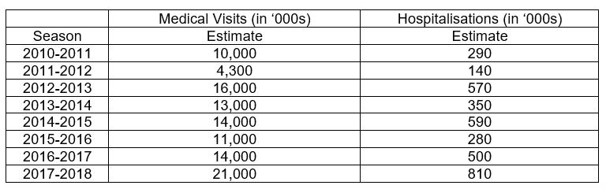
Source: Centers for Disease Control and Prevention, 2018

Extract 2: Getting vaccinated is important

As a new flu season gets underway, public health officials say last year’s toll underscores the importance of getting a flu vaccine each year. So getting the flu vaccine is better than getting the flu. The shot can prevent infections and reduce the severity of complications from the disease. An annual seasonal flu vaccine is the best way to help protect against flu. Vaccination has been shown to have many benefits including reducing the risk of flu illnesses, hospitalisations and even the risk of flu-related death in children.

Flu vaccines cause antibodies to develop in the body about two weeks after vaccination. These antibodies provide protection against infection with the viruses that are used to make the vaccine. There are many vaccine options to choose from, but the most important thing is for all people 6 months and older to get an influenza vaccine every year. People should get a flu vaccine before flu viruses begins spreading in their communities, since it takes about two weeks after vaccination for antibodies to develop in the body and provide protection against flu.

Despite last year’s dreadful season, overall vaccination take-up remained lower than desired by the government. As in previous years, less than half of the U.S. population was vaccinated. But most concerning to officials was a drop in vaccination coverage among the youngest children and elderly who are at highest risk for serious flu complications. Officials and clinicians speculate that some people decided that flu vaccines, which are thought to be not as effective, aren’t worth the effort.

Adapted from Centers for Disease Control and Prevention, 18 September 2019

Extract 3: Global influenza vaccines market

According to the World Health Organization (WHO), annually, 3 to 5 million cases of severe illness due to influenza are recorded worldwide. Increasing prevalence of influenza epidemics and seasonal outbreaks are expected to expand the sales of influenza vaccines in the forecast period. The key factors that drive the growth of the global influenza vaccine market include advancements in existing vaccines that minimises side effects, and development of new vaccines as seen from an upsurge in R&D activities. However, longer timelines are required for vaccine production. Vaccines are trickier to produce. Several peculiarities of the influenza virus itself and its production process make flu vaccine production especially complicated. There are numerous points at which the process could fail.

Adapted from PRNEWSWIRE, 2 January 2019

Figure 1: Flu Vaccination Take-Up Among Adults,
by Season, United States, 2010-2018
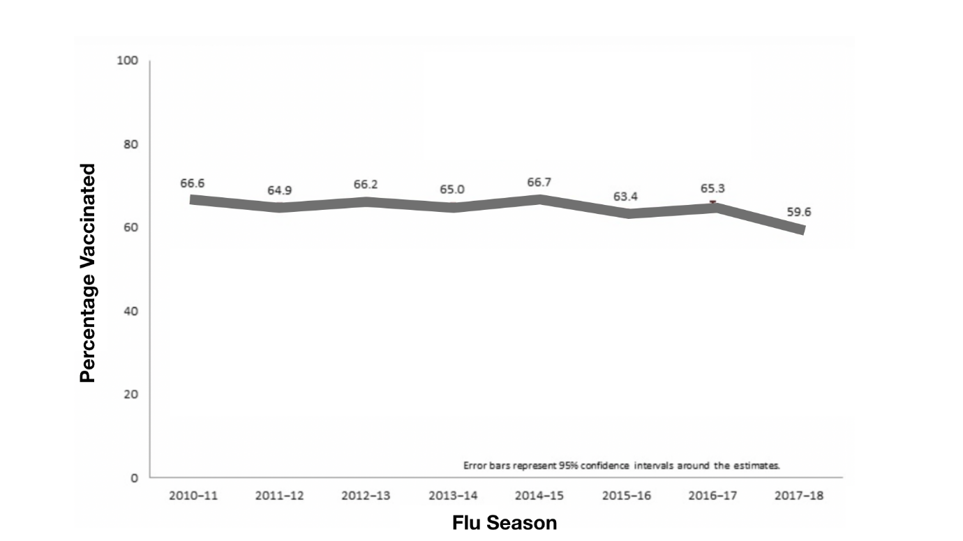
Source: Centers for Disease Control and Prevention, 2018

Extract 4: Vaccines shortage frustrates everyone in the U.S.

Government administrators cap prices of influenza vaccines at low levels to provide vaccines to people who lacked health insurance or who could not otherwise afford the vaccines. However, as the flu season is beginning, physicians and patients are scrambling to make the most of a scarce resource -- only having about half of the total anticipated U.S. vaccine available for fall and winter months. As a result, physicians are facing another frustrating year of influenza shot shortages. Family physicians are waiting for vaccine that may not arrive in West Virginia. Similar scenarios of vaccine shortages and distribution woes have played out from New England to the West Coast as the influenza virus spreads nationwide. The government are considering to lift price cap on influenza vaccines that aims to encourage the production of influenza vaccines.

Adapted from Amednews, 16 July 2018
Extract 5: When vaccination rates dip, government intervention is often strengthened

Earlier this year, the WHO named hesitancy to vaccinate as one the ten gravest threats to global health. As a result, governments around the world are considering policies that would make vaccinations free and mandatory. Singapore provides some free-of-charge vaccines. Over the past 5 years, legislators in Australia, France and Italy have restricted school access for children who haven’t received the country’s recommended panel of vaccinations. Some U.S. states are doubling down on existing vaccination requirements for school children by removing the ability for parents to legally refuse vaccines for non-medical reasons. A variety of incentives and penalties have been employed, with differing levels of enforcement, and the effectiveness of each approach is not clear cut.
Adapted from Nature, 12 September 2019
Questions
(a) | (i) | With reference to Table 1 and Figure 1, compare the trend in the number of influenza-related hospitalisations and flu vaccination take-up from season 2010-2011 to season 2017-2018. [2]
 | (ii) | Account for the difference in (a)(i). [1]
(b) |  | Using the Production Possibility Curve, explain how the “highest fatalities season” (Extract 1) might impact the economic growth in the United States and comment briefly on whether such impact is inevitable. [5]
(c) |  | With reference to Extract 3 and using demand and supply analysis, discuss the likely effects of the factors mentioned on the global influenza vaccines market. [8]
(d) |  | Discuss the factors that the U.S. government might consider in deciding whether to remove the price cap in the market for influenza vaccines on the basis of equity. [7]
(e) |  | Explain whether the statement in Extract 2 that “getting the flu vaccine is better than getting the flu” is a normative one. [4]
(f) | (i) | Explain why “vaccination take-up remained lower than desired by the government” (Extract 2) in the United States. [6]
 | (ii) | “The best way to increase influenza vaccination take-up in the United States is through free provision”.  Using evidence from the case study and/or your own knowledge, discuss the validity of this statement. [12]

[Total: 45]

Suggested Answers
(a)(i) With reference to Table 1 and Figure 1, compare the trend in the number of influenza-related hospitalisations and flu vaccination take-up from season 2010-2011 to season 2017-2018. [2]

Hospitalisations increased while vaccination coverage decreased. Hospitalisations and vaccination take-up increased from season 2013-2014 to 2014-2015 or from season 2015-2016 to 2016-2017.

(ii) Account for the difference in (a)(i). [1]

While the vaccination take-up fell, more people were susceptible to influenza viral infection. Hence, more hospitalisations.

(b) Using the Production Possibility Curve, explain how the “highest fatalities season” (Extract 1) might impact the economic growth in the United States and comment briefly on whether such impact is inevitable. [5]

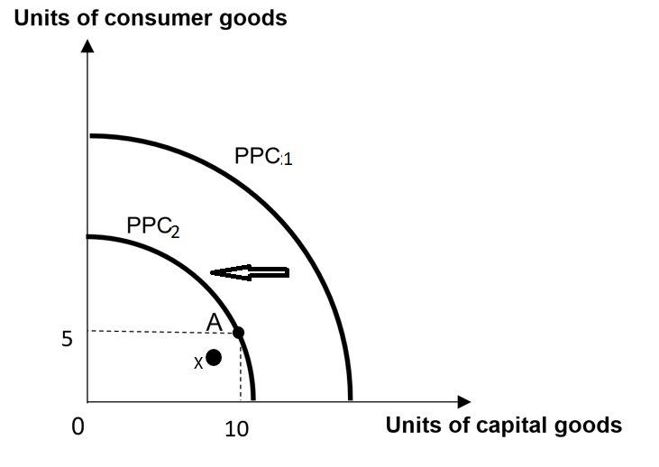
Flu fatalities → quantity of labour falls → productive capacity falls → inward shift of PPC (from PPC1 to PPC2) → negative potential growth

Flu fatalities → widespread sickness → quality of labour falls → labour is not used efficiently → underutilisation of FOPs (labour) → a point moves from on the PPC(new) to inside the PPC(new) (point X) → negative actual growth

The negative impacts are not inevitable. The influenza epidemics usually take place in winter and do not spread across all states in the US, thus making high flu fatalities localised and spike for a short duration.

(c) With reference to Extract 3 and using demand and supply analysis, discuss the likely effects of the factors mentioned on the global influenza vaccines market. [8]

DD determinant:
In Extract 3, advancements to minimise side effects of existing vaccines → safer to consume (change in T&P) → higher DD for influenza vaccines → higher price and quantity → total revenue rises

SS determinant:
In Extract 3, an upsurge in vaccine R&D → unit COP falls → higher SS of influenza vaccines → higher quantity and lower price + PES <1 (longer timelines for vaccine production) → price increases more than proportionately → total revenue rises

Combined analysis :
Quantity increases while the overall change in price is dependent on the relative shifts of DD and SS curves.

Price adjustment process: If DD increase > SS increase → shortage (Qd > Qs) at initial price → upward pressure on price → producers increase their Qs while consumers reduce their Qd → overall increase price, quantity and total revenue of flu vaccines, ceteris paribus.

Evaluation:
DD increase > SS increase because the flu vaccine production is complicated and there are numerous points at which the process could fail. This make the successful rate of vaccine R&D low, thus limiting the effective supply of flu vaccines. Overall, price, quantity and total revenue increase.

(d) Discuss the factors that the U.S. government might consider in deciding whether to remove the price cap in the market for influenza vaccines on the basis of equity. [7]

Definition of price ceiling

Explain how it works

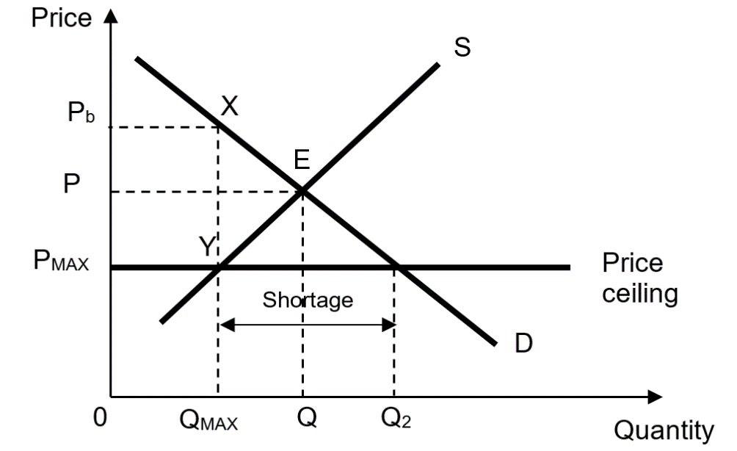
Benefit
When the price cap is removed → the new market price transacted will be P instead of PMAX. → At P, shortage clears, where the quantity demanded equals quantity supplied. The shortage can be eliminated by the free market due to the removal of price cap (ceiling). → this can prevent the formation of black markets → price of flu vaccines lowers from Pb to P → this ensures affordability of basic healthcare necessities such as flu vaccines → equity improves

Cost:
A price cap (ceiling) is usually imposed with the goal (intended consequence) of achieving equity. For example, if there is a sudden surge in the demand for flu vaccines, this will lead to an increase in the equilibrium price. As a result, those in the lower-income group might not be able to afford more expensive flu vaccines. Hence, to ensure affordability of basic healthcare necessities such as flu vaccines. Now the government intervenes in the flu vaccines market by removing the price cap (ceiling). The price of flu vaccines would increase from Pmax to P. Those who used to pay at Pmax become worse off. It makes flu vaccines less accessible to this lower-income group. Inequity worsens.

Constraint:
Removing the price cap inevitable increases the price of flu vaccine → politically unfavourable → public pressure + political resistance/friction between the state governments and federal government → difficult to implement across the entire US.

Evaluation:
The benefit of removing the price cap is more significant → it does not only prevent the formation of black markets, but also helps increase the total revenue earned by flu vaccine firms → this incentivises the firms to engage in R&D to produce more vaccines with better quality → further reduces the price of flu vaccines → further improve equity

(e) Explain whether the statement in Extract 2 that “getting the flu vaccine is better than getting the flu” is a normative one. [4]

Yes: A normative statement expresses a value judgment, originating from personal opinions which cannot be tested by facts.

No: The statement can be confirmed/supported by reference to the case evidence. For example, in Extract 2, it states a flu shot can prevent or reduce the severity of many complications. The vaccine can reduce flu illness and hospitalizations and it can also reduce the flu-related death in children.

(f)(i) Explain why “vaccination take-up remained lower than desired by the government” (Extract 2) in the United States. [6]

Positive externalities in consumption:
With vaccination, the consumer will enjoy private benefits because he has a lower chance of being infected with a disease, and hence will be healthy and work productively to earn higher income. However, the consumer does not take into account the fact that others around them such as his family, friends and colleagues (third parties) will enjoy external benefits in terms of higher income when they also enjoy a lower risk of contracting the disease and hence will be healthy and productive at work, without having to pay for the vaccination.

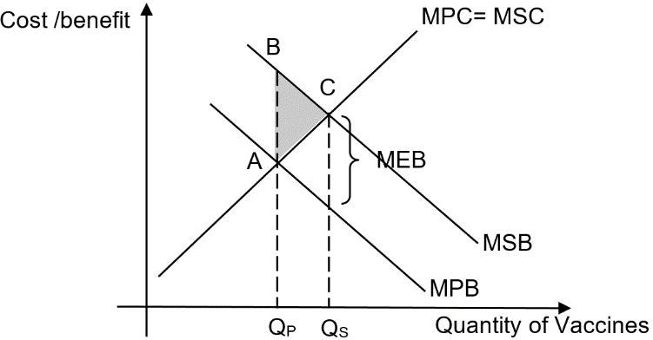
Due to the positive externality in consumption, the social benefits of vaccinations are higher than the private benefits (MSB>MPB). In the figure, the MSB curve lies above the MPB curve by a vertical distance equal to marginal external benefit (MEB). In the pursuit of self-interest, the consumer considers only his private benefits and private costs when consuming vaccination. This leads to the market equilibrium output QP, where MPB=MPC. However, the socially optimal output is given by QS, determined by the intersection of the MSB with the MSC curves. Since QP < QS, [or 1] the consumer under-consumes vaccination, leading to an under-allocation of resources. Between QP and QS, marginal benefit to society is greater than marginal cost to society. This means that societal welfare could have been gained by increasing quantity of vaccine consumed up to the socially optimal output of QS. This forgone societal welfare is the deadweight loss (area ABC),[or 1] leading to allocative inefficiency and hence market failure.
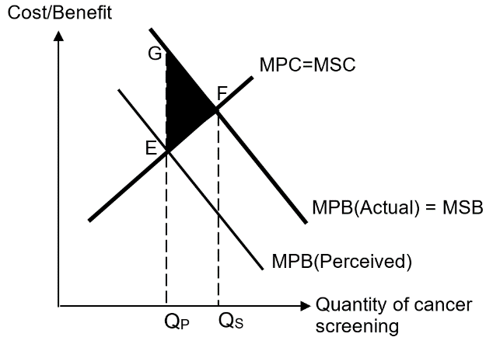
Imperfect information in consumption
Consumers may not buy flu vaccines even though they are beneficial, due to inaccurate/insufficient information on the actual benefits of consuming them. For example, consumers may be unaware that the actual benefit of consuming flu vaccines includes reducing the risk of flu illnesses, hospitalisations and even the risk of flu-related death in children This makes consumers underestimate their actual marginal private benefit (MPB(Actual)), causing MPB(Actual) to be higher than MPB(Perceived). Assuming no positive and negative externalities, MPB(Actual) equals to marginal social benefit (MSB), and marginal private costs equals to marginal social costs (MPC=MSC). Due to incomplete information, rational consumers will consume up to QP where MPB(Perceived)=MPC. However, the socially-optimal amount is QS where MSB=MSC. Hence, incomplete information causes an under-consumption of amount QPQS. Between Qp and Qs, Area QPGFQS which is the total social benefit is greater than area QPEFQS which is the total social cost. This means that societal welfare could have been gained by increasing quantity consumed up to the socially optimal output of QS. This forgone societal welfare is the deadweight loss (area EFG) [or 1] due to under-consumption [or 1] of and under-allocation of resources to cancer screening, leading to allocative inefficiency and hence market failure.

(ii) “The best way to increase influenza vaccination take-up in the United States is through free provision”.

Using evidence from the case study and/or your own knowledge, discuss the validity of this statement. [12]

How free provision works:
When the flu vaccines are provided free (at zero price i.e Price=0), MPC to consumers is zero. The quantity demanded will be Q’p units where MPB intersects the horizontal axis. In this case, the socially optimal level of output (Qs) coincides with the level that will be consumed at Qp’ on the x-axis. Deadweight loss is removed. This suggests that an ideal price for the good would be P=0. In such instance, free provision would be deemed to be allocative efficient.

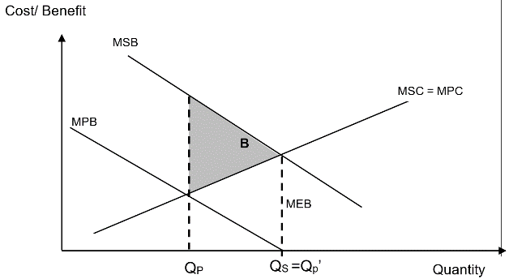
Limitation of free provision:
If the marginal external benefit is of a small amount, divergence between MSB and MPB is not significant. When free provision is implemented, the quantity demanded will be QF units where MPB intersects the horizontal axis. Hence, the new deadweight loss represented by area A is bigger than the previous deadweight loss represented by area B. In this case, the resultant over-consumption would lead to a higher welfare loss as compared to the flu vaccines being provided by the free market. Hence, the government’s free provision gives rise to even greater inefficiency compared to a purely free market outcome.
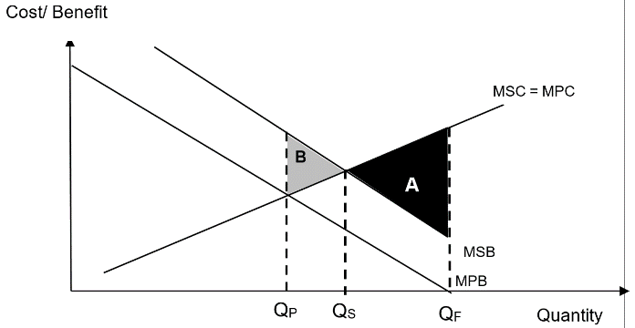

How legislation works:
In Extract 5, governments are considering to make vaccination mandatory and restrict school access to children who have not received the recommend vaccinations. For fear of facing fines / having no school access, parents will have to increase consumption up to the socially optimum level of QS, where MSB = MSC. This eliminates the entire deadweight loss, hence correcting market failure.

Limitation of legislation:
To enforce the legislation, the government faces high monitoring costs. Also, there are loopholes in the enforcement and monitoring which make it difficult to ensure that every person obey with the law. For a large country like the US, the government would find it more costly and difficult to ensure that all citizens obey the law.

Or How public education works:
Government can provide information to correct the MPB from MPB(Perceived) to MPB(Actual) and help consumers make informed choices. The US government uses public education to encourage the consumption of flu vaccines. The government organises education programmes on flu vaccines - for example to raise awareness on the positive effects of getting vaccinated, or holds public talks and exhibitions to inform the public about the benefits of flu vaccines. Assuming the education campaign is successful and increase the amount of correct information, consumers would alter their perception of flu vaccines, thus moving the MPB(Perceived) to MPB(Actual). When MPB(Perceived) is corrected to MPB(Actual) for flu vaccines which were under-consumed, the socially optimal amount QS where MSB=MSC will be achieved since consumers will consume up to where MPB(Actual)=MPC. Hence, deadweight welfare loss is eliminated and allocative efficiency is achieved.

Limitation of public education:
Public education is a long-drawn process (i.e. time lag) that requires time to change pre-existing mind-sets, which can be challenging especially. For example, despite knowing the potential benefits of flu vaccines, consumers who already have bias against flu vaccines still think flu vaccines are overhyped. Hence, the effectiveness of public education is very much dependent on how receptive to new or more information people are.

Evaluation:
There should be a mixture of policies to tackle the problem as there are two sources of market failure. Considering the US consumers’ fixed mindset, the government would able to incentivise consumers to consume more flu vaccines by providing free provision and supplement this policy with education and campaign such that that the consumers are aware of the true benefits and take responsibility of their own health, by going for flu vaccinations. Moving forward, the policy of education and campaign will help to reduce the burden on the government expenditure and ensure that the US has sufficient resources to support other areas of the economy such as education and national defence.

