JC Economics CSQ – Term 1 2015

National Income Accounting
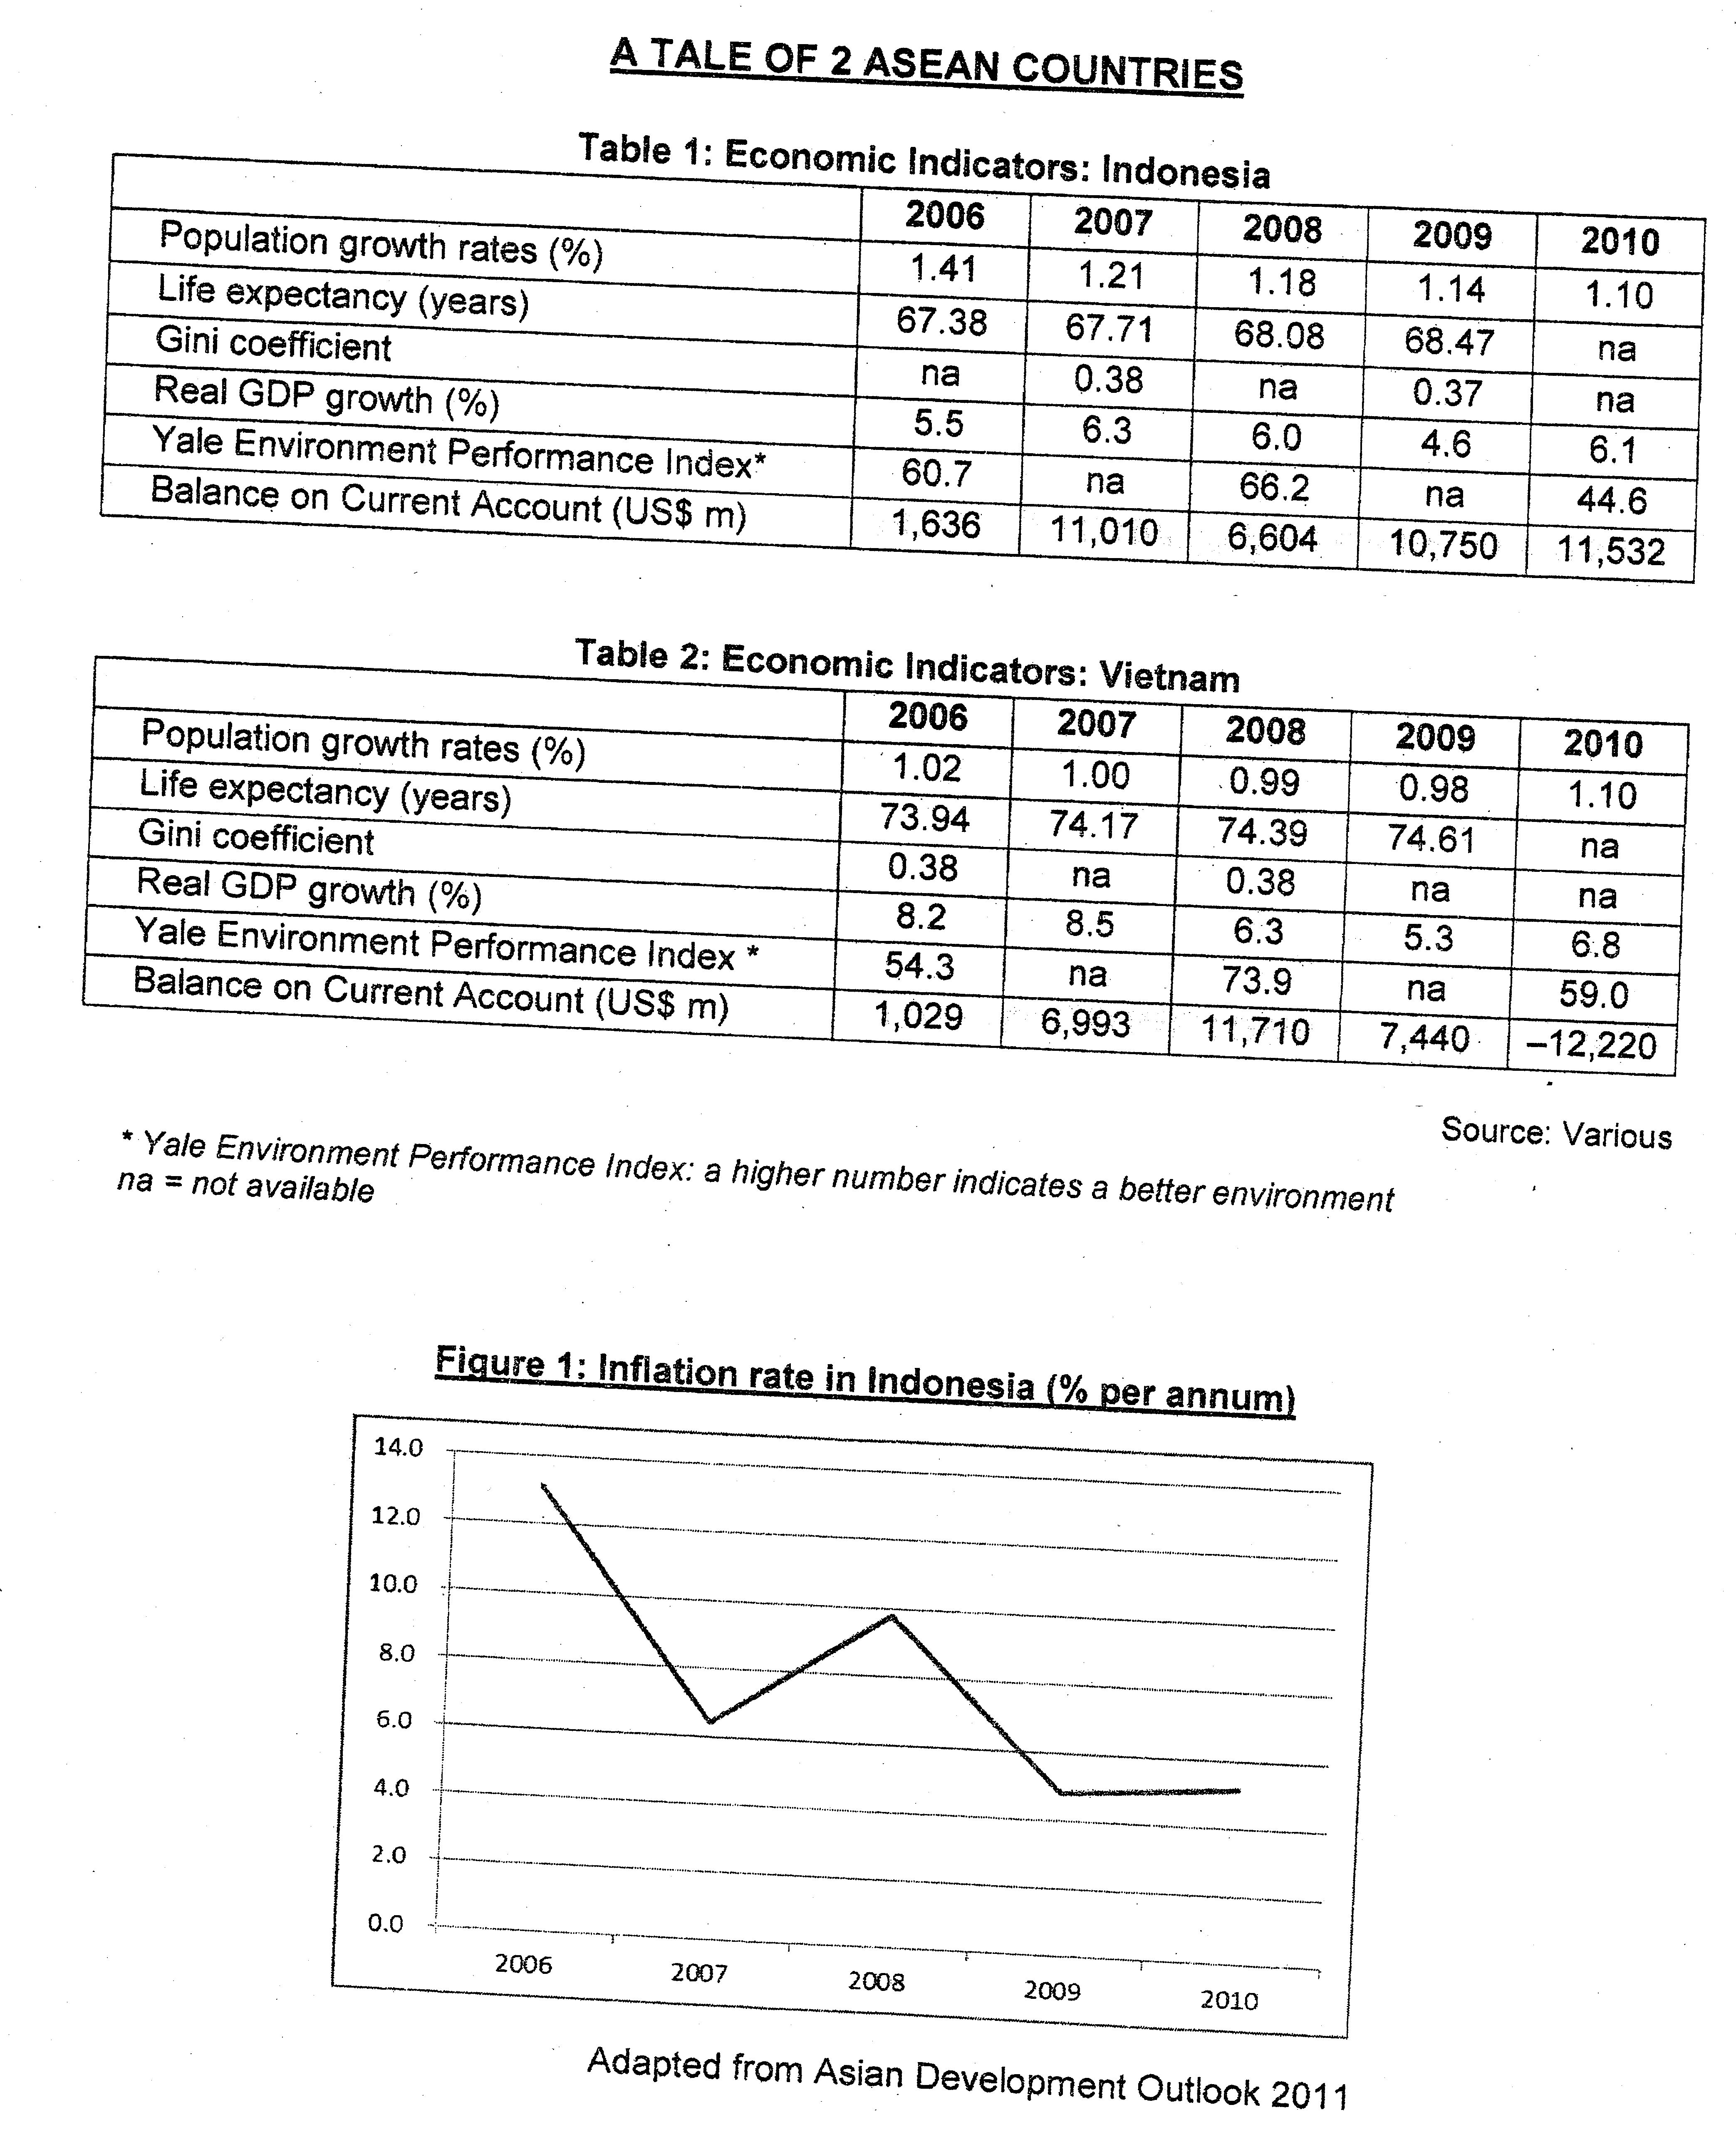

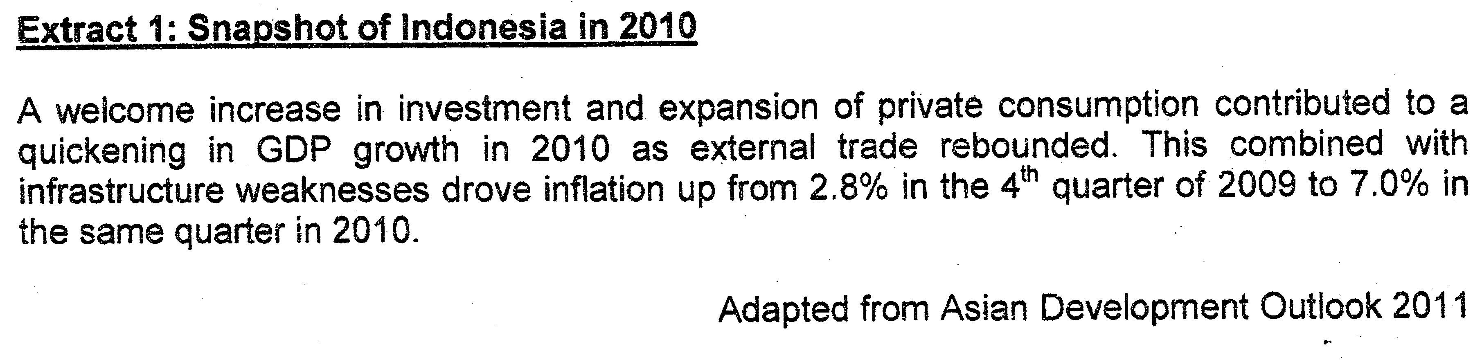

Answer the following questions
(a) Define Real GDP. [2]

(b) With reference to Table 1, account for the trend in real GDP per capita from 2006 to 2010 for Indonesia. [2]

(c) What is the difference between the current account balance for Indonesia and Vietnam between 2008 and 2010? [2]

(d) Describe the trend in consumer prices in Indonesia between 2006 and 2010. [2]

(e) Using an AD-AS diagram, explain the cause of inflation in Indonesia in 2010. [4]

(f) Discuss the usefulness of the data provided in comparing the living standards between Indonesia and Vietnam. [8]

[Total: 20m]

Suggested Answers

(a) Define Real GDP. [2]

Real GDP refers to the total monetary value of goods and services, produced with the geographical boundary of the country within a given time, usually one year, after being discounted for inflation, expressed in base year price level.
-reflects the actual level of production

(b) With reference to Table 1, account for the trend in real GDP per capita from 2006 to 2010 for Indonesia. [2]
(real GDP per capita income will rise if the real GDP growth rate is higher than the population growth rate)
Real GDP per capita in Indonesia would have increased over the period as the percentage increase in real GDP growth was higher than the percentage increase in the population growth rates. This implies more goods and services are produced and are shared by a population that has not increased extensively, meaning that the individuals in Indonesia can enjoy higher income or have goods and services to enjoy.

(c) What is the difference between the current account balance for Indonesia and Vietnam between 2008 and 2010? [2]

Indonesia have enjoyed current account surplus over the years from 2008 to 2010 but Vietnam’s current account surplus reduced from 2006 to 2008 and fell into deficit in 2010.

(d) Describe the trend in consumer prices in Indonesia between 2006 and 2010. [2]
1. overall pattern
2. change in pattern

The consumer price level increases between 2006 and 2010 (The price level changes in a year to year basis). It increases at a decreasing rate from 2006 to 2007 and 2008 to 2009. As for other years, it increases at an increasing rate.

Inflation rate is the rate of change in consumer price level.
Consumer price refers to the actual price level – must add in rate of change in CPI

(e) Using an AD-AS diagram, explain the cause of inflation in Indonesia in 2010. [4]

i) Evidence (from the passage)
ii) Economic Causation – economic principle
iii) Diagram/Description of Diagram
iv) Evaluation

I. Economic Causation
From Extract 1, there is an increase in investment and expansion of private consumption which has contributed to a rise in aggregate demand. Furthermore, the ‘external trade has rebounded’ as seen from the improvement in trade surplus. At the same time, the economy is experiencing rising or full employment capacity as there is infrastructure weaknesses which will make it difficult for Indonesia to expand capacity of production. (near rising cost condition) Consequently, the rise in aggregate demand will create an excess demand condition which will lead to inflationary condition when the economy is operating at rising cost or full employment condition.

Real GDP
AS
P₂
P₁
P₀

Y₀
Y₁=Y₂=Y_{F}
GPL
AD₂
AD₁
AD₀
As seen from the diagram, the rise in aggregate demand from AD₀ to AD₂ will create an excess demand condition at original price level when the economy is operating at rising cost or full employment condition, which will lead to an increase in price level from P₀ to P₁ and then to P₂, indicating demand-pull inflation.

Types of inflation: 2. Dd-pull inflation
1. Cost-push inflation
1.1 wage-price spiral
1.2 imported inflation
1.3 asset-based inflation
1.4 tax-based inflation

(f) Discuss the usefulness of the data provided in comparing the living standards between Indonesia and Vietnam. [8]

Standard of living measures the average quality of life of a population which includes the monetary and non-material aspects of life. Quantitatively or material wise, it is measured in term of the purchasing power which will reflect the level of material conflicts and this is commonly represented by the real GDP per capita while qualitatively or non-material wise, it is measured in term of the intangible aspect of life of the people and is commonly represented by mortality rate, birth rate and the environmental aspect of life.

For Indonesia and Vietnam, the economic indicators of real GDP growth rate and population growth would measure the quantitative aspect of the standard of living (SOL) as the real GDP per capita can be used to measure the level of material comfort Although the Gini-coefficient ratio was not complete, it was able to help to measure the extent of distribution of level of material comfort among the people in the country. For Indonesia and Vietnam, their Gini-coefficient ratio was around 0.37 and 0.38 which was quite similar, implying the extent of distribution of material comfort in both countries was the same.

As for the qualitative aspect of standard of living (SOL), the Yale Environment Performance Index and life expectancy indicators are useful in measuring the standard of living (SOL) of Indonesians and Vietnamese. As the Environment Performance Index has improved for Indonesia from 2006 to 2010 but it has worsened for Vietnamese for the same period, it can be deduced that Indonesians live in a better environment than Vietnamese. Similarly, it is noted that the Indonesians have a larger lifespan than the Vietnamese over this time period, indicating that they have better medical care and health support to raise their lifespan.

Nonetheless, these economic indicators have certain limitations in making them useful indicators to improve standard of living. (SOL).

Firstly, both countries’ Real GDP value may be denoted in US dollars which mean that exchange rate fluctuation will distort the value of standard of living (SOL). It would be more appropriate if the value of real GDP is converted on purchasing-power parity rate.

Secondly, the composition of production of goods and services must be noted too as the concentration of production in goods with little welfare for the people will lower the level of quality of life enjoyed by the people. Countries which produce more merit or public goods will raise the quality of life for the people but those with more goods like military goods will undermine the welfare of the people.

Thirdly, more countries in this comparison are very often criticized for their administration system and will have inaccurate data which will distort the comparison.

In sum, the economic data provided will give a good comparison of the tangible and intangible aspect of standard of living (SOL0 for both countries but there are still certain degree of limitation of its usefulness in measuring standard of living (SOL).

