1. "After five years in the World Trade Organization, China is drafting an anti-monopoly law that might force companies such as Microsoft to give up leading market shares in the world's fastest-growing economy."
Bloomberg News, Thursday, August 24, 2006
a) Contrast the features of perfect competition with those of a monopoly. [10]

a)
Interpretation of question:
•What are you expected to do?
- Identify the contrasting features, emphasizing on the main differences.
- Contrast the implications of these market structures.
- Illustrate with appropriate examples.

Isolation and application of relevant economics concepts:
•Features include:
- Freedom of entry and nature of product r> Number of firms
- Number of firms - degree of competition that influence market power
- Long-run equilibrium -> price, output and profit levels, and Pareto efficiency

Introduction
- Market structure is defined as the way in which a market or industry is organized. It is traditional to classify industries according to the degree of competition. There are four such categories. At one extreme is perfect competition (e.g. primary produce) where there are very many firms competing to sell homogeneous products. At the other extreme is monopoly (e.g. TV media: MediaCorp), where there is one dominant firm in the industry and hence no direct competition from within the industry.
- Given such contrasting setups, it is no wonder that their relative efficiency is opposing.

Development

Characteristics
- Perfect Competition
Number of firms
Very Many
Nature of product
Homogeneous
Freedom of entry
Completely unrestricted due to perfect knowledge and perfect factor mobility

Characteristics
- Monopoly
Number of firms
One centre firm
Nature of product
Unique
Freedom of entry
Restricted or insurmountable barriers to entry that may be natural or man-made

Note that:
•Nature of the product/service - homogeneous or differentiated can influence the ease of entry.
• Nature of barriers to entry - type and degree dictate the number and size of the firms.
• These will influence the firms' price and output decisions and their level of profitability in the long run.

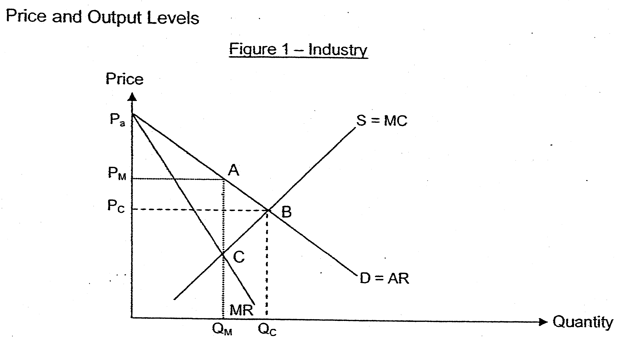

•A competitive industry has a demand curve, D and a supply curve, S. Equilibrium occurs where the quantity demanded equals to quantity supplied at output Qc and price Pc.
•In the case of a monopoly, the profit maximizing output where marginal revenue equals marginal cost is Qm and price charged is Pm.
•Thus, the monopoly price is higher than the competitive price and the monopoly output is less than the competitive industry output.
•As price is higher than MC, the monopoly is said to be allocatively inefficient while the perfectly competitive industry is allocatively efficient.
•Teaching Point: Besides if the monopolist can perfectly price discriminate, it will charge a different price for each unit sold and increase its output to Qc. The highest price charged is Pa and the lowest price charged is Pc. (Pa is the highest price because there is no demand at any price above it and Pc is the lowest its marginal revenue curve is the same as the demand curve and at any price its marginal cost exceeds marginal revenue.) Hence, the more perfectly the monopoly can price discriminate, the closer its output gets to the competitive output

Profitability
•In the short run, as long as any (competitive or monopoly) firm's total revenue is higher than its total variable costs (i.e. P>AVC), it will continue to produce.
•However, in the long run, competitive firms cannot maintain supernormal profits due to the entry of new firms attracted by these profits. They will eventually compete such profits away till all firms only receive normal profits.
•There is no guarantee that monopoly will always earn supernormal profits as it is still subject to the demand conditions. It could just as well be earning only normal profits (or forced to leave if losses are incurred). However, if supernormal profits are made, the monopoly can continue to reap the profits because of the presence of barriers to entry.

Conclusion
The possibility of sustaining high profits causes many to detest monopoly and subscribe to the belief that appropriate policies are to be implemented to regulate a monopoly.

(b) Discuss whether China's intention to implement anti-monopoly laws is beneficial to the society. [15]

Interpretation of question:
•What are you expected to do?
- Explain what anti-monopoly laws are and how they work.
- Explain how the laws can be beneficial to the society.
- Explain how the laws may not be beneficial to the society.

Isolation and application of relevant economics concepts:
•What are anti-monopoly laws?
Teaching points (Students only need to explain the economic principles underlying the anti-monopoly laws.):
- A monopoly's profit-maximizing level of output is below the level that maximizes the sum of consumer and producer surplus. That is, when the monopoly charges a price above marginal cost, the value society attaches to the consumption is higher than it costs society to produce it. As a result, monopoly causes deadweight losses.
- Policymakers can respond to this inefficiency of monopoly behaviour in various ways. One of the ways would be the use of anti-trust / anti-monopoly laws to try to make the industry more competitive.
- (In the US, anti-trust is a body of law consisting of the Sherman Act, the Clayton Act, and the Federal Trade Commission Act) The purpose of antitrust law is to promote and maintain competitive markets, in order to provide consumers with prices that are reasonably related to the costs of production, with choice, and with innovation. Antitrust laws deal with such issues as monopolization, collusion, and merger controls.
- That is to say, any anti-monopoly laws prohibit obtaining a monopoly by anti competitive methods or the abuse of monopoly (not monopoly itself): "Every person who shall monopolize, or attempt to monopolize, or combine or conspire with any other person or persons, to monopolize any part of the trade or commerce among the several States, or with foreign nations, shall be deemed guilty of a felony." Thus, great size alone or market share alone is hot illegal.

•How the anti-monopoly laws work?
Teaching points (Students only need to explain the economic principles underlying the anti-monopoly laws.):
- First it is necessary to determine whether a firm is dominant based on its concentration ratio, an indicator of the relative size of firms in relation to the industry as a whole. A monopoly has a near-100% four-firm measurement.
- A dominant firm may impair competition on the market.
- With collusive conduct, market shares are determined with reference to the particular market in which the firm and product in question is sold. For instance, tying one product into the sale of another can be considered abuse too, being restrictive of consumer choice and depriving competitors of outlets. This was the alleged case in Microsoft (22 December 2004) leading to an eventual fine of €497 million for including its Windows Media Player with the Microsoft Windows platform.
- Corporations have been fined large penalties for bleaching the law.
Benefits of anti-monopoly laws to China:
- To local companies:
- Good for small businesses in that it keeps big businesses from monopolizing a market. Promotes competition for goods and services.
- Prevent collusive behaviour - keeps companies from making agreements on setting prices which will deter competition.
- To help local companies to compete as the country prepares to remove the final trade barriers and investment hurdles after five years in the World Trade Organization. However, anti-trust laws may deter multi-national corporations from investing in China and hence may affect China's rate of growth.
- To consumers:
- Consumers benefit when companies have to compete vigorously for their business. Such competition leads to lower prices, better service, more innovative offerings, and a wider range of choices.
- Lower prices also reduce redistribution of wealth from consumers to monopolies.
- In the absence of choice, the consumer must deal with one seller and thus lacks bargaining power.
- Prevent first-degree and second-degree price discrimination - keeps businesses from charging customers different prices which can reduce consumers' surplus-
However, for a monopoly which practices third-degree price discrimination, cross-subsidisation is in the interest of consumers.
- To society: More efficient allocation of resources (Pareto Efficiency) with the increased competition, reducing deadweight loss (Area ABC in Figure 1).

Allocative Efficiency
- Is attained when the marginal cost of production is equal to the price (P = MC).
Here price indicates the value that the consumer places on the last unit of the good consumed. MC indicates the opportunity cost incurred by the market in providing that last unit.
- Allocative efficiency is achieved in a perfectly competitive market because firms always equate marginal cost to price prevailing in the market (Figure 1).
- The monopoly is allocatively inefficient because the monopoly's price always exceeds its marginal cost. Consumers would be prepared to buy additional units for an amount that is higher than the cost of producing these units. Some consumers could be made better off, and none need be made worse off, by shifting extra resources into production of this commodity sold by the monopoly.
- Anti-trust laws that promote and maintain competition is expected to result in lower price so that it is near to marginal cost.
- An exception occurs when the monopolist is able to practise perfect price discrimination. His demand curve is his MR curve and at equilibrium output, price charged for the last unit will equal MC (Figure 1).
Productive Efficiency
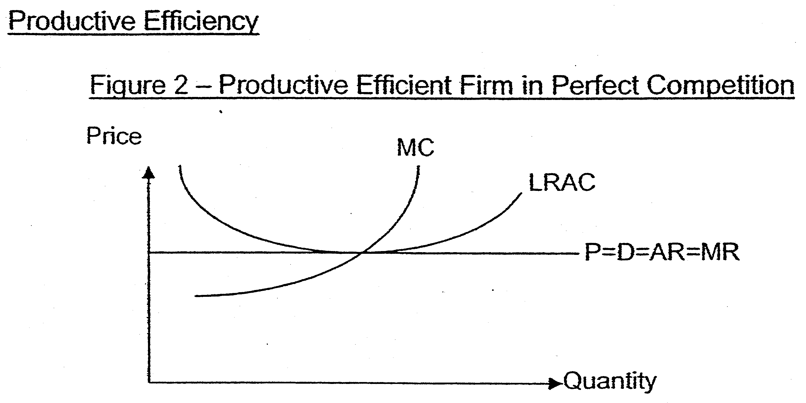
- Productive efficiency is achieved when a given level of output is produced at the lowest possible cost. Each firm is producing on its relevant LRAC curve.
- In a perfectly competitive industry, in the long run, each firm produces at the lowest point on its LRAC curve.
- AH firms in a competitive industry face the same price for their product and equate MC to that of price. It follows immediately that MC will be the same for all firms. No further reallocation of resources among the firms could reduce the total industry cost of producing a given output.
- Productive efficiency is achieved under perfect competition because all firms in the industry have identical marginal costs and identical minimum average costs in long-run equilibrium.

- For a profit-maximizing monopoly, it may have the incentive to be productively efficient since profits will be greatest when they adopt the lowest- cost method that can be used to produce a given level of output. Thus monopolist will operate at LRAC but the output level does not correspond to minimum LRAC.
- However, a monopoly may be productively inefficient as it may not have the incentive to be efficient due to the lack of competition.
- With the implementation of anti-trust laws, there will be greater incentive to be productive efficient, producing near minimum efficient scale.
- Costs of anti-monopoly laws to China:
- To businesses and the society:
- Reduce dynamic efficiency, where dynamic efficiency is gained through improvements in technology due to the ability to invest profits on research and development and hence lowering costs over the long run.
- Working with other companies to perhaps create better products and services for consumers can be viewed as a violation.
- Creates uncertainty for successful businesses because they have no way of knowing if and when their business practices will be targeted. For example if their prices are high it can be considered a monopoly, prices that are too low can be considered predatory pricing and, prices that are the same can be considered as collusion.
- Creates exploitation of successful businesses by making successful companies the targets of other rival competitors who want to destroy their competition and antitrust enforcers who make their living off enforcing antitrust laws and who, therefore, seek out companies to hold in violation. This is particularly so for a less transparent, more corrupted government.
Conclusion:
- For China, developing scale sufficient to raise competitiveness and engage in international markets is a major challenge. The bigger problem is however poor governance. With widespread corruption, inadequate public finances, and weak judiciary and oversight institutions, competition policy may become in itself a barrier to entry which may reduce incentive of multinationals like Microsoft to invest in China. With a fall in investments, this may slower down China's growth and development.

