J1 June Intensive Revision

Market Failures (Type II) – Q1

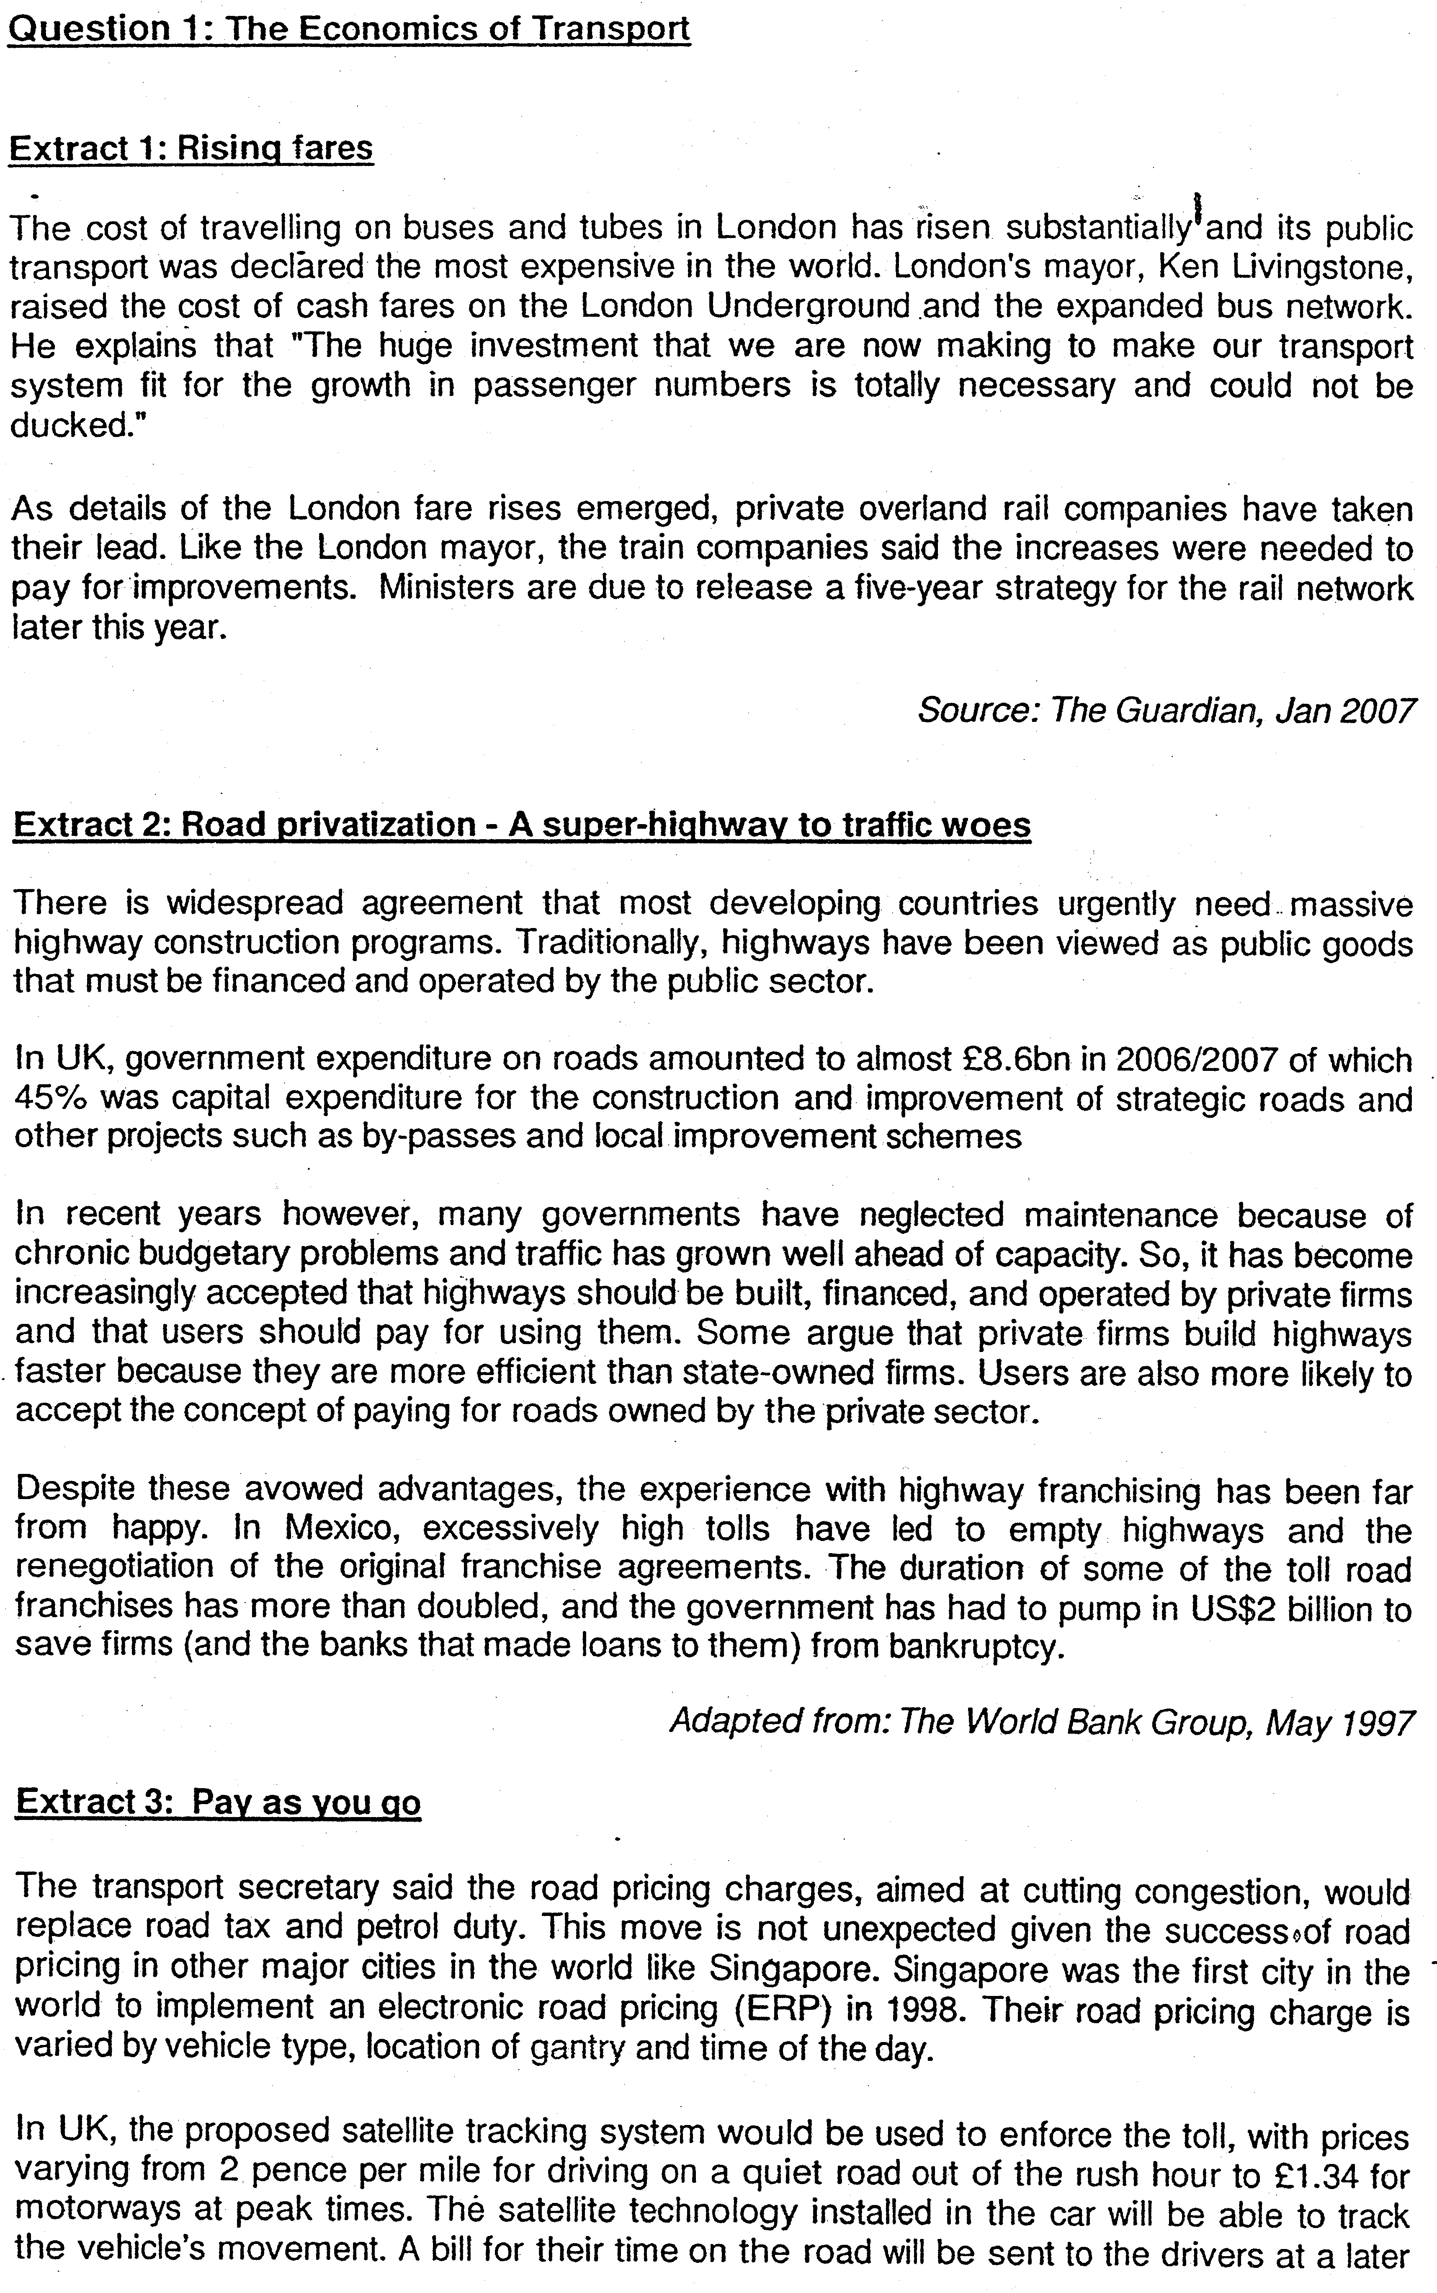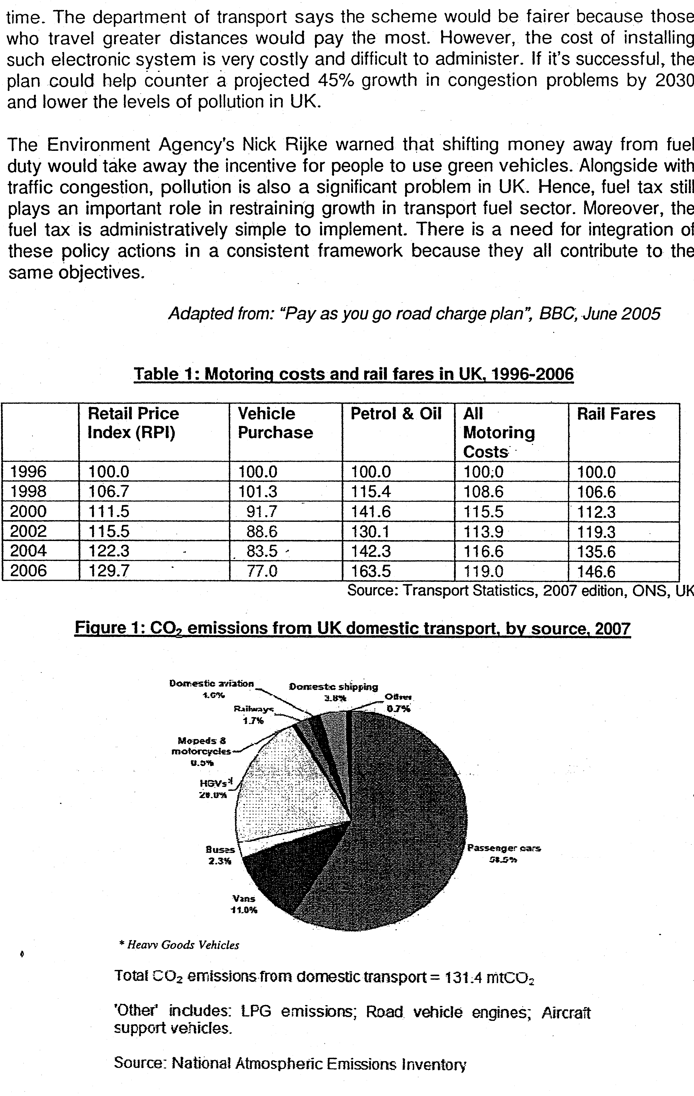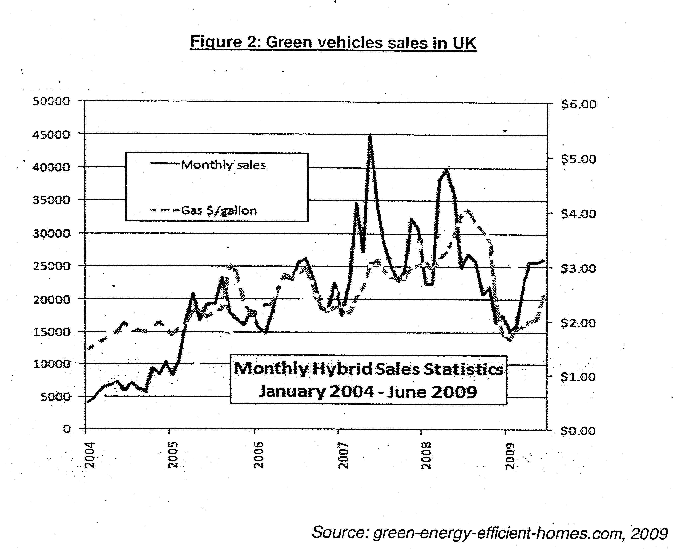

Answer all questions

(a) (i) Compare the changes between motoring costs and rail fares. [2]

(ii) Account for the changes observed. [4]

(b) To what extent does the data support the view that roads should be provided by the UK government? [6]

(c) Evaluate the impact of "shifting money away from fuel duty" (Extract 3). [8]

(d) Evaluate the relative effectiveness of road pricing and fuel duty in solving traffic congestion and pollution problems. [10]
[Total marks: 30]

Suggested Solutions
(a)(i) Compare the changes in prices between motoring costs and rail fares. (2m)

The prices have increased for both
The increase in rail fares is 2.5 times the. increase in overall motoring costs.

(a)(ii) Account for the changes observed. (4m)

Similarity
Rising petrol prices (From Table 1) indicates that there is higher energy cost. Therefore, with the increased cost of driving and operating of rail transport, there is a reduction in supply leading to the increase in prices.

Or

Difference
Rail transport is a mode of public transport in UK. It is a substitute to private motoring and there has been an increase in demand for public transport due to the "growth in passenger numbers" (Extract 1. Coupled with the rising cost of driving, consumers have been switching to rail services thus leading to a substantial rise in prices of rail travel

Or
Privatization and deregulation of the rail industry has led to the private firms having the ability to increase prices due to their monopoly power and as mention in Extract 1, they have taken national rail's lead to raise prices.
Additional revenue required to fund the rising cost of production and to make improvement to rail services.

*Note: Students can also analyze the increase in supply- "expanded" network for public transport but they must reconcile to explain for the price increase.
(2m similarity + 2 m difference)

b. To what extent does the data support the view that roads should be provided by the UK government? (6m)

Thesis: Data supports that roads should be provided by government
Traditionally, roads were treated like public goods where they were deemed to have exhibited the characteristics of non-excludability and non-rivalry. If such goods were to be left to the private enterprise, they would not be provided at all and there would be allocative inefficiency.

High initial capital outlay (Extract 2 - UK £8.6billions).Evidence of how the private firms have failed in other countries and required government "bail-outs"->Toll charges were high and commuters were responsive to the charges (Extract 2)

Positive externalities in providing roads (Extract 2-"Strategic roads")

Anti-Thesis: Data does not support that roads should be provided by government
However,
Excludable -> Road pricing (Extract 2 and 3)-> It is now possible to charge the users of the roads and exclude those who are not willing or able to pay.
Rival in nature-> Depends on whether there is spare capacity on the roads -> There is a congestion problem in UK (Eg. Extract 1- "traffic has grown well ahead of capacity") -> probably rival in nature for some of the more congested roads.

Huge burden on finance especially if the country is in deficit (Extract 2- Huge expenditure/ Private firms has to loan from banks)
Evaluation - However, there's a lack of evidence from other countries before and after privatization to make a basis for comparison.

Synthesis: Roads can be seen as quasi-public goods and there are benefits associated with its provision. While there is a need for intervention, UK could possibly also adopt the strategy of auctioning roads to private firms and to allow them build the road. The franchise payment will help raise funds to improve public transportation (Which is a problem as seen in Extract 1) and at the same time the public might be more receptive to the government's recommendation to road pricing for the more congested roads.

(c) Evaluate the impact of "shifting money away from fuel duty" (8m)

Introduction:
Respond the Signpost: Briefly explain context of the statement

Impact on Market for Fuel based cars
- fall in equil price and increase in equil qty exchanged in the market.
(reduction in tax – dercrease in cost of production – increase
Impact on Market for green vehicles -
- Equilibrium price and qty exchanged in the market for green cars fall.
Illustrate with DD - SS diagram

Evaluation on the implications on pollution as a source of market failure
Examples:
- The extent of fall in the demand for green cars will depend on the PES of fuel based cars. It can be assumed that generally PES for car production is relatively inelastic due to high barriers to entry into the market for car production. Hence, the fall in quantity exchanged in the market for fuel based cars will be a lesser extent implying a lesser fall in demand for green cars.
- Whilst the fuel tax maybe decreased, overall pollution level accrued to fuel usage can still fall if the road pricing policy is successful in reducing car usage across the UK hence air pollution as well. Evidence: Ext 3 If it's successful, the plan could help counter a projected 45% growth in congestion problems by 2030 and lower the levels of pollution in UK.

(d) Evaluate the relative effectiveness of road pricing and fuel duty in solving traffic congestion and pollution problems. (10m)

Introduction:
Road pricing and fuel duty are forms of taxation to increase the cost of car usage.
Evidence: In extract 3 both UK and S'pore have adopted road pricing to tackle the problem of traffic congestion. The pollution problem is also evident from the extract and figure.
Explain how road pricing works to reduce traffic congestion & pollution
- Road pricing will directly increase the costs of car usage and hence increase the MPC of car usage to the left as seen below

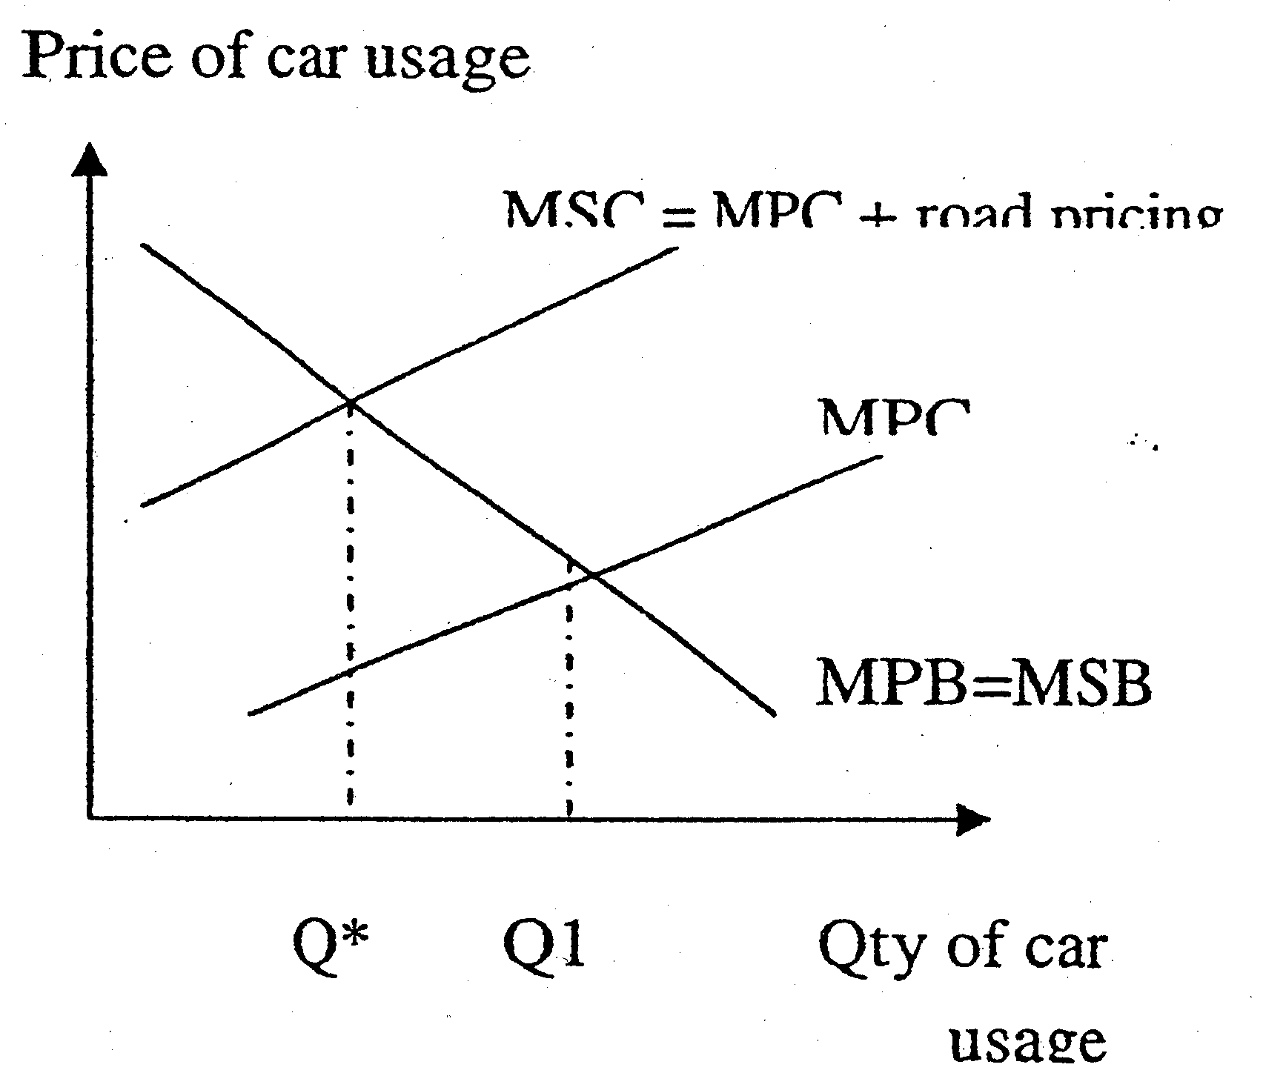
- The road pricing internalizes the external cost associated with traffic congestion & pollution. For e.g. traffic congestion increases incidences of accidence and the 3rd party impacted is uncompensated for. Pollution can also lead to respiratory health problems for 3rd parties and left uncompensated for. For e.g. in Figure 1 - private car usage is the main source of pollution in UK of 58.5% -

Explain how fuel tax works to reduce traffic congestion & pollution
Fuel tax will directly increase the cost of using petrol for car usage.
- Increase in fuel tax —> increase in cost of supplying fuel —>
- Equilibrium price of fuel increases & equilibrium qty of fuel exchanged is reduced.
- Hence with lower levels of fuel usage, level of pollution will be reduced.
- Higher prices of fuels —> increase cost of car usage —> shift the MPC for car usage to the left and hence socially optimal level of car usage will be attained —> traffic congestion will be reduced.
- Hence, with road pricing, the equilibrium qty of car usage will be reduced to Q* which coincides with the socially optimal level of car usage.
- Society's welfare loss resulting from the presence of externality would be eliminated.
- Hence, the level of traffic flow will be at the socially optimal—> with less car usage —> lower pollution levels. .

Evaluate the effectiveness of Road pricing and Fuel tax according to Evidence available
Examples:
- Road pricing is more effective in reducing traffic congestion than pollution - e.g. in S'pore case the ERP system may redirect traffic flows according to time and space but not reduce car usage and hence pollution levels
- In UK case - the satellite system takes into account the distance traveled hence will be more effective in reduce both the traffic congestion and pollution levels.
- Fuel tax works primarily to reduce usage of fuel - however, citizens can
- [ switch to using non-fuel based cars hence the traffic congestion problem may still prevail. Evidence fig 2: there is growing sales of green vehicles in UK which is a substitute for fuel based cars and even though pollution has fallen the traffic congestion problem can still prevail.
- In UK they have existing fuel and road taxes however the need to introduce a new road pricing system imply that existing policy is insufficient. This may imply that fuel tax alone is not effective in reducing traffic congestion.
Evidence: Ext 3 - the road pricing replaces the road & fuel tax. This may imply that road pricing is a more superior policy to reduce both traffic congestion & pollution in UK.

Synthesis:
In one way or another both road pricing and fuel tax will have an impact on reducing traffic congestion and pollution through the channels of raising the cost of car usage. However a combination of the use of road pricing and fuel tax is needed to specifically target the root source of externality.

