Economics Term 3 2017
CSQ – Lesson 4 – AD-AS Model & National Income Accounting – Q1

Emerging Economies as Engines of Growth in the Global Economy

Extract 5: BRIC Economics as Future Powerhouses

Following the global economic slowdown in 2009, emerging economies are leading the recovery with high rates of economic growth and increasing consumer demand. It is predicted that emerging markets will account for more than half of world GDP, according to the International Monetary Fund (IMF).

Among them, the four BRIC countries — Brazil, Russia India and China — are identified as the future economic powerhouses. These countries are propelling the global recovery as their economic growth rates exceed global averages. With the 42% of the global population that reside within them becoming more affluent and seeking higher living standards, the rise of the BRIC consumer will only become more marked over the next decade.

A new trend which has influenced the flow of goods and services is that of intra-BRIC trade. Previously, the BRIC countries were seen as the factories and commodity supplies to the world, but now they are working together as consumers and producers and trading with one another. Should we see a slowdown in the developed world, the BRIC countries are well-positioned to ride out the storm.
Adapted Source: The Telegraph, 11 Nov 2011

Figure 2: Emerging Market Share of World GDP

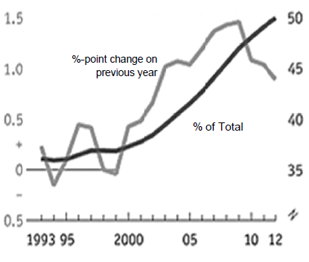
Source: IMF Website

Table 2: Real Economic Growth (Annual %)
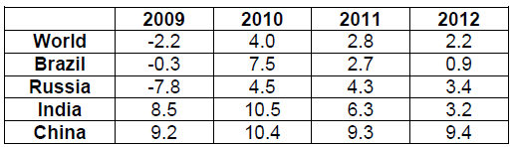

Source: World Trade Organisation Website, accessed on 7 August 2013

Table 3: Selected Economic Statistics, 2011

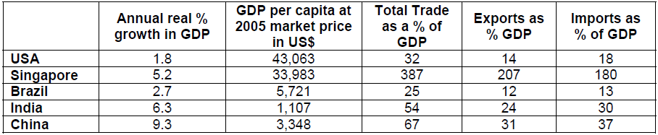

Source: The World Bank Website

Extract 6: BRIC Nations Rocked by Aftershocks of Eurozone Crisis
The devastating slowdown in the European economies has shown that 'decoupling' – the idea that emerging countries would go on growing despite problems in the west -- is a myth. Plunging demand from the markets of Europe, many of which remain deep in recession, and collapsing global confidence in politicians' ability to stop the rot, has ruthlessly exposed the weaknesses of emerging markets.

The rupee plunged as investors take flight and head for the safety of the US dollar. China slowed most alarmingly. If the slowdown in its manufacturing output is serious enough to hit China's demand for imported oil, iron ore and industrial components, it could create problems for Brazil too.

Most analysts expect the radical shift of economic power from the west to the emerging markets to continue but as Europe and the US turn inwards to tackle their own crises, it could be a tough couple of years for the BRICs.

Adapted Source: The Observer, 24 June 2012

Extract 7: New-wave Economies Going for Growth
Economists say there are a number of key factors that will allow emerging countries to grow more quickly than the mature markets of the west. Firstly, they must have sound macroeconomic policies, including control of inflation and budget deficits. Secondly, they must invest in human capital and improve their educational standards. Thirdly, they must be able to import new technologies from the west. Finally, they must have young and growing populations.
Source: The Guardian, 18 December 2012
Questions
(a) (i) Compare the growth rates of the BRIC countries between 2009 and 2011 in Table 2. [2]

(ii) Using Extract 5, explain how the growth rates in the BRIC countries affect the pattern of trade. [4]

(b) Comment on whether Table 3 and Figure 2 support the view that emerging economies will be the ‘Engines of Growth in the Global Economy’. [6]

(c) (i) With reference to Table 3, which indicator would you use to assess the standard of living in a country? Justify your answer. [2]

(ii) Explain two other pieces of information that would be useful in assessing the standard of living in a country. [4]

(d) With reference to Extract 6 and using appropriate diagrams, explain why the rupee fell in value as investors took flight and headed for the safety of the US dollar. [4]

(e) Discuss the extent to which the factors highlighted in Extract 7 can help emerging countries sustain their economic growth. [8]

Suggested Answers

(a)(i) Compare the growth rates of the BRIC countries between 2009 and 2011 in Table 2. [2]

The four countries experienced positive growth rate in general for the three year period except for Brazil and Russia which experienced negative growth at the start of the period in 2009.

Except for India, the economic growth rate increased over the given period from 2009 - 2011

Their economic growth rates actually peaked in 2010 and fell after that. China consistently achieved the highest growth rate over the three year period

(a)(ii) Using Extract 5, explain how the growth rates in the BRIC countries affect the pattern of trade. [4]

BRIC countries experienced positive growth rate and higher than that of the global average HH Ys increase relative to the rest of the world higher purchasing power greater ability to import goods and service. change in trade patterns in terms of volume, type of goods/svs trades and trading partners.

Change in the types of goods traded (from exporting low-valued goods and commodities to exporting higher-valued consumer goods/services; and perhaps from importing capital equipment to importing consumer goods/services), change in trade volume (increasing imports) and change in trading partners (from BRIC-rest of the word trade to intra-BRIC trade)

(b) Comment on whether Table 3 and Figure 2 support the view that emerging economies will be the ‘Engines of Growth in the Global Economy’. [6]

Introduction
‘Engines of growth in the global economy’ means ‘forces that drive economic growth in the global economy

Thesis
- Figure 2 – shows that the share of emerging countries’ GDP as a % of total World GDP has been increasing and accounts for more than 50% of world GDP. Increase in relative GDP higher purchasing power higher demand for imports helps in creating X dd for trading partners spur economic growth of its trading partners driver of global demand engine of growth
- Table 3 – real GDP growth for BRIC in 2011 -> increase in PP increase in dd for M and hence drive global growth (consistent with Figure 2), their imports as a % of GDP are high compared to US too.

Anti-thesis
- Figure 2 also shows that rate of increase in emerging market’s share of GDP has been falling since 2009 contradicting data as it raise question on the sustainability of emerging countries to drive economic growth
- Figure 2 only shows that share of emerging countries’ GDP as a % of total World GDP. It does not show if GDP is increasing.
- Table 3 does show the growth in GDP but restricted to only 3 of the BRICS countries and for one year only. Hardly conclusive insufficient data.
- Data on GDP per capita is not useful as population size is not given. It is the real GDP figures (i.e. aggregate figures) that reflect the purchasing power and hence importance of a country.

Judgment
Data from Figure 2 and Table 3 reinforce each other to show the increasing importance of emerging countries in stimulating global economic growth through increasing imports. However, it is difficult to gauge as data are contradicting and insufficient as well.

(c)(i) With reference to Table 3, which indicator would you use to assess the standard of living in a country? Justify your answer. [2]

GDP per capita at 2005 market price in US$. Takes into consideration the population size. Rep the average income per person average purchasing power average consumption per person which is a good indicator of the material SOL.

(c)(ii) Explain two other pieces of information that would be useful in assessing the standard of living in a country. [4]

Highlight that there is both material and non-material SOL. To suggest two appropriate indicators, e.g. infant mortality rate, literacy (preferably one to assess material SOL and one to assess non-material SOC). For each indicator, explain how it can be used to assess the SOL of a country.

Education
literacy rate - With better education, the people in a country will be able to read and appreciate aesthetics or literacy work, enjoy the fine arts and engage in pursue of their own aspirations. This ability to pursue self-realisation is a non-material aspect of SOL.

Health
Infant mortality rate, life expectancy, quality adjusted life years, availability of medical infrastructure per 1000 person – Infant mortality measures the proportion of babies born who die before the age of one out of total births. A low infant mortality rate signals availability and accessibility healthcare services. This would indicate both material and non-material SOL.

(d) With reference to Extract 6 and using appropriate diagrams, explain why the rupee fell in value as investors took flight and headed for the safety of the US dollar. [4]

Investors ‘take flight’ and head for the safety of US dollar hot money outflow from India to US Rise of Rupee SS in the exchange rate market; At the same time, there is less inflow of hot money fall in Rupee DD increase in SS and fall in DD excess ss of rupee in the market.

Assuming free exchange rate system rupee depreciates until market clears.
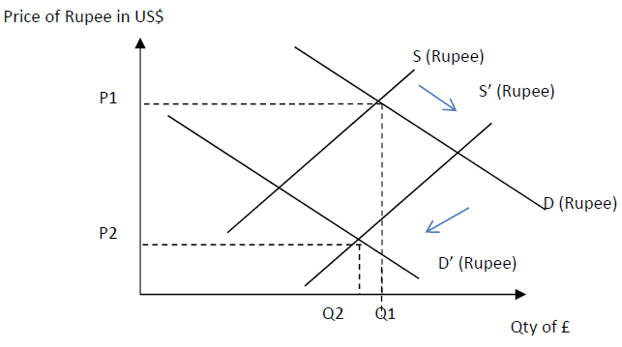

(e) Discuss the extent to which the factors highlighted in Extract 7 can help emerging countries sustain their economic growth. [8]

Explain how each of the factors will help emerging countries grow:
- Sound macro-economic policies to control of inflation rate and budget deficits build consumers’ and investors’ confidence ensure healthy C and I promoting both actual and potential Economic Growth through AD and AS
- Investment in human capital and improvement of educational standards improve quality of fop
- Import new technologies from the west -> increase in qlty of fop as above
- increase productivity productive capacity reduce unit cost increase AS attract foreign investment facilitate restructuring of economy build up the value-added chain increase potential growth
- Finally, they must have young and growing populations increase in quantity of labour as above

Discuss whether the factors can help emerging countries sustain its economic growth. Depends on:
- Ability of macro-economic policies to help emerging countries sustain EG - Depends on effectiveness, sustainability, appropriateness etc of the policies
- Current economic condition of the economy – If there is an economic downturn / inflationary pressure / chronic budget deficit - Need to be resolved through demand-management policies and not supply
- Economic characteristics of the economy – urgent need to invest in human capital and import new technologies if the country is short of these resources. For example, India may not place this as the top priority given its abundance unlike other less developing countries like Mexico

