Chapter 2.1 – Central Economics Problems I – Economics Principles

Economics is a social science. It deals with how the society allocates scarce resources to produce goods amd services to maximize human wants.

Economics is studied on a normative and positive approach.

It is divided into two main areas: Microeconomics or Macroeconomics
2.2.1 The problems of scarcity
I. Meaning
The problem of scarcity exists as there are limited resources while the wants are unlimited. This will lead to the need to conduct resource allocation to solve the problem of scarcity.

II. Diagrammatical Illustration
(Please include the diagram from the notes - under the problems of choice - create a circle with the word opportunity cost)
Diagram 1 - Problem of Scarcity and Resource Allocation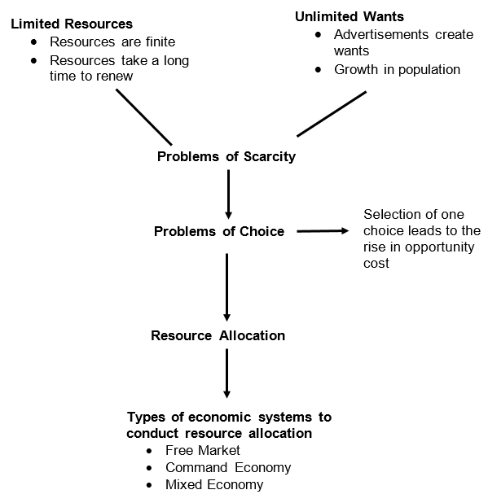

2.2.2 Concept of resource Allocation

I. Meaning
In the process of resource allocation, the economy will involve in solving the three fundamental economic problems on what to produce (amount to produce), how to produce and for whom to produce. In this process, the economy will be based on the type of economic system.

II. Process of Resource Allocation
In this process of resource allocation, it will involve the following process:
a) Allocation of resources
- to decide what goods and services to produce
- how much of each to produce at any given time
b) Organization of production (profit maximization)
- to choose the best technique of production (labour and capital intensive)
c) Distribution of Commodities
- how to appropriate the products among the individuals and organization in an economy (distribution of goods and services)

2.2.3 Opportunity Cost and Production Possibility
I. Meaning of Opportunity Cost
Opportunity cost is defined as the cost of using resources for a certain purpose, measured in terms of the next best benefit it can derive when use for another alternative.

II. Meaning of Production Possibility Curve
The production possibility curve shows all combinations of the goods that an economy can produce, with the given resources and technology.

Main characteristics of the PPC
a) The PPC can be used to show scarcity where the attainable and unattainable production are shown.
b) It shows the alternative combination of production.
c) It will also show the existence of opportunity and the degree of opportunity cost.

III. Illustration of Opportunity Cost through the use of PPC

The concept of opportunity cost can be illustrated through the use of the production possibility curve where certain assumptions must be held constant. From the PPC, we can observe that the increase in the production of one good will lead to the reduction of another good and thus, the value of opportunity of cost of the increase in production of the first good will be seen in the value of reduction in the production of the second good.

Basic assumptions of the PPC
- The economy is at a specific state of technology.
- The economy can fully utilize all of its available resources.
- Only 2 goods are analyzed.
- Resources are fixed.

Diagram 2 - PPC and the concept of Opportunity Cost
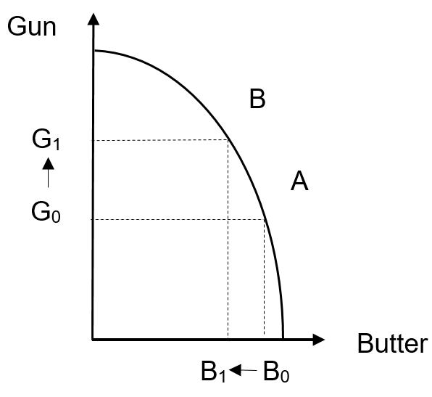

The increase in production of more guns will mean that there is a decrease in production of butter. Therefore, the opportunity cost for production of guns is seen in terms of the reduction in quantity of butter. The opportunity of Go G1 units of guns will be the reduction in units of Bo B1 of butter.

IV. Rate of Opportunity Cost as seen by PPC

From the PPC, the rate of opportunity cost of the good in terms of another good can be observed by examining the slope of the PPC.

When the PPC is a straight line, there is constant opportunity cost. This implies that the increase in production of gun will lead to a proportional reduction in butter.

What is the implication of this observation?

………………………………………………………………………………………......

………………………………………………………………………………………......

………………………………………………………………………………………......

………………………………………………………………………………………......

………………………………………………………………………………………......

V. Implications of the Production Possibility Curve
Diagram 3 - Implications of PPC
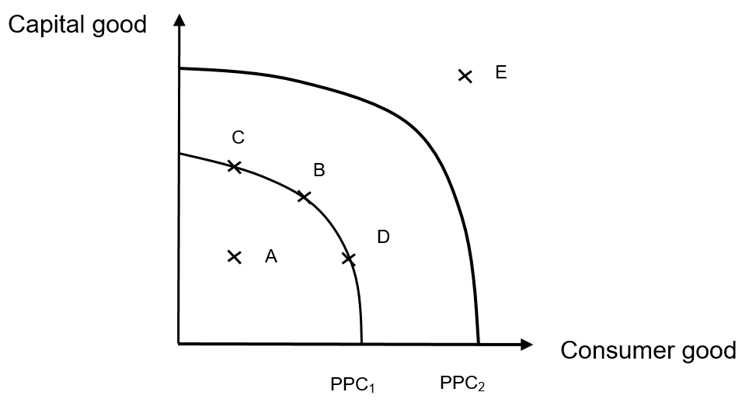

Changes in the PPC can be seen when there is a change in the production level of the PPC from one point within the PPC to another point of the PPC and this means that there is an increase in the actual production as seen from how the production level has changed from point A to point B or to Point C and Point D. However, the economy is unable to increase production from point A to point E as the resources available for the production is beyond the capacity of the economy. This can only be attained when there is an outward shift of the PPC, implying that there is an increase in the actual production capacity

The outward shift of the PPC represents an increase in the production capacity of both goods. This can be due to Increase in labour supply, improvement in technology or an increase in capital employment. However, the economy can also experience an inward shift of the PPC which represents a decrease in the production of both goods. This can be due to decrease in labour supply or decrease in capital employment

2.2.4 How the concept of PPC is used to depict Economic Growth?

Actual economic growth refers to the actualization or utilization of resources into products, contributing to the growth of production capacity. This means that the level of national income has increased and this is represented by the movement of the production level within the PPC to the production level on the PPC.
Potential growth refers to the expansion of the availability of the resources, implying that there are more resources for production in the economy. This means that the potential production capacity has expanded and this is represented by the outward shift of the PPC.

2.2.5 Application of concept of Opportunity Cost through the use of PPC.

Based on the following resource employment, draw the diagram of PPC and explain how the PPC will Change.

Situation 1: Import of resources suitable for the production of capital goods

………………………………………………………………………………………......

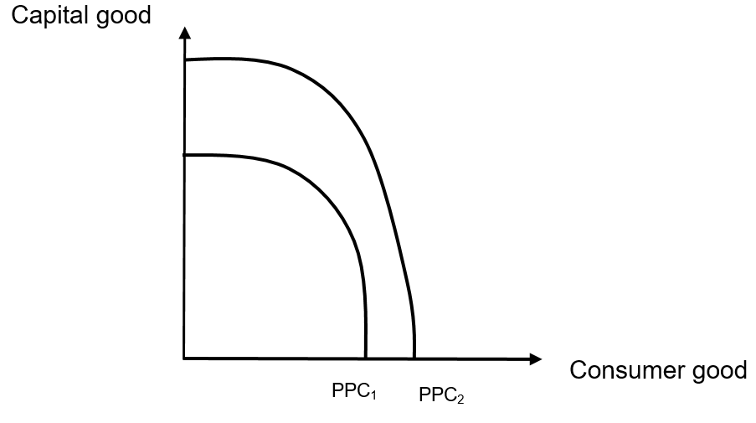
………………………………………………………………………………………......

………………………………………………………………………………………......

………………………………………………………………………………………......

………………………………………………………………………………………......

………………………………………………………………………………………......

Situation 2 :Import of goods and services for consumption

………………………………………………………………………………………......

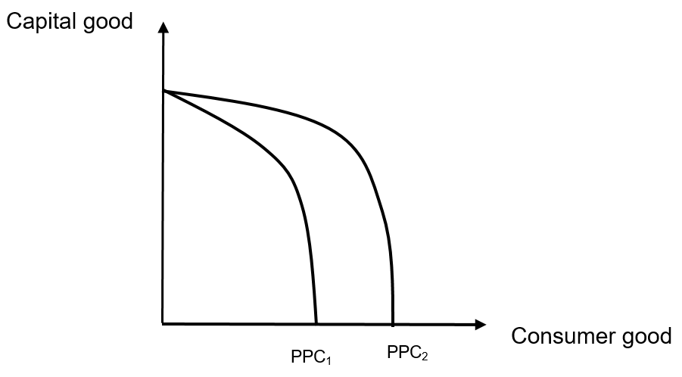

………………………………………………………………………………………......

………………………………………………………………………………………......

………………………………………………………………………………………......

………………………………………………………………………………………......

………………………………………………………………………………………......
Situation 3: Increase in the production of capital goods and decrease in the production of consumer goods.

………………………………………………………………………………………......













