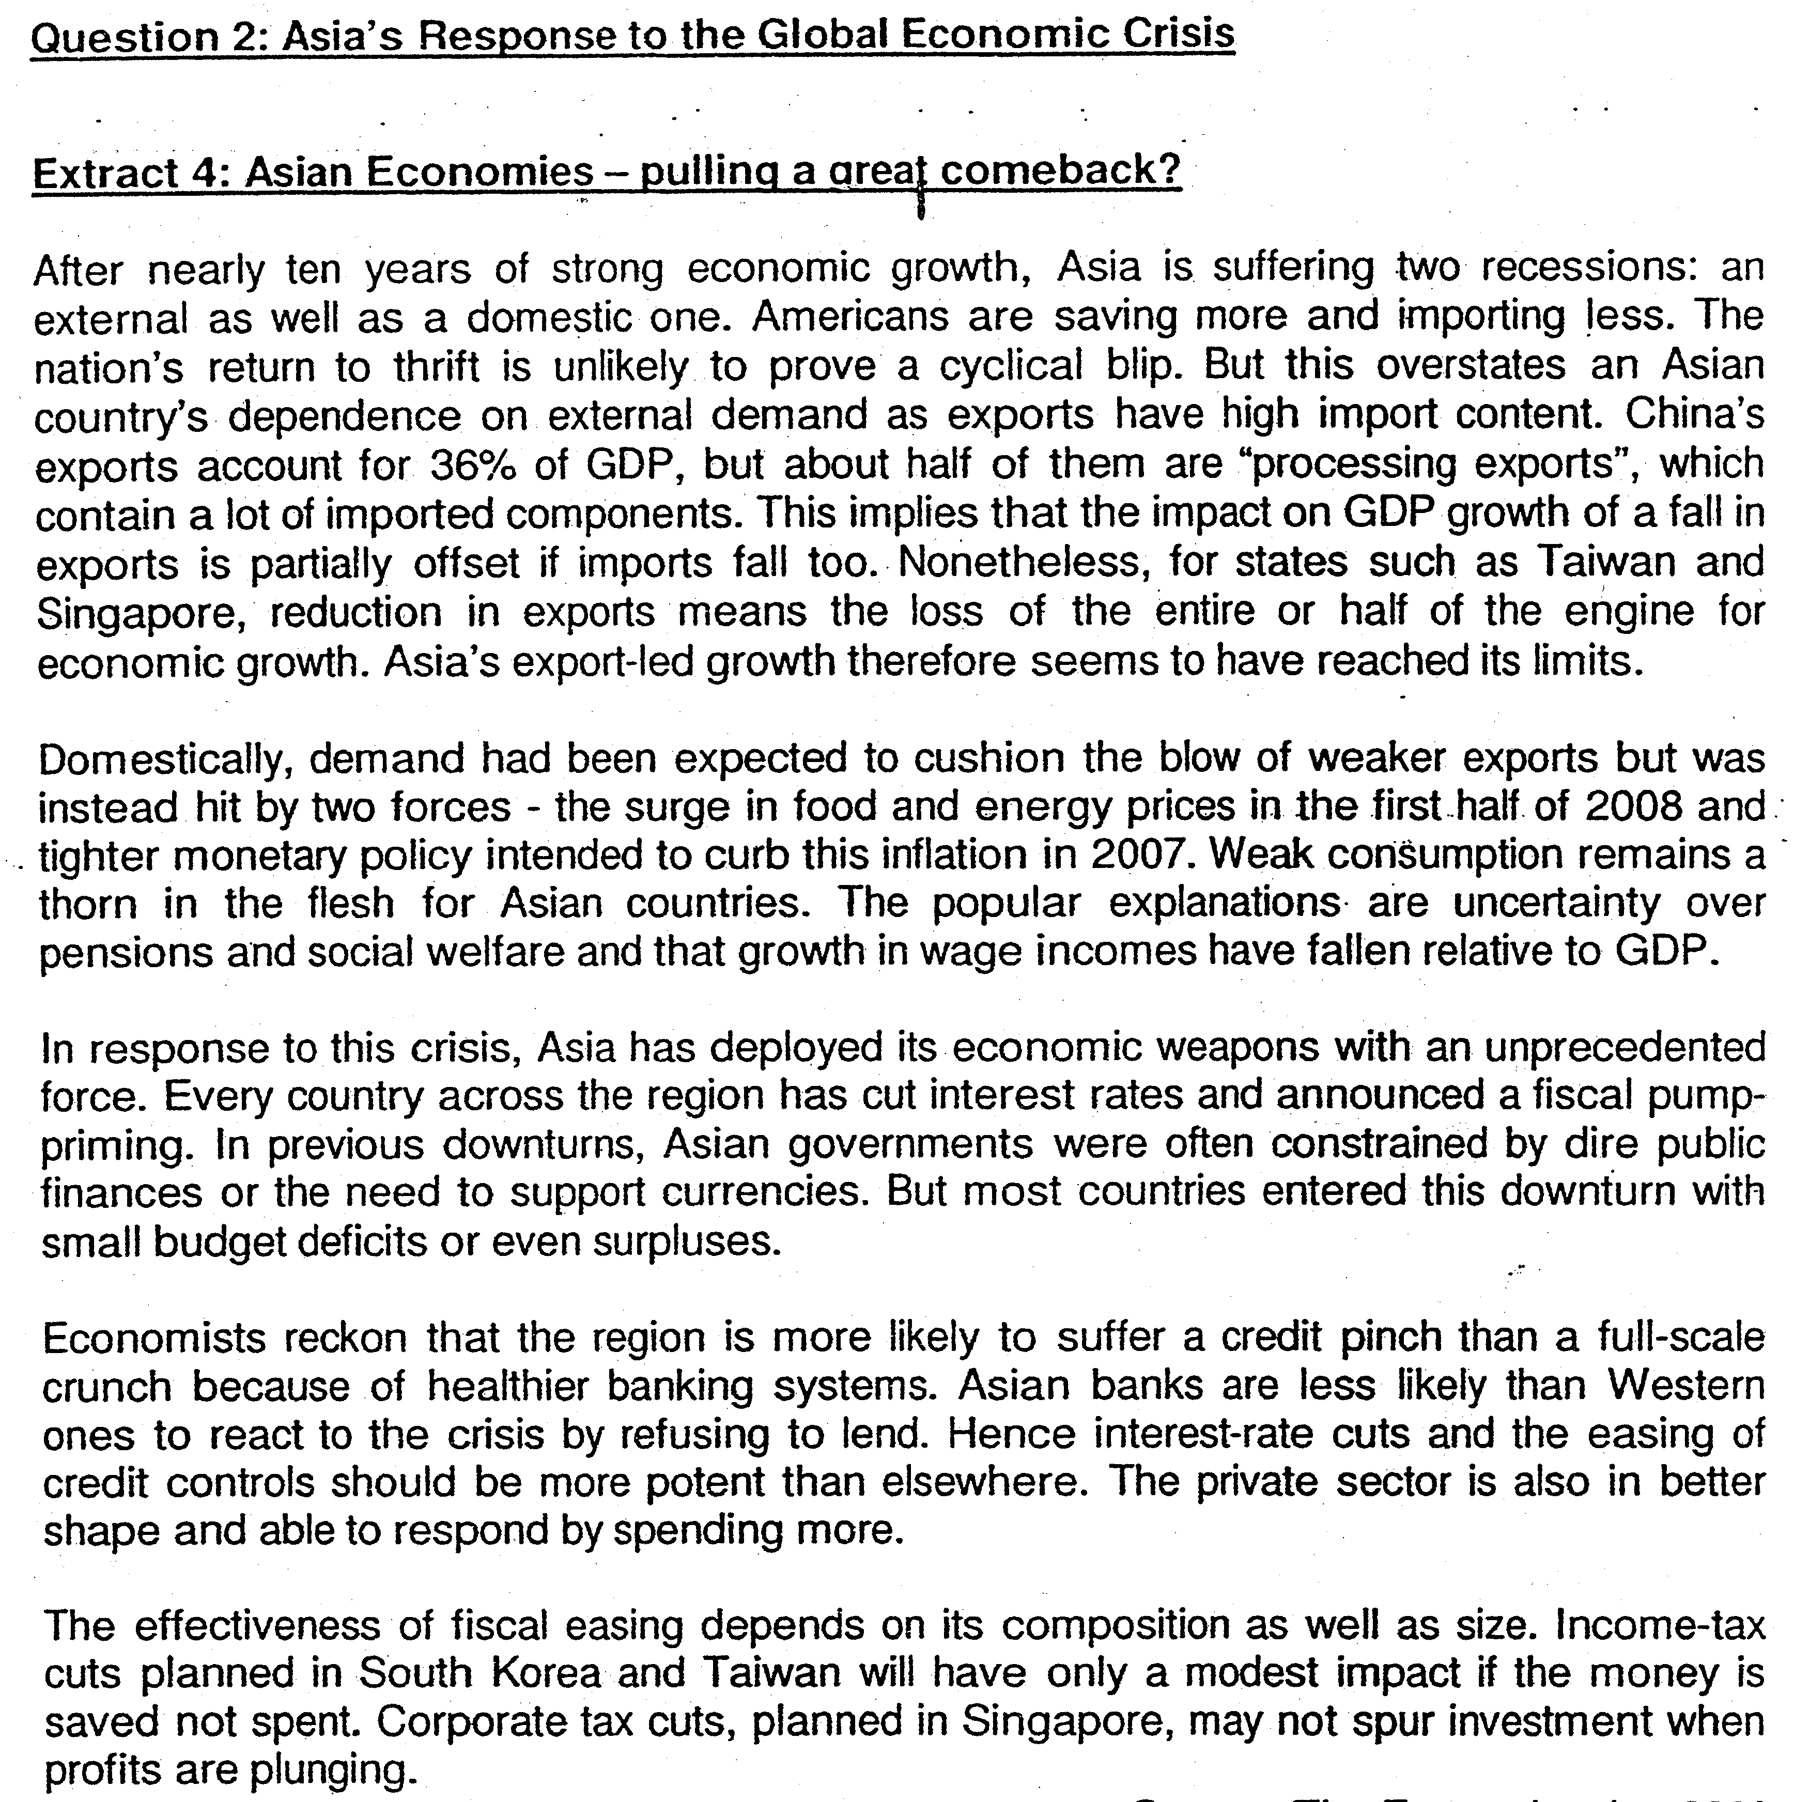
Explain why consumption in China is unable to replace the contribution of export to the growth of economy?

Why Asian policies are not effective to curb recession?
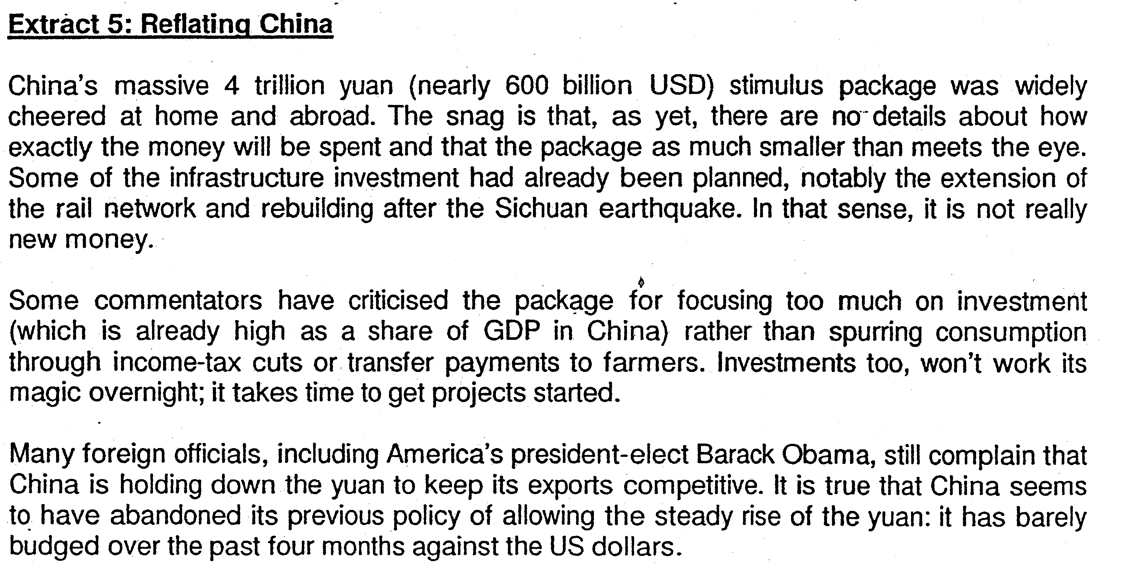
Explain how the ‘massive 4 trillion Yuan stimulus package helps to grow the economy in China?
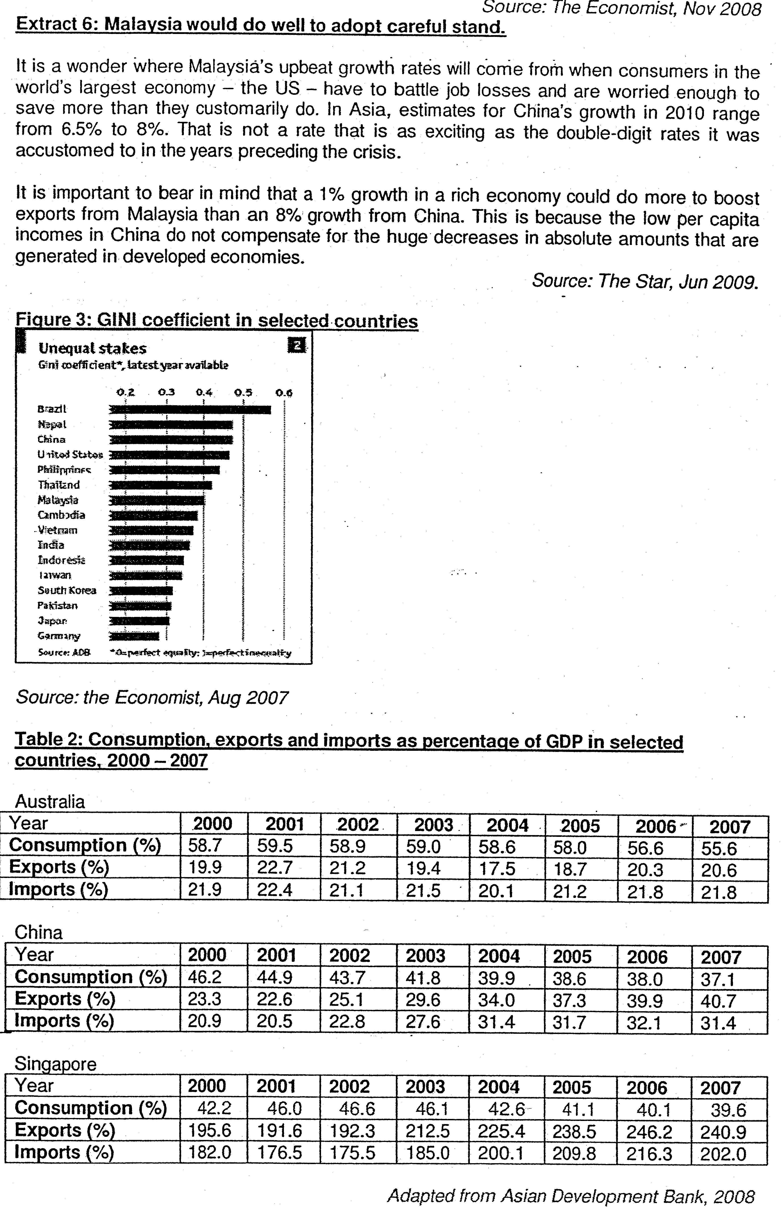
Explain why export growth to China is less beneficial than to rich countries.
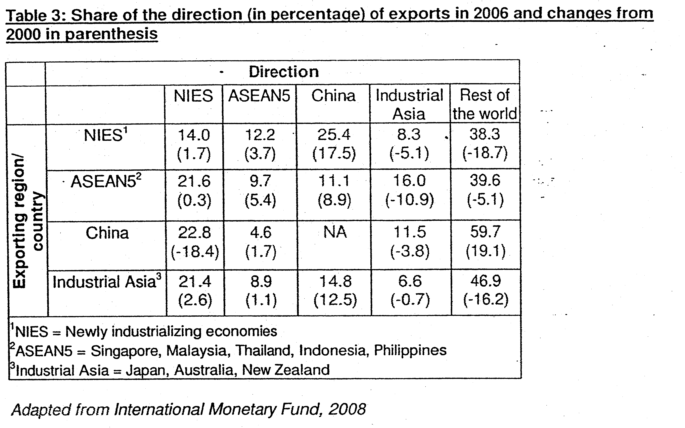
Answer aLl questions
(a)(i) Account for the differences in the imports as a percentage of GDP for Singapore and China between 2000 and 2007. [4]
(ii) With reference to the data, the change in import expenditure and export revenue for China. (6)

b) Using AD-AS analysis, comment on the causes of recession in Asia in 2008. (6)

(c) Discuss whether the data provided is sufficient to conclude that standard of living in China has improved since 2000. [8]

(d) Governor of the People's Bank of China, Zhou Xiaochuan said that China's "greatest contribution to the world" is to keep the Chinese economy running smoothly amidst the global recession.

Discuss the extent to which economic intervention by the Chinese government, would contribute to economic recovery in the ASEAN countries. [10]

Answers
a(i) Account for the differences in the imports as a percentage of GDP for Singapore and China from 2000 to 2007.

Observation 1
Singapore's import to GDP ratio is significantly higher, and exceeds 100%

Explanation
Singapore is essentially a re-export economy, whereas China re-exports on a smaller scale due to its higher domestic demand.
Evidenced ->China's exports account for 36% of GDP, but about half of them are "processing exports", which contain a lot of imported components/
'Nonetheless, for states such as Taiwan and Singapore, reduction in exports means the loss of the entire or half of
the engine for economic growth.' [Extract 4]

Observation 2
The relative change in imports as a percentage of GDP is greater for China (50.2%) compared to Singapore (11%)

Explanation
Higher growth rate in China compared to Singapore
Evidence -> In Asia, estimates for China’s growth in 2010 range from 6.5% to 8%. That is not a rate that is as exciting as the double-digit rates it was accustomed to in the years preceding the crisis’ (Extract 3)
(Both observations above for the full mark)

a (ii) With reference to the data, explain the different average propensities to consume in Singapore and Australia in the period 2003 to 2007. [3]

Observation:
The average propensity to consume, ape is measured by the ratio of consumption to GDP.
As seen from table 1 the ape for Australia is consistently higher compared to Singapore (ape for Australia is more than 0.5 unlike Singapore).

Explanation:
Lower level of of social welfare (social safety net) in Singapore compared to Australia tends to encourage more precautionary savings, thus lowering the ape.
Wage income relative to total income has been falling suggesting that workers permanent income may have decrease hence reducing the propensity to consume.

Evidence (Extract 3)
Weak consumption remains a thorn in the flesh for Asian countries. The popular explanations are uncertainty over pensions and social welfare and that growth in wage incomes have fallen relative to GDP.

b. Using AD-AS analysis, comment on the causes of recession in Asia in 2008.

Define recession: A recession is defined as a period of two consecutive quarters of negative economic growth.

Triggers
Fall in export revenues
Evidence: Americans are saving more and importing less. [Extract 4,para 1]
Theory: Demand for Asia's exports fall, lowering AD. Firms produce less, lowering overall output in Asian economies.
Contractionary Monetary Policies (2007)
Evidence: tighter monetary policy. [Extract 4, para 2]
Theory: increase in i/r- increases cost of borrowing. I & C components fall, reducing AD. Firms produce less, lowering overall output in Asian economies.
Higher fuel and energy prices
Evidence: surge in food and energy prices [Extract 4]
Theory: Increase in fuel prices increases CoP. Higher prices passed on to consumers will lead to fall in quantity demanded for finished products. Output will reduce.
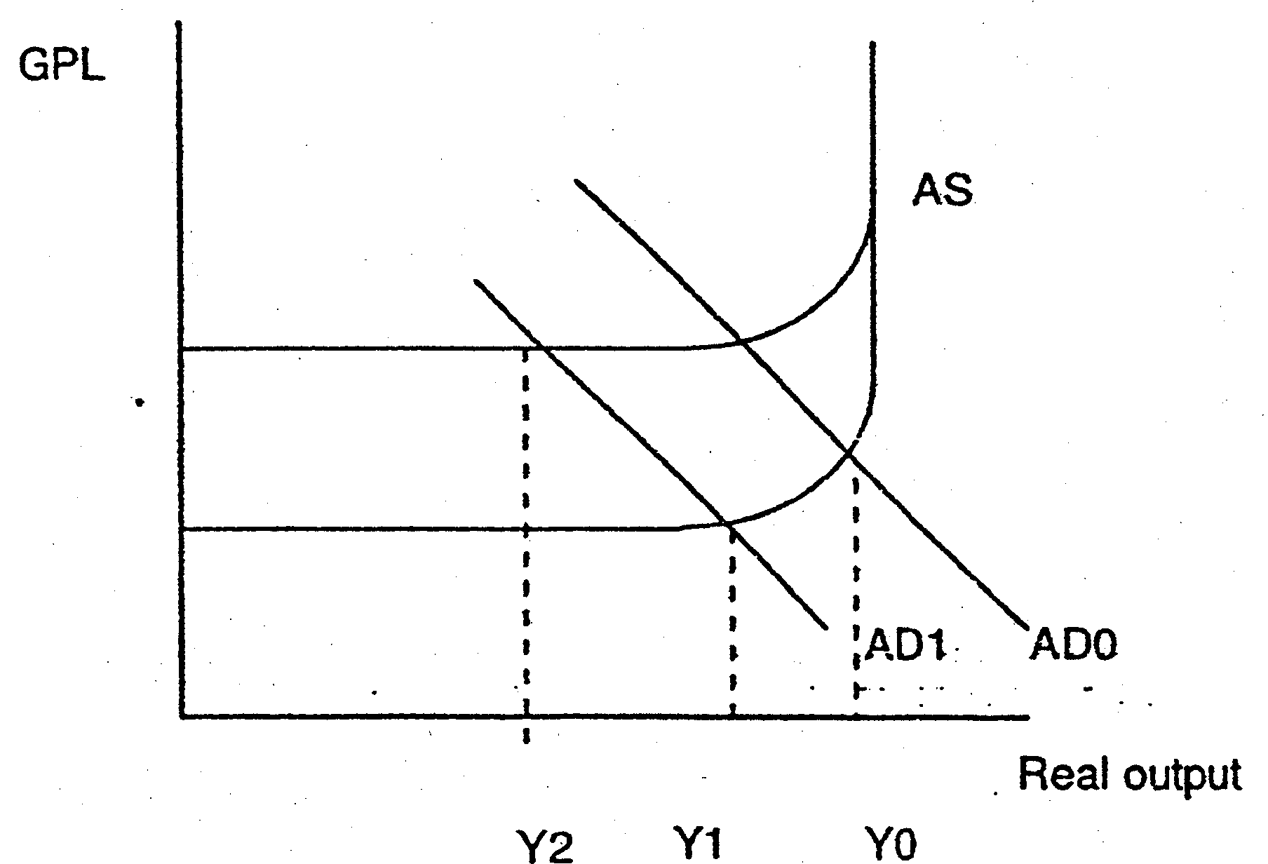GPL
(+) increase in food prices reduce the real wage of workers, prompting them to request for wage increment. Wage increment increases CoP which leads to higher prices. Output then falls as a result.

2 marks for evidence, 2 marks for theory, 1 mark for diagram.

c. Discuss whether the data provided is sufficient to conclude that standard of living in China has improved since year 2000.

Introduction, setting of criteria: Standard of living refers to the level of material as well as non-material well-being of an individual. The data does imply that standard of living in China has improved but is insufficient.

Thesis: data shows improving SOL
1) As indicated in extract 1, economic growth in China, being an Asian country, has been strong over the past ten years. Another evidence in Extract 3where there was double digit growth in China.

2) The "previous" policy of Yuan appreciation as a measure of reducing prices of imported goods, there by controlling rises in CPI, hence arguing for improvement in real income. This would lead to improvement in standards of living. [Extract 5][3 marks max]

Anti-Thesis: data shows worsening SOL
1) Balance of payments wise, the exports as a percentage of GDP is higher than imports, indicating that large proportion of China's output is for foreign consumption.

2) Consumption expenditure as a percentage of GDP is falling (Table 1). This is further enhanced by the fact that income wages are not increasing as rapidly as GDP growth (Extract 3).

3) Purchasing powers may also be eroded rapidly when food and energy prices increased rapidly in the earlier 2008 (Extract 1).

4) As shown in Figure 1, the GINI coefficient in China is one of the highest globally.[5 marks max for at least 3 of the above points]

Limitation of data:
1) Standards of living also depend on the non-material well-being such as stress and pollution.

2) Human development index (HDI) not shown in the data. HDI would have included information on the availability of clean water, healthcare, education etc. which are essential to sustain standards of living.

3) Also lacking is data on GDP per capita which shows the income per person.

Synthesis - Data suggests improving standards of living in China to a very limited extent. On the contrary, data is more biased towards worsening standards of living.

d. Governor of the People's Bank of China, Zhou Xiaochuan said that China's "greatest contribution to the world" is to keep, the Chinese economy running smoothly amidst the global recession.

Discuss the extent to which economic intervention by the Chinese government would contribute to economic recovery in the ASEAN countries [10]

Introduction:

Interpret economic intervention, evidence of manipulation and meaning of economic recovery

Theoretical framework: AD-AS or Income-Expenditure diagram

Thesis: Policy measures will have positive and significant contribution
1. Successful fiscal policy will lead to an increase in demand for ASEAN5 exports since China uses these for re-exports. This will lead to economic growth in ASEAN5countries via the multiplier.

Evidence: Table 2 shows the increase in ASEAN 5exports to China over time.
China's exports account for 36% of GDP, but about half of them are "processing exports", which contain a lot of imported components.

2. Fiscal and monetary policy is coordinated among affected Asian countries with individual countries implementing their own expansionary measures. The financial and budgetary positions of Asian countries are also sound suggesting that recovery in China will also be accompanied by recovery in ASEAN countries.

Evidence: [Extract 4]:
Asia has never before deployed its economic weapons with such force. Every country across the region has cut interest rates and announced a fiscal pump-priming.

But most countries entered this downturn with small budget deficits or even surpluses.

Asian banks are less likely than Western ones to react to the crisis by refusing to lend. Hence interest-rate cuts and the easing of credit controls should be more potent than elsewhere. The private sector is also in better shape and able to respond by spending more.

[MEI gentler in China, ASEAN cf. West] - MP will be more successful in triggering actual growth.

Anti-thesis: Policy measures may have an insignificant contribution
1. Stimulus may not be significant enough to stimulate Chinese economy
- to groups that have low MPC instead of those with high MPC (e.g. farmers)
- time lags
- information imperfection

Evidence: The snag is that, as yet, there are no details about how exactly the money will be spent and that the package as much smaller than meets the eye.'' Some commentators have criticised the package for focusing too much on investment (which is already high as a share of GDP in China) rather than spurring consumption through income-tax cuts or transfer payments to farmers. Investments too, won't work its magic overnight; it takes time to get projects started.'

2. ASEANs trade links with China may not be significant enough to stimulate a recovery

Evidence:
ASEAN5S exports to China less significant than to the rest of the world (Table 2)It is important to bear in mind that a .1% growth in a rich economy could do more to boost exports from Malaysia than an 8% growth from China. This is because the low per capita incomes in China do not compensate for the huge decreases in absolute amounts that are generated in developed economies. (Extract 3)

3. There could be some possible negative impacts on recovery. China could be seen as an export competitor toASEAN5.

Evidence:
As seen from Table 2 ASEAN5s exports to the rest of the world had fallen by -5.1% whereas China's had risen by 19.1% over the period.

4. Small multipliers amongst Asian economies.
-FP in China may not induce increase in demand for imports - demand for ASEAN exports would increase to a limited extent, [low social security]
-Even if exports in ASEAN increase, low willingness to consume (implying low MPC) means that increase in expenditure will be limited, hindering the growth of AD. [Consumption remains a thorn in the flesh]

Synthesis:
If Chinese MP and FP are successful in increasing economic growth rates in China, ASEAN will benefit, given the good economic foundation of the region. There will also be indirect positive impact on ASEAN through the US economy.

