CSQ Class Practice – Q3 (2021)
Economic Growth, Inflation
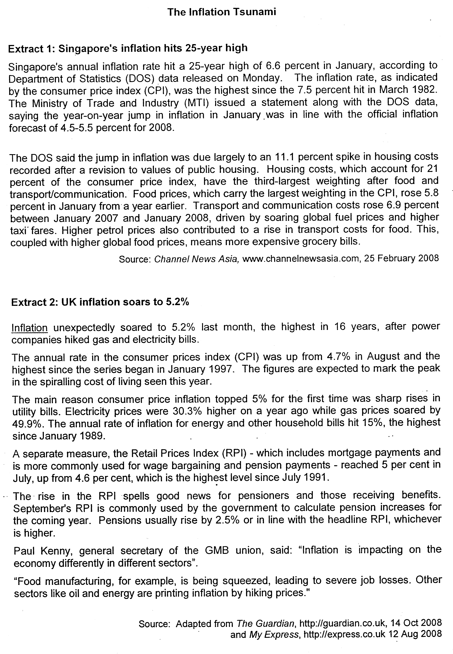
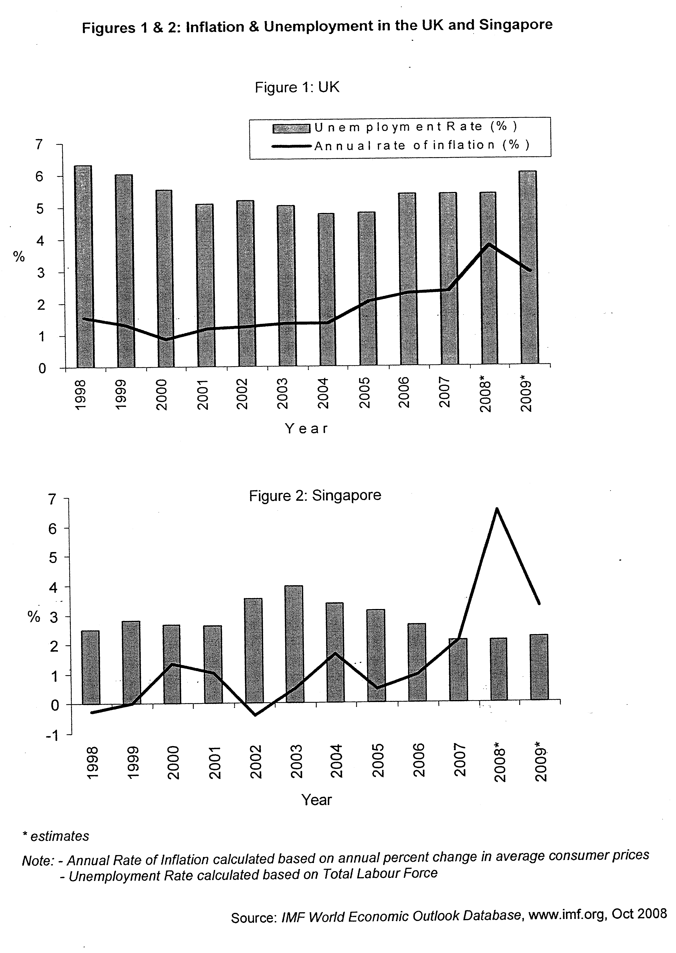

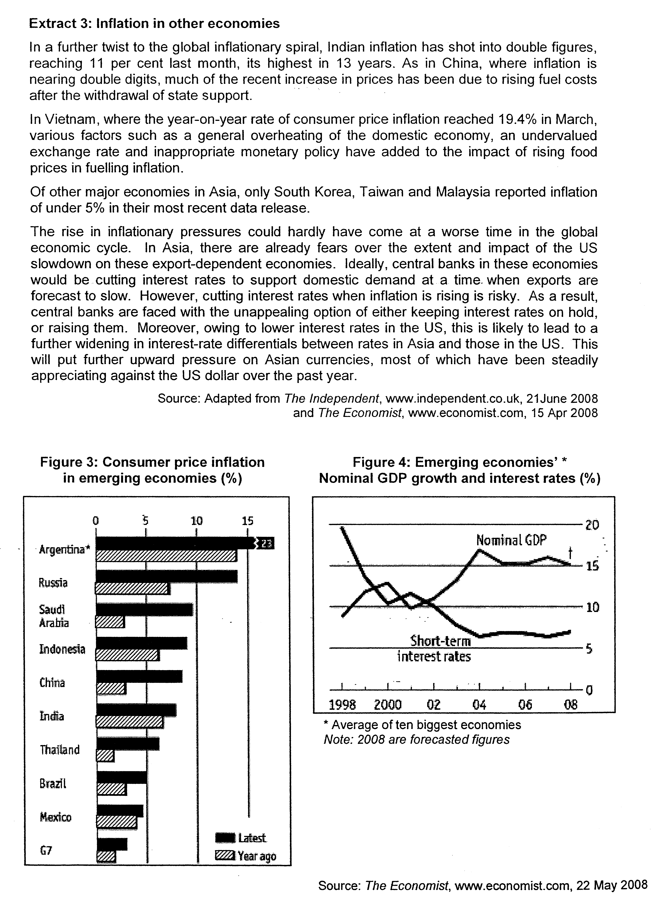

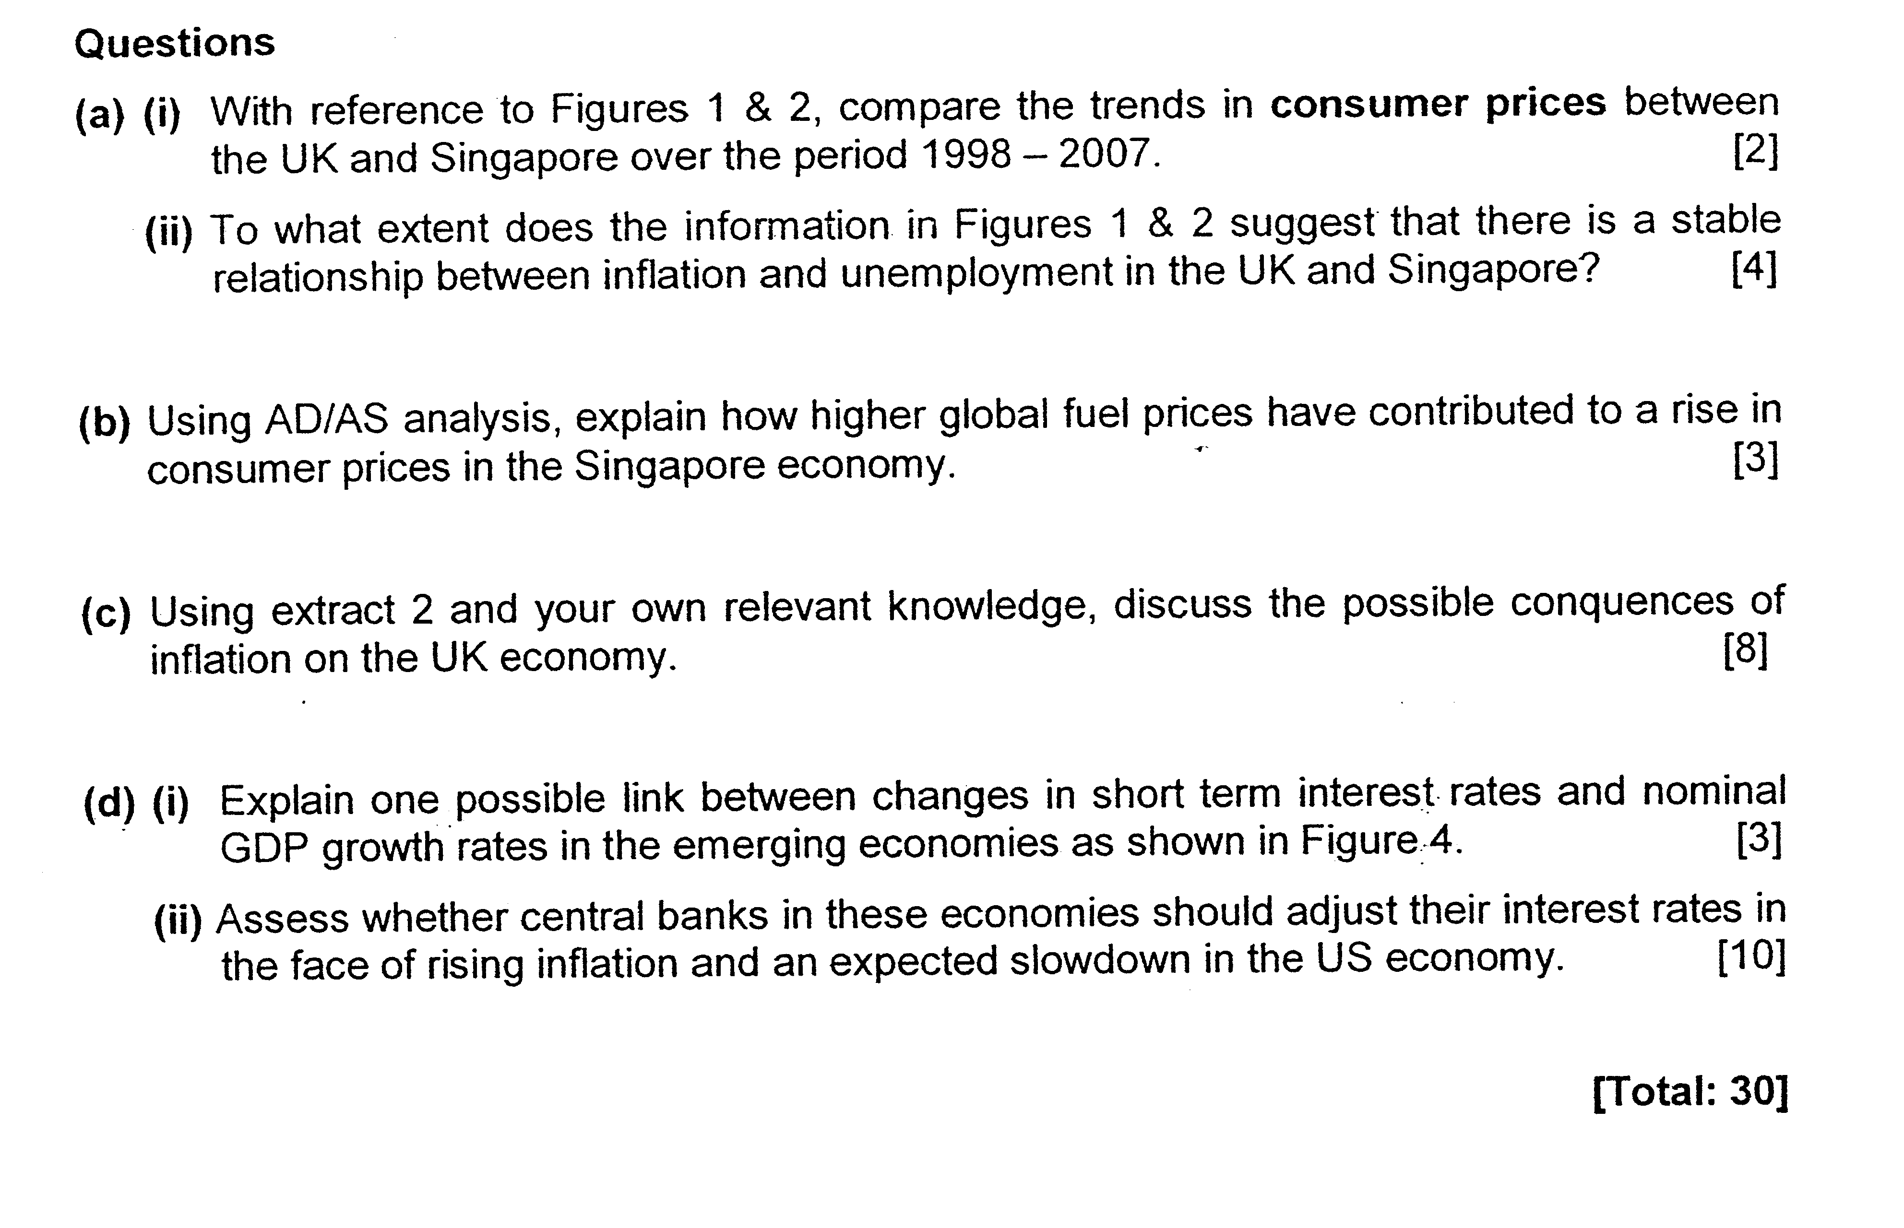
Based on extract 3, explain the types of inflation that occur in different economies in China. (10)

Suggested Answers

(a) (i) Using Figures 1 & 2, compare the trends in consumer prices between the UK and Singapore over the period 1998 - 2007. [2]

Consumer prices have generally been rising in both countries over the years.

However, while prices in UK have been rising at a relatively steady rate, the rate of increase in prices in Singapore is more uneven. In addition, there were years where consumer prices fell in Singapore (2002 compared to 2001), unlike in UK where prices have always been rising every year.

(ii) To what extent does the information in Figures 1 & 2 suggest that there is a stable relationship between inflation and unemployment? [4]

A 'stable relationship' would exist if the both inflation and unemployment within the country exhibit a consistent trend with one another over the same period.

As such, Figure 1 provided more evidence of a stable relationship. The variations in the rates of inflation and rate of unemployment are not significant. Throughout the period from 1998 to 2007, the year on year change in inflation and unemployment rate is consistent with each other.

However, such a stable relationship is not evident in Figure 2. There are greater fluctuations in inflation rate during the whole period compared to unemployment rate. While unemployment rate increases from 1998 to 2003, inflation rate fluctuates – it increases and falls and increases again - with the change in percentage point being greater.

Thus, the information in Figures 1 & 2 does not offer a clear conclusion that there is a stable relationship between inflation & unemployment.

(b) Using AD/AS analysis, explain how higher global fuel prices have contributed to a rise in consumer prices in the Singapore economy. [3]

Higher fuel prices increase the petrol costs, which in turn raise the transport costs of firms and this will lead to rise in cost of shipping. Consequently, importing goods becomes more expensive too.

Since Singapore imports all its raw materials, and many of its intermediate and final goods, this will inadvertently increase the average production costs for many firms. This may cause producers to cut down on production to maintain profits levels, ceteris paribus, causing the aggregate supply to fall in the short run.

With a reduction in planned production and aggregate demand remaining unchanged, this will cause the general consumer prices to rise, as the higher costs is passed on down to the whole supply chain and ultimately to the consumers.

As seen from the diagram, the rise in cost of production will lead to the reduction in production which will decrease the aggregate supply from ASo to As1 and this will cause an excess demand condition at Po. Consequently, there is an upward increase in GPL from Po to P1 whereby cost-push inflation occurs.

(c) Using extract 2 and your own relevant knowledge, discuss the possible consequences of inflation on the UK economy. [8]

Inflation refers to a sustained and inordinate rise in general price level over a period of time. According to Extract 2, inflation in UK had soared to its highest level in 2008, based on changes in both CPI & RPL. This may likely bring about many negative consequences, although there are possible positive impacts as well.

With inflation, shoe-leather and menu costs are often incurred. Since each dollar can now buy fewer goods and services, households will demand more cash for transactionary purposes (e.g. for paying the utility bills etc) and this may necessitate more trips to the bank. This incurs time & effort. Firms, on the other hand, will have to adjust their price lists upwards to reflect the higher prices. Extra resources are again needed to carry this out. As a result, there are opportunity costs involved when there is inflation. Such opportunity costs will rise in UK if inflation rises.

Second, inflation can bring about inefficiency in the UK economy if it rises too rapidly and one is no longer able to anticipate the inflation rate correctly. When firms are no longer certain of the future costs and prices, they may find it difficult to predict the profitability of additional investments and are thus less willing to engage in such risky ventures. As a result, new investments may be less forthcoming. This can adversely affect the long run aggregate supply of UK as its productive capacity would now grow at a slower rate.

Inflation can also lower the ability of firms to invest. As mentioned in Extract 2, with energy prices rising by its highest rate since 1991, certain sectors in the UK are already suffering from lower profits (e.g. food manufacturers mentioned in Extract 2, para 7), causing unemployment to rise in these sectors. With fewer profits, such firms are less able to invest in capital goods and new technologies, negatively impacting on future growth.

In addition, rising inflation may drive firms and household to hedge against the falling value of money. Resources may be diverted into other assets whose values are rising, such as properties and gold. However, these are usually non-productive assets, which do not really increase the productive capacity of the country. As a result, with more resources allocated in these areas, firms will have less funds to invest in new plants and machineries. Capital formation is adversely affected and growth in productive capacity may slow down in the long run. This will negatively impact on the potential growth of the UK economy.

Externally, inflation can adversely impact on the UK's balance of payments in the current account. If relative inflation rate in the UK is higher than its trading partners, then UK exporters (e.g. food manufacturers) will have difficulty selling their goods and services as the prices will now be relatively higher. Conversely, UK residents may turn to importing more as they are relatively cheaper than domestic goods. If export demand is price elastic, then export value will fall, while import expenditure will rise. This can worsen the balance of payments, assuming all other things are constant.

However, not all the consequences of inflation are necessarily undesirable. There are certain sectors that may actually benefit from inflation. As seen in Extract 2, oil and energy firms are actually earning more with inflation. This is because demand for such products is generally inelastic as they are basic inputs in the production of many goods and services. As such, with higher prices, their total revenue tends to rise as well. In addition, inflation can bring good news to pensioners and other people receiving state benefits (Extract 2, para 5) because such handouts are indexed to the inflation rates, although it remains debatable whether such nominal increases will actually raise their overall purchasing power.

In conclusion, the net impact of inflation on the UK economy depends very much on what are the underlying causes and whether it is anticipated or not. But given that the inflation is unanticipated (Extract 2 para 1), the soaring inflation that the UK is currently facing will therefore spell more trouble for the economy if it is not contained soon enough.

(d) (i) Explain one possible link between changes in short term interest rates and nominal GDP growth rates in the emerging economies as shown in Figure 4. [3]

There is inverse relationship between the 2.
Explanation: Any one:-

-Interest rate falls -> cost of borrowing falls -> If MEI > i/r -> profitable to borrow & invest more -> Investment rises -> AD rises -> stimulates production and output -> GDP growth rises (since GDP measures the total value of output produced within the country)

- Interest rate falls -> lower rates of returns from savings -> opportunity cost of consumption falls -> households have less incentive to save and more incentive to spend out of current income -> C rises -> AD rises -> stimulates production and output -> GDP growth rises

- SR interest rates falls (relative to other countries') -> lower rates of returns from saving in domestic currency -> more outflow of short term capital -> demand for domestic currency falls while supply of domestic currency rises -> currency depreciates -> export prices fall in foreign prices while import prices rise -> assuming Marshall-Learner condition is satisfied -> net X will rise -> AD rises -> -> stimulates production and output -> GDP growth rises

