Chapter 2.3 – Central Economic Problems – Economics Principles IIn w

2.3.1 Concept of Marginal Principles in decision-making
I. Meaning
Decision-making made by the government, firms and individuals can be done on a marginal basis by considering whether the additional consumption or production of one extra unit will provide more satisfaction. This is done by examining whether there is net marginal gain to be gained from the additional consumption or production. – the concept about maximization

As long there is positive net marginal benefit (MB-MC) to be gained, the total benefit derived from additional consumption or production will increase and the decision is to continue the consumption or production.

For example, if an individual can gain more monetary satisfaction from the purchase of an orange at a price of $1, he will continue to consume more additional oranges. He will only stop to consume when the monetary satisfaction he gains from the consumption is less than what he is paying for it. Thus, it can be observed that the decision-making on the number of oranges the individual will consume will be at the level where the additional monetary benefit he gains from the consumption is equal to the additional cost of the orange.

Qty price ADDITIONAL GAIN ADDITIONAL NET GAIN Total net gain
1 $1 4 3 2
2 $1 3 2 5
3 $1 1 0 5
4 $1 0.5 -0.5 4.5

This concept of marginal principle in decision-making also applies when the firms make decision on production or when the government makes decision on government expenditure.

II. How the concept of marginal principle is conducted?

By attaining market equilibrium, the society will be able to attain social maximization whereby it maximizes economic surplus in terms of greater net social benefit gain. This is attained by using the concept of marginal principle which involves the calculation of the value of marginal benefits and marginal costs.

A. Meaning of Marginal Benefits and Marginal Costs

- Marginal benefits are the additional benefits gained by undertaking an incremental increase or decrease in consumption or production.
- Marginal cost refers to the additional cost incurred by undertaking an increase or decrease in consumption or production.

B. How to attain equilibrium in consumption and production

Equilibrium level of consumption or production is attained at the level where the MB = MC. At this level of equilibrium, the total net benefit derived will be the greatest.

When MB>MC, the net benefit is positive, total benefit is rising. Therefore, consumption and production can be increased to the level where the equilibrium is attained when MB=MC.

When MB<MC, the net benefit is negative, total benefit is falling. Therefore, consumption and production can be reduced to the level where the equilibrium is attained when MB=MC.

C. Graphical Illustration on the concept of Marginal Principles

The concept of Marginal Principles can be graphically illustrated to show how the consumers, producers or the society attains equilibrium in the particular industry or market.

Diagram 1 - Equilibrium level of output based on Marginal Principle
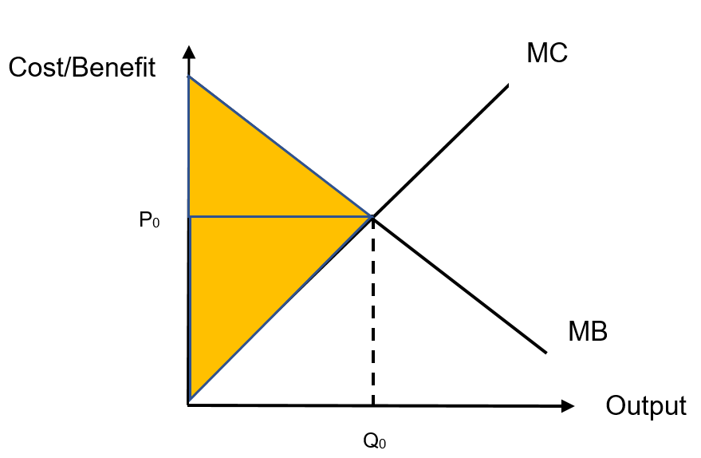

As seen from the graph, the marginal benefit is downward-sloping from left to right as the additional gain in monetary benefit as consumption increases while the marginal cost is upward-sloping as the additional cost in monetary cost is increasing as production increases. The difference between the marginal benefit and marginal cost is the net marginal gain and the equilibrium level of output for this market is set at Qo where the marginal net gain is zero. At this point of output, the level of total gain of the consumption and production is maximised as represented by the shaded portion and it will be the equilibrium level of output for this market.

Why the output level is at the equilibrium when the Marginal Revenue is equal to the Marginal Cost?

………………………………………………………………………………………......

………………………………………………………………………………………......

………………………………………………………………………………………......

………………………………………………………………………………………......

………………………………………………………………………………………......

………………………………………………………………………………………......

D. Applications of the concept of Opportunity Cost in economic decision
The concept of opportunity cost can be seen in the process of economic decision whereby the decision to select one choice will lead to the forgone of the next best alternative which is the value of opportunity cost.

i. The consumption decision
The selection of consumption of one good will lead to the rise of opportunity cost which is ‘the value of the next best alternative forgone’ (the next best choice of consumption).

ii. The employment decision
The selection of one job will lead to forgone of the next best alternative employment. Since the worker will choose the job with highest earning, the opportunity cost will be seen as the job with the next highest earning. This amount is known as the transfer earning which is the minimum reward required for a worker to remain in the employment.

iii. The investment decision
The investment of fund in a particular project will mean the firm has to forgo the next best alternative earning of other investments. This is known as the implicit cost which includes the interest earning forgone and the potential earnings the individuals can earn in other employment.

Opp cost for the investment – salary forgone, interest from the saving instead of investment, future consumption of the saving
iv. The social decision
The allocation of government expenditure will also give rise to opportunity cost seen in term of alternative usage of resource. In the allocation of more resources for operating expenditure (day-to day expenditure), there will be loss of potential growth which can be attained from development expenditure. It can also be seen in terms of the loss of net benefit from the next best alternative of production of one public good due to the selection of the public good which gives highest level of net benefits. Lastly, the opportunity cost of unemployment includes the loss of domestic output and the cost of subsidies given to the unemployed.

v. The international specialization decision
The notion of opportunity cost can be used to demonstrate how countries can specialize in the areas of relative advantage and then trade within the acceptable level of trading prices.

This concept is applied in David Ricardo’s theory of comparative advantage. In this theory, there will be mutual benefits to be gained by the respective participating countries when they specialize in the production which they have comparative advantage in it. This C.A. is seen in terms of the opportunity cost which must be the lowest in comparison to other countries. The opportunity cost will also help to derive the trading price that will determine how the trade can be made more beneficial for the participating countries.

For example:

If country A’s opportunity cost of the production of oranges in terms of apple is 1 unit of orange to 2 units of apples while country B’s opportunity cost of producing an orange is in terms of apple is 1 unit of orange to 4 units of apples. It can be implied that country A is more efficient in the production of orange and should specialise in producing oranges while country B should specialise in producing apples.

As country A’s opportunity cost of orange in terms of apple is 1 O to 2 A, the selling price of an orange is two apples. For country B’s opportunity cost of orange is 1 O to 4A, the buying price in country B of one orange is one unit of orange for four apples. If the trading price (term of trade) is 1 unit of orange is three units of apples, both countries will gain.

Country A – 1 orange to 2 apples – CA is with A – A is exporter/seller
Country B – 1 orange to 4 Apples – B is importer/buyer
Trading price is 1 orange to 3 apples – A can sell orange at a high international trading than local selling price and B can buy orange at a lower international trading than local buying price
Country A will then specialise in the production of oranges and sell the orange to country B as it can get more units of apples while country B will specialise. In the production of apples and pay less in terms of apples when the trading price is one unit of orange for three units of apples.

Thus, it can be seen that the concept of opportunity can be used to explain how countries trade and specialize.

2.3.2 Concept of Economic Efficiency
I. Meaning

In the conduct of economic activity of consumption and production, it is imperative to play emphasis on economic efficiency (pareto optimality). The economy will seek for efficient resource allocation.

The notion of economic efficiency – it means to attain the maximum yield or gain out of the resources used for the economic activity. – maximum number of units of production or the least cost of production

This is attained when the two conditions are satisfied:

a) All resources are fully utilized in production and no potential output is lost. This implies that the economy is at full employment.

b) There is also optimization of consumption whereby the preference of consumption is attained, maximizing the satisfaction.
When economic efficiency is attained, the economy has attained productive efficiency (production is at minimum level for the production level) and allocative efficiency (Price is equal to marginal cost)

II. Production Efficiency

Production efficiency is attained when the firm can produce at the minimum level for the unit cost of output at various level of output or producing at the greatest number of unit of output for that production level.

III. Allocative Efficiency

Allocative efficiency is attained when the gain of one party cannot be attained without the loss of another. When this occurs, the increase of one unit of the production of a good cannot be attained without the reduction of another good. It also can be explained when the price of the good is equal to the cost of producing one additional unit of output. (P=MC)

2.3.3 Types of goods
I. Dimension of Goods

Goods produced in an economy includes all forms of physical production and services. It is imperative to take note that goods have two notable dimensions. First, goods can be rivalrous or non-rivalrous in consumption. Second, there is the issue of excludable where the owner possesses the right to exclude others from consuming the good.

Goods can also be classified based on the influence of externality which can be classified to have positive or negative externality.

Rivalrous in consumption is seen when the consumption of a good will deny another from consuming it.

Private good – rivalrous and excludable – lights in my office
Public good – non-rivalrous and non-excludable - streetlights

iI. Meaning of Externality
Spillover effect (positive or negative), which will affect the third party, although he has not engaged in the direct production and consumption of the good. If it is a positive externality (education), it will generate external benefit and if it is a negative externality, it will generate external cost. This will raise the social marginal cost and benefit and thus distort the social market equilibrium (SMC = SMB). When this happens, market failures occur, and the society experiences welfare loss. (Deadweight Loss)

III. Classification of Goods
A Public Good (pure)
A good that is non-rival in consumption and non-payers cannot be excluded from consumption.

A Private Good
A good that is rival in consumption and non-payers can be excluded from consumption.

Quasi Public Good
A good that is non-rival in consumption but non-payers can be excluded from consumption – swimming pool

A Merit Good
A merit good is a private good with positive externality whereby the consumption or production of the good will create third party effect which is beneficial. (education)

A Demerit Good
A demerit good is a private good with negative externality whereby the consumption and production of the good will create third party effect which is detrimental. (smoking)

IV. Illustration of the types of goods
