2014 – Economics MCQ – Chapter 1 – Central Problem of Economics
- The diagram shows the production possibility curves LL’, MM’, NN’. The country operating at full employment on MM’. An epidemic resulted in the death of thousands of people in the country.
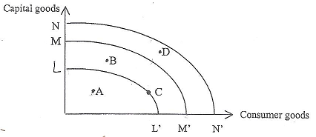

Which of the following points, A, B, C or D would the country be operating on after the epidemic if there is unemployment present?

- The diagram shows an economy’s production possibly frontier
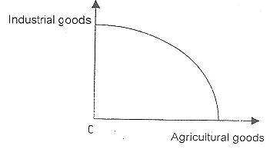

What does the slope of the curve measure?

- the opportunity cost in terms of industrial goods of producing an additional unit of agricultural goods
- the maximum quantity of industrial goods that can be produced for any given level of agricultural output
- the maximum attainable combinations of agricultural and industrial goods
- the relationship between the total resources devoted to the production of agricultural goods and industrial goods

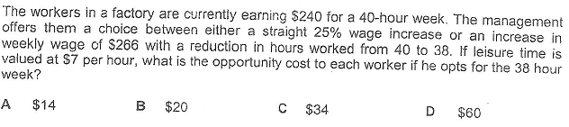

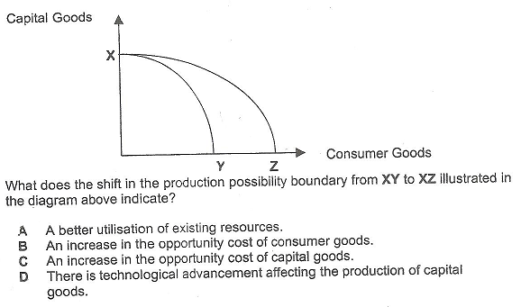

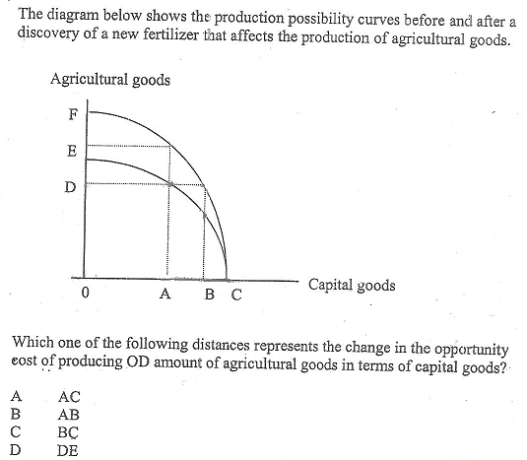

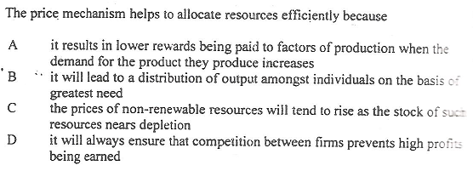

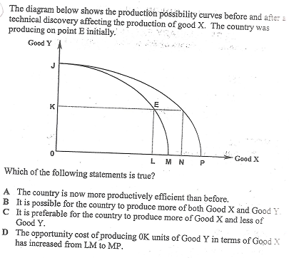

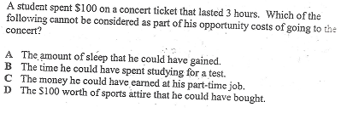

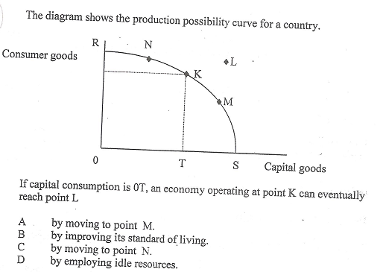

- Mr. A allocates his expenditure over time. What could cause a decrease in the opportunity cost to Mr. A of current consumption?
  - A decrease in his current income
  - A decrease in interest rates
  - An interest in income tax rates
  - An increase in contributions by his current employer to the CPF

- Why are production possibility curves concave to the origin?
  - Because resources are limited
  - Because resources are not perfect substitutes
  - Because resources do not have alternative uses
  - Because of the existence of increasing returns to scale

