Unit 1 The Central Problem of Economics

Question 1

Economics is concerned with the problem of choice which arises from scarcity of commodities in relation to human wants. The diagram below shows the possible combinations of agricultural and manufactured products which an economy could produce given its available resources.

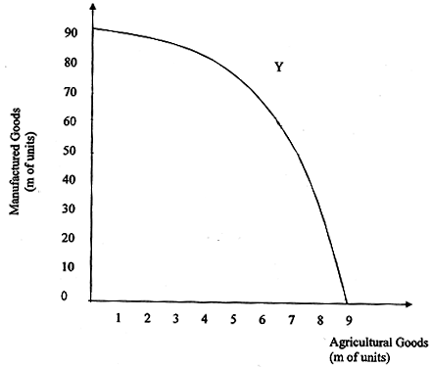

(a) (i) Define the term opportunity cost. [2]
(ii) What is the opportunity cost of increasing the production of agricultural products from 5m to 6m units? [1]
(b) In which economic sector is physical productivity the highest? Explain your choice. [2]
(c)If production took place at position X in the diagram what conclusion can be drawn about the efficient use of factors of production? [2]
(d) Suggest three ways in which the country might be able to achieve the levels of output represented by position Y in the diagram. [3]

(a)(i) Define the term opportunity cost. [2]
explain in the context of the question – agricultural product and manufactured product

Opportunity cost is defined as the cost of using resources for a certain purpose, measured in term of the next best benefit it can derive when use for another alternative. In this context, the opportunity cost of one unit of agricultural product produced will be measured in term of the number of manufactured goods the economy must forgo to produce one additional unit of agricultural product.

(ii) What is the opportunity cost of increasing the production of agricultural products from 5m to 6m units? [1]

The opportunity cost is 10 m units of manufactured goods.

(b) In which economic sector is physical productivity the highest? Explain your choice. [2]

For this economy, the productivity is higher in the manufacturing sector as it is more efficient. As the additional unit of production for agricultural good increase, it will lead to higher value of opportunity cost in terms of the production of manufactured goods. This implies that the resources in this economy are more suitable for the production of manufactured goods.

why the economy can be more efficient in the production of manufactured good?

- skilful workers
- investment in capital equipment / machinery
- technology

(c) If production took place at position X in the diagram what conclusion can be drawn about the efficient use of factors of production? [2]

It implies that there is inefficient utilization of resources for the production as the resources are not fully utilized. The underemployment of the resources can be due to the lack of investment and lower consumption level.

(d) Suggest three ways in which the country might be able to achieve the levels of output represented by position Y in the diagram. [3] requirement – how to shift the PPC outwards

To attain production or consumption at the position Y, the economy is consuming beyond the production possibility curve. This implies that there is a need to shift the PPC outward which means the growth of the potential capacity of production. To do so, the government can increase their import of resources which will lead to the expansion of PRODUCTION capacity, enabling the economy to produce a higher level of production.

The economy can also expand the resource capacity with the introduction of manpower development policy which allows the economy to have more labour supply. The skills of the workers can be improved through training and development which raises the efficiency of the economy and thus, shifting the PPC outward.

Lastly, the economy can engage in trade which will make it able to consume more goods at lower price level through import and export. The country can either export their goods at a higher price than what they can sell domestically or import their goods at a lower price than what they can buy in their country. This will allow the economy to consume at a level beyond their production possibility as the PPC will pivot outward to TPC (trading possibility curve).

POLICIES – EXPANDING THE AVAILABILITY OF RESOURCES – RAISE THEIR PRODUCTION CAPACITY – OUTWARD SHIFT OF THE PPC – THE ACTUAL PRODUCTION CAN BE RAISED TO POINT Y WHICH IS BEYOND THE CURRENT PPC.

