Economics MCQ – Chapter 2 – The Allocation of Resources: How the market works; Market Failure

Section 1 – Demand
Q1. Which statement could explain a decrease in the demand for natural rubber?
- Demand for car tyres has increased.
- New techniques of producing substitutes for rubber have been introduced.
- Productivity of rubber plantations has increased.
- The area of land on which rubber is grown has increased.
( C )

Q2. The diagram shows a change in demand for coffee.
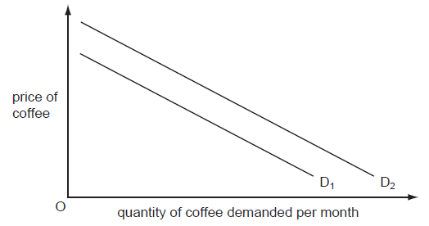
What might cause the demand for coffee to change from D₁ to D₂?
- a good coffee harvest
- a rise in the price of alternative drinks
- a rise in the wages of coffee workers
- a successful advertising campaign for tea

( B )

Q3. What combination of events might cause a rise in the willingness and the ability of consumers to buy a product?
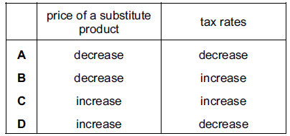
( D )

Q4. A demand curve for a product shows the relationship between its price and
- cost of production.
- population changes.
- the income of the consumer.
- the quantity of the product consumed.
( D )

Q5. The following was printed in a magazine. More soft drinks are being consumed than ever before by the 16 – 34 age group. Schweppes, the drink manufacturers, claim that over 45 per cent of their soft drinks are now being consumed without alcohol as people switch away from alcoholic spirits.

How would this change be represented on a demand and supply diagram for soft drinks?
- decrease in demand
- decrease in supply
- increase in demand
- increase in supply
( C )

Q6. Tea and sugar are complementary goods. What will happen if the price of tea falls, other things being equal?
- The demand curve for sugar will move to the right.
- The demand curve for tea will move to the right.
- The price of sugar will fall.
- The supply curve of sugar will move to the left.
( A )

Q7. What is not held constant in calculating a demand schedule?
- the incomes of consumers
- the prices of complementary goods
- the price of the good itself
- the tastes of consumers
( C )

Q8. The table shows the demand schedule for maize.
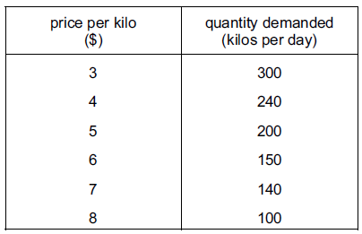

What will happen if price rises from $5 to $6 per kilo?
- Total revenue will rise.
- Demand will rise.
- Total revenue will fall.
- Total costs will rise.
( C )

Q9. What would not cause a shift in the demand curve for a good?
- a change in incomes
- a change in the price of a substitute good
- a change in the price of the good
- a change in the tastes of consumers
( C )

Q10. What is an example of complementary demand?
- buses and bus fares
- cotton and cotton seed
- televisions and electricity
- wood and sawdust
( C )

Q11. The diagram shows the demand for chocolate.
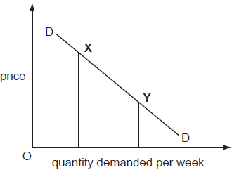

What could cause the movement from point X to point Y?
- a change in tastes
- a fall in the price of chocolate
- an increase in income
- a successful advertising campaign for chocolate
( B )

Q12. X and Y are substitutes and X and Z are complements. If a specific tax is imposed on X, then
- the demand for Y and Z will fall
- the demand for Y and Z will rise
- the demand for Y will rise and the demand for Z will fall
- the demand for Y will fall and the demand for Z will rise
( C )

Explanation: The imposition of tax on good X will lead to a fall in demand for good X. Given that X and Z are complements, the demand for Z will also fall. Also, since X and Y are substitutes, the fall in demand for good X will lead to an increase in demand for good Y.

Q13. The diagram below shows two demand curves for good X. Good Y is a substitute of good X and good Z is a complement of good X.
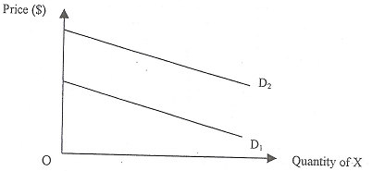
Which one of the following could explain the change in demand from D₁ to D₂?
- A decrease in the price of Y.
- An increase in the popularity of Y.
- A decrease in the cost of production of Z.
- A removal of the subsidy given by the government on Z.
( C )
Explanation: A fall in COP of good Z will lead to an increase in supply of good Z, thus equilibrium price of good Z will fall. Given Z and X are complements, demand for good X will increase.

