Economics MCQ – Chapter 2 – The Allocation of Resources: How the market works; Market Failure

Section 2 – Supply
Q1. Which will encourage domestic producers to grow more maize?
- granting subsidies to maize producers
- increasing the sales tax on maize
- removing guaranteed minimum prices for maize
- removing quotas on imported maize
( )

Q2. A supply curve for a commodity is drawn to show how quantity supplied varies with
- government taxes.
- income.
- tastes.
- the price of the commodity.
( )

Q3. In 2010, floods caused severe damage to wheat production. How would this be shown on a market demand and supply diagram for wheat?
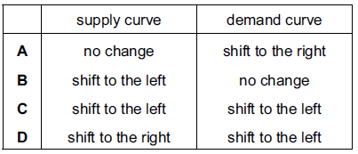
( )

Q4. Drought in African countries often results in poor harvests. Other countries then help by sending quantities of food. What are the likely results of these events for the price of food in the drought-affected countries?
- It will fall and then rise.
- It will rise and continue to rise.
- It will rise and remain at this higher level.
- It will rise and then fall.
( )

Q5. Australian mines are among the world’s largest suppliers of uranium but the mines are contaminating Australia’s natural environment. It is recommended that the mining companies install new equipment which causes less pollution.

If this is done, how would it be represented on a demand and supply diagram for uranium?
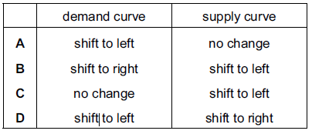
( )

Q6. Four changes affecting the supply of a good are listed below. What would cause the supply curve to shift to the right?
- an improvement in technology
- an increase in its market price
- a reduction in labour productivity
- the introduction of a sales tax
( )

Q7. Which of the following is likely to lead directly to a shift in the supply curve for cars?
- An increase in consumers’ incomes
- The increased efficiency of public transport
- An increase in the price of cars
- The entry of new agents selling new cars
( )

Q8. Which of the following will lead to an increase in the supply of computer software?

- A decrease in the price of computers
- An increase in the price of computer software
- An improvement in the technology of producing computer software
- More people wanting to play computer games
( )

Q9. Goods X and Y are substitutes, what will be the effect on the equilibrium price and quantity of good X when there is a decrease in the supply of good Y?

Price of X Quantity of X
- Decrease Decrease
- Decrease Increase
- Increase Decrease
- Increase Increase
( )

