Economics MCQ – Chapter 2 – The Allocation of Resources: How the market works; Market Failure

Section 4 – Price Elasticity of Demand and Supply
Q1. Which change would make the supply of a product more price elastic?
- an increase in the number of close substitutes for the product
- an increase in the proportion of firms working at full capacity
- a reduction in the time taken to make the product
- a reduction in the time that the product can be stored
( C )

Q2. There is a sales tax (VAT) on a good which has a price elasticity of demand greater than 1 (>1). Which of the following correctly matches a change in sales tax to the change in total expenditure on the good?
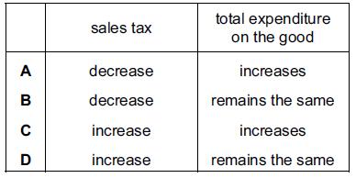
( A )

Q3. Many people are life-long, devoted fans of the Los Angeles Lakers basketball team in the United States. The team’s stadium can seat 19 000 spectators and tickets are always sold out.

What does this suggest about the price elasticity of demand and the price elasticity of supply of tickets to watch the Lakers play?
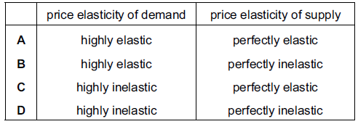
( D )

Q4. The demand for a good is totally inelastic with regard to price. What will happen to the firm’s revenue if the price rises by 20 %?
- It will fall by 20 %.
- It will fall to zero.
- It will remain unchanged.
- It will rise by 20 %.

( D )

Q5. The graphs, drawn to the same scale, show the demand curves of four firms. The market price is $10. The price then falls to $8. Which firm will have the largest increase in total revenue?
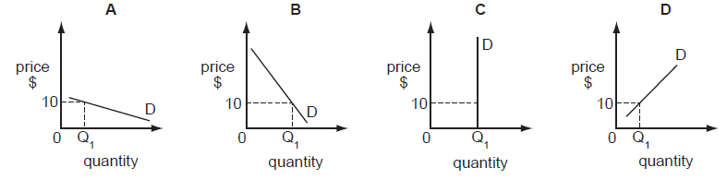

( A )

Q6. The table illustrates the demand and supply for rice in a market in Africa.
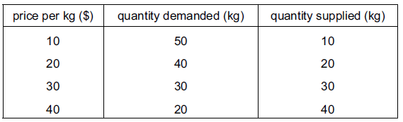

When the price rises from $20 to $30 per kg, what is the approximate price elasticity of demand for rice?
- 0.25
- 0.5
- 1.0
- 2.0
( C )

Q7. A product has a totally inelastic price elasticity of demand. What will happen to total revenue if the price of the product falls by 25 %?
- It will fall by 25 %.
- It will fall to zero.
- It will remain unchanged.
- It will rise by 25 %.
( A )

Q8. What could cause the demand for a product to become more price-elastic?
- a smaller proportion of income being spent on the product
- more substitutes coming onto the market
- the product becoming more of a necessity
- the product falling in price
( B )

Q9. When the price of a product rises from $10 to $15, the demand falls from 5000 to 4000 units. What is the value of the price elasticity of demand for the product?
- 0.2
- 0.4
- 1.5
- 2.5
( B )

Q10. A firm produces a good with a price elasticity of demand greater than 1. What must the firm experience if there is a fall in the price of this good?
- a decrease in costs
- a decrease in sales
- an increase in revenue
- an increase in profits
( C )

Q11. The table shows the value of the price elasticity of demand for four products.
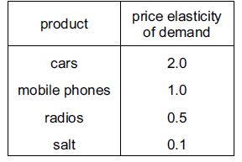
What would have an increase in sales revenue if prices rose by 10 %?
- cars only
- cars and mobile phones
- radios and salt
- salt only
( C )

Q12. The demand for cocoa beans is price-inelastic. What is most likely to increase as a result of a decrease in demand for cocoa beans?
- income of cocoa bean producers
- price of cocoa bean products
- production of cocoa beans
- unemployment among cocoa bean farmers
( D )

Q13. There are a fixed number of seats at a concert. Most of the audience would continue to attend even if the seat prices were increased. Which diagram represents this situation?
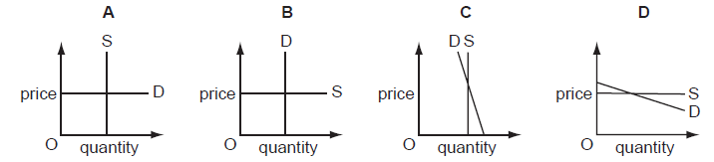
( C )

Q14. A bus company knows that demand for travel before 09 00 hours is price-inelastic and that after 09 00 hours it is price-elastic. How is the company certain to increase total revenue?
- by increasing all fares
- by increasing fares before 09 00 hours
- by reducing all fares
- by reducing fares before 09 00 hours
( B )

Q15. Which of the following is true for any price-inelastic demand curve?
- A price cut causes a fall in expenditure.
- A price rise has no effect on demand.
- A price rise has no effect on total profit.
- The percentage change in demand is greater than the percentage change in price.
( A )

Q16. The demand curve for tickets to a rock concert is given below.
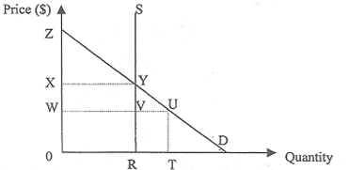
If the supply curve is perfectly inelastic and the price per ticket is charged at 0W, what is the total consumer surplus gained?
- WVYZ
- WUYX
- WUZ
- XYZ
( A )

Explanation: Consumer surplus is the difference between the maximum amount that consumers are willing to pay for a given quantity of good and what they actually pay.

Q17. It was estimated that bread has an income elasticity of demand of 0.5. What can be concluded about bread from this information?

- It is a necessity.
- It is an inferior good.
- It has very few substitutes.
- It takes up a small proportion of household expenditure.
( A )

Explanation: YED for inferior good is less than zero. YED for luxury good is more than one. YED for normal goods is between zero and one. Hence, bread can be seen as a necessity.

Q18. Which of the following statement is true?

  - If the price elasticity of demand is unit elastic, then a fall in price will result in a proportionate fall in total spending on the product.
  - If the demand for the good is perfectly elastic, a unit tax will leave the unit price to consumers unchanged.
  - The income elasticity of demand is zero in the case of inferior goods.
  - The cross elasticity of demand for complements will always be positive.
( A )

Explanation: Unitary PED (PED=1) implies a direct relationship between price and quantity demanded. If the demand for the good is perfectly elastic, a unit tax would result in a change in unit price to consumers, in which P=0. YED for inferior goods is less than zero. CED for complements is always negative. CED for substitutes is always positive.

Q19. Ceteris paribus, the elasticity of supply will be greater
- the greater the changes in the quantity demanded
- the smaller the economies of scale to be obtained
- the greater the proportion of costs attributed to fixed factors of production
- the longer the good can be stored
( D )
Explanation: Higher PES value implies that the supply for the good will be more price-elastic. Longer storage duration, such as non-perishables like dried food, would represent a higher PES value.

Q20. A firm discovers that when it raises the price of its product by 10%, its total revenue increases. During a recession, when real income falls by 12%, the quantity demanded for the product falls by 18%.

Which of the following is consistent with the above observations?

Price Elasticity of Demand Type of Good Income Elasticity of Demand
- Elastic Normal Elastic
- Elastic Normal Inelastic
- Inelastic Normal Elastic
- Inelastic Inferior Elastic
( C )

Explanation: Since total revenue increases when price of the product increases, the PED for the good is inelastic. Since the YED is greater than one, the product cannot be an inferior good, thus it has to be either a normal or luxury good. YED is elastic.

Q21. In which of the following circumstances will consumer surplus be zero?
- PED is perfectly inelastic
- PED is perfectly elastic
- PED is 1
- PES is perfectly inelastic
( A )

Explanation: A perfectly inelastic PED is represented by a horizontal demand curve. When plotted against an upward sloping supply curve, consumer surplus will be zero, whereas producer surplus is greater than zero.

Q22. The diagrams show different conditions of demand and supply for a product. In which diagram would market price remain unchanged if consumers’ incomes fell?
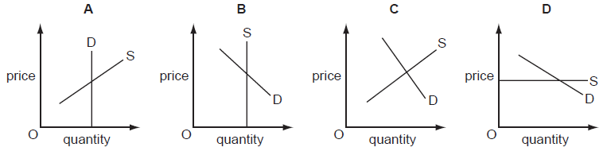

( D )

Q23. It was reported that a company producing designer clothes had increased its revenue by 20 % at a time when it decreased its prices. What does this suggest about the demand for these goods at that time?
- It was perfectly price elastic.
- It was perfectly price inelastic.
- It was price elastic.
- It was price inelastic.
( C )

