Economics MCQ – Chapter 2 – The Allocation of Resources: How the market works; Market Failure

Section 3 – Market Equilibrium
Q1. The diagrams show different conditions of demand and supply for a product. In which diagram would market price remain unchanged if consumers’ incomes fell?
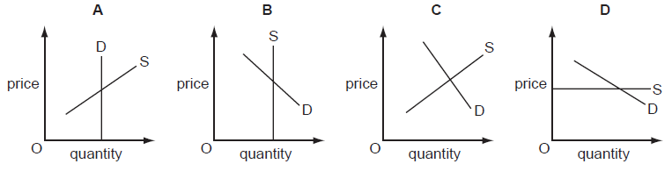

( D )

Q2. In 2011, a company selling milk in glass bottles replaced them with new plastic bottles. When they were introduced, the equilibrium quantity on the market fell. What could be a reason for this fall?
- Consumers preferred the new bottle because it was lighter to carry.
- Milk from the farms used to fill the bottle cost more.
- The bottle was cheaper than the existing glass bottle to produce.
- The new bottle was introduced with a successful advertising campaign.
( B )

Q3. Supermarkets sell petrol (gas) outside their stores. They reduce the price of petrol below other suppliers to attract more customers to buy goods in the store when they buy more petrol. If this were successful, how might it be shown on demand and supply diagrams?

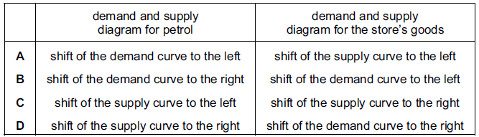
( D )

Q4. The market for a normal good is in equilibrium at point X. Consumers’ incomes fall and the cost of producing the good rises.
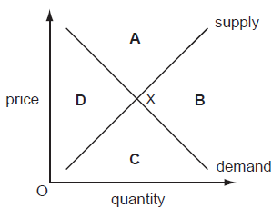

In which area of the diagram will the new equilibrium be?
( D )

Q5. Wet weather in 2009 led to a fall in the sales of summer clothes. To support businesses the government reduced the sales tax (VAT). How would these events be shown on a demand and supply diagram for summer clothes?
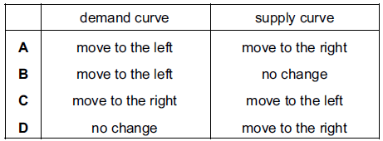
( A )

Q6. The diagram shows demand and supply curves for a product at its equilibrium price P.
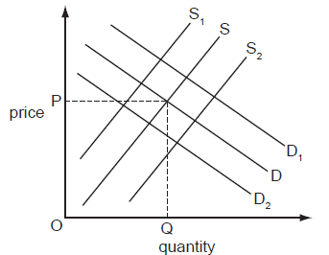

How would the introduction of a subsidy be shown?
- Demand would shift to D₁.
- Demand would shift to D₂.
- Supply would shift to S₁.
- Supply would shift to S₂.
( D )

Q7. The diagram shows that when a tax of $2 on a good raises the supply curve from S₁ to S₂, the price to the consumer rises from $4 to $5.
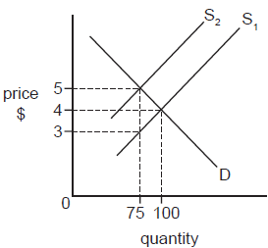
What is the total tax yield to the government?
- $75
- $150
- $200
- $375
( B )

Q8. The market for a good was in equilibrium. A change occurred which resulted in a new equilibrium with a higher price for the good and a lower quantity traded. What change would have caused this?
- The demand curve moved to the left.
- The demand curve moved to the right.
- The supply curve moved to the left.
- The supply curve moved to the right.
( C )

Q9. It was reported that a company producing designer clothes had increased its revenue by 20 % at a time when it decreased its prices. What does this suggest about the demand for these goods at that time?
- It was perfectly price elastic.
- It was perfectly price inelastic.
- It was price elastic.
- It was price inelastic.
( C )

Q10. Due to good weather, there is a surplus in the market for an agricultural product. Which change would cause the market to return to equilibrium?
- a decrease in demand
- a fall in price
- an increase in supply
- a rise in price
( B )

Q11. In July 2006, the UK chocolate producer, Cadbury Schweppes, had to withdraw one million bars of chocolate from the market because of food contamination at one of its factories. This was widely reported in UK newspapers.

Which diagram shows the likely effect on the market for chocolate produced by Cadbury Schweppes?
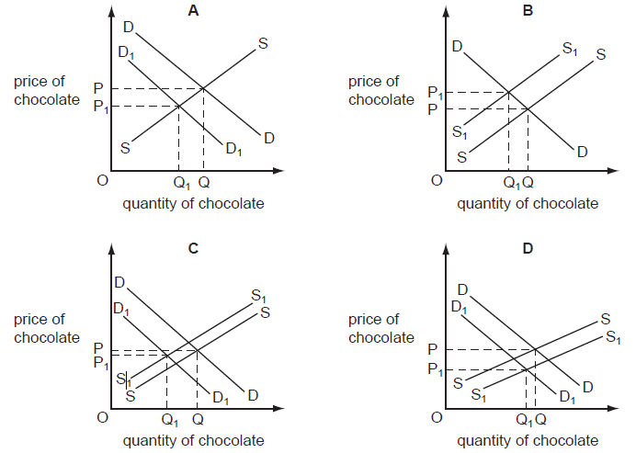

( C )

Q12. The diagram shows the demand and supply of places in independent (private) schools which charge fees. The equilibrium position is X. The costs of independent (private) schools rise. Also a report is issued which states that Government schools achieve very good examination results.

What is likely to be the new equilibrium position?

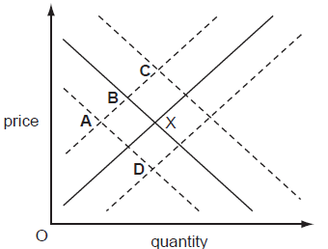
( A )

Q13. The price of a good is temporarily above the market equilibrium price.
What must happen for the market to be brought back to equilibrium?
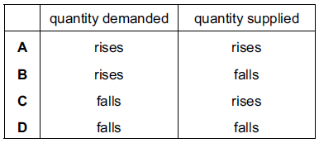
( B )

Q14. As petrol prices increase, demand for petrol remains constant.
What does this say about the price elasticity of petrol?
- The demand is price-elastic.
- The demand is price-inelastic.
- The supply is price-elastic.
- The supply is price-inelastic.
( B )

Q15. The price elasticity of demand for a good is unitary. What would be the effect of a 1 % fall in its price?
- to increase total revenue by 0.1 %
- to leave quantity demanded unchanged
- to leave total revenue unchanged
- to reduce quantity demanded by 1 %
( C )

Q16. What is an important influence on price elasticity of demand?
- average earnings
- tastes of consumers
- the cost of living
- the number of close substitutes
( D )

Q17. A good is successfully advertised. What is the most likely impact on the demand and supply curves for the good?
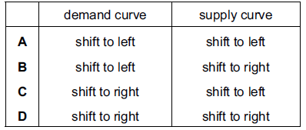
( D )
Q18. The diagram shows the supply and demand curves for a good. The market is in equilibrium at point X.
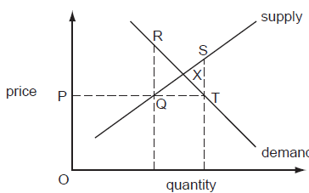
What is the excess demand at price P?
- PT
- QR
- QT
- ST
( C )
Q19. The diagram shows the demand for and supply of a product. The original equilibrium is at X. Which point indicates the new equilibrium position if there is an increase in the price of a close substitute for the commodity while other things remain the same?
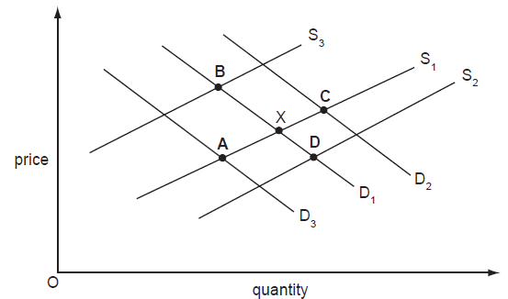
( C )

Q20. The diagram shows the demand for and supply of a firm's product. The original equilibrium is at X. The firm pays for a successful advertising campaign. What is the new equilibrium?
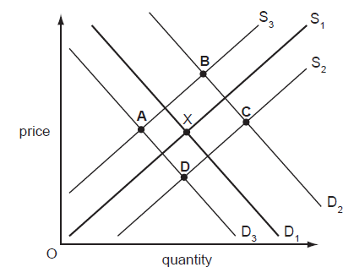
( B )

Q21. The table shows the price of, demand for and supply of X per week.
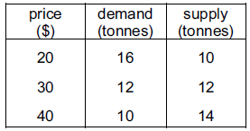
What will be the effect if the government imposes a minimum price of $40 per tonne?
- a fall in the price of X
- a shortage of X
- a surplus of X
- a waiting-list for X
( C )

Q22. In many countries, extra staff are employed by the postal service and additional collections of post are made to clear the large amount of mail before holiday periods. What happens to the demand and supply curves for postal services during these periods?
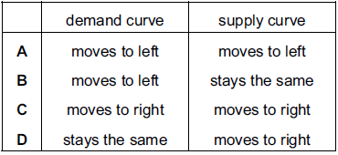
( C )

Q23. The graph shows the market for rice. It was in equilibrium at X. Later, there is a very good harvest of rice. What is the new equilibrium point?
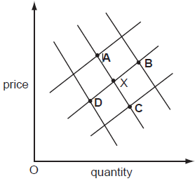
( C )
Q24. If the cost of computer components falls, what will happen to the equilibrium price and quantity of computers, ceteris paribus?

- A decrease in equilibrium price and an increase in equilibrium quantity
- An increase in both equilibrium price and quantity
- An increase in equilibrium price and a decrease in equilibrium quantity
- A decrease in both equilibrium price and quantity

( A )

Explanation: A decrease in the cost of computer components contributes to the fall in cost of production for computers, thus resulting in the increase in supply of computers. Assuming there is no change in the demand for computers, the increase in supply from S₀ to S₁, represented by a rightward shift of the supply curve, would result in the fall in equilibrium price and an increase in equilibrium quantity of computers.

Q25. Two goods X and Y are complementary in consumption. A tax on imported raw materials used to produce good Y will result in

- A leftward shift of the demand curves of both X and Y
- An upward movement along the demand curve of good Y and a leftward shift of the demand curve for good X
- A leftward shift of the demand curve of good Y and a downward movement along the demand curve of good X
- A leftward shift of the supply curve of good Y and a rightward shift of the demand curve of good X
( C )
Explanation: Tax on imported raw materials used to produce good Y will increase the cost of production of good Y, thus leading to the fall in supply of good Y from S₀ to S₁. This can be seen in terms of a leftward shift of the supply curve of good Y. As such, equilibrium price of good Y has increased, while its equilibrium quantity has decreased.

Given that goods X and Y are complementary in consumption (e.g. kaya and bread), the increase in price of good Y will lead to a fall in demand for good X, represented by a downward shift of the demand curve of good X from D₀ to D₁.

